MECS PREMOCK 2023 MARKING SCHEME
- Rhythm
  - Drum rhythm
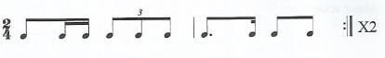
1 mark for each correct beat
Total (4 marks)
  - Rhythm of a melody in simple time
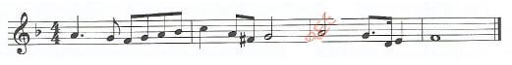
¹/₂ mark for each correct note value (15 notes) (7¹/₂ marks)
¹/₂ mark for correct time signature (¹/₂ mark)
Total (8 marks)
  - Rhythm of a melody in compound time.
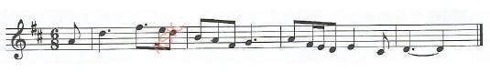
¹/₂ mark for each correct note (16 notes) (8 marks)
Total (8 marks)

  - Melody in a major key.
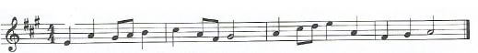
¹/₂ mark for each correct note-pitch and value (17 notes) (8 ¹/₂ marks)
1 mark for correct key signature (1 mark)
¹/₂ mark for key signature ¹/₂ mark
*Deduct 1 mark per bar for incorrect note values where pitches are correct
Total (10 marks)
  - Melody in a minor key.
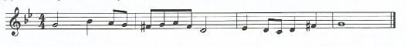
¹/₂ mark for each correct note (pitch and value) (15 notes) (7¹/₂ marks)
1¹/₂ mark for correct key signature (1¹/₂ mark)
1 mark for correct time signature (1 mark)
* Deduct 1 mark per bar for incorrect note values (Where pitches are correct)
Total (10 marks)
- Intervals
  - 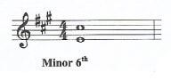
Award 1 mark for a fully described interval (1¹/₂ mark)
Award only ¹/₂ mark if the interval is not fully named. e.g. 6th
  - 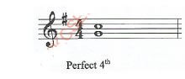
Award 1 mark for a fully described interval (1 ¹/₂ mark)
Award only ¹/₂ mark if the interval is not fully described. e.g. 4th
- Cadences
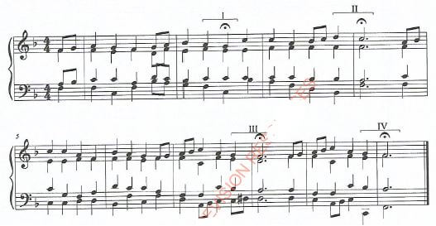
  - Imperfect cadence (1 mark)
  - Plagal cadence (1 mark)
  - Interrupted cadence (1 mark)
  - Perfect cadence (1 mark) Total 4 marks
- Modulation
  - 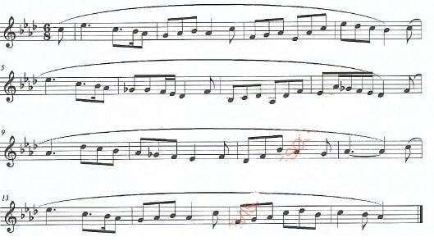
The melody modulates from the tonic, (A flat major), to Subdominant key (D flat major).
(Mark as a whole) (1¹/₂ mark)
  - 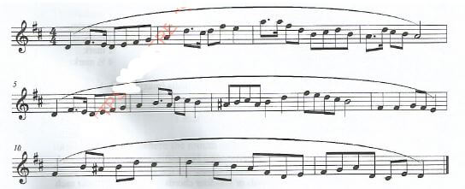
The melody modulates from the tonic (D major), to the relative minor (B minor).
(Marks as a whole) (1¹/₂ mark)

