INTERNAL LAND FORMING PROCESSES – EARTHQUAKES.
1. (a) Name two scales used to measure the intensity of an earthquake (2mks)
(b) Give three causes of earthquakes (3mks)
2. The diagram below represents the internal structure of the earth. Use it
to answer question(a)
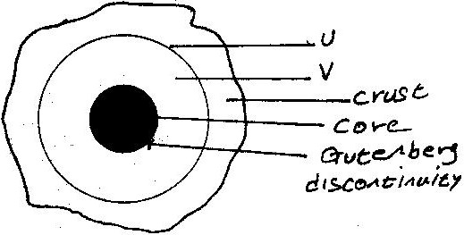

- Name the part marked U and V.
- Describe the deposition of:
    - The crust
    - The core
- (i) What are earthquakes
(ii) Name two types of earthquakes.
(iii) State the five ways in which the earths’ crust is affected by earthquakes.
- You intend to carry out a field study of an area recently affected by intense earthquake.
    - Give two sources of information that you would use in preparation for the study.
ii. Explain two factors that would make it difficult for you to collect accurate data during the field study.
3. (a) State three causes of earthquakes
(b) Give two effects of earthquakes in built up areas
4. State the major causes of earthquakes (2mks)
5. Explain how intensity of earthquake is measured. (2mks)
6. List major effects of earthquakes where they occur. (4mks)
7. Distinguish between seismograph and seismogram (4mks)
8. Differentiate between intensity and magnitude of earthquake (4mks)
9. Students from your school intend to carry out a field study of an area recently affected by intense earthquake.
(i) Give two sources of information that you would use in preparation for the
study.
(ii) Explain two factors that would make it difficult for you to collect accurate data during the field study.

