**ENERGY.**

1. (a) Apart from providing power, state three other benefits of the dams along

River Tana. 3 mks

(b) State two problems that affect hydro­electric power production along river Tana. 2 mks

(c) State two factors that hinder the expansion of geothermal power. 2 mks

2. (a) Name two non-renewable sources of energy. 2 mks

(b) Explain four physical factors that influence the location of a hydro­electric power station. 8 mks

3. (a) Explain three benefits that would result from rural electrification in

Kenya. 6 mks

(b) In what three ways did the power shortage resulting from the drought of the years 1999 and 2000 affect this industrial sector in Kenya? 5 mks

4. (a) Give three reasons that make tropical countries to have the potential to

develop HEP. 3 mks

(b) Give two reasons why tropical countries are not sufficient in HEP production. 2 mks

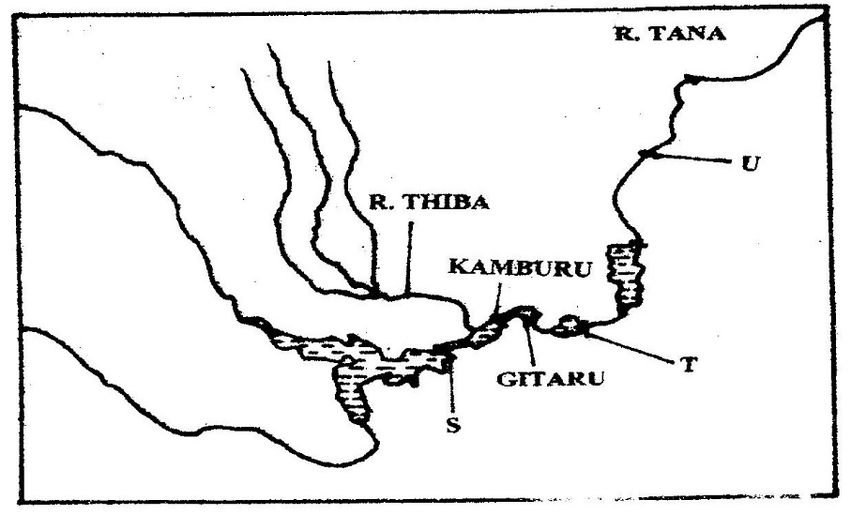5. Use the diagram to answer questions below.

(a) Name

(i) The HEP stations marked S & T 2 mks

(ii) Name the proposed HEP station marked U. 1 mk

(b) Name renewable sources of industrial energy other than water 2 mks

6. The diagram below shows the occurrence of petroleum in the earth's crust. Use it to answer question (a).

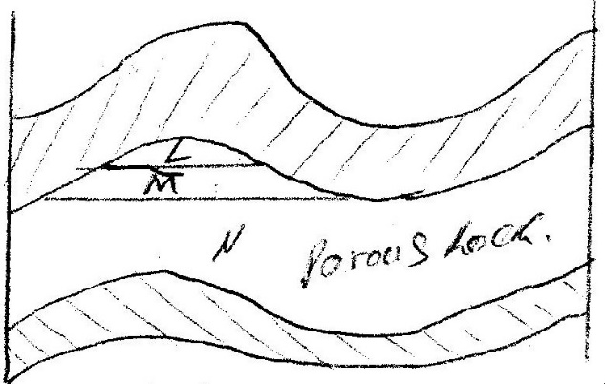

(a) Name the substances labeled I, M and N. 3 mks

(b) Give two by-products obtained when crude oil is refined. 2 mks

(c) Explain efforts by Kenyan government to reduce cost on importation of petroleum. 6 mks

7. Name two main disadvantages of using coal as a source of energy. 2 mks

8. Suggest four solutions to Kenya's energy deficit. 4 mks

9. What are the causes of energy crises? 4 mks

10. List uses of nuclear energy. 4 mks

11. Name uses of wind energy. 2 mks

12. Name two non- renewable sources of energy. 2 mks

13. Why has usage of coal as a source of energy declined? 4 mks

14. Give four reasons why Kenya has been unable to exploit high geothermal power potential. 4 mks

15. Name the various methods that can be used to conserve energy. 4 mks

16. Define biomass. 2 mks

17. (a) Define energy. 2 mks

(b) List three renewable; sources of energy. 3 mks

(c) State the disadvantages of coal as a source of energy. 4 mks

18. (a) What is the name of power projects along river Tana.

(b) Apart from hydroelectric power production, state the other benefits of the dams along the Tana. 4 mks

(c) Identify the problems facing hydroelectric power production along the Tana. 4 mks

19. (a) Apart from the Tana, name three other hydroelectric power projects in

Kenya. 3 mks

(b) State the benefits of the Owen Falls Dam in Uganda. 4 mks

(c) State the factors limiting the expansion of geothermal power production in Kenya. 4 mks

20. Apart from hydro-electric power production; state the other benefits of the dams.

4 mks

21. State the significance of energy. 5 mks

22. (a) What is energy crisis? 2 mks

(b) State the causes of energy crisis. 2 mks

23. Explain the problems Kenya faces due to overdependence on petroleum. 4 mks

24. (a) Differentiate between management and conservation of energy. 2 mks

(b) Describe the measures of management and conservation of energy. 10 mks