451/1
COMPUTER STUDIES
Paper 1
THEORY
SEPTEMBER 2021
2 ½ Hours
WISDOM PREMOCK EXAMINATION
Kenya Certificate of Secondary Education (K.C.S.E)
MARKING SCHEME

1. During a visit to the typing room, Jane a computer student observed a type of printer that uses a beam to create an image on a rotating drum. As the beam hits the drum, some regions attract ink toner particles. The toner is then fused onto a piece of paper.
i. State the name of this type of printer and indicate whether it is an impact or non-impact printer. (1mark)
Laser printer / Non Impact (both correct @ 1mark)
ii. List two advantages of using the printer mentioned in a. above. (2marks)
High quality print out
Speed of printing is fast
The cost per page of toner catridges is lower than other printers
(any two @ 1)
2. Bunam Water Company sends out field officers to take consumer meter readings. The data collected by the officers is then keyed into the computer. The system then generates utility bills which are printed and sent to the consumers.
i. State two transcription errors that are likely to occur during meter reading or input (1 mark)
- Transposition
- Misreading
(any 2 @ 1mark)
ii. State two ways such errors can be avoided (1 mark)
- Design user interfaces that minimize chances of invalid data entry.
- Using error detection and correction software when transmitting data.
- Using devices that capture data directly from the source. E.g. digital cameras, optical character readers
(any 2 @ ½ mark)
3. Highlight the dangers associated with the following in a computer laboratory set up:
a. Purchasing software before assessing requirements (1mark)
May be a pirated software (correct @ 1mk)

b. Using foreign flash disks on the computer. (1mark)

Spread of viruses (correct @ 1mk)

4. To process an instruction, the CPU goes through a cycle of three stages. Name each of the stages. (3 marks)
- Fetch
- Decode
- Execute
(correct@ 3 marks)
5. Explain the importance of the following spreadsheet operations. ( 2 marks)
(i) Freezing columns
· It enable the use to view only required records at a time
( correct @ 1mark)
(ii) Data validation
· Ensures the records are valid as per the user need
(correct @ 1 mark)
(b) Name two types of relationships that can be applied in database design. (1 mark)

- One to one
- One to many
- Many to many
(any 2 @ 1/2 mark)
6. Briefly explain any Four block operations that can be performed on data in word processing (4 marks)
- copying text- creating duplicate copy of the specific text
- moving text- transferring text to a new location
- deleting text-Erasing the specific block of text
- formatting text- to apply a formatting feature like, bold, italics, underline, change style etc
- Columns- applying columns to the specific text selected
- Applying bullets and numbering
(state @1, explain @1mark)
7. (a) Mutiso wanted to upgrade the RAM of his computer. State two factors Mutiso should consider when purchasing a RAM module. (1 mark)

- Memory capacity of the module
- Compatibility with the current modules
- Availability of an empty slot
- The type of module supported by the motherboard
(state @½ mark)
(b)Define the following terms: (2 marks)
(i) Computer Port
Is a special kind of connector or socket on the system unit which a cable from an external peripheral device is plugged to facilitate transfer of data/information
(correct @ 1 mark)
(ii) Power supply unit
Is a special unit inside the system unit that supplies power to the motherboard and other internal devices
(correct @ 1 mark)
8. Mkulima Bora is a society that embraced E-Commerce recently. The manager is convinced that there is illegal access to the company’s system. State TWO ways in which the society can overcome this problem. (2 marks)

- Encryption
- Firewall
- User profile/password/user accounts
- Limit the number of log-in attempts
- Audit trail/tracking

9. (a) Study the diagram below and answer the questions that follow.

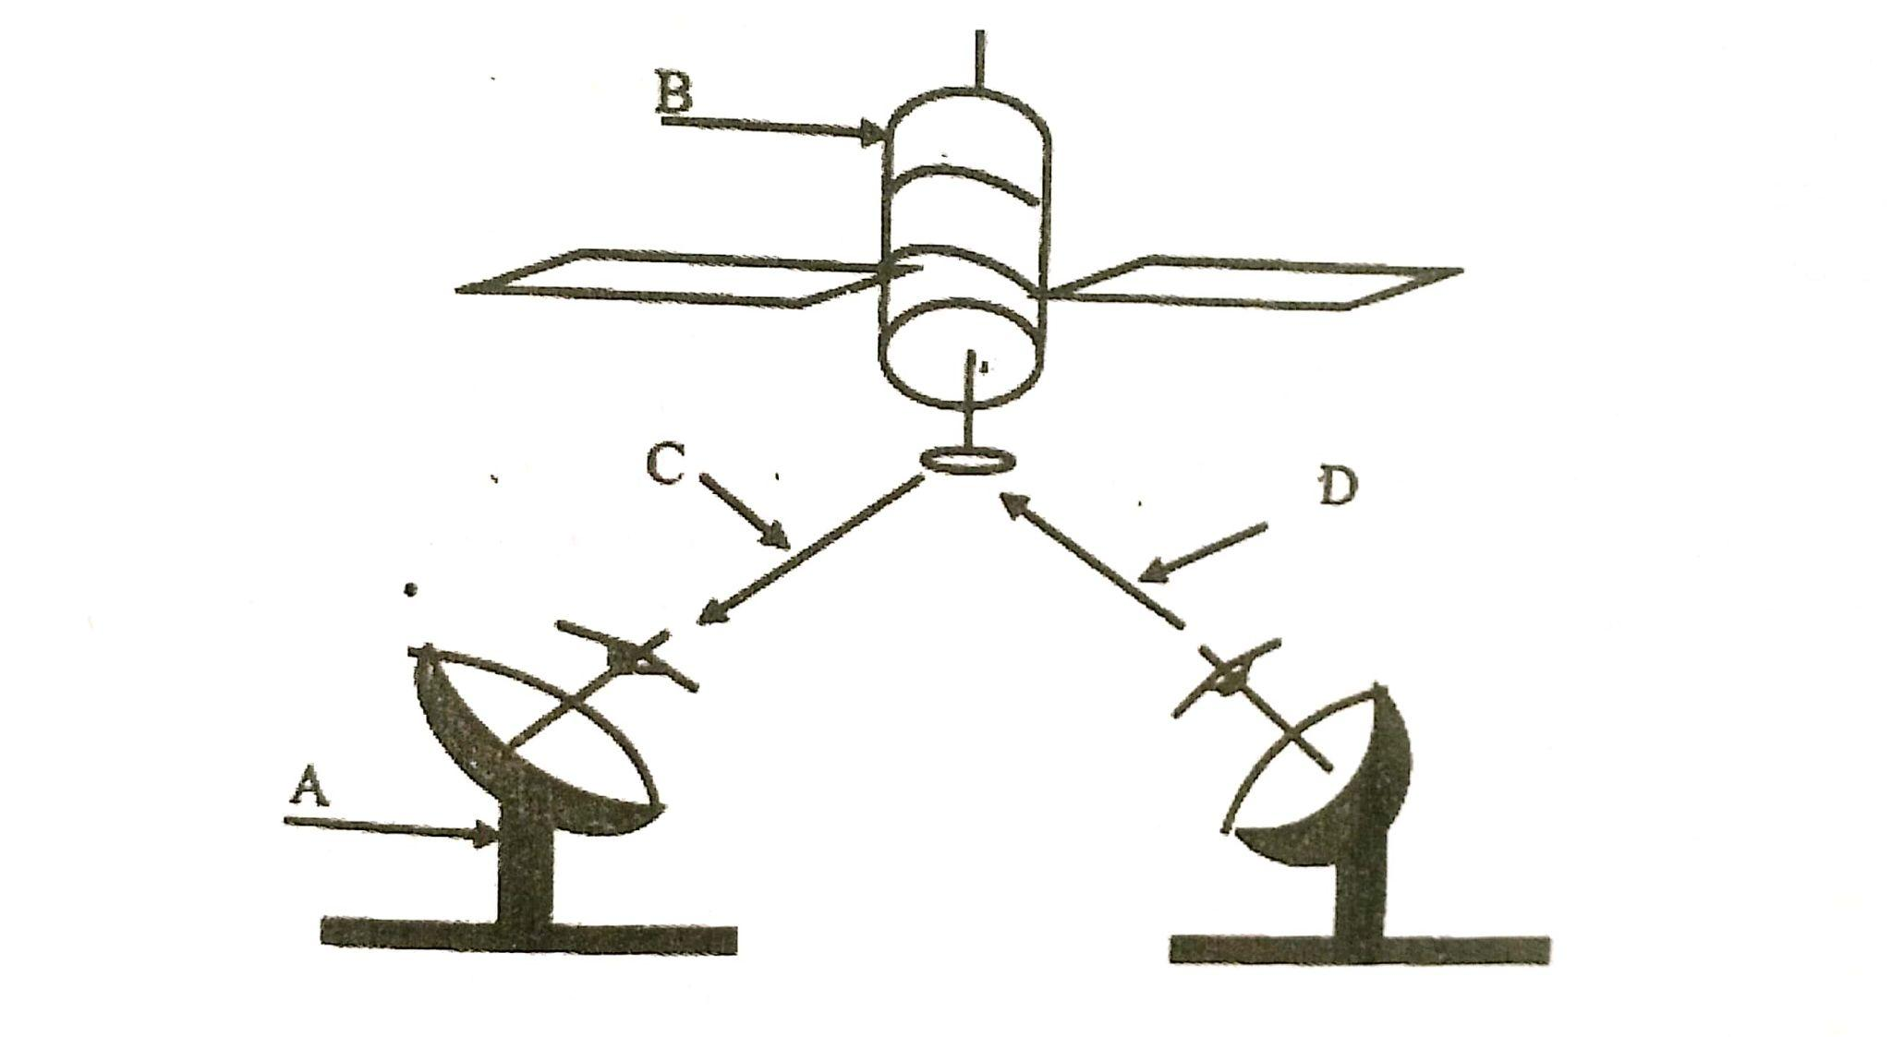

(i) Name the communication media depicted in the above diagram (1 mark)

Satellite communication

(ii) Name the parts labelled A, B, C, and D (3 marks)

A- Receiving earth station
B - Satellite in space
C - Down link
D - Up link

10. In a desktop publishing document, an image embedded can be transformed in various ways. Name any three ways one can use to make the image fit in a designated area. (3 marks)

- Rotation
- Flipping
- Cropping/trimming/cutting/chopping
- Stretching/Enlarging/Increasing
- Squeezing/reducing/shrinking
- Resizing

11. Differentiate between source program and object program (2 marks)

Source code are instructions that a programmer created when writing a program/instructions in the high level language while object code refers to machine language code that is output by a compiler or assembler
A translator converts source code to object code

12. Differentiate between the following terms in Internet (4 marks)
(i) Drafts and outbox
Drafts contain e-mails that are being worked on and are not yet ready to be sent while outbox contains e-mails that are waiting to be sent.

(ii) cc and bcc

cc, the recipients of the mail are able to see who else received the mail while bcc, the recipients of the mail are not able to see who else received the mail

13. State two characteristics of a computer that is infected by computer viruses (2 marks)
- Loss of data
- Change in file sizes
- Slower than normal program operation
- Unusual and frequent error messages
- System crash
- Taking long to load/booting

14. Identify each of the following symbols as used in system flowchart (1 mark)

15. Differentiate between bullets and numbering as used in DTP (2 marks)

Bullets are used to create an unordered list while numbering is used to create an ordered list.
NB: Accept correctly labelled illustrations.

SECTION B
Answer question 16 and any other 3 questions in this section

16. a) State any three activities that occur in a program compilation process (3 marks)

Program code converted into machine language (translation of source program to object code) Program is debugged (checked for syntax errors)
Executable format of file is created
Testing of the program

b) A program is needed for calculating the average age of students in a class. Write a pseudocode that will read the age of the students and calculate the average age. The program should terminate if the value of 999 is entered for age and output the number of times the statements within the loop were executed. (10 marks)

START ½
SUM = 0 ½
COUNT = 0 ½
PRINT “ENTER AGE”
READ AGE 1
WHILE AGE<>999 DO 1
SUM = SUM + AGE 1
COUNT = COUNT + 1 1
PRINT “ENTER AGE”
READ AGE
ENDWHILE
AVERAGE = SUM / COUNT 1
PRINT COUNT 1
PRINT AVERAGE 1
STOP ½

LOGIC 1
TOTAL 10

c) Give two types of errors that may be detected during program testing (2 marks)

- Syntax errors
- Logical errors
- Runtime errors

17. a) State four functions which are specific to Network Operating Systems (4 marks)

- Provide access to network resources
- Enables nodes on the network to communicate with each other efficiently
- Supports interprocess communication
- Respond to requests from application programs running on network
- Implement network security

b) State two advantage of using fibre optic cables over satellite in data communication (2marks)

- Its immune to interference and eavesdropping
- Has low attenuation
- Vast transmission of data at a high speed

c) (i) The figure below shows how data is transmitted through a public telephone line (4 marks)

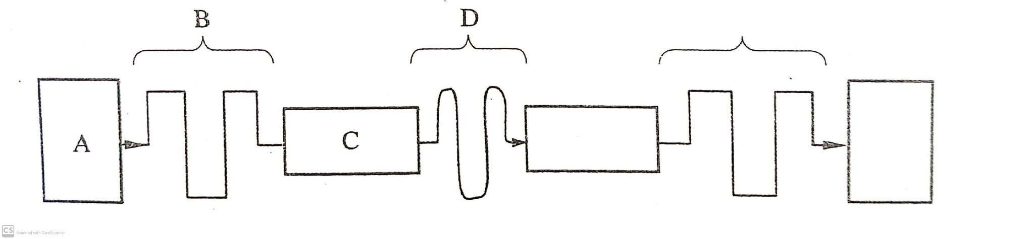
Name A, B, C, and D

A - Sending computer
B - Digital Signal
C - Modem
D - Telephone Line/ Analogue Signal

d) (i) List any two items that may be referred to as data terminal equipments in a network
(2 marks)

- Computer
- Printer
- Visual Display Unit
- Mobile Phone
- Tablet
- Scanner

(ii) Write the acronym MODEM inf full (1 mark)

Modulator Demodulator/ Modulation Demodulation

(iii) Explain the purpose of a modem when connecting to the internet (2 marks)
Convert digital signals to analog format before transmission; and incoming signals from analog to digital before processing

18. (a) State THREE roles of a programmer in system development life cycle (3 marks)

- Coding/writing/constructing (building) the system
- Turning system specification into an Information system
- Modify existing programs to meet changes in information processing needs (maintenance)
- implementing/ installing a system
- Developing system/ program
- Documenting/ giving technical guide

(b) State four activities that may be carried out when disposing off an old system in an organization (4 marks)
- Ensuring that all the accounts or other access control facilities that are associated with the system being disposed are eliminated. Any sensitive data on drives should be gotten rid of
- In the most extreme cases, storage devices may need to be physically destroyed to ensure that sensitive data isn’t leaked to whoever gets the drive next
- Make sure that physical indicators of a system has been fully decommissioned in a secure manner that they don’t consist of something easily misplaced or overlooked like a sticky note
- Whoever is responsible for disposing a machine should sign off on the completion of the process

(c) Distinguish parallel changes over from straight change over as used in system implementation. (2marks)

Parallel change over both old and new systems are run parallel to end other for some time until users have confidence in new system is stopped and discarded and the new system started immediately. While in straight change over the system is immediately implemented and the old one discarded

d) Discuss any two fact finding methods. (4marks)

Interviews – it is carried out with relevant stakeholders in order to get views about the current system.
Questionnaires – Special purpose document that allows a person to collect information and opinions from people who receive and respond to it.
Observation – Require the observer to participate or watch closely as a person performs activities in order to learn about the system.
Automated method – Used when one wants to get actual data which may be difficult to get through interviews,observation or questionnaires.

e) Differentiate between an open system and a closed system. (2marks)
An Open system is that which interacts and communicates with its environment constantly. It receives inputs from & gives output to the environment.
A closed system is that which does not interact or communicate with its environment. It does not communicate to or receive communication from its environment.

19. a)State three standard coding scheme used computing and electronic systems.
(3marks)
- Binary coded decimal\
- American standard code for information interchange
- Extended binary coded decimal interchange code
(correct @ 3 marks)
b) Convert each of the following numbers
i) 1001.001₂ to octal. (2marks)
001|001.001
11.1₈ (correct whole number @ 1 mark, correct fractional part @ 1 mark)
ii) 125.5₁₀ to hexadecimal. (3marks)
 | 125
16 | 7 r 13
16 | 0 r 7
= 7D₁₆ (whole number correct @ 1 mark)
0.5 x 16 = 8.0 (fractional part correct @ 1 mark)
= 7D.8₁₆
iii) Add 1100.011₂ to 11001.0101₂ and leave your answer in decimal (3 marks)
 | 0 | 1 | 1 | 0 | 0 | . | 0 | 1 | 1 | 0
 | 1 | 1 | 0 | 0 | 1 | . | 0 | 1 | 0 | 1
1 | 0 | 0 | 1 | 0 | 1 | . | 1 | 0 | 1 | 1
= 100101.1011₂ (binary @ 1 mark)
1 | 0 | 0 | 1 | 0 | 1 | . | 1 | 0 | 1 | 1
2⁵ | 2⁴ | 2³ | 2² | 2¹ | 2⁰ | . | 2⁻¹ | 2⁻² | 2⁻³ | 2⁻⁴
32 | 0 | 0 | 4 | 0 | 1 | . | 0.5 | 0 | 0.125 | 0.0625
37.6875₁₀
(whole number correct @ 1mark, Fraction part correct @ 1 mark)
c) Using two compliment perform the following arithmetic leaving your answer in binary form. (4marks)
13₁₀ - 15₁₀

 | 13
2 | 6 r 1
2 | 3 r 0
2 | 1 r 1
 | 0 r 1

= 1101₂ (correct @1/2 mark)
 | 15
2 | 7 r 1
2 | 3 r 1
2 | 1 r 1
 | 0 r 1

= 1111₂ (correct @1/2 mark)

00001101+(-00001111)
1c(00001111) = 11110000 (correct @1 mark)
2c =
1 | 1 | 1 | 1 | 0 | 0 | 0 | 0
+ |  |  |  |  |  |  | 1
1 | 1 | 1 | 1 | 0 | 0 | 0 | 1
(correct @1 mark)

 | 0 | 0 | 0 | 0 | 1 | 1 | 0 | 1
+ | 1 | 1 | 1 | 1 | 0 | 0 | 0 | 1
 | 1 | 1 | 1 | 1 | 1 | 1 | 1 | 0
= 11111110₂ (correct @ 1mark)

20. (a) Distinguish between axis labels and data labels as used in spreadsheets
(2marks)
Axis labels refer to data corresponding to the vertical or horizontal lines in a given chart
Data labels are data that provide additional information about a data marker which presents single data point on a value that originates from a worksheet cell
(correct @ 2marks)
(b) Name an electronic spreadsheet feature that allows one to perform the following actions. ( 4 marks)

Action | Feature
Provide pictorial summary of data | Chart / graph
Make one cell out of many | Split cells
List items from Highest to lowest or vice versa | sort
Make many cells out of one | Merge cells

(c) Explain the difference between the printing of multiple pages and multiple copies as used in word processing (2marks)
- printing of multiple pages is Printing more than one page whereas
-multiple copies is Printing several copies of the same page
(correct @ 2 marks)
(d) Describe the following categories of software (4marks)
i) Firmware
Hardware and software instructions recorded on a rom chip
ii) Proprietary software
Software whose source code is hidden from users
(d) Explain the meaning of solid state storage media giving TWO examples of it.
(3 marks)
These are devices which don't have moving parts .

Examples
- Flash disk
- Memory card
- Solid state hard disk

