Name:………………………………………………………. School:……………………………
Adm No. ………………………Class ……………………… Index Number:…………………..
451/1
COMPUTER STUDIES
Paper 1
THEORY
SEPTEMBER 2021
Time: 2 ½ Hours
WISDOM PRE-MOCK 2021
Kenya Certificate of Secondary Education (K.C.S.E)
INSTRUCTIONS TO CANDIDATES
- Write your Name, Class, Admission Number and Index Number in the spaces provided.
- Answer ALL the questions in section A
- Answer question 16 (Compulsory) and any other three questions from section B.
For Official Use Only
Question | Maximum score | Actual score
1-16
17
18
19
20
TOTAL SCORE
This paper consists of 13 printed pages
Candidates should check the question paper to ensure that all the printed pages are printed as indicated and no questions are missing.
SECTION A: (40 MARKS)
Answer ALL Questions in This Section
1. During a visit to the typing room, Jane a computer student observed a type of printer that uses a beam to create an image on a rotating drum. As the beam hits the drum, some regions attract ink toner particles. The toner is then fused onto a piece of paper.
- State the name of this type of printer and indicate whether it is an impact or non-impact printer. (1mark)
___________________________________________________________________
___________________________________________________________________
- List two advantages of using the printer mentioned in a. above. (2marks)
___________________________________________________________________
___________________________________________________________________
___________________________________________________________________
2. Bunam Water Company sends out field officers to take consumer meter readings. The data collected by the officers is then keyed into the computer. The system then generates utility bills which are printed and sent to the consumers.
i. State two transcription errors that are likely to occur during meter reading or input. (1 mark)
__________________________________________________________________
_________________________________________________________________
ii. State two ways such errors can be avoided. (1 mark)
__________________________________________________________________
___________________________________________________________________
3. Highlight the dangers associated with the following in a computer laboratory set up:
- Purchasing software before assessing requirements. (1 mark)
___________________________________________________________________
___________________________________________________________________
- Using foreign flash disks on the computer. (1 mark)
___________________________________________________________________
___________________________________________________________________

4. To process an instruction, the CPU goes through a cycle of three stages. Name each of the stages. (3 marks)
___________________________________________________________________
___________________________________________________________________
___________________________________________________________________
___________________________________________________________________
5. Explain the importance of the following spreadsheet operations. (2 marks)
(i) Freezing columns
___________________________________________________________________
___________________________________________________________________
(ii) Data validation
__________________________________________________________________
__________________________________________________________________

(b) Name two types of relationships that can be applied in database design. (1 mark)
__________________________________________________________________
___________________________________________________________________
__________________________________________________________________
6. Briefly explain any Four block operations that can be performed on data in word processing (4 marks)
__________________________________________________________________
___________________________________________________________________
__________________________________________________________________
__________________________________________________________________
7. (a) Mutiso wanted to upgrade the RAM of his computer. State two factors Mutiso should consider when purchasing a RAM module. (1 mark)
____________________________________________________________________
____________________________________________________________________

(b) Define the following terms: (2 marks)
(i) Computer Port
______________________________________________________________
______________________________________________________________
(ii) Power supply unit
_____________________________________________________________
_____________________________________________________________
8. Mkulima Bora is a society that embraced E-Commerce recently. The manager is convinced that
there is illegal access to the company’s system. State TWO ways in which the society can
overcome this problem. (2 marks)
___________________________________________________________________________
______________________________________________________________________________________________________________________________________________________
___________________________________________________________________________
9. (a) Study the diagram below and answer the questions that follow.

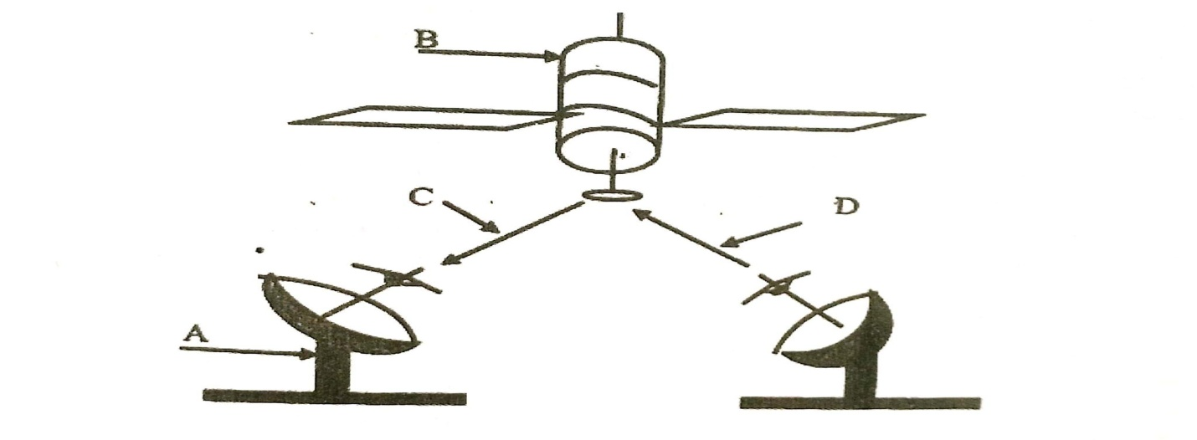
(i) Name the communication media depicted in the above diagram (1 mark)

________________________________________________________________________
(ii) Name the parts labelled A, B, C, and D (3 marks)
A_____________________________________________________________________
B _____________________________________________________________________
C ______________________________________________________________________
D ______________________________________________________________________

10. In a desktop publishing document, an image embedded can be transformed in various ways.
Name any three ways one can use to make the image fit in a designated area. (3 marks)
__________________________________________________________________________
______________________________________________________________________________________________________________________________________________________
___________________________________________________________________________
11. Differentiate between source program and object program. (2 marks)
__________________________________________________________________________
_____________________________________________________________________________________________________________________________________________________
12. Differentiate between the following terms in Internet (4 marks)
(i) Drafts and outbox
____________________________________________________________________
____________________________________________________________________
(ii) cc and bcc
___________________________________________________________________
___________________________________________________________________
13. State two characteristics of a computer that is infected by computer viruses. (2 marks)
_____________________________________________________________________
_____________________________________________________________________
_____________________________________________________________________
_____________________________________________________________________
14. Identify each of the following symbols as used in system flowchart. (1 mark)
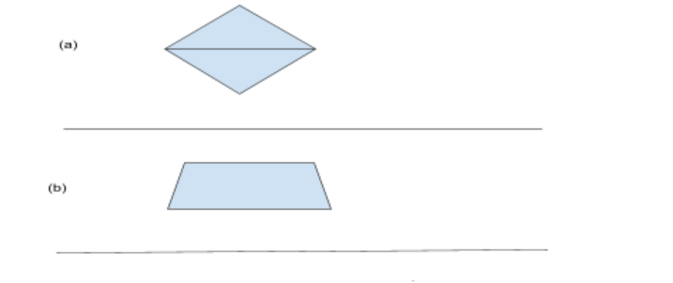
15. Differentiate between bullets and numbering as used in DTP (2 marks)
_____________________________________________________________________
_____________________________________________________________________
_____________________________________________________________________
_____________________________________________________________________

SECTION B (60 marks)
Answer question 16 and any other three questions from this section in the spaces provided.

16. a) State any three activities that occur in a program compilation process. (3 marks)
_____________________________________________________________________
_____________________________________________________________________
_____________________________________________________________________
_____________________________________________________________________
b) A program is needed for calculating the average age of students in a class. Write a pseudocode that will read the age of the students and calculate the average age. The program should terminate if the value of 999 is entered for age and output the number of times the statements within the loop were executed. (10 marks)
_____________________________________________________________________
_____________________________________________________________________ _____________________________________________________________________
_____________________________________________________________________
_____________________________________________________________________
_____________________________________________________________________ _____________________________________________________________________
_____________________________________________________________________
_____________________________________________________________________
_____________________________________________________________________ _____________________________________________________________________
_____________________________________________________________________
_____________________________________________________________________
_____________________________________________________________________ _____________________________________________________________________
_____________________________________________________________________
_____________________________________________________________________
_____________________________________________________________________ _____________________________________________________________________
_____________________________________________________________________
c) Give two types of errors that may be detected during program testing. (2 marks)
_____________________________________________________________________
_____________________________________________________________________ _____________________________________________________________________
_____________________________________________________________________
17. a) State four functions which are specific to Network Operating Systems. (4 marks)
_____________________________________________________________________
_____________________________________________________________________ _____________________________________________________________________
_____________________________________________________________________
b) State two advantage of using fibre optic cables over satellite in data communication. (2 marks)
_____________________________________________________________________
_____________________________________________________________________ _____________________________________________________________________
_____________________________________________________________________
c) (i) The figure below shows how data is transmitted through a public telephone . (4 marks)

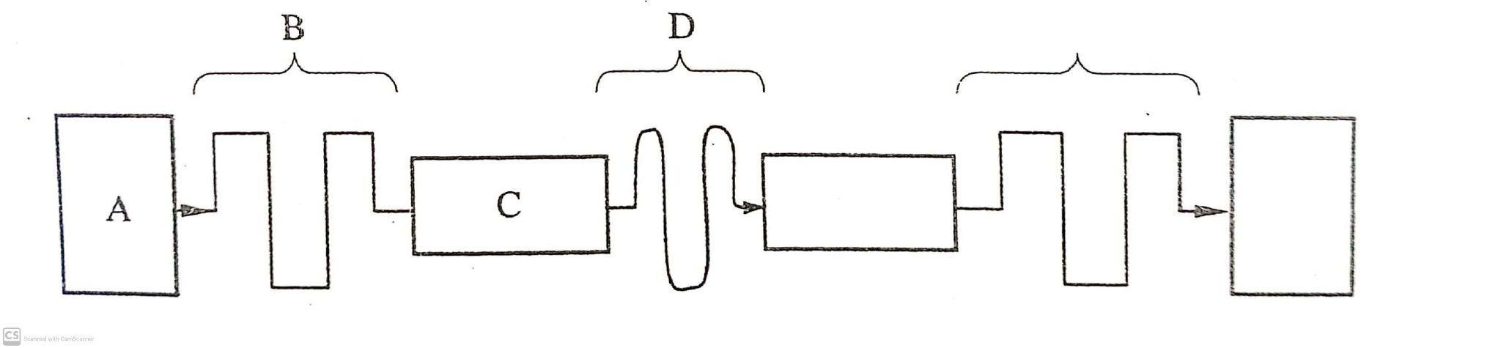
Name A, B, C, and D
_____________________________________________________________________
_____________________________________________________________________ _____________________________________________________________________
_____________________________________________________________________
d) (i) List any two items that may be referred to as data terminal equipments in a network
(2 marks)
_____________________________________________________________________
_____________________________________________________________________ _____________________________________________________________________
_____________________________________________________________________
(ii) Write the acronym MODEM in full (1 mark)
_____________________________________________________________________
_____________________________________________________________________
(iii) Explain the purpose of a modem when connecting to the internet. (2 marks)
_____________________________________________________________________
_____________________________________________________________________
_____________________________________________________________________
_____________________________________________________________________
18. (a) State three roles of a programmer in system development life cycle. (3 marks)
____________________________________________________________________
_____________________________________________________________________ _____________________________________________________________________
_____________________________________________________________________
(b) State four activities that may be carried out when disposing off an old system in an
organization (4 marks)
_____________________________________________________________________
_____________________________________________________________________ _____________________________________________________________________
_____________________________________________________________________
(c) Distinguish parallel changes over from straight change over as used in system implementation. (2 marks)
_____________________________________________________________________
_____________________________________________________________________
_____________________________________________________________________
_____________________________________________________________________

(d) Discuss any two fact finding methods. (4 marks)
___________________________________________________________________
_____________________________________________________________________ _____________________________________________________________________
_____________________________________________________________________
(e) Differentiate between an open system and a closed system. (2 marks)
_____________________________________________________________________
_____________________________________________________________________
_____________________________________________________________________19. a) State three standard coding scheme used computing and electronic systems. (3 marks)
_____________________________________________________________________
_____________________________________________________________________
_____________________________________________________________________
_____________________________________________________________________
b) Convert each of the following numbers
i) 1001.001₂ to octal. (2 marks)
_____________________________________________________________________
_____________________________________________________________________
ii) 125.5₁₀ to hexadecimal. (3 marks)
_____________________________________________________________________
_____________________________________________________________________

iii) Add 1100.011₂ to 11001.0101₂ and leave your answer in decimal (3 marks)
_____________________________________________________________________
_____________________________________________________________________ _____________________________________________________________________
_____________________________________________________________________
c) Using two compliment perform the following arithmetic leaving your answer in binary form. (4 marks)
13₁₀ - 15₁₀
_____________________________________________________________________
_____________________________________________________________________ _____________________________________________________________________
_____________________________________________________________________ _____________________________________________________________________
_____________________________________________________________________ _____________________________________________________________________
_____________________________________________________________________
20. (a) Distinguish between axis labels and data labels as used in spreadsheets. (2 marks)
_____________________________________________________________________
_____________________________________________________________________
_____________________________________________________________________
_____________________________________________________________________

(b) Name an electronic spreadsheet feature that allows one to perform the following actions. (4 marks)
Action | Feature
Provide pictorial summary of data
Make one cell out of many
List items from Highest to lowest or vice versa
Make many cells out of one
(c) Explain the difference between the printing of multiple pages and multiple copies as used in word processing. (2 marks)
_____________________________________________________________________
_____________________________________________________________________
(d) Describe the following categories of software (4 marks)
i) Firmware
__________________________________________________________________
____________________________________________________________________
ii) Proprietary software
__________________________________________________________________
__________________________________________________________________
(e) Explain the meaning of solid state storage media giving two examples of it.
(3 marks)
_____________________________________________________________________
_____________________________________________________________________
_____________________________________________________________________
_____________________________________________________________________

