Name:……………………………………...............ADM No:………......Class:……....
449/2
DRAWING AND DESIGN
PAPER 2
APRIL 2023
$2½ hours$
MECS CLUSTER JOINT EVALUATION
FORM FOUR END OF TERM ONE EXAMINATION 2023

MARKING SCHEME

DESIGN PROBLEM (40 marks)
During rainy seasons, most people are expected to clear mud from their shoes before they get into any office or household. Design a device that can be used to clear mud from shoes considering the following:
- It should be operated by hands
- It should deposit mud in a container.
- The scrapper should be made of brush
- It should spray water to soften the mud.
Requirements
- Make sketches of two possible solutions for your design (6 marks)
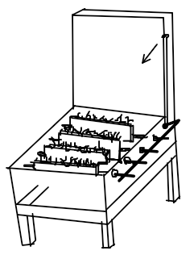
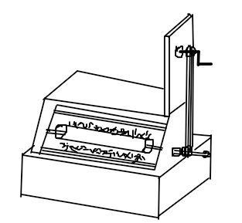

- Select one of the designs in (a) above and make a refined labelled pictorial sketch
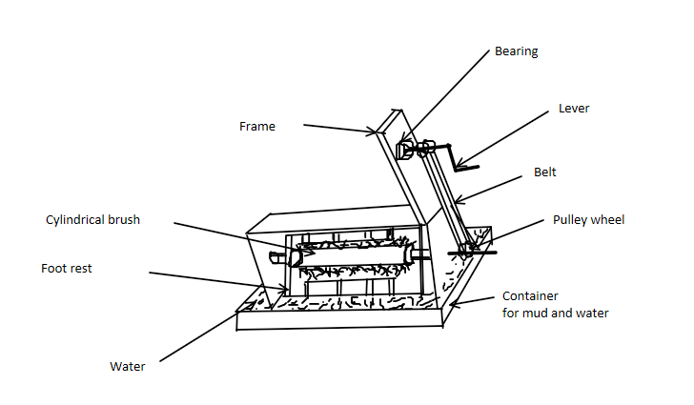
(14 marks)

- Make detailed sketches for the mechanisms to allow for each of the considerations above
(15 marks)

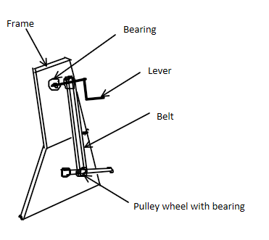

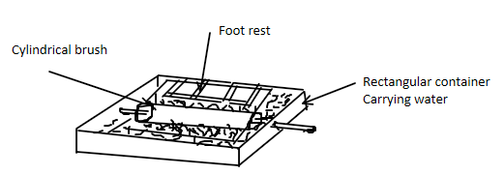

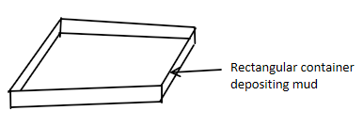

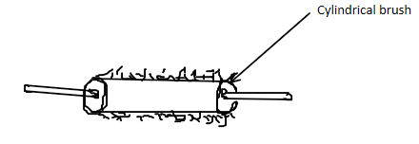

- List three materials used and state one reason for the choice of each. (3 marks)
Steel- to make the lever
Rubber- to make the brush
Iron- to make mud container.
- State two methods of joining the parts and state where each is used (2 marks)
Use of bolts and nuts- assembling the brush.
Welding- to join the body.

