Name:……………………………………...............ADM No:………......Class:……....
449/1
DRAWING AND DESIGN
PAPER 1
APRIL
$2½ hours$
MECS CLUSTER JOINT EXAMINATION
FORM FOUR END OF TERM ONE EXAMINATION 2023
DRAWING AND DESIGN
INSTRUCTIONS TO CANDIDATES
- Write your name, index number and class in the spaces provided above.
- The paper contains three sections: Section A, Section B and Section C
- Section A carries 50 marks, section B carries 20 marks and Section C 30 marks
- The paper contains 11 PRINTED pages make sure all PAGES ARE PRINTED and NONE IS MISSING
- Answer ALL the questions in each section.
- All the answers and working must be written on the question paper in the spaces provided below each question.
- Label every drawing drawn on A3 paper provided

Section A (50 marks)
- (a). State three qualities of a good technical drawing paper (3 marks)

(b). State two ways in which a pencil can be sharpened. Give the purpose for each
(2 marks)

- Construct a right-angled triangle given the hypotenuse as 97 mm and one side as 43 mm (3 marks)

- State three types of wood joints (3 marks)

- State two ways in which a veneer can be obtained from logs (2 marks)

- (a). State three disadvantages of metals as a material used in any design (1$½$ marks)

(b). Identify three factors of lettering that have not been considered in witting the title
below (3 marks)

FIRST ANGLE ORTHOGRAPHIC PROjeCtION

(c). State the aim of technical drawing that requires one to incorporate physical and
mental alertness. Outline the remaining aims of technical drawing (2 marks)

- Draw the view from the object shown below in third angle orthographic projection
(6 marks).

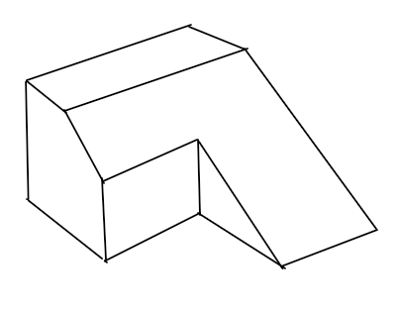

- Sketch a pictorial object for the views below in Isometric (6 marks)
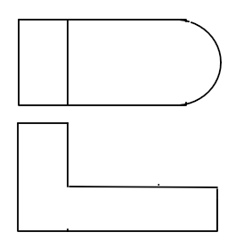

- (i). State three specialized fields where technical drawing skills can be employed. Name the type of drawing done in each field (3 marks)

(ii). State three factors that would cause a business to succeed (1½ marks)

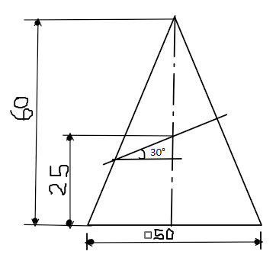
- The figure below shows a truncated square pyramid.

(a). Copy and complete the plan.
(b). Draw the true shape. (6 marks)

- The figure below shows a square pyramid.
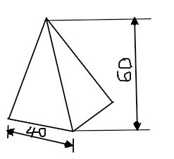

Draw the development of the pyramid (6 marks)

Section B (20 marks)
This question is Compulsory
It should be answered on the A3 paper provided.
Candidates are advised not to spend more than one hour on this question.

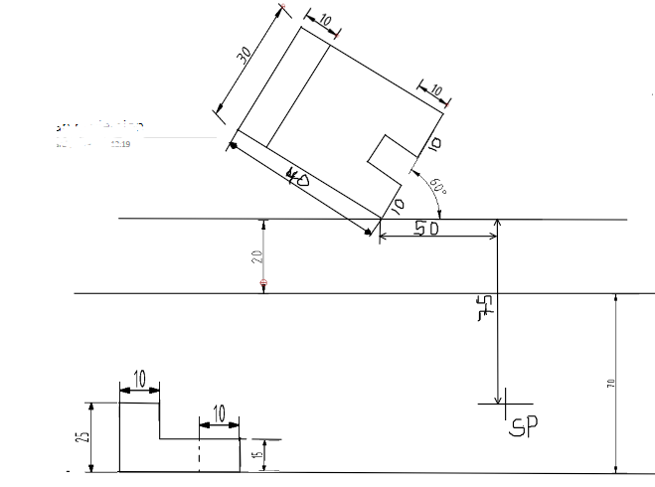
- The figure below shows views of the parts of a tool.

- Draw an involute of a square of sides 25 mm (5 marks)

Section C (30 marks)
Choose any TWO question from this section
- A toy car wheel of 60 mm diameter and four spokes has a point on one of its spokes. The point on the spoke is 10 mm from the circumference of the wheel. Draw the locus of the point as the wheel rolls without slipping for one revolution. (15 marks).

- Below are two views obtained from an object.
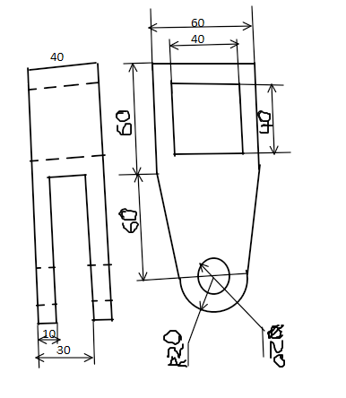

Draw the object from the views in isometric (15 marks)

- The figure below shows front and plan of a truncated prism
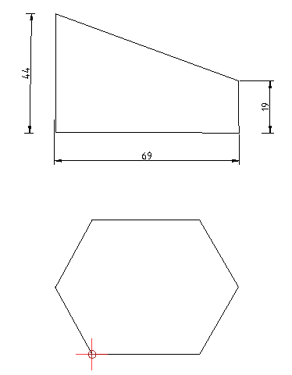

(a). Copy the view
(b) Draw the true shape
(c) Draw the development of the prism (15 marks)

