Name:……………………………………...............ADM No:………......Class:……....
449/1
DRAWING AND DESIGN
PAPER 1
APRIL
$2½ hours$
MECS CLUSTER JOINT EXAMINATION
FORM FOUR END OF TERM ONE EXAMINATION 2023
DRAWING AND DESIGN

MARKING SCHEME

Section A (50 marks)
- (a). State three qualities of a good technical drawing paper (3 marks)

The texture should be smooth
The colour should be white for contrast
The thickness should be adequate so that the pencil does not penetrate through.
The surface finish should not be glossy to cause reflection.
Should be of standard size.
(b). State two ways in which a pencil can be sharpened. Give the purpose for each
(2 marks)
Chisel- used with a compass for drawing arcs and circles.
Pointed/conical- for general purpose e.g lettering and outlines.

- Construct a right-angled triangle given the hypotenuse as 97 mm and one side as 43 mm (3 marks)
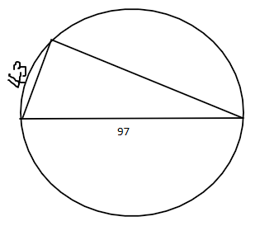

- State three types of wood joints (3 marks)
Widening joints
Angle or box joints
Framing joints

- State two ways in which a veneer can be obtained from logs (2 marks)
Rotary cutting.
Slice cutting
- (a). State three disadvantages of metals as a material used in any design (1$½$ marks)
It is difficult to shape.
It is relatively expensive
Heavy in weight.
(b). Identify three factors of lettering that have not been considered in witting the title
below (3 marks)

FIRST ANGLE ORTHOGRAPHIC PROjeCtION

Uniform height of letters
Uniform spacing of letters
Uniformity in the type of lettering

(c). State the aim of technical drawing that requires one to incorporate physical and
mental alertness. Outline the remaining aims of technical drawing (2 marks)
speed
Other aims are: Technique, neatness and accuracy.

- Draw the view from the object shown below in third angle orthographic projection
(6 marks).

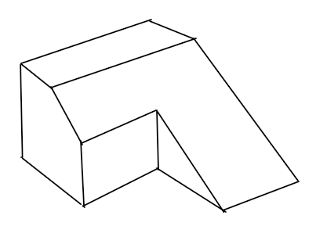

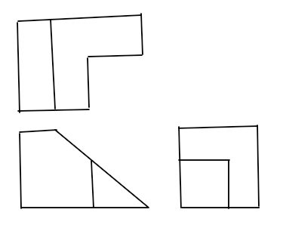

- Sketch a pictorial object for the views below in Isometric (6 marks)
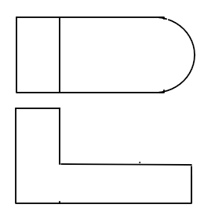

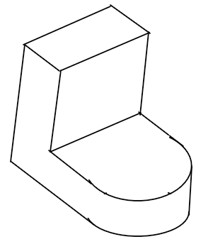

- (i). State three specialized fields where technical drawing skills can be employed. Name the type of drawing done in each field (3 marks)
Building industry- Architectural drawing
Mechanical engineering industry- machine drawing
Electrical industry- Electrical drawing.
Aircraft manufacturing industry- Aeronautical drawing

(ii). State three factors that would cause a business to succeed (1½ marks)
Poor management
Unavailability of capital.
Low level of skills

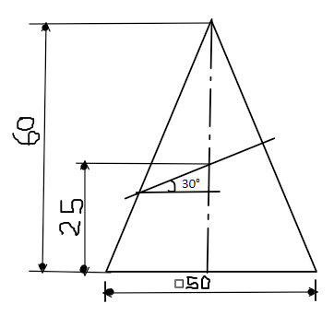
- The figure below shows a truncated square pyramid.

(a). Copy and complete the plan.
(b). Draw the true shape. (6 marks)

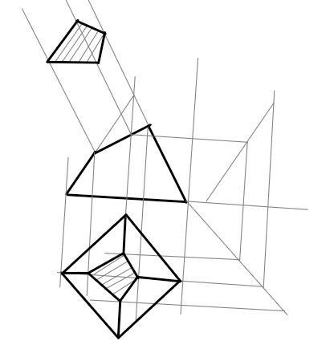

- The figure below shows a square pyramid.
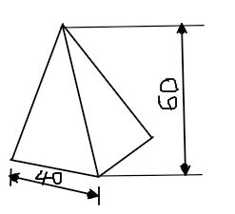

Draw the development of the pyramid (6 marks)

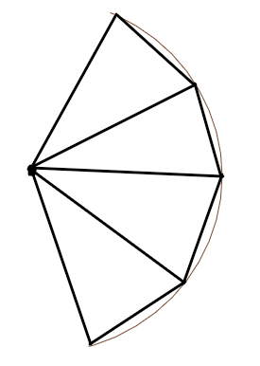

Section B (20 marks)
This question is Compulsory
It should be answered on the A3 paper provided.
Candidates are advised not to spend more than one hour on this question.

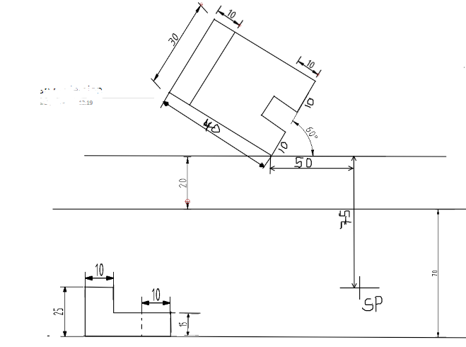
- The figure below shows views of the parts of a tool.

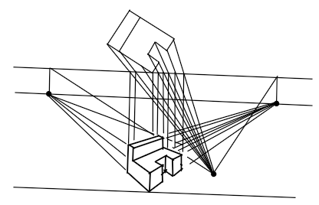

- Draw an involute of a square of sides 25 mm (5 marks)
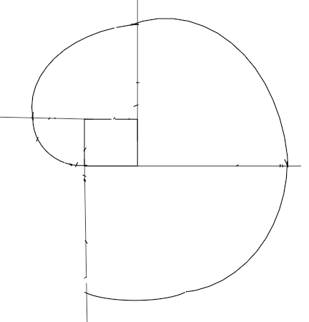

Section C (30 marks)
Choose any TWO question from this section
- A toy car wheel of 60 mm diameter and four spokes has a point on one of its spokes. The point on the spoke is 10 mm from the circumference of the wheel. Draw the locus of the point as the wheel rolls without slipping for one revolution. (15 marks).

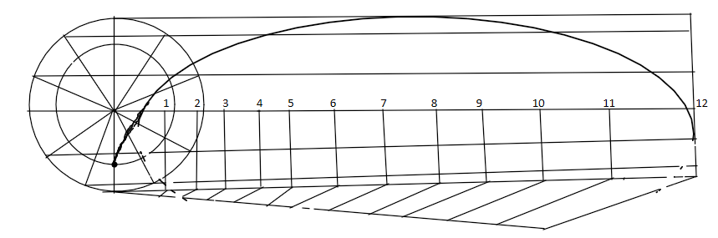

- Below are two views obtained from an object.
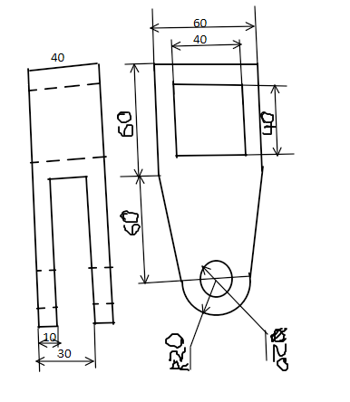

Draw the object from the views in isometric (15 marks)
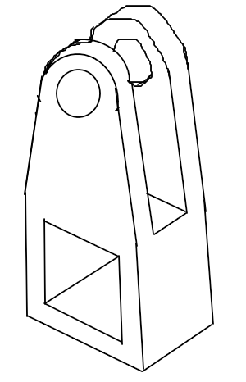

- The figure below shows front and plan of a truncated prism
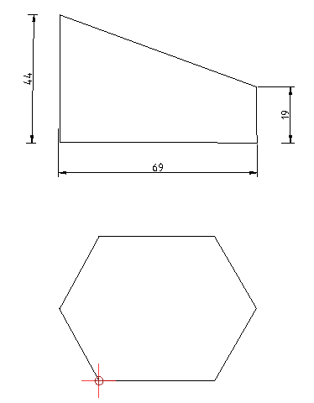

(a). Copy the view
(b) Draw the true shape
(c) Draw the development of the prism (15 marks)

