NAME……………………………………………………….INDEX No:……………….……………

SCHOOL:………………………………………………Candidate’s Signature……………………..

ADMISSION NO……….…………… Date………………………………………….

WISDOM CLUSTER EXAMINATIONS 2021
449/1
DRAWING & DESIGN
Paper 1
September
Time: 2 ½ Hours
INSTRUCTION TO CANDIDATES
- You should have the following for this examination;
- Drawing instruments
- Drawing paper size A3
- Write your name and index number in the spaces provided.
- This paper consists of three sections A, B and C.
- Answer All the questions in sections A and B and any TWO questions from section C.
- Questions from section A must be answered in the provided answer sheets.
- Questions in section B and C should be answered on the A3 drawing paper provided.
- All dimensions are in milimetres unless otherwise stated.
- Candidates may be penalized for not following the instructions given in this paper.

 | FOR EXAMINERS USE ONLY
SECTION A; |  | 1 - 12 | $$(x/{50})$$
SECTION B; |  | 13 | $$(x/{20})$$
SECTION C; |  | 14 - 16 | $$(x/{30})$$
GRAND  TOTALS |  |  | $$({xx}/{100})$$

This paper consists of 8 printed pages.
Candidates should check the question paper to ensure that all the pages are printed as indicated and no questions are missing.
SECTION A (50 Marks)
Answer all the questions in this section
- Define the term:
(a) Designer (1 mark)
……………………………………………………………………………………………………………………………………………………………………………………………………………………………………………………………………………………………………
(b) State two reasons of using different types of lines in engineering drawing. (2 marks)
- ………………………………………….…………………………………………………
- ………………………………………….…………………………………………………
- Define each of the following properties of materials: (2 marks)
- Plasticity……………………………………………………………………………………
………………………………………………………………………………………………
- Tensile strength ……………………………………………………………………….………………………
………………………………………………………………………………………………
- (a). State the two major method of timber conversion. (2 marks)
- ………………………………………………………………………………………….
- ………………………………………………………………………………………….
(b). State two effects of poor disposal of engineering materials to the environment. (2 marks)
- ………………………………………………………………………………………….
- ………………………………………………………………………………………….
- State three advantages for drawing sectional views in drawing. (3 marks)
- ………………………………..……………………………………………………………
- ………………………………………………………………………………………………
- ………………………………………………………………………………………………
- Explain three advantages of using computer in drawing. (3 marks)
- ………………………………………………………………………………………… ………………………………………………………………………………………………..
- ………………………………………………………………………………………………………………………………………………………………………………………………
- …………………………………………………………………………………………………………………………………………………………………………………..…………

- Using a circle of radius 20mm, show the following; (3 marks)
- Sector
- Segment
- Chord
- Quadrant
- Circumference
- Tangent

- Figure below shows two views of a block drawn in third angle projection. Sketch in good proportion the isometric view of the block taking X as the lowest point. (4 marks)
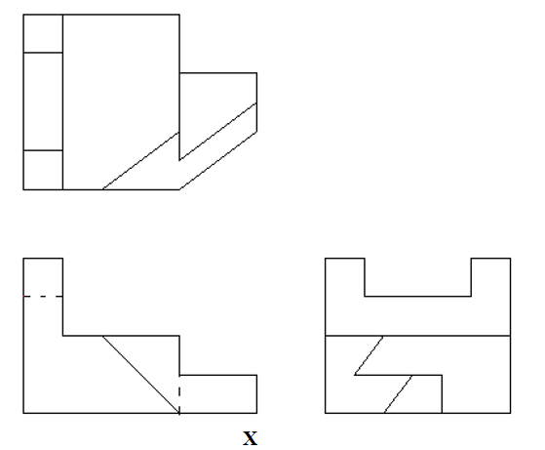

- (a) Give two real practical application of the intersection of surfaces or interpenetration of solids. (2 marks)

- ……………………………………………………………………………………………………………………………………………………………………………………
- ……………………………………………………………………………………………………………………………………………………………………………………
(b). Explain briefly three major areas to be considered in design. (3 marks)
- ………………………………………………………………………………………………………………………………………………………………………………
- ………………………………………………………………………………………………………………………………………………………………………………………………………………………………………………………………………
- ……………………………………………………………………………………………………………………………………………………………………………

- (a). List three characteristics of a good technical drawing paper. (3 marks)
- …………………………………………………………………………………………
- …………………………………………………………………………………………
- …………………………………………………………………………………………
(b). Outline four main steps involved in design process. (4 marks)
- …………………………………………………………………………………………………………………………………………………..…………………………………
- …………………………………………………………………………………………………………………………………………………………………….………………
- ………………………………………………………………………………………………..……………………………………………………………………………………
- ……………………………………………………………………………………………………………………………………………………………………………………
- Define the term: (1 marks)
- Loci ……………….……………………………………………………………………………………..………………………………………………………………………………………………………………………………………………………………………………………….

- State two important points considered before attempting to construct any locus. (2 marks)
- ………………………………………………………………………………………….
- …………………………………………………………………………………………
- Sketch in first angle projection the orthographic views of the block shown below. (6 marks)
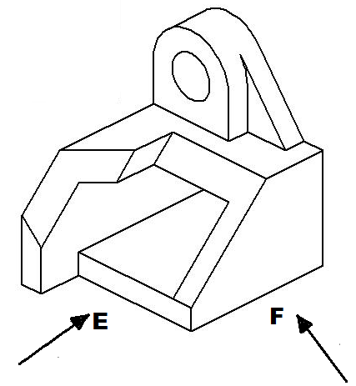

- (a). State three factors considered when lettering. (3 marks)
- ……………………………………………………………………………………..
- ……………………………………………………………………………………..
- …………………………………………………………….……………………….

(b). Construct a diagonal in which 30mm represents 1m, of 5 metres long to read 10mm. Mark
off a distance of 3M 670mm. Show all your working clearly (4 marks)

SECTION B (20 marks)
This question is compulsory.
Candidates are advised to spend not more than an hour on this question.
- The figure below shows parts of a machine component drawing in first angle projection.
Assemble the parts and, FULL SIZE, the following:
- The sectional front elevation along the cutting plane B-B.
- The plan.
- The end elevation

Insert six leading dimensions and part list. Unspecified dimensions are left to the candidate’s discretion. Hidden details may be included where necessary. (20 marks)

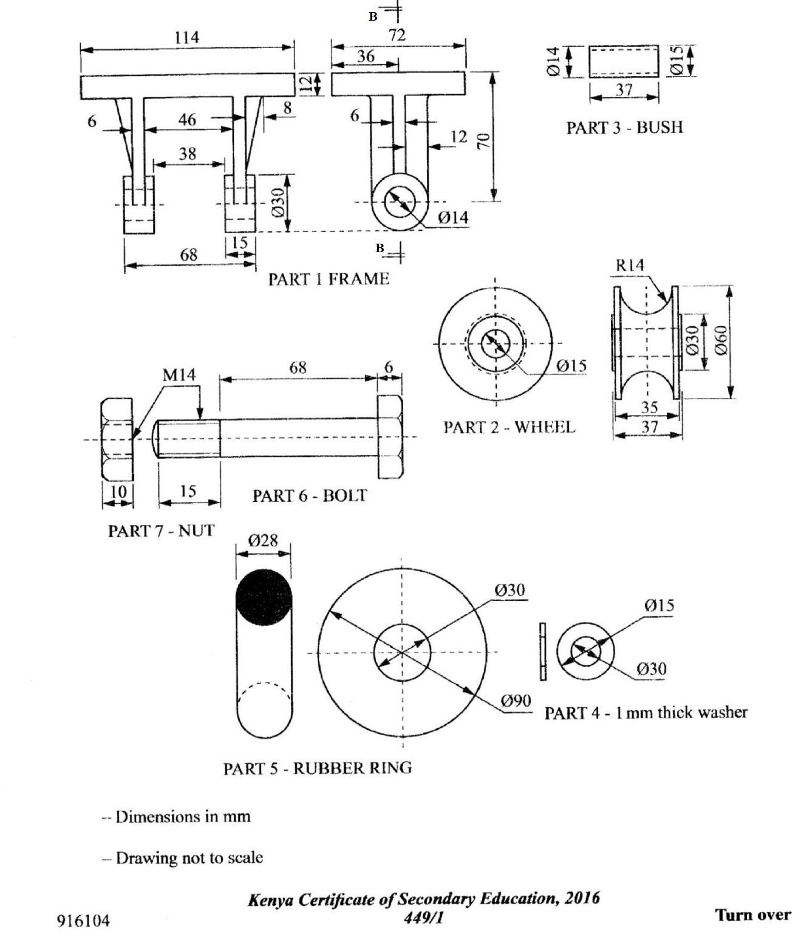

SECTION C (30 marks)
Answer any two questions in this section.
- The figure below shows the front elevation of a regular solid hexagonal pyramid of side 35mm which has been cut by planes X-X and Y-Y. Copy the figure and Draw the following: (15 marks)
- The sectional plan.
- The end elevation in the direction of arrow E.
- The true shape of the section X-X.
- The auxiliary view
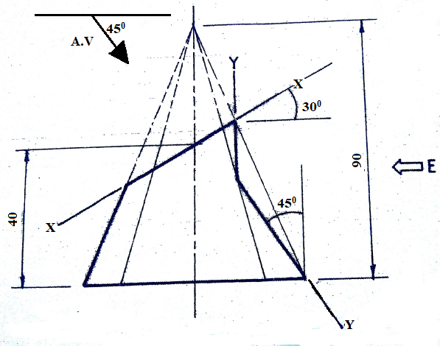
- The figure below shows the incomplete front and end elevation of two dissimilar off-setted squared pipe meeting at right angle. Using the dimension given, show line of interpenetration and then draw in first angle orthographic projection the following views:
- The complete front elevation
- A full plan;
- An end elevation;
- A full development of the smaller pipe. (15 marks)
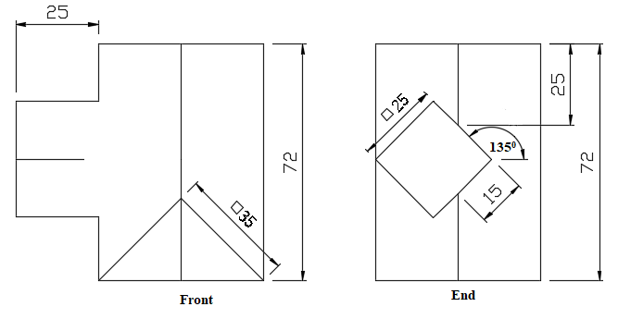

- Orthographic views of machine part in third angle projection are shown below. Draw an isometric view TWICE FULL SIZE SCALE clearly showing all the features of the components taking X as the lowest point. (Include at least six main dimensions, hidden details may be shown where necessary. (15 marks)

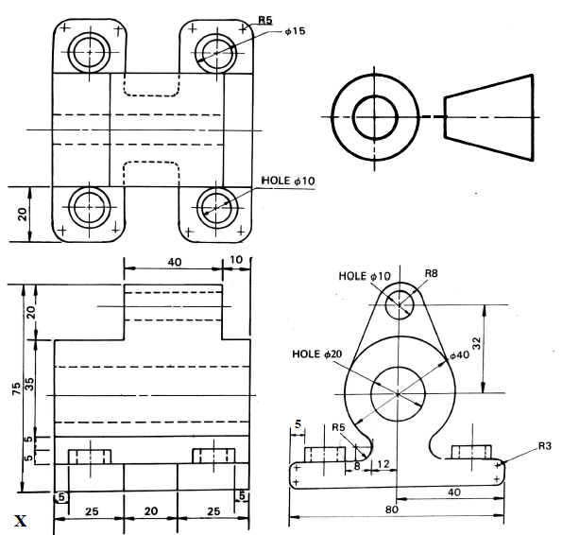

This is the last printed page.

