Name….....................................................................................................................................................
Index No……………………………School……………………………………………………………
Date…………………………………. Signature……………………………………………………….
448/2
ELECTRICITY
(Practical)
Paper 2
Time: 2 ½ hours
September /October

WISDOM CLUSTER EXAMINATIONS 2021
448/2
ELECTRICITY
(Practical)
Paper 2
2021
Time: 2 ½ hours
September /October

INSTRUCTIONS TO CANDIDATES
- This paper contains four exercises each 20 marks.
- Attempt all the exercises for 30 minutes each.

EXERCISE 1
Using materials, components and equipment provided, perform the following tasks.
(i) Correct the circuit shown in ﬁgure 1. (3 marks)
Let the examiner check your work.
Potentiometer
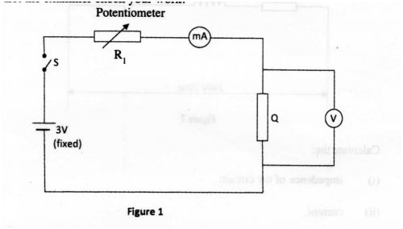
Figure 1
(ii) Close switch S.
(iii) Adjust the potentiometer for the ammeter to obtain current values in table 1 and in each case record the corresponding voltage values. (7 marks)
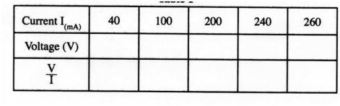
(iv) Calculate the values of and record them in the spaces provided in the table.

(v) Use the values in the table to draw a graph of voltage against current.

(vi) Determine the slope of the graph. (2 marks)
(vii) From the graph, determine the voltage, V when the current I = 160 mA.
V = ................................................................................................ .. (1 mark)
(viii) State the purpose of the experiment. (1 mark)

EXERCISE 2
Use the tools, equipment and materials provided to make the bracket shown in ﬁgure
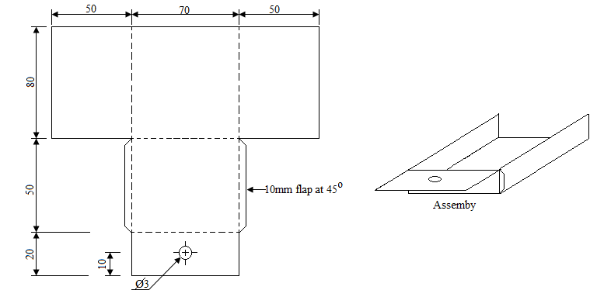

EXERCISE 3
3. Use the components and equipment to connect the circuit illustrated in ﬁgure 4. Let the examiner see your work. (2 marks)
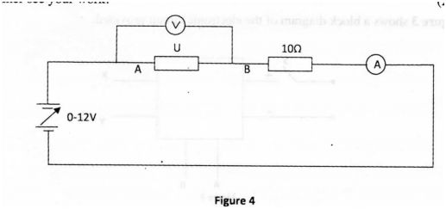
Perform the following tasks:
a) Switch on the power supply.
b) Adjust the power supply to obtain each of the voltage values across U as shown in table 3 and in each case, record the corresponding current: (5 marks)
Table 3
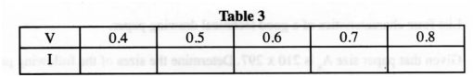
c) Switch off the power supply and reverse its connections.
d) Adjust the power supply to obtain each of the voltage values across U as shown in table 4 and in each case, record the corresponding current. (5 marks)
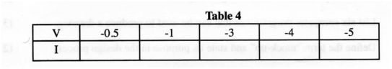

e) Use the values of I and V from tables 3 and 4 to draw the graph of current (I) against voltage (V) on the same axes. (7 marks)

f) From the shape of the graph, identify component U. (4 marks)

EXERCISE 4
Figure 5 shows the layout of a lighting installation. Using PVC sheathed cables, install the circuit such that the lamps are controlled at one point. (20 marks)
