Name…........................................................................................................................................
Index No……………………………School……………………………………………………
Date………………………………….Signature……………………………
448/1
ELECTRICITY
(Theory)
Paper 1
Time: 2 ½ hours

September/October

WISDOM CLUSTER EXAMINATIONS 2021

448/1
ELECTRICITY
(Theory)
Paper 1
Time: 2 ½ hours
September/October

INSTRUCTIONS TO CANDIDATES
- This paper has 12 printed pages.
- Answer all questions in section A and B.
- Mathematical tables or non-programmable electronic calculators maybe used

SECTION A (48 marks)
Answer all the questions in this section in the spaces provided.

- (a) Outline the procedure of connecting an ammeter to take a measurement in a circuit. (2 marks)
……………………………………………………………………………………………………………………………………………………………………………………………………………………………….

(b) Figure 1 shows a resistor with color bands.

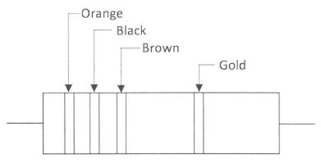
Figure 1

Determine its:
- Nominal resistance: (1 mark)

- Maximum resistance. (2 marks)

- (a) State two reasons for using a circuit diagram when troubleshooting n electrical
equipment. (2 marks)
………………………………………………………………………………………………………………………………………………………………………………………………………………………………
(b) State four components of a bill of materials in project fabrication. (2 marks)
…………………………………………………………………………………………………………………………………………………………………………………………………………………………………………………………………………………………………………

- (a) Explain the effect of each of the following in a p-n junction: (2 marks)
- Forward bias;
…………………………………………………………………… …………………………………………………………………… ……………………………………………………………………
- Reverse bias.
…………………………………………………………………… …………………………………………………………………… ……………………………………………………………………

(b) State the meaning of each of the following ratings of a light emitting diode: (2 marks)
(i) I_{F(max)};
…………………………………………………………………… …………………………………………………………………… ……………………………………………………………………
(ii)V_{F(typ)};
…………………………………………………………………… …………………………………………………………………… ……………………………………………………………………

- Figure 2 shows a transformer whose primary resistance is 1kΩ.
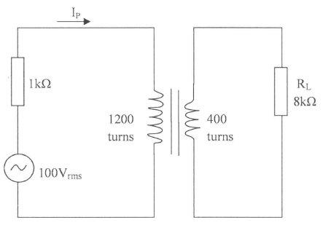
Figure 2
Determine the: (5 marks)
- Primary current I_{P};

- Voltage across R_{L}.

- With the aid of labeled diagrams, illustrate the arrangement of magnetic domains in:
- Unmagnetised material;
- Magnetized material. (3 marks)

- (a) Figure 3 shows a voltage divider circuit.

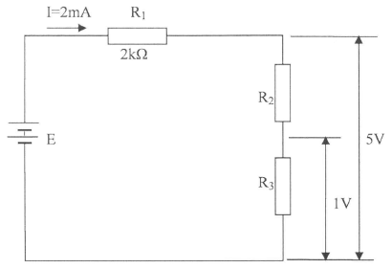
Figure 3

Determine the value of; (4 marks)
- E

- R₂;

- R₃.

- A consumer has the following loads connected to the supply.
- Five 60W lights for 4 hours;
- One 2kW kettle for ½ hour.
Calculate the total:
- Energy consumed;

- Cost of energy used if the rate is 80 cents per unit. (3 marks)

- (a) State three safety precautions to be observed by an operator using portable electric drill. (3 marks)
……………………………………………………………………………………………………………………………………………………………………………………………………………………………………………………………………………………………………………………………………………………………………………………

(b) Name four communication service provider companies currently operating in Kenya. (2 marks)
……………………………………………………………………………………………………………………………………………………………………………………………………………………………………………………………………………………………………………………………………………………………………………………

- (a) Name four types of insulating materials used in electrical circuits. (2 marks)
……………………………………………………………………………………………………………………………………………………………………………………………………………………………………………………………………………………………………………………………………………………………………………………

(b) State three advantages of PVC conduit wiring systems. (3 marks)
…………………………………………………………………………………………………………………………………………………………………………………………………………………………………………………………………………………………………………………………………………………………………………………..

- (a) Calculate the inductance required to cause resonance at 150kH_{Z} when the capacitance is
1.0pF. (2 marks)

(b) In a 240V circuit, the load current is 2.5A. If the power factor is 0.6, calculate: (3 marks)
- Apparent power;

- True power.

- Make a free hand isometric drawing of a conduit saddle in the space below. (5 marks)

SECTION B (52 marks)

Answer any four questions from this section in the spaces provided.

- Figure 4, in the next page, shows the front elevation, end elevation and an incomplete plan of an object.
- Complete the plan.
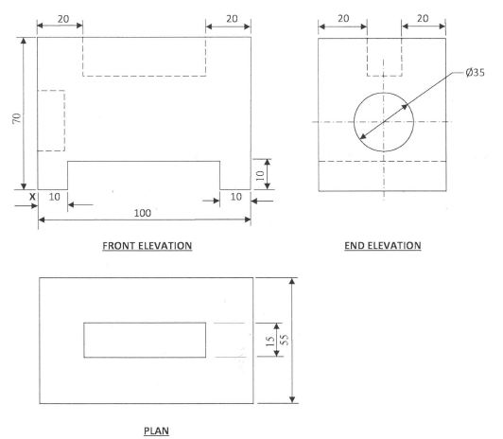
Figure 4

- On the isometric grid provided, draw the isometric projection of the object making X as the lowest point. (13 marks)

- Figure 5 shows waveforms A and B. their vertical and horizontal scales are given.
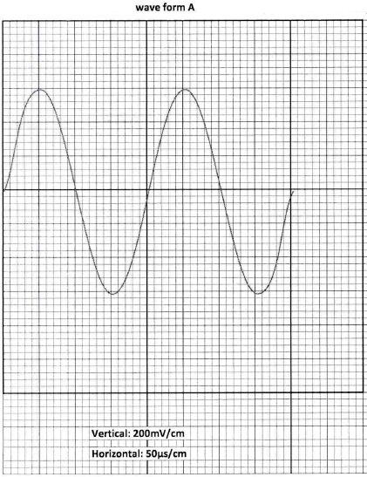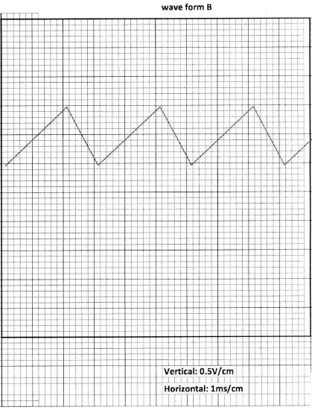
Figure 5

- Name each of the two waveforms. (1 mark)
……………………………………………………………………………………………………………………………………………………
…………………………………………………………………………

- State the number of cycles displayed in each waveform. (2 marks)
……………………………………………………………………………………………………………………………………………………
………………………………………………………………………… …………………………………………………………………………

- Calculate; (10 marks)
- Frequency of waveform A;

- Amplitude of each waveform;

- RMS voltage of waveform A

- (a) Draw a labeled diagram of a consumer unit with the following circuits. (11 marks)
- Lighting circuit
- Water heater circuit;
- Bell circuit
- Cooker circuit;
- Ring circuit.

- State the typical fuse ratings for any four of the final circuits in (a). (2 marks)
…………………………………………………………………………………………………………………………………………………………………………………………………………………………………………………………………………………………………………………………………………………………………………………..

- Figure 6 shows an amplifier circuit whose current gain is 50.
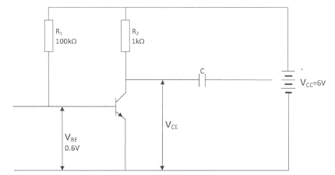
Figure 6
- (i) Name the type of transistor.
…………………………………………………………………… …………………………………………………………………… …………………………………………………………………..
(ii) State the function of the capacitor C.
…………………………………………………………………… …………………………………………………………………… …………………………………………………………………..

(iii) Name the type of biasing. (3 marks)
…………………………………………………………………… ……………………………………………………………………
……………………………………………………………………

- Calculate the values of; (10 marks)
- Voltage across R₁;

- Base current I_{B};

- Collector current I_{C};

- Voltage V_{CE}.

- Figure 7 shows an R-L-C circuit.
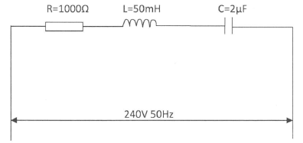
Figure 7
- Calculate the:
- Impedance of the circuit; (7 marks)

- Current. (3 marks)

- Draw the phasor diagram. (3 marks)

THIS IS THE LAST PRINTED PAGE

