WISDOM PRE-MOCK
MARKING SCHEME
1 a) Procedure of connecting an ammeter to take measurements in a circuit
- Turn - off the power
- Ammeter should be connected in series with the load current.
- Observe polarity.
- Select the range starting from the highest.
b) (i) Nominal resistance
Orange Black
30
Brown
x 10¹ = 300
Nominal = 300Ω
(ii) Maximum resistance
300 ± 5% = 315Ω
2. a) Circuit diagram
- Shows connection of every component.
- Shows values of components.
- Shows the position of the components.
- Shows functionality of the circuit.
b) Bills of materials
- Materials/parts.
- Quantity.
- Size.
- Estimate costs.
3. a)
(i) Forward bias reduces the PN-junction (depletion layer) and hence the diode conducts
(ii) Reverse bias increases the PN-junction (depletion layer) hence the diode does not conduct.

b)
i) I_{F(max)} is the maximum forward current that the diode can pass without burning out.
ii) V_{F (typ)} is the forward voltage across the diode at the typical operating current.

4.
a)
$$I=\frac{V}{R}=\frac{100}{1000}=0.1A$$

b)

5.
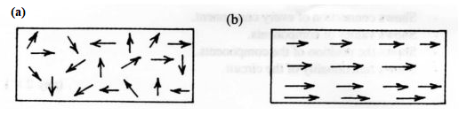
6. (a) (i)
$$E=5+\left(1.2mAx2000\right)=7.4V$$
(ii) R₂=$\frac{5-1}{1.2mA}=3,333.33Ω$
(iii) R₃=$\frac{1}{1.2mA}=833.33Ω$
b) (i) Energy consumed
Lights$\frac{5x6x4}{1000}=1.2kwh$
Kettle$1x2x0.5=1.0kwh$
Total energy = 2.2kwh
(ii) Cost of energy
= 2.2 x80 = 1.76 sh

7. Safety precautions to be observed
a) - Ensure that the equipment is properly earthed.
- Do not use it in damp areas.
- Always remove the plug from the socket when the equipment is not in use.
- When using extensions, ensure the joints are firm and insulated using the electricians insulation tape.
- Hold it ﬁrmly.
- Avoid loose clothing like ties.

b) Communication service providers in Kenya
- Telkom Kenya
- Safaricom
- Airtel
- Yu
or any other existing ones
8. a) Insulating materials used in electrical circuits
- PVC .
- Porcelain
- Magnesium oxide
- Paper
- Rubber
- Air
- Formica
b) Advantages of PVC
- Ease of erection.
- It is cheap.
- It is resistant to corrosion.
- It is light.
- There is no risk to earth leaks.
9. a) Inductance required
$$L=\frac{1}{4x∏x∏xfxfxC}=\frac{1}{4x∏x∏x150000x150000x1.0pF}=1.12579H$$

b) (i) Apparent power
P=IV=2.5x240=600 VA
(ii) True power
= apparent power X power factor
=600 X 0.6=360W
10.
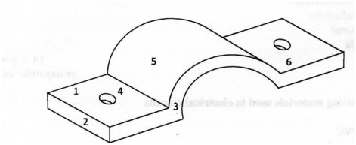
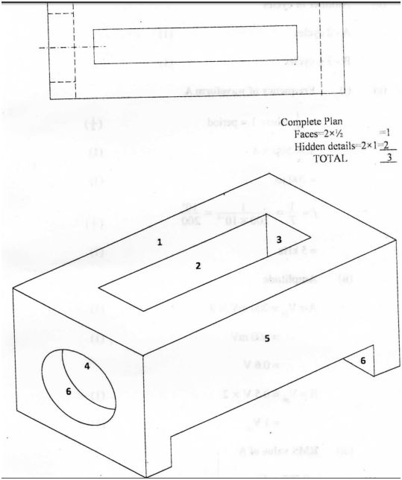
12. a) Name of waveforms
A - sine wave
B - saw tooth
b) Number of cycles
A - 2 cycles (1)
B - 3 cycles (1)
(c)
(i) Frequency of waveform A
Where T=period
T= 50µsx4
=200µs
$$f=\frac{1}{T}=\frac{1}{\frac{200}{1000000}}=5000Hz=5kHz$$
(ii) Amplitude
A=V_{peak}=200mVx3=600mV=0.6V
B=V_{peak}=0.5V X 2=1V
(iii) RMS value of A
=0.707xV_{p}=0.707x0.6=0.424V
13.
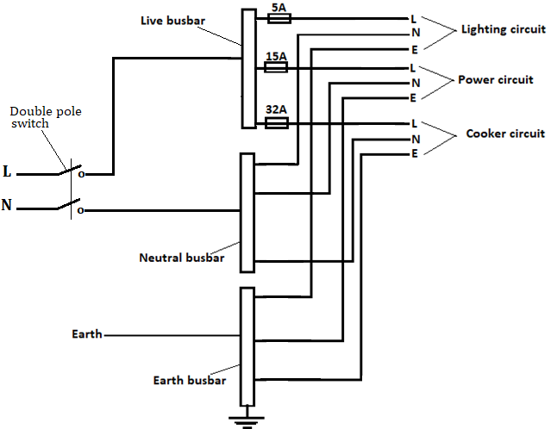
Correct drawing (6 marks)
Each subcircuit correctly labelled (½x6=3 marks)

14 a) Type of transistor
NPN (1)
Function of capacitor C
To block D.C (1)
Type of biasing
Fixed bias (1)
b)
(i) VR=V_{CC}-V_{BE} =60-0.6=5.4V
(ii)
I_{B}=$\frac{5.4}{10000}=0.54A$
(iii)
I_{C}=$βxIB=54μAx50=2.7mA$
(iv)
R_{C}I_{C}= 2.7mAx1 x 10³=2.7V
V_{CE}=V_{CC}-V_{R2}
= 6-2.7V
=3.3V
15. a) X_{L}=2∏fL
=2x∏x50x50x10⁻³
=15.708Ω (2 marks)
X_{C}=$\frac{1}{2∏fC}$
=$\frac{1}{2x∏x50x2x10-6}$
=1591.5494Ω (2 marks)
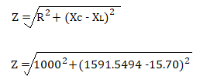= 1866.36Ω (3 marks)
b) $I=\frac{E}{Z}=\frac{240}{1866.36}=0.1286A$ (3 marks)
c)
