Name………………………………………..ADM No……………. Class………………..

448/1
ELECTRICITY
Paper 2
(PRACTICAL)
MAY 2023
Time: 2 ½ hours

MECS CLUSTER JOINT EXAMINATION

FORM FOUR TERM ONE EXAMINATION 2023
ELECTRICITY

Instructions To Candidates

1. There are FOUR exercises in this paper
2. Candidates are allowed 30 minutes for each exercise
3. Each exercise will be awarded a maximum of 20 marks
4. Write your Name and Index number at the top of this page
5. Do NOT do work related to other stations while at a different station
6. Attempt All the exercises as directed by the examiner(s)

For Examiner’s Use Only

Exercise |  | 1 | 2 | 3 | 4 | Total
Total Marks |  | 20 | 20 | 20 | 20 | 80
Marks Scored

This paper consists of 6 printed pages. Candidates should confirm that all the pages are printed as indicated and that no questions are missing.

EXERCISE 1 (20mks)

40
80
20
40
50
20
40
40
(a) Pictorial view
Two soldered flap joints
5mm wide cut at 45º
Two ø 3mm holes
(b) Development

EXERCISE 2: (20mks)

The figure below shows the isometric view of a metal bracket. Study the drawing carefully. The bold arrow indicates the front view of the bracket.

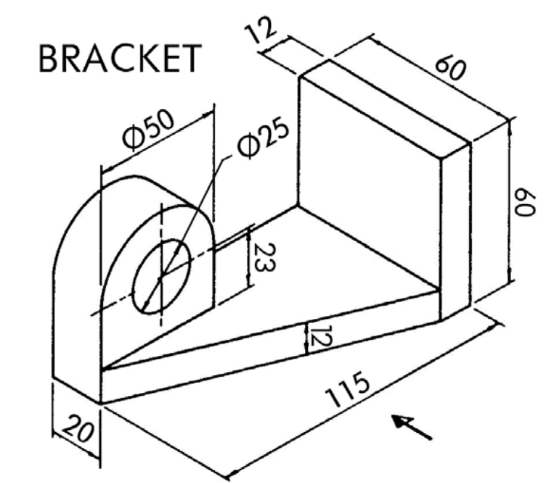
F

On the plain paper provided, draw the following third angle orthographic views of the guide:
- The Front elevation
- The End elevation
- The Plan view
Label the views and indicate six main dimensions on the drawing

EXERCISE 3: (20mks)
The figure below shows a Zener diode testing circuit
milliammeterr
R 47Ω
+ve I_{D}

Power
Supply
Unit

Voltmeter
D_{z} V_{D}

-ve
Switch
Use the equipment and components provided to carry out the following tasks:
(a) With the power OFF, set up the circuit as shown in the figure above. Let the examiner check your circuit before proceeding (5mks)

(b) Put ON the power and set the supply voltage, Vs to various values as shown in the table below. Record the corresponding values of the current through the diode, ID and the voltage across the diode, V_{D} (8mks)

Vs (v) | ID (mA) | VD (v)
2
4
6
8
10
12

(c) Reduce the supply voltage to zero and turn OFF the power supply

(d) Draw a graph of I_{D} against V_{D} on the graph paper provided please turn over(PTO) (4mks)

(e) From the graph, determine the voltage at which the Zener diode starts conducting significantly (1mk)
V_{Z} = --------------------------------------------------------------------
(f) Give a practical application of the circuit tested above (2mks)

------------------------------------------------------------------------------------------------------------------
------------------------------------------------------------------------------------------------------------------

EXERCISE 4: (20mks)

The figure below shows the layout diagram of a lamp circuit carried out in p.v.c. insulated and sheathed cables.

Lamp
1-way Switch
Junction box
CCU
200
250
250
250

(a) Install and wire the circuit such that the lamp is controlled by the one-way switch (17mks)

(b) Name three types of tools and three types of accessories used in the exercise (3mks)
Tools:

Accessories:

