Name………………………………………..ADM No……………. Class………………..

448/1
ELECTRICITY
Paper 1
(THEORY)
MAY 2023
Time: 2 ½ hours

MECS CLUSTER JOINT EXAMINATION

FORM FOUR TERM ONE EXAMINATION 2023
ELECTRICITY

INSTRUCTIONS TO CANDIDATES

Candidates should have the following for this examination
- Drawing instruments
- Mathematical tables
- Drawing paper(A3)
- Answer ALL the questions in section A and any four in section B
- All dimensions are in millimeters unless otherwise stated.

This paper consists of 10 Printed pages.
Candidates should check the question paper to ensure that all the
Papers are printed as indicated and no questions are missing

SECTION A (52 MARKS)
Answer all the questions in this section.
1. a) i) State three processes involved in fabricating the saddle shown in figure 1
Figure 1
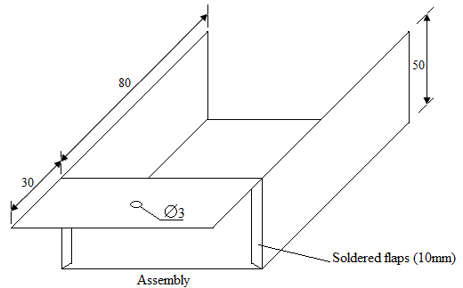
………………………………………………………………………………………..
………………………………………………………………………………………..
………………………………………………………………………………………..
ii) State one safety precaution to be observed in each process. (3mks)
………………………………………………………………………………..
…………………………………………………………………………………………………………….
……………………………………………………………………………………………………………..

b) List two types of institutions one can join to pursue higher diploma in electrical
Engineering (1mks)
………………………………………………………………………………………..
………………………………………………………………………………………..
2. a) Define each of the following terms (2mrks}
i) Conductor …………………………………………………………………….

ii) Insulator ………………………………………………………………………

iii} forward bias …………………………………………………………………….

iv) leakage current………………………………………………………

b) Explain the importance of indicating the power rating on a resistor. (3mks)
………………………………………………………………………………………..
………………………………………………………………………………………..
………………………………………………………………………………………..
………………………………………………………………………………………..
3. a) State three properties of magnetic lines of force. (1 ½ mks)
………………………………………………………………………………………..
………………………………………………………………………………………..
………………………………………………………………………………………..
………………………………………………………………………………………..

b) Figure 2 shows an arrangement of resistors in an electric circuit. If terminals
X and Y are shorted. (4mks)

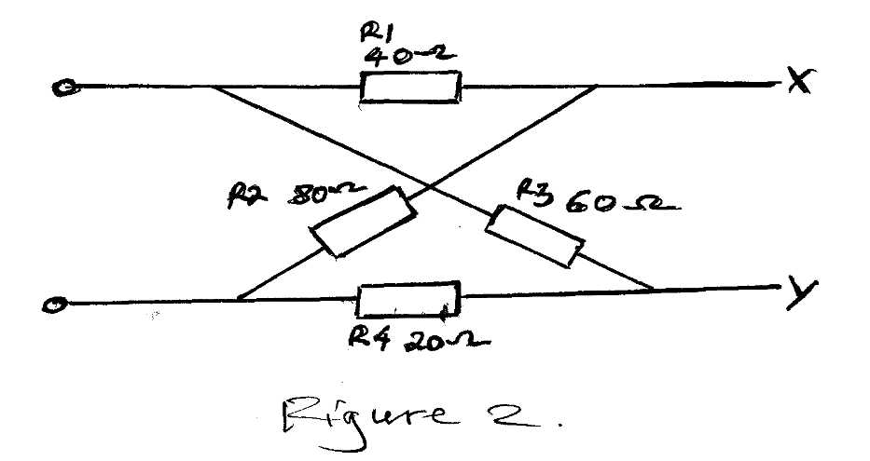
- Sketch the equivalent circuit

ii) Calculate the total resistance of the circuit

4. a) A moving coil instrument of internal resistance of 100 requires a current
of 0.5MA to give fullscale deflection. If the instrument is modified to a voltmenter.
- Sketch the circuit of the modified instrument.

ii) Calculate the value of the multiplier for the instrument to measure up to
100 volts. (3mks)

5. a) Name four electrical equipment at the consumers intake point in a domestic
Installation (2 mks)
………………………………………………………………………………………..
……………………………………………………………………………………….. ………………………………………………………………………………………..
………………………………………………………………………………………..
b) List four main types of electrical power consumers who are charged for their
Power consumption on different tariffs. (2 mks)
………………………………………………………………………………………..
………………………………………………………………………………………..
………………………………………………………………………………………..
………………………………………………………………………………………..
c) list three types of transistor configurations and draw their schematic diagrams( 3 mks)

6. Draw a schematic diagram of a lighting circuit with two bulbs such that the lamps are
Controlled by two switches independently. Label all parts. (5mks)

7. Draw a labeled diagram of a capacitor-start split phase motor. (5mks)

8. a) Draw the discharge curve of a capacitor (2mks)

b) Outline how insulation resistance test is carried out between conductors (5mks)
………………………………………………………………………………………..
………………………………………………………………………………………..
………………………………………………………………………………………..
………………………………………………………………………………………..
………………………………………………………………………………………..
………………………………………………………………………………………..
9. A coil draws a current of 0.5A from a 240V a.c. supply. A voltmeter connected in the circuit
Indicates a power dissipation of 90W. Determine (5mks)
a) True power

b) Apparent power

c) Power factor

10. a) Sketch the symbols for each of the following (3mks)
i) Wires crossing but not connected

- Coil

- Rheostat

- Intermediate switch

- Twin fluorescent lamp

- Circuit breaker

b) Sketch in first angle projection, a plan and front elevation of a cylindrical
dry cell with the positive terminal facing up. (3mks)

SECTION B (48 MARKS)
Answer any four questions from this section.
11. A resistor of 10 K, an inductance of 0.5H and a capacitance of 0.01 are connected in series across a 100V 50HZ supply. Calculate (12mks)
a) Line current

b) Voltage across each component

c) Circuit power factor

- Power dissipated in the circuit

12. a) With the aid of a diagram, explain how an e.m.f is induced in a conductor (6mks)

b) Explain the three factors that determine the magnitude of induced e.m.f (6mks)
………………………………………………………………………………………..
………………………………………………………………………………………..
………………………………………………………………………………………..
………………………………………………………………………………………..
………………………………………………………………………………………..
………………………………………………………………………………………..
13. Figure 3 shows a resistor network circuit.
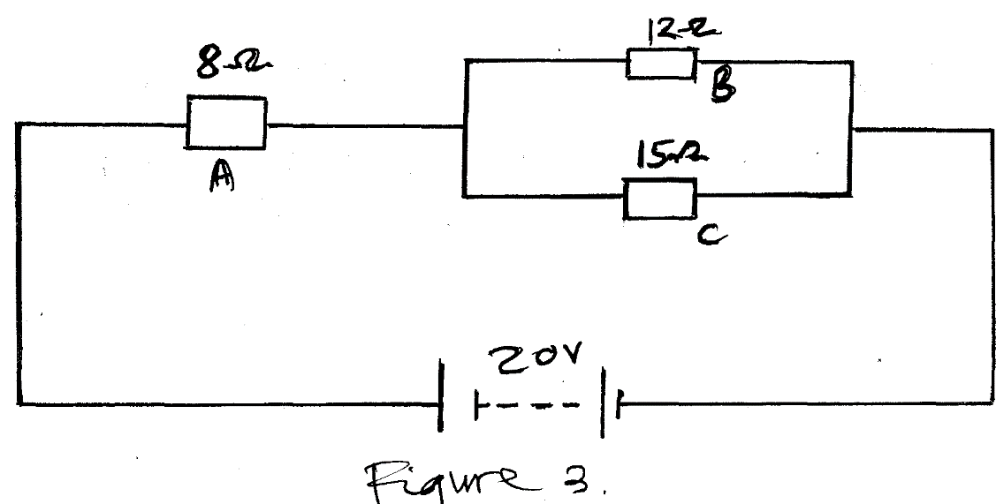

a) Determine the equivalent resistance of the circuit (2mks)
………………………………………………………………………………..
………………………………………………………………………………..
- Calculate the supply current 1mks

b) Draw labeled npn transistor when it is used to make a single stage common-emitter amplifier. (6mks)

c) define the following terms. (3 mks)
i. inductive reactance

ii. impedance

iii. power factor

14. Figure 4 shows a bracket. Draw full size in first angle projection. 12mks

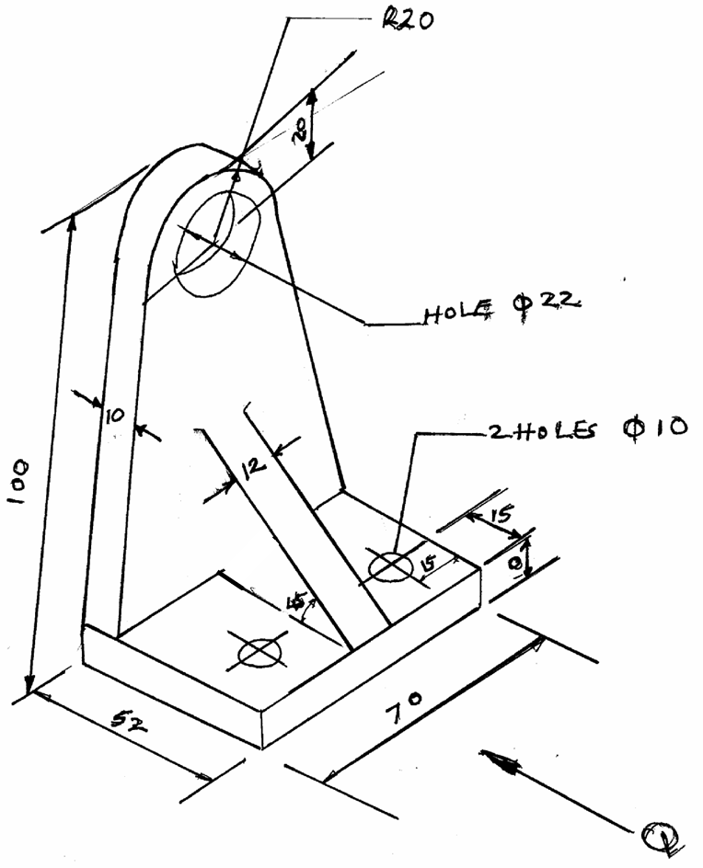

a) Front elevation in the direction of arrow Q
b) End elevation
c) plan
d) indicate at least four main dimensions

