Name………………………………………..ADM No……………. Class………………..

448/1
ELECTRICITY
Paper 1
(THEORY)
MAY 2023
Time: 2 ½ hours
MARKING SCHEME

MECS CLUSTER JOINT EXAMINATION

FORM FOUR TERM ONE EXAMINATION 2023
ELECTRICITY

INSTRUCTIONS TO CANDIDATES

Candidates should have the following for this examination
- Answer booklet
- Drawing instruments
- Mathematical tables
- Drawing paper(A3)
- Answer ALL the questions in section A and any four in section B
- All dimensions are in millimeters unless otherwise stated.

This paper consists of 11 Printed pages.
Candidates should check the question paper to ensure that all the
Papers are printed as indicated and no questions are missing

SECTION A (52 MARKS)
Answer all the questions in this section.
1. a) i) State three processes involved in fabricating the saddle shown in figure 1
Figure 1
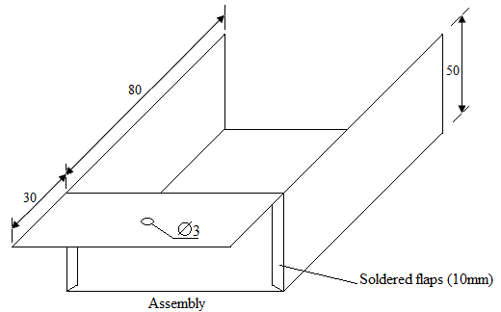
Laying out and marking, Cutting, Drilling, foaming and folding, Filling and soldering

ii) State one safety precaution to be observed in each process. (3mks)
measurements should be checked clearly before marking
- Sheet metal should be laid flat on bench before marking
- When using shears keep fingers away from blades
- work piece must be clamped firmly in the vice before hacking or drilling
- sharp edges of sheet metal should be filed or folded to avoid cuts

b) List two types of institutions one can join to pursue higher diploma in electrical
- Engineering (1mks)
- Kenya technical trainers college
- Kenyatta university
- Technical university of kenya

2. a) Define each of the following terms (2mrks}
- Conductor- a material that easily allows flow of current through it
- Insulator –a material that does not easily allow flow of current through it
- Forward bais- positive terminal of emf is connected to the p-type of ordinary diode while negative terminal n-type.

- Leakage current- current flow in ordinary diode or transistor due to minority charge carries
b) Explain the importance of indicating the power rating on a resistor. (3mks)
- magnitude of voltage to be applied will be known
- amount of current to flow through it
- this prevents burning the resistor
3. a) State three properties of magnetic lines of force. (1 ½ mks)
- They do not cross
- They are directed from north to south pole outside the magnet
- They repel each other side ways
- Are closer near the poles and further away from the poles

b) Figure 2 shows an arrangement of resistors in an electric circuit. If terminals
X and Y are shorted. (4mks)

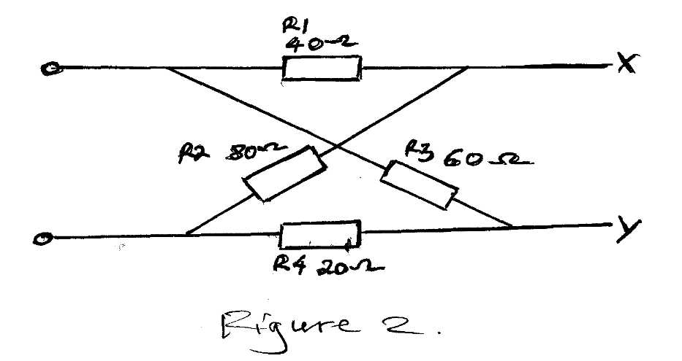
- Sketch the equivalent circuit

ii) Calculate the total resistance of the circuit

4. a) A moving coil instrument of internal resistance of 100 requires a current
of 0.5mA to give full scale deflection. If the instrument is modified to a voltmenter.
- Sketch the circuit of the modified instrument.
V_{C}
R_{m}
R_{C}
V
I_{C}
V_{m}
T
T
ii) Calculate the value of the multiplier for the instrument to measure up to
100 volts. (3mks)
$V_{m}=V-V_{c };100-0.5mAx100Ω=99,95Ω$

5. a) Name three electrical equipment at the consumers intake point in a domestic
Installation (2 mks)
- Electricity cut out
- Power meter
- Main switch
- Consumer control unit
b) List four main types of electrical power consumers who are charged for their
Power consumption on different tariffs. (2 mks)
- Domestic
- Agricultural
- Industrial
- commercial
c) list three types of transistor configurations and draw their schematic diagrams( 3 mks)
common emitter
common base
common collector

6. Draw a schematic diagram of a lighting circuit with two bulbs such that the lamps are
Controlled by two switches independently. Label all parts. (5mks)

7. Draw a labeled diagram of a capacitor-start split phase motor. (5mks)

Starting windings
Running windings
Vs
Rotor
Capacitor
Centrifugal switch

8. a) Draw the discharge curve of a capacitor (2mks)

- Ve
+ Ve
0
Current, I_{d}
Voltage, V_{c}
Graphs of capacitor voltage and current during discharge

time
NB: Direction of discharge current is negative compared to the charging current

b) Outline how insulation resistance test is carried out between conductors (5mks)
- insulation resistance tester (MEGGER) is used
- test voltage is set such that it is not less than twice the rms voltage of the supply eg not exceed 500v d.c.
- loads be in position
- switches be in the on position
- fuses or MCB’s be in position
- one test lead of megger is connected on live conductor and other lead on neutral conductor at any load point
- the reading on the megger should be a low reading if infinity, then an open is present, if zero then a short circuit

9. A coil draws a current of 0.5A from a 240V a.c. supply. A voltmeter connected in the circuit
Indicates a power dissipation of 90W. Determine (5mks)
a) True power
90W

b) Apparent power

$P_{app}$=VI 240x 0.5=100 W

c) Power factor

power factor=$\frac{true power}{apparent power}$ =$\frac{90}{100}=0.9$

10. a) Sketch the symbols for each of the following (3mks)
i) Wires crossing but not connected

- Coil

- Rheostat

Intermediate switch
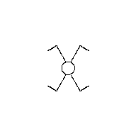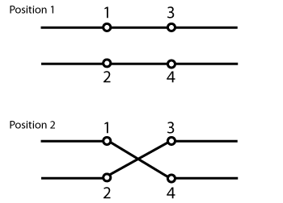

- Twin fluorescent lamp

- Circuit breaker

b) Sketch in first angle projection, a plan and front elevation of a cylindrical
dry cell with the positive terminal facing up. (3mks)

SECTION B (48 MARKS)
Answer any four questions from this section.
11. A resistor of 10 K, an inductance of 0.5H and a capacitance of 0.1 are connected in series across a 100V 50HZ supply. Calculate (12mks)
a) Line current
$X_{L}=2πfL=2πx50x0.5;157Ω$
$X_{c}=\frac{1}{2πfC}; \frac{1}{2πx50x0.1x{10}^{-6}}=31831Ω$
$$Z=\sqrt{{(R}^{2}}+{\left(X_{C^{-X_{L}}}\right);}^{2} \sqrt{{(1x{10}^{8})}^{2}}-{\left(31614\right)}^{2}=33215Ω$$
$I=\frac{V_{s}}{Z}; 33215=0.003A$

b) Voltage across each component
$V_{R }=IR;0.003x10kΩ=30V$
$V_{c }={IX}_{c};0.003Ax131831Ω=95.5V$
$V_{L }={IX}_{L};0.003Ax157Ω=0.471V$

c) Circuit power factor
$$cosƟ=\frac{X_{c}}{R}; \frac{0.09}{0.3}=0.3$$

- Power dissipated in the circuit

$P=I^{2}R=1µAx0.01=1x{10}^{-8}W$

12. a) With the aid of a diagram, explain how an e.m.f is induced in a conductor (6mks)
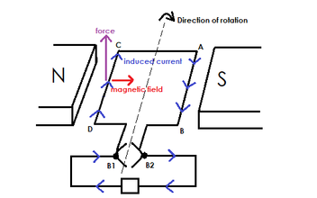
- When armature conductors are rotated inside magnetic field between a pair of permanent/electromagnets, emf is induced in the conductors in accordance to the principle of electromagnetic induction.
- If a load is connected to the external circuit direct currect flows via commutator and carbon brushes

b) Explain the three factors that determine the magnitude of induced e.m.f (6mks)
- angle of inclination between conductor and main field-maximum emf is induced when angle between conductor and field is normal
- strength of main field- the stronger the filed the greater the magnitude
- speed of rotation of the conductor- the greater the speed, the greater the magnitude
13. a) Determine the resistance of each of the following carbon resistors if their
colour codes are (4mks)
i) Red, Red, Gold, Gold
2.2Ω ±5%

ii) Yellow, Violet, Orange Gold
47kΩ ±5%

b) i) list 2 types of diode s and where they are applicable
ordinary diode-poer rectification
zener diode- power stabilizer
b) Sketch a labelled diagram of a single phase double wound transformer.
Indicate all the quantities (4mks)
Laminated iron core
Flux path
I₂
I₁
V₂
E₂
V₁
E₁
Load
A.C.
Source
Primary winding
Secondary winding

c) A transformer connected to a 240V 60HZ supply has a primary winding of
1200 turns. Calculate the (4mks)
i) Number of turns in secondary winding to produce a e.m.f of 1000V
$\frac{V_{p} }{V_{s}}=\frac{N_{p}}{N_{s}}; \frac{240}{1000}=\frac{1200}{N_{s}};5000turns$

ii) Output power if the secondary current is 2000mA
$P_{s}=V_{s}I_{s};1000x2000mA=2000W$

14. Figure 3 shows a resistor network circuit.
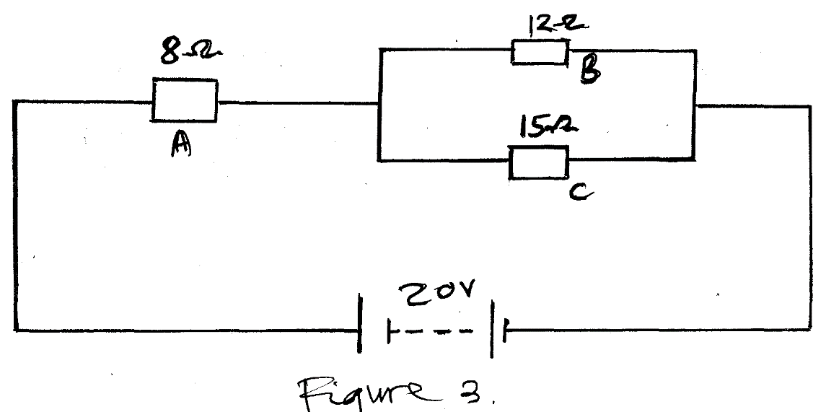

a) Determine the equivalent resistance of the circuit (2mks)

$R_{t}=A+\left(\frac{BxC}{B+C}\right);8+\frac{180}{27}=14.67Ω$

Calculate the supply current (1mks)
$I=\frac{V}{R}; \frac{20}{14.67}=1.36A$

b) Draw labeled pnp transistor when it is used to make a single stage common-emitter self bias amplifier.

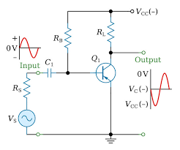
6mks
c) define the following terms
I inductive reactance
Opposition to the flow of current due to inductance in an ac circuit
ii. impedance
total opposition to the flow of current in an ac circuit

iii. power factor
is the ratio of true power to the apparent power
15. Figure 4 shows a bracket. Draw full size in first angle projection. 12mks

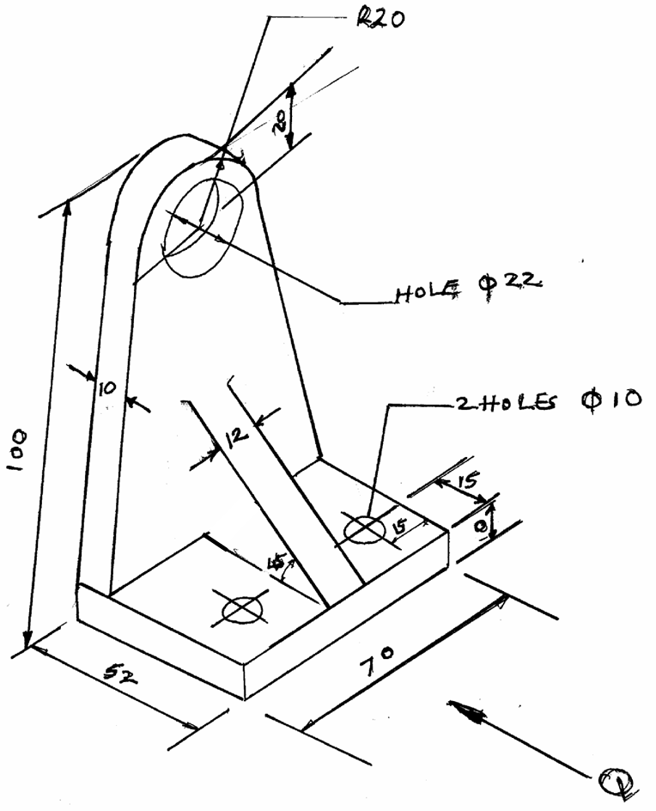

a) Front elevation in the direction of arrow Q
b) End elevation
c) plan

