WISDOM MARKING SCHEME-POWER MECHANICS
STATION 1

INSTRUCTIONS:

Draw the exploded view of the valve assembly shown below and label the parts. (10 marks)
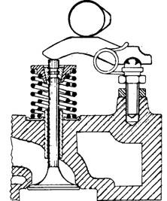

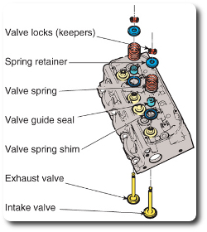

CORRECT SKETCH ………………………………………………………………………….4 MARKS
CORRECT LABELING……………………………………………………………………….6 MARKS

STATION 2

INSTRUCTIONS:
Using the galvanized sheet material and the hand tools provided make the template shown.
(10 marks)

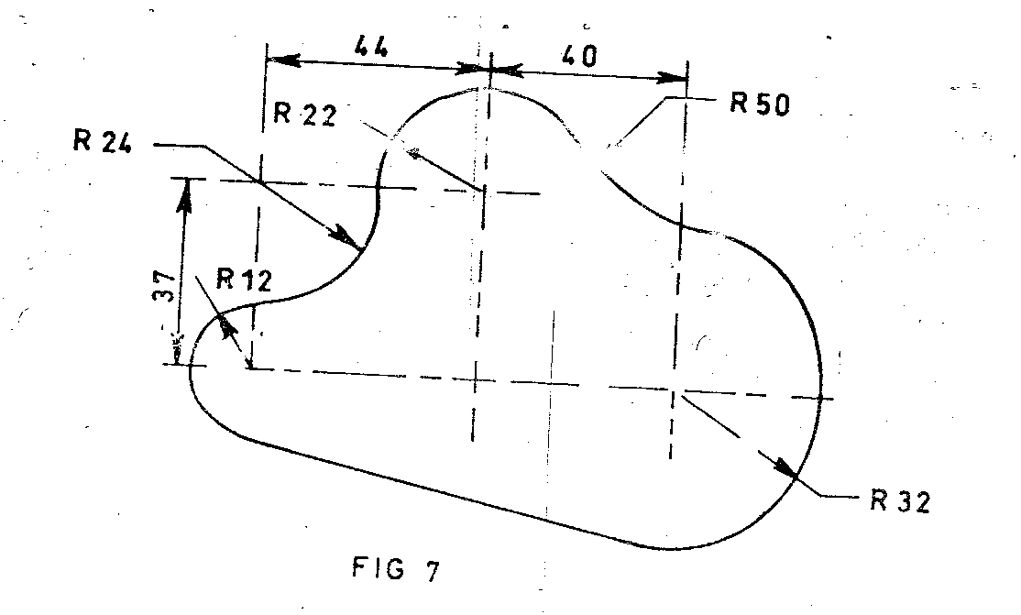

CORRECT CURVE OF R32…………………………………………………………………………1 ½ MKS
CORRECT CURVE OF R12…………………………………………………………………………1 ½ MKS
CORRECT CURVE OF R24…………………………………………………………………………..1 ½ MKS
CORRECT CURVE OF R22……………………………………………………………………………1 ½ MKS
CORRECT CURVE OF R50……………………………………………………………………………1 ½ MKS
FILING OFF SHARP EDGES………………………………………………………………………….1 ½ MKS
FINISHING IN TIME…………………………………………………………………………………….1 MK

STATION 3

INSTRUCTIONS:
- On the tyre provided on the workbench, determine the following;
- Tyre height
- Tyre width
- Tyre aspect ratio (6 marks)

AS PER THE DATA IN SCHOOLS PER THE TYRE PROVIDED.
EACH CORRECT DATA TO EARN THE CANDIDATE 2 MARKS

- Identify two wear patterns on the tyre and state one cause of each. (4 marks)

CANDIDATE EXPECTED TO CHECK FOR WEAR PATTERNS LIKE SHOULDER WEAR, CENTER WEAR, SPOTS WEAR, ETC. EACH CORRECT WEAR PATTERN TO EARN THE CANDIDATE 2 MARKS.

STATION 4

INSTRUCTIONS:
Identify the the fluids labeled in the beakers and state one use of each in the motor vehicle.
(10 marks)

FLUID | NAME | USE
A | PETROL | FUEL FOR S.I. ENGINES
B | DIESEL | FUEL FOR C.I. ENGINES
C | KEROSENE | WASHING OILY ENGINE PARTS
D | AIR | WHEEL TUBE INFLATION
E | VASELINE | BATTERY TERMINALS

CORRECT IDENTIFICATION…………………………………………………………..1 MK EACH
CORRECT USE……………………………………………………………………………..1 MK EACH

STATION 5

INSTRUCTIONS:
Identify the locking devices labeled A to E and state a feature that makes each locking device unique in the class. ( 10 marks )
LOCKING DEVICE | NAME | UNIQUE FEATURE
A | SPRING WASHER | THE STEPPED UP ENDS THAT MAKE IT SPRINGY
B | TANG WASHER | THE INNER LOCKING PROTRUTION
C | SPLIT PIN | IT IS SPLIT AND MALLEABLE
D | WOODRUFF KEY | ITS HARDNESS AND HALF MOON SHAPE
E | SERRATED WASHER | THE SERRATIONS ON THE CIRCUMFERENCE

NAME AND UNIQUE FEATURE….…1/2 MARK EACH RESPECTIVELY
STATION 6

INSTRUCTIONS:
On the single cylinder engine provided measure the bore and stroke then calculate the swept volume.

Bore…………………………………………..mm (2 marks)
Stroke………………………………………...mm (2 marks)

Sweptvolume…………………………………………………………………………………………………………………………………………………………………………………………………………………………………………………………………………………………………………………………………………………………………………………………………………………………………………………………………………………………………………………………………………………………………………………………………………………cubic mm
(6 marks)
AS PER THE SAMPLE DATA

STATION 7

INSTRUCTIONS:
Use the multimeter and determine the following and fill your results in the table below.
COMPONENT | MEASUREMENT | RESULT
ARMATURE | Grounding
IGNITION SWITCH | Continuity
SPARK PLUG | Resistance
STATOR | Continuity

(10 marks)

AS PER THE SAMPLE DATA

STATION 8

INSTRUCTIONS:
- Demonstrate to the examiner how to measure the VOLTAGE of each cell of the battery.
(3 marks)

(-) (+)

METER

BATTERY
CORRECT METHOD EARNS THE CANDIDATE 3 MARKS
- Connect a horn circuit and let the examiner check your work. (7 marks)

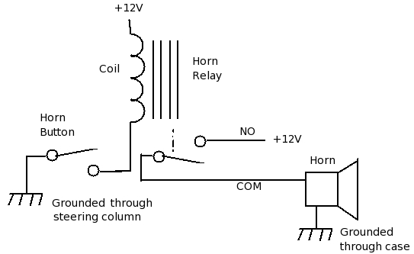

CORRECT CONNECTION EARNS THE CANDIDATE 7 MARKS.
STATION 9

INSTRUCTIONS:

- On the gearbox assembly provided, demonstrate to the examiner how to engage gear position 1 and reverse. (4 marks)
- Determine the number of times the input shaft will rotate as the output shaft completes one revolution in reverse gear position.

Number of input shaft revolutions……………………. (6 marks)

AS PER THE SAMPLE DATA

STATION 10

INSTRUCTIONS:
On the multi-cylinder engine provided:
- Remove the fan belt and show it to the examiner. (3 marks)
- Inspect and record two defect on the belt. (2 marks)
- Assemble back the fan belt on the assembly. (3 marks)
- List two functions of the fan belt. (2 marks)

CORRECT REMOVAL OF FAN BELT……………………………………………………..(3MKS)
TWO DEFECTS………………………………………………………………………………….(2MKS)
CORRECT ASSEMBLY…………………………………………………………………………(3MKS)
CORRECT FUNCTIONS OF THE FAN BELT…………………………………………..(2MKS

