Name………………………………………………………Index Number………………………
Class ………………………………………. Admission Number………………………………..

447/1
POWER MECHANICS
(Practical)
Paper 1
September 2021
Time: 2 ½ hours

WISDOM CLUSTER EXAMINATIONS 2021
447/1
Kenya Certificate of Secondary Education
POWER MECHANICS
(PRACTICAL)
Paper 1
Time: 2 ½ hours
Instructions to Candidate’s
- Write your Name, Index Number, Class and Admission Number in the spaces provided above.
- Answer all the questions in section A in the spaces provided.
- Answer question 11 and any other three questions in section B.

SECTION A (40 Marks)
Answer all the questions in this section in the spaces provided.
- State four uses of internal combustion engine. (4 marks)
- ________________________________________________________
- ________________________________________________________
- ________________________________________________________
- ________________________________________________________
- State two safety precautions that should be observed when using each of the following tools.
- Hammer (2 marks)
- ____________________________________________________________________________________________________________________________________________
- ____________________________________________________________________________________________________________________________________________
- Spanner (2 marks)
- ______________________________________________________________________________________________________________________________________________
- ______________________________________________________________________________________________________________________________________________
- a) Give two reasons for allowing materials. (2 marks)
- __________________________________________________________________________________________________________________________________________
- __________________________________________________________________________________________________________________________________________
- Explain the functions of the following engine components. (2 marks)
- Spark plug_____________________________________________________________ ______________________________________________________________________

- Recoil starter___________________________________________________________ ______________________________________________________________________
- a) Draw the following types of bearings.
- Flanged blind bearing. (1 mark)

- Plain bush (1 mark)

- Differentiate between a gasket and a seal in terms of their uses. (2 marks)
________________________________________________________________________________________________________________________________________________________________________________________________________________________

- The table below shows components that are found in an engine cam shaft. State the function of each. (4 marks)
Component | Function
Cam lobes
Eccentric cam
Spiral gear
Bearing journals
- a) Differentiate between a lean mixture and a rich mixture. (2 marks)
________________________________________________________________________________________________________________________________________________________________________________________________________________________
- Explain the following types of an engine. (3 marks)
- Over square_________________________________________________________ ____________________________________________________________________
- Under square________________________________________________________ ____________________________________________________________________
- Square____________________________________________________________________________________________________________________________________
- List four causes of oil contamination in an engine. (4 marks)
- _____________________________________________________
- _____________________________________________________
- _____________________________________________________
- _____________________________________________________

- The following is a component found in an engine,
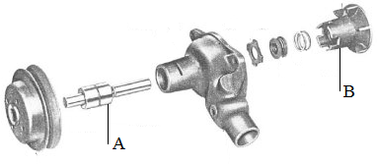
- Name the component:___________________________________________(1 mark)
- State in which system it is found:__________________________________1 mark)
- Name that parts labelled A and B;
A _______________________________________________________ (1 mark)
B ________________________________________________________ (1 mark)
- a) Explain two reasons why an alternator is preferred to a d.c generator. (2 marks)
________________________________________________________________________________________________________________________________________________________________________________________________________________________
- Name the component of an labeled B below. (1 mark)
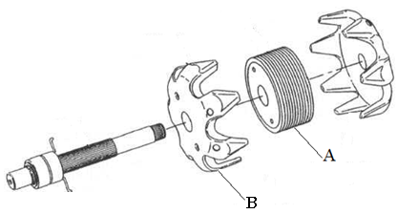
- State the use of the part labeled A. (1 mark) _______________________________________________________________________________________________________________________________________________

- Sketch, in 1st Angle orthographic projection, the F.E. and E.E. of the shaped block shown. (3 marks)

E.E F.E

SECTION B: (60 MARKS)
Answer question 11 and any other three questions from this section.
- The figure below shows components drawn in fist angle orthographic projection. On A3 paper provided draw full scale the isometric view of the object. (15 marks)

20
20

- a) State two functions of a soldering flux. (2 marks)
- ____________________________________________________________________
- ____________________________________________________________________
- State three properties of a good soldering flux. (3 marks)
- ____________________________________________________________________
- ____________________________________________________________________
- ____________________________________________________________________
- Explain the difference between welding and soldering. (2 marks)
________________________________________________________________________________________________________________________________________________________________________________________________________________________
- Study the diagram below.
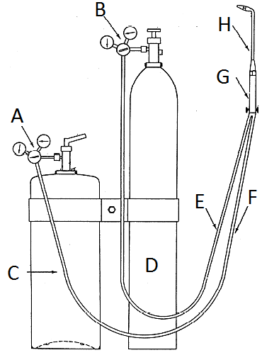
- Name the parts labeled. (5 marks)
A__________________________________________________
C___________________________________________________
D___________________________________________________
G___________________________________________________
H___________________________________________________
- Explain the function of the following parts. (3 marks)
B___________________________________________________
E___________________________________________________
F___________________________________________________

- The diagram below shows a diesel fuel system with parts labeled A to F.
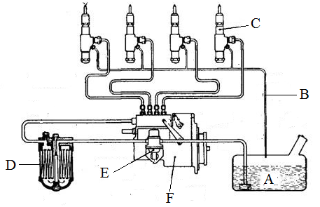
- State the name and function of the parts and fill your and the table below;
(10 marks)
COMPONENT | NAME | FUNCTION
B
C
D
E
F

- State two functions of a fuel tank cap. (2 marks)
- ______________________________________________________________________________________________________________________________________________
- ______________________________________________________________________________________________________________________________________________
- List three types of diesel fuel filters. (3 marks)
- ____________________________________________________________
- ____________________________________________________________
- ____________________________________________________________

- a) Draw a neat diagram of a dry plate clutch assembly and label at least four parts.
(6 marks)

- Explain how the above assembly functions;
- During engagement (3 marks) _____________________________________________________________________________________________________________________________________________________________________________________________________________________________________________________________________________________________________________________________________________________________________________________________________________________________
- During disengagement (3 marks) ______________________________________________________________________________________________________________________________________________________________________________________________________________________________________________________________________________________________________________________________________________________________________________________________________________________________

- Explain the effect of the following in a clutch assembly. (3 marks)
- Presence of oil on the friction plate_____________________________________ ____________________________________________________________________
- Weak thrust spring___________________________________________________ ____________________________________________________________________
- No cushion springs on the clutch plate__________________________________ ____________________________________________________________________
- The size of a four cylinder combustion engine is given by;
- Bore 90mm
- Stroke 90mm
- Clearance volume 71.6cc
Determine the following;
- The engine capacity to the nearest cc. (5 marks)
______________________________________________________________________________________________________________________________________________________________________________________________________________________________________________________________________________________________________________________________________________________________________________________________________________________________
- Compression ratio to one decimal place. (4 marks)
______________________________________________________________________________________________________________________________________________________________________________________________________________________________________________________________________________________________________________________________________________________________________________________________________________________________

- Explain if the engine is spark ignition or compression ignition engine.
(2 marks)
____________________________________________________________________________________________________________________________________________________________________________________________________________________________________________________________________________________
- Explain the following terms as used in engine description. (4 marks)
- Model ____________________________________________________________________________________________________________________________________
- Make ____________________________________________________________ __________________________________________________________________
- Capacity _________________________________________________________ __________________________________________________________________
- Serial number_____________________________________________________ __________________________________________________________________

