Name: …………………………………………………………………… Index No: …………………………………………………

Candidate’s signature……………………………………………. Date………………………………………………………….

446/1
BUILDING CONSTRUCTION
PAPER 1
Time: 2 ½ Hours
September/October

WISDOM CLUSTER EXAMINATIONS 2021

INSTRUCTIONS TO CANDIDATES
(a) Write your and index number in the spaces provided above.
(b) Sign and write the date of examination in the spaces provided above.
©Candidates should have the following for this exam:.
- Drawing paper size A3
- Drawing instruments
-Scientific calculator
(d) This paper consists of two sections; A and B.
(e) Answer all questions in section A in the spaces provided.
(f) From section B, answer question 11 on A3 paper and any other three questions in the spaces provided.
(g) All dimensions are in millimeters unless otherwise stated.
(h) This paper consists of 11 printed pages.
(i) Candidates should check the question paper to ascertain that all the pages are printed as indicated and that no questions are missing.
(j) Candidates should answer the questions in English.
For Examiner’s Use Only
Section | Question | Maximum Score | Candidate’s Score
A | 1-10 | 40
B | 11 | 15
 | 12 | 15
 | 13 | 15
 | 14 | 15
 | 15 | 15
Total Score

SECTION A (40 MARKS)
Answer ALL the questions in this section
- (a) Explain the term ‘peat ground’. (1 mark)
……………………………………………………………………………………………………………………………………………… ………………………………………………………………………………………………………………………………………………
(b) List four regulations that are considered in the site selection. (2 marks)
……………………………………………………………………………………………………………………………………………… ……………………………………………………………………………………………………………………………………………… ……………………………………………………………………………………………………………………………………………… ………………………………………………………………………………………………………………………………………………
- (a) Name four factors that may influence the type of building to be constructed in region. (2 marks)
……………………………………………………………………………………………………………………………………………… ……………………………………………………………………………………………………………………………………………… ……………………………………………………………………………………………………………………………………………… ………………………………………………………………………………………………………………………………………………
(b) Describe the following members of a scaffold: (2 marks)
(i) Standard:- ……………………………………………………………………………………………………………………………………………… ……………………………………………………………………………………………………………………………………………… ………………………………………………………………………………………………………………………………………………
(ii)Guardrail:
……………………………………………………………………………………………………………………………………………… ……………………………………………………………………………………………………………………………………………… ………………………………………………………………………………………………………………………………………………

- (a) Name two qualities of cow dung as a walking material. (1 mark)
……………………………………………………………………………………………………………………………………………… ……………………………………………………………………………………………………………………………………………… ………………………………………………………………………………………………………………………………………………
(b) List four causes of collapse (failure) of timbering to trenches. (2 marks)
……………………………………………………………………………………………………………………………………………… ……………………………………………………………………………………………………………………………………………… ………………………………………………………………………………………………………………………………………………
- (a) List four factors to consider before a system of painting is selected. (2 marks)
……………………………………………………………………………………………………………………………………………… ……………………………………………………………………………………………………………………………………………… ……………………………………………………………………………………………………………………………………………… ………………………………………………………………………………………………………………………………………………
(b) Give two reasons why foundations are built below ground level. (2 marks)
……………………………………………………………………………………………………………………………………………… ……………………………………………………………………………………………………………………………………………… ………………………………………………………………………………………………………………………………………………
5. Sketch a Flemish bond (4 marks)

6. (a) Explain the term ‘site clearing’ (2 marks)
………………………………………………………………………………………………………………………………………………………………………………………………………………………………………………………………………………………………………………………………………………………………………………………………………………………………………………………………………………………
(b) Give two reasons for site investigations. (2 marks)
……………………………………………………………………………………………………………………………………………………………………………………………………………………………………………………………………………………………………………………………………………………………………………………………………………………………………………………………………………………..
7. (a) List four types of floor finishes. (2 marks)
……………………………………………………………………………………………………………………………………………………………………………………………………………………………………………………………………………………………………………………………………………………………………………………………………………………………………………………………………………………………………………………………………………………………………………………………………………………………………………………………………………………………………………………………………………………………………………………………………………….
(b) A kitchen floor is to receive a terrazzo finish. Describe the procedure of laying the floor finish. (4 marks)
…………………………………………………………………………………………………………………………………………………………………………………………………………………………………………………………………………………………………………………………………………………………………………………………………………………………………………………………………………………………………………………………………………………………………………………………………………………………………………………………………………………………………………………………………………………………………………………………………………………
8. (a) Give any four duties of a quantity survey (2 marks)
……………………………………………………………………………………………………………………………………………………………………………………………………………………………………………………………………………………………………………………………………………………………………………………………………………………………………………………………………………………………………………………………………………………………………………………………………………………………………………………………………………………………………………………………………………………………………………………………………………………………………………………………………………………

(b) Briefly explain four sources of capital for starting a small scale building business. (2 marks)
…………………………………………………………………………………………………………………………………………………………………………………………………………………………………………………………………………………………………………………………………………………………………………………………………………………………………………………………………………………………………………………………………………………………………………………………………………………………………………………………………………………………………………………………………………………………………………………………………………………………………………………………………………………..
9. a) Give the reasons why compaction is necessary in fresh concrete. (2 marks)
………………………………………………………………………………………………………………………………………………………………………………………………………………………………………………………………………………………………………………………………………………………………………………………………………………………………………………………………………………………………………………………………………………………………………………………………………………………………………………………………………………………………………………………………………………………………………………………………………………………………………………………………………………….

(b) Give two reasons why drawing is so much effective as a means of communication. (2 marks)
………………………………………………………………………………………………………………………………………………………………………………………………………………………………………………………………………………………………………………………………………………………………………………………………………………………………………………………………………………………………………………………………………………………………………………………………………………………………………………………………………………………………………..
10. (a) List four factors to consider when selecting type of a roof structure. (2 marks)
………………………………………………………………………………………………………………………………………………………………………………………………………………………………………………………………………………………………………………………………………………………………………………………………………………………………………………………………………………………………………………………………………………………………………………………………………………………………………………………………………………………………………..
………………………………………………………………………………………………………………………………………………………………………………………………………………………………………………………………………………………………………………………………………………………………………………………………………………………………………………………………………………………………………………………………………………………………………………………………………………………………………………………………………………………………………..

(b) ) State any four barriers to the trenches. (2 marks)
…………………………………………………………………………………………………………………………………………………………… …………………………………………………………………………………………………………………………………………………………… …………………………………………………………………………………………………………………………………………………………… …………………………………………………………………………………………………………………………………………………………… ………………….………………………………………………………………………………………………………………………………………… …………………………………………………………………………………………………………………………………………………………… …………………………………………………………………………………………………………………………………………………………… ……………………………………………………………………………………………………………………………………………………………
Answer question 11 and any other three questions from this section.
Candidates are advised not to spend more than 25minutes on question 11.
11. Figure 3 shows a pictorial view of a block
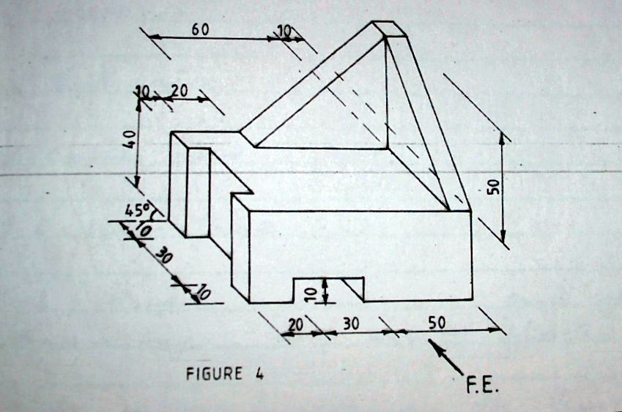
Figure 3.

Draw full size the three views of the block in 1st angle projection. Insert two major dimensions each view. (15 marks)

12. (a) Using a labeled vertical cross sectional sketch, show the damp proof details provided on a
parapet wall and roof covered with iron sheets. (8 marks)

((b) A fountain wall is 150mm thick. With the aid of a labeled sketch, determine the: (7 marks)

(i) Depth of foundation concrete
(ii) Projection of the foundation concrete
(iii) Foundation width

13. (a) Give two reasons for using each of the following types of oil based paint : (4 marks)
(i) Primary paint:-
…………………………………………………………………………………………………………………………………………………………… …………………………………………………………………………………………………………………………………………………………… ……………………………………………………………………………………………………………………………………………………………
(ii) Undercoating paint: -
…………………………………………………………………………………………………………………………………………………………… …………………………………………………………………………………………………………………………………………………………… ……………………………………………………………………………………………………………………………………………………………
(b) ) State five different types of wall finishes. (5 marks)
…………………………………………………………………………………………………………………………………………………………… …………………………………………………………………………………………………………………………………………………………… …………………………………………………………………………………………………………………………………………………………… …………………………………………………………………………………………………………………………………………………………… ……………………………………………………………………………………………………………………………………………………………
(c) Give three advantages and three disadvantages of terrazzo. (6 marks)
…………………………………………………………………………………………………………………………………………………………… …………………………………………………………………………………………………………………………………………………………… …………………………………………………………………………………………………………………………………………………………… …………………………………………………………………………………………………………………………………………………………… …………………………………………………………………………………………………………………………………………………………… …………………………………………………………………………………………………………………………………………………………
14. (a) State five performance requirements of doors. (5 marks)
…………………………………………………………………………………………………………………………………………………………… …………………………………………………………………………………………………………………………………………………………… …………………………………………………………………………………………………………………………………………………………… …………………………………………………………………………………………………………………………………………………………… …………………………………………………………………………………………………………………………………………………………… ……………………………………………………………………………………………………………………………………………………………
(b) Sketch a dependent scaffold and label it fully. (10 marks)

15. (a) State four requirements when transporting concrete on wheel barrows. (5 marks)
……………………………………………………………………………………………………………………………………………… ……………………………………………………………………………………………………………………………………………… ……………………………………………………………………………………………………………………………………………… ……………………………………………………………………………………………………………………………………………… ……………………………………………………………………………………………………………………………………………… ………………………………………………………………………………………………………………………………………………

(b) Sketch and label a longitudinal sectional view through a concrete flat roof showing the
details at the eaves and the parapet wall (10 marks)

