SUNRISE ONE TERM 1 EXAMINATIONS 2023
Kenya Certificate of Secondary Education
FORM FOUR

Form 4 AGRICULTURE Term 1
PAPER 2 APRIL 2023 – 2 Hours

Name: …………………………………………….. Adm No: ………Index No.……
Class: ……………… Date: ….………STUDENT’S TARGET ……….…
INSTRUCTIONS TO CANDIDATES.
- Write your name, admission number and class in the spaces provided above.
- Sign and write the date of examination in the spaces provided above.
©This paper consists of 3 sections; Section A, B and C respectively.
For Examiner’s Use Only
Section | Question | Maximum Score | Candidates Score
A | 1 – 19 | 30
B | 20 – 23 | 20
C | 24 – 26 | 40
Total Score |  | 90

  - SECTION A (30 MARKS
  - Answer all questions in this section.
- State four characteristics of exotic dairy breeds. (2mks) ………………………………………………………………………………………………………………………………………………………………………………………………………………………………………………………………………………………………………………………………………………………………………………………………………………………………………………………………
- Differentiate between the following terms; (2mks)
(a). Steer and a bullock. ………………………………………………………………………………………………………………………………………………………………………………………………………………………………………………………………………………………………………………………………………………
(b). Boar and Sow. ………………………………………………………………………………………………………………………………………………………………………………………………………………………………………………………………………………………………………………………………………………
- Name two tools used for dehorning. (1mk) ………………………………………………………………………………………………………………………………………………………………………………………………………………………………
- Name two hormones that control milk let- down. (1mk) ………………………………………………………………………………………………………………………………………………………………………………………………………………………………
- State four signs of farrowing in pigs. (2mks) ………………………………………………………………………………………………………………………………………………………………………………………………………………………………………………………………………………………………………………………………………………………………………………………………………………………………………………………………
- Outline four management practices carried out while rearing a heifer. (2mks)
………………………………………………………………………………………………………………………………………………………………………………………………………………………………………………………………………………………………………………………………………………………………………………………………………………………………………………………………
- State two effects caused by Keds in sheep. (1mk) ………………………………………………………………………………………………………………………………………………………………………………………………………………………………
- Outline four characteristics of an African wild bee. (2mks) ………………………………………………………………………………………………………………………………………………………………………………………………………………………………………………………………………………………………………………………………………………………………………………………………………………………………………………………………
- Name the breeding terms used to describe parturition in the following farm animals; (2mks)
- Sheep. ………………………………………………………………………………………
- Cattle. ……………………………………………………………………………………
- Rabbit. ……………………………………………………………………………………
- Goat. ……………………………………………………………………………………
- Name four routes through which the vaccines can be administered. (2mks) ………………………………………………………………………………………………………………………………………………………………………………………………………………………………………………………………………………………………………………………………………………………………………………………………………………………………………………………………
- State two abnormalities observed during egg candling. (1mk) ………………………………………………………………………………………………………………………………………………………………………………………………………………………………
- State four advantages of natural incubation. (2mks) ………………………………………………………………………………………………………………………………………………………………………………………………………………………………………………………………………………………………………………………………………………………………………………………………………………………………………………………………
- Outline four disease causing micro-organism. (2mks) ………………………………………………………………………………………………………………………………………………………………………………………………………………………………………………………………………………………………………………………………………………………………………………………………………………………………………………………………
- State two factors that determine amount of water required by a dairy cow. (1mk) ………………………………………………………………………………………………………………………………………………………………………………………………………………………………
- Name two dual purpose sheep breeds. (1mk) ………………………………………………………………………………………………………………………………………………………………………………………………………………………………
- Name four parts found in a piggery unit. (2mks) ………………………………………………………………………………………………………………………………………………………………………………………………………………………………………………………………………………………………………………………………………………………………………………………………………………………………………………………………
- State four advantages of embryo transplant. (2mks) ………………………………………………………………………………………………………………………………………………………………………………………………………………………………………………………………………………………………………………………………………………………………………………………………………………………………………………………………
- Name four disorders caused by mineral imbalances in cattle. (2mks) ………………………………………………………………………………………………………………………………………………………………………………………………………………………………………………………………………………………………………………………………………………………………………………………………………………………………………………………………
- Outline two physiological body functions that indicate illness in livestock. (1mk) ………………………………………………………………………………………………………………………………………………………………………………………………………………………………

SECTION B: (20 MARKS)
- (a) A farmer was advised to prepare 180kg of calf ration containing 20% DCP. Using Pearson’s square method, calculate the amount of maize containing 10% DCP and sunflower
containing 40% DCP the farmer needs to use. Show your working. (4 mks)

(b) State two factors considered when formulating a livestock ration. (2 mks) ……………………………………………………………………………………………………………………………………………………………………………………………………………………
- Study the diagram below and answer the questions that follow.
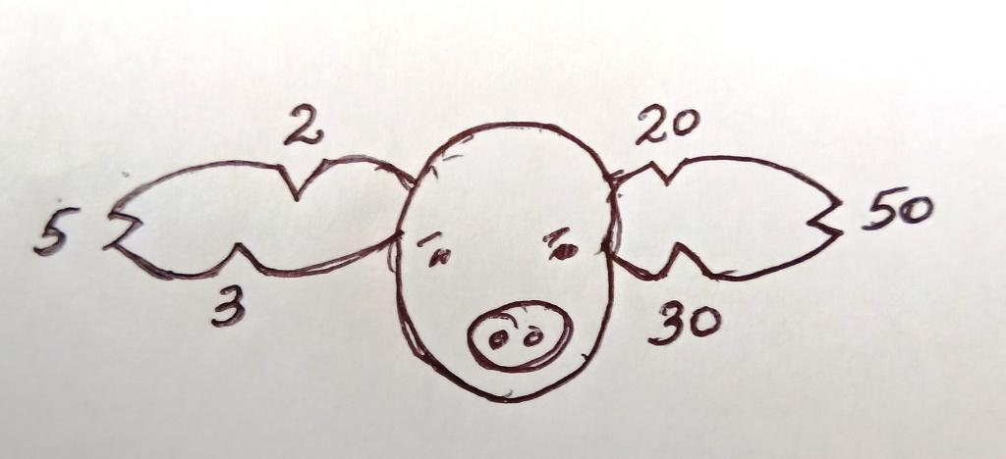
(a) Name the type of identification illustrated above. (1 mk) …………………………………………………………………………………………………………
(b) Give the identification number of the pig illustrated above. (1 mk) …………………………………………………………………………………………………………
(c) Using a diagram, illustrate how animal number 83 can be identified using the above
method. (2 mks)

- What is the use of metal rails in a farrowing pen? (1 mk) …………………………………………………………………………………………………………
- The diagrams below show the behaviour of chicks in a brooder in response to heat.

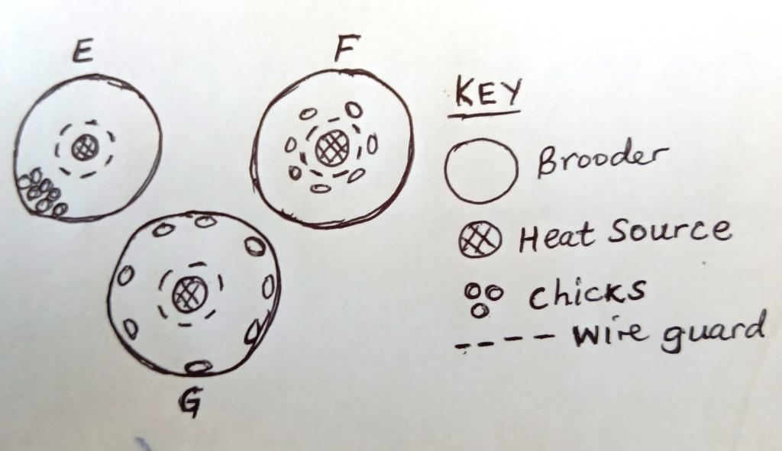

(a) Explain the behaviour of chicks in brooder;
E – (1 mk) …………………………………………………………………………………………………………………………………………………………………………………………………………………………………………………………………………………………………………………….…………

F – (1 mk) ………………………………………………………………………………………………………………………………………………………………………………………………………………………………………………………………………………………………………………………………
G – (1 mk) ………………………………………………………………………………………………………………………………………………………………………………………………………………………………………………………………………………………………………………………………
(b) Explain why the brooder is rounded. (1 mk) ……………………………………………………………………………………………………………………………………………………………………………………………………………………………………………………………………………………………….………………………………
- The diagram below shows the structure of the udder of a cow. Study it then answer the questions that follow.
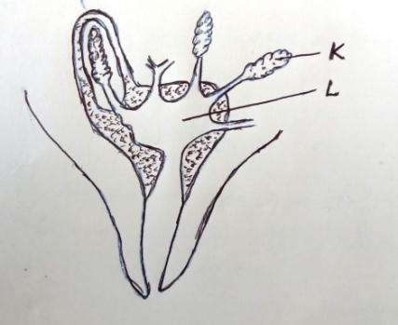
(a) Identify parts labeled K and L. (2 mks)
K –…………………………………………………………………………………………………
L –…………………………………………………………………………………………………
(b) Name two hormones that control milk let-down in a dairy cow. (2 mks) ……………………………………………………………………………………………………………………………………………………………………………………………………………………
(c) Name one disease that attack part labeled L. (1 mk) ……………………………………………………………………………………………………………………………………………………………………………………………………………………

SECTION C: (40 MARKS
Answer ONLY TWO questions from this section.
- (a) Describe the physical characteristics of a good dairy cow for breeding. (10 mks)

(b) (i) State five functions of water in the body of livestock. (5 mks)

(ii) Explain the advantages of a four-stroke cycle engine. (5 mks)

- (a) Explain five factors that affect milk composition in dairy cattle. (5 mks)

(b) Describe five factors that may lead to failure of a cow to conceive after service. (5mks)

(c) Explain the factors that a farmer should consider when selecting materials to construct a zero-grazing unit. (10 mks
- (a) Describe milk fever under the following sub-headings:
(i) Animal affected. (1 mk)

(ii) Cause of disease. (1 mk)

(iii) Symptoms. (5 mks)

(iv) Control measures. (3 mks)

(b) Outline the advantages of artificial insemination in cattle. (10 mks)

