NAME………………………………………………………ADM NO…………… CLASS………..

DATE………………SIGN.............………

443/1

PAPER 1

TIME: 2 HOURS

MECS CLUSTER JOINT EXAMINATION
FORM FOUR END OF TERM ONE 2023
AGRICULTURE
PAPER ONE
TIME: 2 HOURS

INSTRUCTIONS TO CANDIADATES
- Write your name, admission number and class
- This paper contain three sections and 11 pages
- Answer all question in section A and B
- In section C answer any two questions
- Candidates should check the question paper to ascertain that all pages are printed as indicated and that no questions is missing
- Candidates must answer all the questions in English

For examiner’s use only

Section | Questions | Maximum score | Candidate score
A | 1 -17 | 30
B | 18 -21 | 20
C |  | 20
 |  | 20
Total score |  | 90

SECTION A (30marks).
Answer all Questions in this section
1. Name two branches of horticulture. (1marks)
………………………………………………………………………………………………………………………………………………………………………………………………………………………………………………………………………………………………………………………
2. List two advantages of mixed farming. (1 mark)
………………………………………………………………………………………………………………………………………………………………………………………………………………
3. State two advantages of metal water pipes over plastic pipes in piping water in the farm.
(1 mark)
………………………………………………………………………………………………………………………………………………………………………………………………………………

4a) State two characteristics of extensive farming system. (1marks)

………………………………………………………………………………………………………
………………………………………………………………………………………………………
………………………………………………………………………………………………………
………………………………………………………………………………………………………
b) List four characteristic of fertile soil (2maks)

………………………………………………………………………………………………………
………………………………………………………………………………………………………
………………………………………………………………………………………………………

………………………………………………………………………………………………………

5. Give four advantages of raising cabbage seedlings in a nursery before transplanting (2maks)
………………………………………………………………………………………………………………………………………………………………………………………………………………
………………………………………………………………………………………………………………………………………………………………………………………………………………

6. State four benefits of a land title deed to a farmer (2marks)
………………………………………………………………………………………………………………………………………………………………………………………………………………………………………………………………………………………………………………………
………………………………………………………………………………………………………
7. State four factors which should be considered when deciding type of irrigation on crop production (2marks)
………………………………………………………………………………………………………………………………………………………………………………………………………………
………………………………………………………………………………………………………………………………………………………………………………………………………………

8. Give two ways by which overstocking encourage soil erosion. (1mark)
………………………………………………………………………………………………………………………………………………………………………………………………………………
………………………………………………………………………………………………………

9. State two physical agent of weathering (1mark)
………………………………………………………………………………………………………………………………………………………………………………………………………………
………………………………………………………………………………………………………

10. State four objectives of the million-acre scheme. (2marks)

………………………………………………………………………………………………………………………………………………………………………………………………………………………………………………………………………………………………………………………
………………………………………………………………………………………………………
11.State four symptoms of attack by the bean fly in bean production. (2marks)
………………………………………………………………………………………………………………………………………………………………………………………………………………………………………………………………………………………………………………………
………………………………………………………………………………………………………
12. State any four measures that are taken to minimize water pollution in the farm. (2 marks)
………………………………………………………………………………………………………………………………………………………………………………………………………………………………………………………………………………………………………………………
………………………………………………………………………………………………………

b). Outline four ways through which soil loses its fertility. (2 marks)
………………………………………………………………………………………………………………………………………………………………………………………………………………………………………………………………………………………………………………………
………………………………………………………………………………………………………

13. List Four practices that achieve minimum tillage. (2 marks)
………………………………………………………………………………………………………………………………………………………………………………………………………………………………………………………………………………………………………………………
………………………………………………………………………………………………………
14.a) List four farming practices that can be carried out to increase the amount of light harnessed by crops. (1 marks)
………………………………………………………………………………………………………………………………………………………………………………………………………………………………………………………………………………………………………………………
15. State two ways of preparing planting materials before planting (1mark) ………………………………………………………………………………………………………………………………………………………………………………………………………………………………………………………………………………………………………………………
16.State four ways of increasing labour efficiency on the farm (2marks)
………………………………………………………………………………………………………………………………………………………………………………………………………………………………………………………………………………………………………………………
………………………………………………………………………………………………………

17. State four factors which may affect the quality of Hay. (2 marks)
………………………………………………………………………………………………………………………………………………………………………………………………………………………………………………………………………………………………………………………………………………………………………………………………………………………………………………………………………………………………………………………………………

SECTION B (20 MARKS)
Answer ALL the questions in this section in the spaces provided.
18.The diagram below shows an experiment set up using three different sets of soil, and the observations made after 24hrs. Study the diagram and answer the questions that follow.
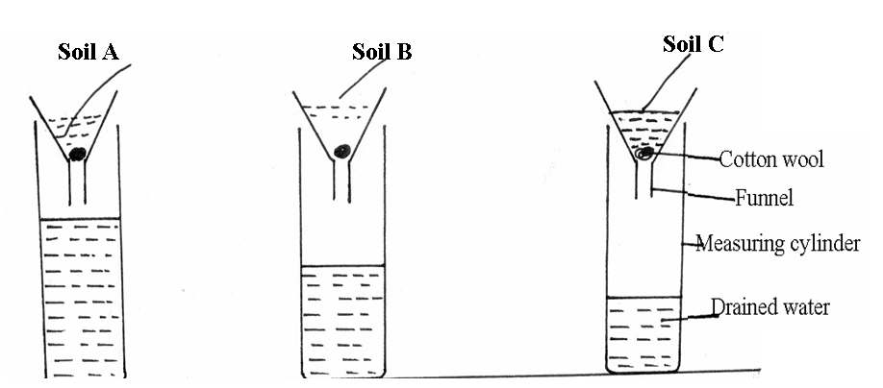
(a)What is the experiment set up above designed to study. (1 mark)
………………………………………………………………………………………………………
(b)Name soil types B and C. (2 marks)
C…………………………………………………………………………………………………
B…………………………………………………………………………………………………
(c)What are the characteristic textures of the soil type A and C (2 marks)
Soil type A
………………………………………………………………………………………………………

Soil type C
………………………………………………………………………………………………………

19.The diagrams below show a practice carried out on various crops on the farm. Study them carefully and answer the questions that follow.
B
A
Before after
a) Identify the farm practice represented by B. (1mark )
………………………………………………………………………………………………………
b) State one the importance of the above practice in the following crops. (3marks)
- Maize
………………………………………………………………………………………………………
- Irish Potatoes
………………………………………………………………………………………………………
- Tobacco
……………………………………………………………………………………………………....
c) At what stage of growth should the above practice be carried out in maize. (1mark )
………………………………………………………………………………………………………
20.Study the farm record below and the questions that follow:
Date | Disease symptoms | Animals affected | Drug used | Cost of treatment | Remarks
(a)Identity of the record (1mark)
…………………………………………………………………………………………………….
(b) State two different information that should be entered in the remarks column (2marks)
………………………………………………………………………………………………………………………………………………………………………………………………………………
(c) Give two importance of keeping the farm record illustrated above (2marks)
………………………………………………………………………………………………………………………………………………………………………………………………………………

21.The diagram below illustrates common weeds in arable land, study them carefully and answer the questions that follow.

a) Identify the weed labeled C and D (2marks)
C…………………………………………………………………….…..
D………………………………………………………………………...
b). Classify the weed labeled C according to plant morphology. (1 mark)
…………………………………………………………………………..........................................
c). Explain the reason why it is difficult to control the weed labeled D. (2 marks)
………………………………………………………………………………………………………………………………………………………………………………………………………………

SECTION C ANSWER ONLY TWO QUESTION 40 MARKS
22.Describe the management of cabbages under the following sub-headings.
(a) Nursery preparation and establishment (7 marks)
(b) Management of seedlings in the nursery (5 marks)
(c) Transplanting of seedlings (8 marks)
23a) Explain five ways government policy contributes to Agriculture. (5 marks)
b) Explain any five factors considered when spacing crops. (10marks)
c) Describe the advantages of mixed grass -legume pasture over a pure grass pasture (5marks)
24a) State and explain four ways in which soil loses its fertility (8marks)
b) State the precautions that should be observed when harvesting cotton. (4marks)
c) Explain four importance of crop rotation. (8marks)
…………………………………………………………………………………………………………………………………………………………………………………………………………………………………………………………………………………………………………………………………………………………………………………………………………………………………………………………………………………………………………………………………………………………………………………………………………………………………………………………………………………………………………………………………………………………………………………………………………………………………………………………………………………………………………………………………………………………………………………………………………………………………………………………………………………………………………………………………………………………………………………………………………………………………………………………………………………………………………………………………………………………………………………………………………………………………………………………………………………………………………………………………………………………………………………………………………………………………………………………………………………………………………………………………………………………………………………………………………………………………………………………………………………………………………………………………………………………………………………………………………………………………………………………………………………………………………………………………………………………………………………………………………………………………………………………………………………………………………………………………………………………………………………………………………………………………………………………………………………………………………………………………………………………………………………………………………………………………………………………………………………………………………………………………………………………………………………………………………………………………………………………………………………………………………………………………………………………………………………………………………………………………………………………………………………………………………………………………………………………………………………………………………………………………………………………………………………………………………………………………………………………………………………………………………………………………………………………………………………………………………………………………………………………………………………………………………………………………………………………………………………………………………………………………………………………………………………………………………………………………………………………………………………….……………………………………………………………………………………………………………………………………………………………………………………………………………………………………………………………………………………………………………………………………………………………………………………………………………………………………………………………………………………………………………………………………………………………………………………………………………………………………………………………………………………………………………………………………………………………………………………………………………………………………………………………………………………………………………………………………………………………………………………………………………………………………………………………………………………………………………………………………………………………………………………………………………………………………………………………………………………………………………………………………………………………………………………………………………………………………………………………………………………………………………………………………………………………………………………………………………………………………………………………………………………………………………………………………………………………………………………………………………………………………………………………………………………………………………………………………………………………………………………………………………………………………………………………………………………………………………………………………………………………………………………………………………………………………………………………………………………………………………………………………………………………………………………………………………………………………………………………………………………………………………………………………………………………………………………………………………………………………………………………………………………………………………………………………………………………………………………………………………………………………………………………………………………………………………………………………………………………………………………………………………………………………………………………………………………………………………………………………………………………………………………………………………………………………………………………………………………………………………………………………………………………………………………………………………………………………………………………………………………………………………………………………………………………………………………………………………………………………………………………………………………………………………………………………………………………………………………………………………………………………………………………………………………………………………………………………………………………………………………………………………………………………………………………………………………………………………………………………………………………………………………………………………………………………………………………………………………………………………………………………………………………………………………………………………………………………………………………………………………………………………………………………………………………………………………………………………………………………………………………………………………………………………………………………………………………………………………………………………………………………………………………………………………………………………………………………………………………………………………………………………………………………………………………………………………………………………………………………………………………………………………………………………………………………………………………………………………………………………………………………………………………………………………………………………………………………………………………………………………………………………………………………………………………………………………………………………………………………………………………………………………………………………………………………………………………………………………………………………………………………………………………………………………………………………………………………………………………………………………………………………………………………………………………………………………………………………………………………………………………………………………………………………………………………………………………………………………………………………………………………………………………………………………………………………………………………………………………………………………………………………………………………………………………………………………………………………………………………………………………………………………………………………………………………………………………………………………………………………………………………………………………………………………………………………………………………………………………………………………………………………………………………………………………………………………………………………………………………………………………………………………………………………………………………………………………………………………………………………………………………………………………………………………………………………………………………………………………………………………………………………………………………………………………………………………………………………………………………………………………………………………………………………………………………………………………………………………………………………………………………………………………………………………………………………………………………………………………………………………………………………………………………………………………………………………………………………………………………………………………………………………………………………………………………………....................................................................................................................................................

