WISDOM PRE-MOCK MARKING SCHEME
WOODWORK PAPER 1
. (a) Levels of qualiﬁcations.
- Artisan
- Craftsman
- Technician

.Characteristics of polyvinyl actate (PVA) glue.
-Easily applied.
-Sets at room temperature.
- Does not stain.
-Sets clearly and does not damage the edge of tools.
-Water resistant.

.-Functions of the knob in a bench plane.
-The knob allows the user to control and direct the plane with both hands.
-It allows the user to hold and leverage the plane during use.
Characteristics of polyvinyl actate (PVA) glue.
Easily applied.
Sets at room temperature.
Does not stain.
Sets clearly and does not damage the edge of tools.
􀂇Water resistant.
(Any 4 x 1) = 4 marks
7(b).Selection of finish;
Appearance
Protection
Durability
Ease of application
Safety
Reversibility
hygiene
(a) Reasons that make a mortice gauge produce inaccurate marks.
-Loose spurs.
-Loose thumbscrew.
-If the stem is worn out.
-If the stock hole is not tightly ﬁtting the stem.
-If accurate readings were not taken before locking the thumb screw.
8 Favourable conditions for fungal growth.
(i) Moisture in wood - must be above 20%
(ii) Temperature - between 30 - 37°C. Lower temperatures may reduce growth higher temperatures will kill fungi.
(iii) Air - essential requirement for growth and respiration.

9
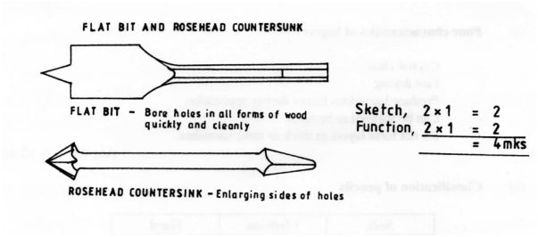

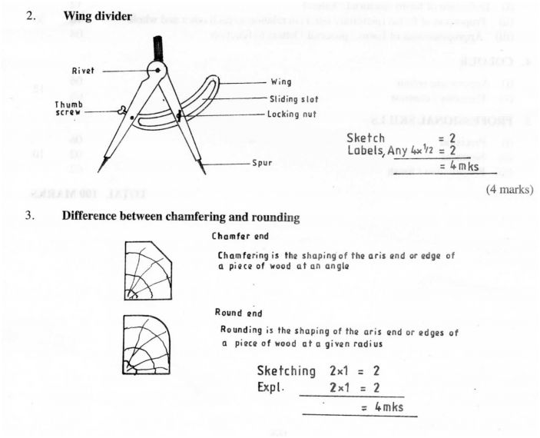
13(b) Parts of brush and function
Part Function
P - handle - to hold brush.
Q - ferrule - connects handle to bristles.
- plug - holds and spreads the bristles.
- bristles - spread the paint

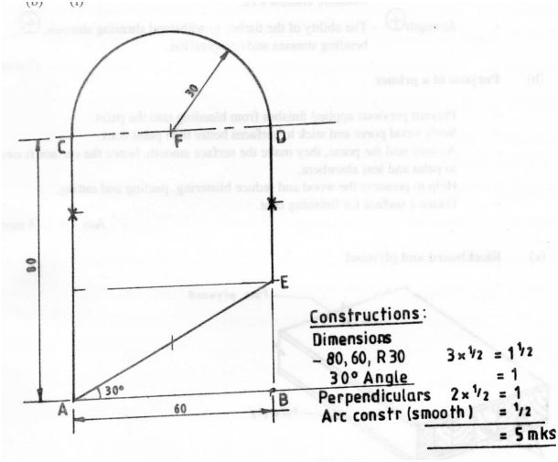

(ii) Step of marking out the shape
Establish line AB = 60 mm
At point A and B construct perpendicular lines.
At point A and B and along the perpendicular line, mark 80 nun - C and D
At point A construct L30“ to cut at E.
Measure 30 mm from point E to establish point F.
At point F construct an arc 30 mm radius to meet at C and D.
Join points A, C, D and E to produce the desired shape. 7 x 1 = (7 marks)

