STATISTICAL METHODS
1. The table below shows petroleum production in thousand barrels per day for countries in the Middle East in April 2006. Use it to answer question (a)

Country | Production in ‘000”  barrels
Iran  Kuwait  Qatar  Saudi Arabia  United Arab Emirates  Iraq | 3800  2550  800  9600  2500  1900

a) (i) What is the difference in production between the highest and the
lowest producer (1mk)
(ii) What is the total amount of petroleum produced in April 2006 in
the region? (1mk)

b) State three conditions that are necessary for the formation of petroleum (3mks)

2. The graph below shows percentage value of some export commodities from Kenya between 1999 and 2003. Use it to answer questions (a) and (b)
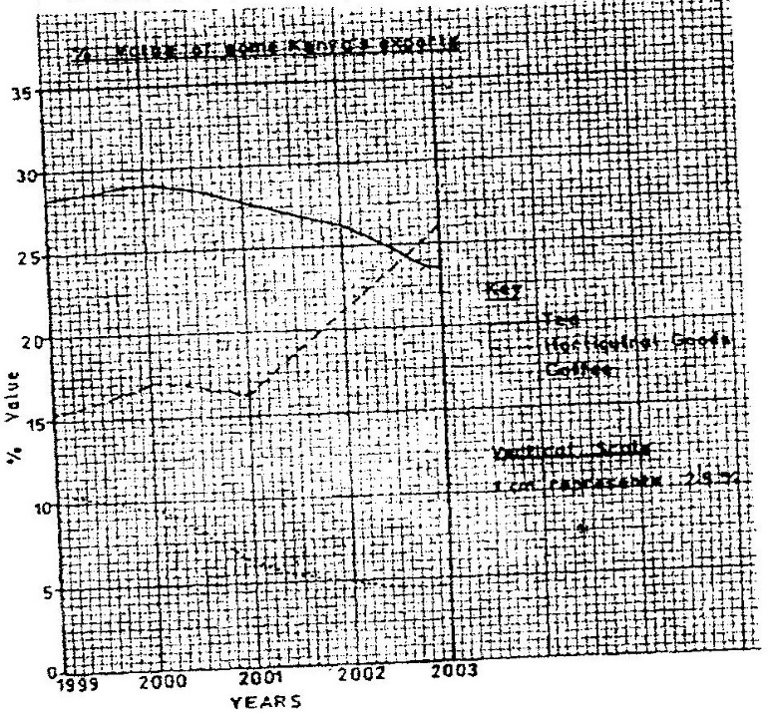

(a) (i) What was the percentage value of the tea exported in the year
2000? (2mks)
(ii) What was the difference in the percentage values of the
horticultural products and coffee exports in 1999? (2mks)
(iii) Describe the trend of the value of coffee exports from 1999 to
2003 (3mks)
(iv) Explain three factors which may have led to the increased export earnings from horticultural produce in Kenya between years 1999 and 2003 (6mks)
(v) Give three advantages of using simple line graphs to represent
data. (3mks)
(b) State four reasons why Kenya’s agricultural export earnings are generally low (4mks)
(c) State five reasons why the common market for Eastern and southern Africa (5mks)
3. (a) Define the following terms
- Statistics
- Statistical data
- Statistical methods (6mks)
(b) State two types of statistical data. (2mks)
(c) Write down two types of questionnaires. (2mks)
4. (a) What factors must be considered in selecting methods of data collection.
(3mks)
(b) Differentiate between discrete data and continuous data giving relevant examples. (4mks)
5. (a) What is sampling (1mk)
(b) State 3 types of sampling. (3mks)
6. (a) Name two main methods used in analyzing statistical data. (2mks)
(b) What is the significance of statistics in geography? (5mks)
7. (i) Name two types of graphs that you have learnt about. (2mks)
(ii) What are the advantages of using graphs named above in representing statistical data? Give advantages. (4mks)
8. (i) What is a questionnaire?
(ii) State four advantages of using questionnaires in collection of' statistical data. (4mks)
(iii) Explain oral interview method. (2mks)
9. Explain the following methods of data recording.
- Tabulation
- Photographing
- Tape recording
- Tallying
10. What is data? (2mks)
11. Marks 72, 60, 65, 70, 65, 80, 65, 70, 80, 84, 63, 75, 63, 71, 74
Use the data above to find out mean and mode. (4mks)
12. With the help of data above explain how median is obtained. (3mks)

