INTERNAL LAND FORMING PROCESSES – VULCANICITY
1. The diagram below shows some intrusive features formed by vulcanicity.
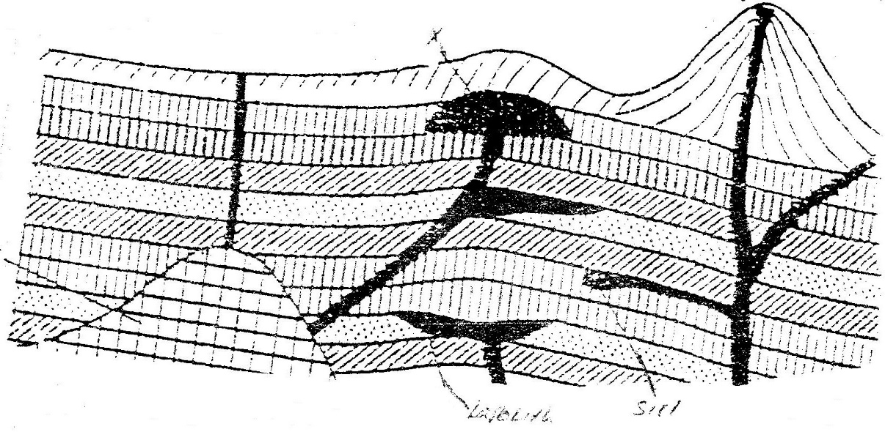
Use it to answer question (a)

a) i) Name features marked X,Y, and Z (3mks)
ii) Explain how a sill is formed (4mks)
b) Describe the characteristics of a composite volcano (4mks)
c) Explain four ways in which volcanic mountains positively influence human activities. (8mks)
d) Students carried a field study on volcanic rocks
i) Give four reasons why it is necessary to collect rock samples during such a field study. (4mks)
ii) State two problems they are likely to have experienced during the field study (4mks)
2. (a) Differentiate between plutonic rocks and volcanic rocks
(b) Describe how lava plateau is formed
(c) (i) Name three volcanic features found in the rift valley of Kenya
(ii) Explain four negative effects of vulcanicity in Kenya
(d) You intend to carry out a field study of a volcanic landscape
(i) State four reasons why it is necessary to conduct a reconnaissance
of the area of study.
(ii) During your field work, you intend to study volcanic rocks, state
why you would need the following items
3. Name three volcanic features found in the Rift Valley of Kenya. (3mks)
4. Explain four negative effects of vulcanicity in Kenya. (8mks)
5. Describe how lava plateau is formed. (5mks)
6. Differentiate between sill and dyke. (4mks)
7. What is vulcanicity. (2mks)
8. Describe how Crater Lake is formed. (5mks)
9. Describe how Mt. Kenya was formed.

