ACTION OF RIVERS
1. (a) Name two types of the coastal deltas (2mks)
(b) State two conditions that lead to deposition of silt at the mouth of a river
(2mks)
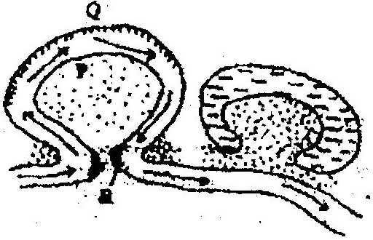
2. The diagram below shows river Mandera. Use it to answer question (a)

(a) (i) Name the process that take place at each of the points marked P
and Q. (2mks)
(ii) Name the feature formed at the point marked R (1mk)
(iii) Describe how an Ox- bow lake is formed (5mks)
(b) State five characteristics of a flood plain (5mks)
(c) Explain three causes of river rejuvenation (6mks)
- Your class is required to carry out a field study of a river
(i) What would be the advantages of dividing the class into groups according to the stages of the long profile of a river? (4mks)
(ii) What would be the disadvantage of using secondary data in this kind of a field study? (2mks)
3. (a) State two factors which influence the occurrence of surface run- off
(b) The diagram below shows a waterfall. Name the feature marked X, Y and
Z
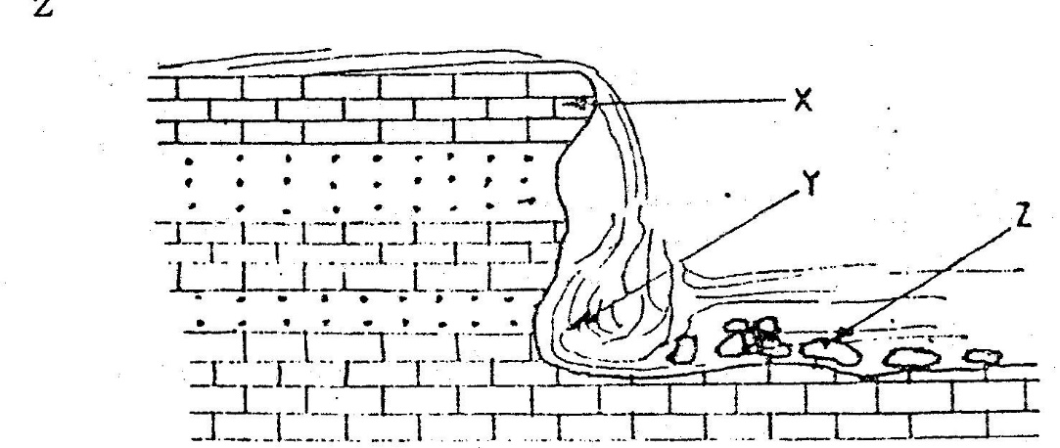

4. Describe three ways in which rivers transports its load.
5. Describe the following drainage patterns
(i) Dedritic.
(ii) Trellis.
(iii) Centipetal.
6. a) State two factors that influence the rate of erosion by the river in its
upper course.
b) (i) Define river rejuvenation
Name two features that result from river rejuvenation
7. Explain the following:
(a) River basin
(b) Watershed
(c) Catchment area
(d) River regime (8mks)
8. With examples from Africa, explain the differences between the following river features:
(a) Inland delta and alluvial fan.
(b) Estuarine delta and an estuary.
(c) Bluff and river cliff.
(d) Levees and river bank.
(e) River valley and river channel.
(f) Paired terrace and unpaired terrace.
(g) Drainage pattern and drainage system,
(h) Misfit river and deferred river,
(i) Antecedent drainage and superimposed drainage. (18mks)
9. Describe how a river erodes its channel through the following processes
(i) Abrasion
(ii) Hydraulic (4mks)
10. (a) (i) In which stage is the river at 'A'
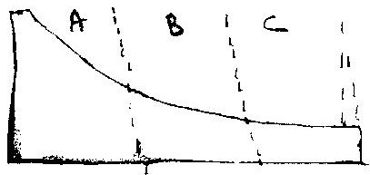

(ii) Name 3 features found at the above stage. (3mks)
(b) (i) In which stage is the river at 'B'
(ii) Which are the characteristics of the river at stage B?
(iii) Describe the characteristics of the river at the above stage C.
(4mks)

(c) In which stage is the river at C.
11. Explain the significance of rivers to man. (10mks)12.
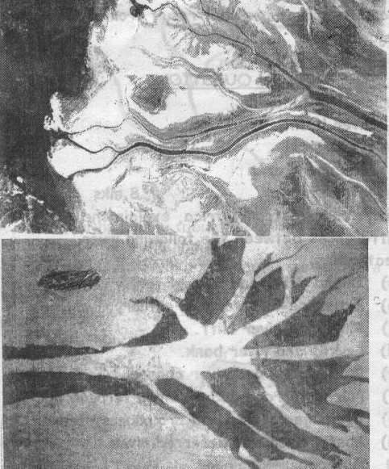

a) Name the type of photograph. (1mk)
b) Name the features shown by the photograph. I and II. (2mks)
c) State the conditions necessary for formation of these features. (3mks)

