SUNRISE ONE TERM 1 EXAMINATIONS 2023
Kenya Certificate of Secondary Education
FORM FOUR

Form 4 GEOGRAPHY Term 1
PAPER 2 APRIL 2023 – 2HRS 45 MINS

Name: ……………………………………………................ Adm No: ………Index No.……....
Class: ……………… Candidate’s Signature: ……. Date: …..……………..

Instructions to candidates
- Write your Name and Index Number in the spaces provided above,
- This paper consists of two Sections; A and B.
- Answer aU the questions in Section A.
- Answer question 6 and any other two questions from Section B.
- This paper consists of § printed pages. Candidates should check the question paper to ascertain that all the pages are printed as indicated and that no questions are missing.
(fi Indicate the question you have chosen to do in section B in the table below
For Examiner’s us© only
Section | Question | Maximum score | Candidate’s score
A | 1-5 | 25
B | 6 | 25
 |  | 25
 |  | 25
TOTAL SCORE

SECTION A: 25 MARKS
Answer ALL questions in this section
- (a) (i) Define Geography. (2 mark)
...................................................................................................................................................................... ...................................................................................................................................................................... ......................................................................................................................................................................
(ii) Name two branches of Geography (2 marks)
...................................................................................................................................................................... ...................................................................................................................................................................... ......................................................................................................................................................................
(b) State three reasons why it is important to study Geography. (3 marks)
...................................................................................................................................................................... ...................................................................................................................................................................... ......................................................................................................................................................................
- (a) Name two breeds of dairy cattle reared in Kenya. (2 marks)
...................................................................................................................................................................... ...................................................................................................................................................................... ......................................................................................................................................................................
(b) State two factors which favour dairy farming in Denmark. (2 marks)
...................................................................................................................................................................... ...................................................................................................................................................................... ......................................................................................................................................................................
- (a) Give two types of ground photographs. (2 marks)
...................................................................................................................................................................... ...................................................................................................................................................................... ......................................................................................................................................................................
(b) State two limitations of using photographs. (2marks)
...................................................................................................................................................................... ......................................................................................................................................................................

- The diagram below shows the occurrence of petroleum on the earth crust. Use it to answer questions (a)and (b)
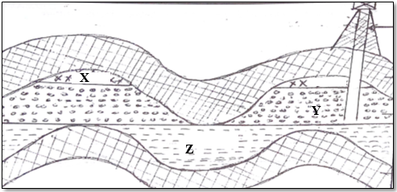
(a) Name the substance in the areas labeledX, Y and Z. (3marks)
X................................................................................................................................................................. Y.................................................................................................................................................................. Z.................................................................................................................................................................
(b) Give two by products obtained when crude oil is refined. (2marks)
...................................................................................................................................................................... ...................................................................................................................................................................... ......................................................................................................................................................................
- (a) State two factors that influence the distribution forests in Kenya. (2marks)
...................................................................................................................................................................... ...................................................................................................................................................................... ......................................................................................................................................................................
(b) State three effects of deforestation to the environment. (3marks)
...................................................................................................................................................................... ...................................................................................................................................................................... ......................................................................................................................................................................
......................................................................................................................................................................
SECTION B
Answer question six (6) and any other two Questions from this section.
- The table below shows three main crops produced in Kenya in the years 2008-2010
(Amounts in metric tonnes). Use it to answer questions below.
Crop | 2008 | 2009 | 2010
Maize | 200,000 | 380,000 | 400,000
Wheat | 100,000 | 130,000 | 150,000
Tea | 250,000 | 300,000 | 350,000

(a)(i) Using a scale of 1cm represent 50,000 metric tonnes, draw a comparative bar graph to represent the data above. (8 marks)
(ii). State two advantages of using comparative bar graph. (2 marks)
(b) i). Name two counties in Kenya where wheat is grown in large scale. (2 marks)
ii). State three conditions that favour wheat farming in Kenya. (3 marks)
(c). State four benefits of wheat growing in Kenya. (4 marks)
(d). Explain three factors that make Canada produce more wheat than Kenya. (6 marks)
- (a) (i) Define the term mining? (2 marks)
(ii) Give four methods of underground mining. (4 marks)
(b) Explain how the following factors influence mining:
(i) Level of technology (4 marks)
(ii) Quality of the ore (2 marks)
(c) Explain fourbenefits of trona mining at Lake Magadi to Kenya. (8 marks)
(d) State fivenegative effects of mining on the environment. (5 marks)
- Use the world map below to answer question (a).
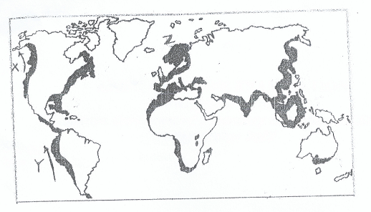
(a) (i). Name the ocean currents marked x and Y. (2 marks)
(ii). Name the fishing ground marked Z. (1 mark)
(b). Explain three physical factors that favour fishing in the fishing ground marked Z.
(6 marks)
(c) (i). What is fish farming? (2 marks)
(ii). Name two fish species reared in fish farms in Kenya. (2 marks)
(iii). Explain four problems which are experienced by fish farmers in Kenya. (8 marks)
(d). Give four uses of fish. (4 marks)
- a) State the difference between forest and forestry. (2marks)
b) Explain four measures that the Government of Kenya is taking to conserve forest in the country. (8marks)
c) i) List any three examples of softwood tree species found in Canada. (3marks)
ii)State and explain any three factors that have favoured forestry in Canada. (6marks)
d)You intend to carry out a field study on forestry within your local environment.
i)State three objectives you would formulate for the study. (3marks)
ii)Give three reasons why it is important to have a working schedule. (3marks)
- a)i). Differentiate between Land Reclamation and Land Rehabilitation. (2marks)
ii). Give three methods used in reclaiming land in Kenya. (3marks)
b i). State three benefits of reclaiming Yala swamp. (3marks)
ii). State four physical conditions that favour the establishment of Perkerra Irrigation Scheme. , (4marks)
c. Explain three problems faced by rice farmers in Mwea Irrigation Scheme. (6marks)
d. i). What is a polder? (lmark)
ii). Outline the stages involved in reclaiming land from the sea in the Netherlands. (6marks)

