GEOGRAPHY PP2 MARKING SCHEME 2023
1. (a) (i) Define Geography. (2 mark)
It is the study of the interrelationship between physical and human phenomena in
relation to the earth surface.
(ii) Name the two branches of Geography (2 marks)
- Physical Geography
- Human Geography
- Practical Geography
(b) State two reasons why it is important to study Geography. (2 marks)
- It provides knowledge about the immediate and the wider environment/it makes us to
- understand the earth on which we live.
- It creates awareness about the country and the rest of the world / promotes international
- understanding.
- It promotes awareness on the sustainable use of resources.
- It promotes development of skills and critical thinking.
- It prepares one for career opportunities.
2. (a) Name two breeds of dairy cattle reared in Kenya. (2 marks)
- Guernsey
- Jersey
- Friesian
- Ayrshire
- Zebu swiss brown
(b) State two factors which favour dairy farming in Denmark. (2 marks)
- well-developed co-operative movement
- Availability of market for dairy produce
- Availability of extension services
- Suitable climate/moderate temperature
- Handy fodder/ pasture
- Advanced technology/specialization
- Mechanization2x 1 = 2 marks
3.(a) Two limitations of using photographs.
- Vertical aerial photographs are difficult to interpret without special instruments e.g. stereoscopes
- Photographs are expensive to produce
- Cameras need well focusing to avoid blurred images
- Objects that are far away from the camera may not be clear thus leading to wrong interpretation.
(2marks)
(b) Two types of ground photographs.
- Ground close-up photographs
- Ground general view photographs
- Ground oblique photographs (2marks)
2. The diagram below shows the occurrence of petroleum on the earth crust. Use it to answer questions (a)and (b)

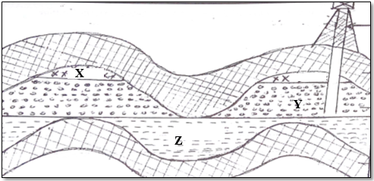
(a) Name the substance in the areas labeled X, Y and Z. (3marks)

- X – Natural gas/gas
- Y – Oil/crude oil
- Z – Water

(b) Give two by products obtained when crude oil is refined. (2marks)

- Bitumen/Asphalt/Pitch/Tar,
- Lubricant /Grease,
- Wax,
- Resin/Petrochemicals,
- Sulphur.

3. (a) Name two indigenous softwood trees species found in Kenya. (2marks)

- Podo
- Juniper
- Bamboo
- Kenya cedar/Red/White cedar

(b) State three effects of deforestationto the environment. (3marks)

- Cause destruction of water catchment areas
- lead to extinction of some tree species/loss of biodiversity
- May cause soil erosion
- May cause aridity /desertification
SECTION B
Answer question six (6) and any other two Questions from this section.
6. The table below shows three main crops produced in Kenya in the years 2008-2010
(amounts in metric tonnes). Use it to answer questions below.

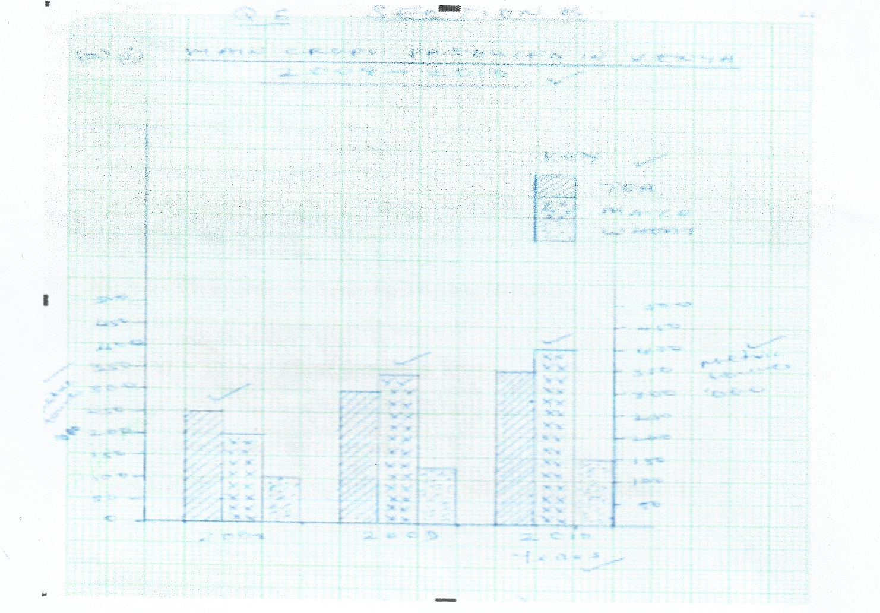
(a)(i) Using a scale of 1cm represent 50,000 metric tonnes, draw a comparative bar graph to represent the data above. (8 marks)
(ii). State two advantages of using comparative bar graph. (2 marks)
- It gives a clear visual impression
- Values in the same group can be compared easily
- The individual contribution made by the variables in each group can be easily identified
- It is easy to draw/construct
- It is easy to read/interpret
(b) i). Name two counties in Kenya where wheat is grown in large scale. (2 marks)
- Nakuru
- Narok
- UasinGishu
- Nyandarua
ii). State three conditions that favour wheat farming in Kenya. (3 marks)
- Gently sloping land for ease of mechanization
- High altitude (1500 – 2000m) above sea level
- Moderate rainfall (500mm – 1270mm)
- Moderate temperature/warm conditions (15ºc – 20ºc) for at least three months
- Deep fertile volcanic soils
- Warm dry sunny spell to enhance ripening and harvesting
(Any 3x1=3mks)
(c). State four benefits of whet growing in Kenya. (4 marks)
- Source of income for those involved in the activity
- Source of food to the Kenyan people
- Through wheat farming many are employed either directly or indirectly
- Saves foreign exchange if it was to be imported
- Promotes industrialization in Kenya
- Improvement of roads
(d). Explain three factors that make Canada produce more wheat than Kenya. (6 marks)
- Canada has extensive tracts of land which has enabled large scale mechanization of wheat
- Canada is a developed country therefore has more capital enabling farmers to sustain production unlike Kenya which has inadequate capital.
- Advanced scientific research in Canada enables the production of higher yielding seeds, better farming tools, seeds, pest control, disease control etc.
- Wheat farmers in Canada specialize in wheat unlike Kenya where farmers practice mixed farming
- There is higher demand for wheat in Canada while in Kenya low demand
- Farmers in Canada have had a long experience in wheat production spanning over centuries unlike Kenya where wheat farming is relatively new/introduced by white settlers (6 marks)
7.(a) (i) Define the term mining? (2 marks)
Mining refers to the process of extracting valuable minerals and fossils fuels on or from the earth’s crust.
(ii) Give four methods of underground mining. (4 marks)
- Deep shaft
- Drilling
- Adit/drift
- Solution
(b) Explain how the following factors influence mining:
(i) Level of technology (4 marks)
Advanced technology has improved mining operations thus leading to high quality /large quantity mineral products.
High level technology allows for effective exploration of minerals leading to accurate location of minerals.
Advanced technology boost effectiveness in production hence reducing wastage.

(ii) Quality of the ore (2 marks)
High grade ores yield more metal thus very economical to mine while low grade ores yield low metal.
Crude oil with very light and with the least Sulphur is the best quality thus highly preferred than heavy crude with more Sulphur.

(c) Explain fourbenefits of trona mining at Lake Magadi to Kenya. (8 marks)
- Export of soda ash earns foreign exchange to Kenya which is used in foreign trade.
- Trona mining has created employment opportunities to many Kenyans who earn income thus improving their standards of living.
- Development of glass and bottle industry as soda ash provides the main raw material.
- Trona mining has led to development of a tarmac road and railway branch from Konza to Magadi.
- Provision of social amenities such as schools and a hospital thus improving living standards of the local people.
- The Kenyan government (national and county) earns revenue through taxation on the profit of the company.
- The company provides free water to the local people for both domestic and livestock use.
- Trona mining has led emergence and growth of Magadi town

(d) State fivenegative effects of mining on the environment. (5 marks)
- The land is left bare with large craters which are ugly/ loss of the beauty of land.
- Heaps of rock waste hinders any other form of land use.
- Clearance of land before exploitation of minerals encourages soil erosion.
- Clearing natural vegetation in an area for mining leads to loss of plant and animal life/loss of biodiversity.
- Open cast mining leads to shortage of land due to displacement of people and land dereliction.
- Dust produced during open cast mining pollutes the atmosphere.
- Large scale blasting of rocks causes instability of basement rocks.

10. Use the word map below to answer question (a).
(a) (i). Name the ocean currents marked x and Y. (2 marks)
- X- Warm North pacific drift
- Y – Cold Peruvian ocean currents
(ii). Name the fishing ground marked Z. (1 mark)
- North East Atlantic fishing ground
(b). Explain three physical factors that favour fishing in the fishing ground marked Z.
(6 marks)
- Extensive continental shelf host a lot of planktons the basic food for fish
- Indented coastlines suitable site for fish breeding/port development
- Rugged landscape not ideal for Agriculture hence fishing is ideal alternative.
- Cool water s favours growth of varieties of fish species.
(c) (i). What is fish farming? (2 marks)
- It is artificial rearing o fish in fish ponds/rice field
(ii). Name two fish species reared in fish farms in Kenya. (2 marks)
- Tilapia
- Trout
- Nile Perch
(iii). Explain four problems which are experienced by fish farmers in Kenya. (8 marks)
- Poor feeder roads-delay transportation of fish to the market.
- Pour feeder roads-delay transportation of fish to the market
- Exploitation by middlemen reduces profit
- Inadequate market due to low purchasing power
- Some cultures despises eating fish hence low market.
- Inadequate capital to expand fish farming.
(d). Give four uses of fish. (4 marks)
- Food
- Sold to earn income
- Raw material for making feeds
- Alleviates chest problems e.g.cod liver oil

7 a)
Forest is a continuous and extensive growth of trees covering a large track of land while forestry is a science of developing or cultivating forests/ science of planting, caring and using trees .(2marks)
b)
- Getting forest areas to reduce encroachment of public
- Creating public awareness through mass media on the importance of conserving forests / forest resources
- Enacting laws to prohibit the cutting of trees without a license
- Establishing NEMA/ ministry of environment and natural resources to coordinate environment management and conservation activities
- Setting aside national tree planting day to encourage people to plant more trees
- Advising people to practice agroforestry so as to avoid cutting trees from the forests
- Employing forest guards to protect forests from fires /other illegal human activities
- Encouraging recycling of papers / wood-based products / use of other resources of energy to reduce the demand of trees
- Carrying out research through KEFRI and ICRAF for controlling pests and diseases .(8marks)
c)i)
- Spruce
- Douglas
- Fir
- Pine (any 3x1=3mks)
ii)
- The low temperatures experienced discourages settlements and other land use forms making forest the only alternative.
- There is ready market in Canada and the neighboring USA for the forest products
- The ruggedness of the landscape and thin soil discourages agriculture therefore most of the mountain’s slopes are under forests
- Valley bottoms along the coast provide sides for the paper mills
- High precipitation throughout the year promoted forest growth
- The coastal location also favors the exportation of timber products from the mills
- Rivers such as Ottawala and Frazer provide cheap means of water transport
- There are many rivers with waterfalls for instance river Ottawala which provide constant volume of water used to generate hep for use in industries such as pulp and paper industries. ( Stating alone earns 1 mk but state and explain earns 2mks i.e any 3x2=6mks)
d.i)
- To find out the types of tree species in the forest
- To identify characteristic of the forest
- To identify factors influencing forest distribution in the area
- To determine the main causes of forest destruction I the area
- To identify the methods that can be used to conserve the forest.(any 3x1=3mks)
ii)
- Gives ample time for each activity so that none is forgotten
- Reduced the tendency to waste time and forces the research team to work within allocated time of the project
- Provides estimate of time required for field study
Provides basis for evaluating field work while still in progress
Maintains the scope of field work(any 2x1=2mks)

- a), i). Differentiate between Land Reclamation and Land Rehabilitation. (2marks)
Land reclamation is a process by which unproductive land such as deserts, mash or swamp is converted into a land fit for cultivation while/whereas Land rehabilitation is the restoration of land that has been ruined through man’s negligence to its former reputation or good condition.
ii). Give three methods used in reclaiming land in Kenya. (3 marks)
Irrigating dry land.
K Draining of swamps S Adding manure to infertile soils Introducing drought resistant crops ^ Planting of trees/Afforestaion S Tse-tse fly control
- . i). State three benefits that result from reclaiming land. (3marks)
S It has helped resettle landless people ^ The scheme has opened productivity in former wasteland K Tenants generate income from horticultural farming which has helped raise their living standards K Creation of employment for the local people.
ii). State four physical conditions that favour the establishment of Perkerra Irrigation Scheme. (4marks)
Steady supply of water from R. perkerra used for irrigation
Gently sloping land makes water to flow by gravity
Presence of clay loam soilswhich is rich in calcium/ph osphate enables growth of variety crops
The area was receiving inadequate rainfall which necessitated irrigation
. Explain three problems faced by rice farmers in Mwea Irrigation Scheme. (6niks)
Stagnant pools of water have led to water borne diseases e.g bilharzias and malaria which weakens farmers hence lowering their productivity.
Siltation of canals which calls for regular dredging which is expensive. K High rates of evaporation has led to salinisation of soils.
Pest like quelea destroy crop and reduce yield thereby reducing farmers income
Mismanagement of funds has led to delayed payments to farmers.
- .i). What is a polder? (1mark)
P Part of the low lying land covered by sea water is enclosed using strong walls/ ring dykes
ii). Outline the stages involved in reclaiming land from the sea in the Netherlands.
(6 inks)
Protective dykes were constructed to enclose the part of the sea to be enclosed
Ring canals are constructed to lead water to pumping station.
The water is pumped out using windmills/dieselpumps/electricity pumps.
Ditches are then dug to drain the excess water from the enclosed land P Chemicals are added to the soil to reduce salinity /fresh water is pumped into the enclosed land to reduce sality.
Oats, rye and sugar beets are planted to improve the PH of the soil and reduce the land salinity further.
The land is left to dry
Land was put to use- agric, settlement, industry

