SUNRISE ONE TERM 1 EXAMINATIONS 2023
Kenya Certificate of Secondary Education
FORM FOUR

Form 4 GEOGRAPHY Term 1
PAPER 1 APRIL 2023 – 2HRS 45 MINS

Name: …………………………………………… Adm No: ………Index No.……
Class: ………………Candidate’s Signature: ……. Date: …..……………..

Instructions to candidates
- Write your Name and Index Number in the spaces provided above,
- This paper consists of two Sections; A and B.
- Answer aU the questions in Section A.
- Answer question 6 and any other two questions from Section B.
- This paper consists of § printed pages. Candidates should check the question paper to ascertain that all the pages are printed as indicated and that no questions are missing.
(fi Indicate the question you have chosen to do in section B in the table below
For Examiner’s us© only
Section | Question | Maximum score | Candidate’s score
A | 1-5 | 25
B | 6 | 25
 |  | 25
 |  | 25
TOTAL SCORE

SECTION A
ANSWER ALL QUESTIONS IN THIS SECTION
- a) Define the term Geography (2mks)
....................................................................................................................................................................... ...................................................................................................................................................................... ........................................................................................................................................................................
b) What is the relationship between Geography and Biology (2mks)
....................................................................................................................................................................... ...................................................................................................................................................................... ........................................................................................................................................................................
- a) Use the diagram below to answer the following questions
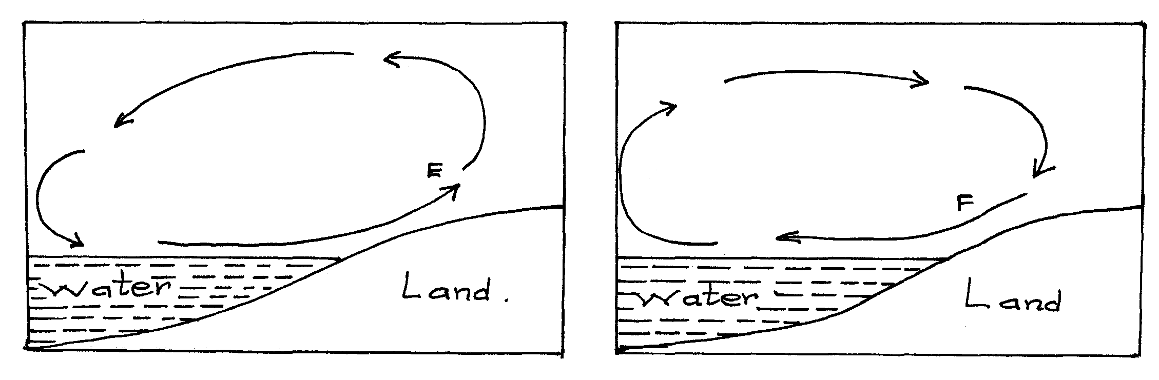
i) Name the air currents marked E. (1mk)
....................................................................................................................................................................... ......................................................................................................................................................................
ii) Why does the air current marked F flow at night. (3mks)
....................................................................................................................................................................... ....................................................................................................................................................................... ........................................................................................................................................................................
b) Give reason why air cools as it rises. (2mks)
....................................................................................................................................................................... ....................................................................................................................................................................... ........................................................................................................................................................................ ........................................................................................................................................................................

- (a)Define folding. (2mks)

b) List four types of folds. (4mks)
....................................................................................................................................................................... ...................................................................................................................................................................... ........................................................................................................................................................................
....................................................................................................................................................................... ......................................................................................................................................................................
- The diagram below illustrates a mass wasting process. Use it to answer question (a) and (b)
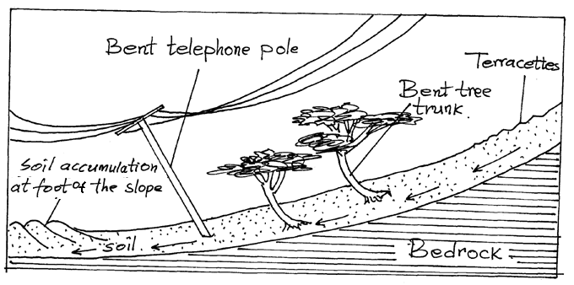
a.) Identify the process. (1mk)
....................................................................................................................................................................... ........................................................................................................................................................................
b.) Explain how the process occurs . (3mks)
....................................................................................................................................................................... ...................................................................................................................................................................... ........................................................................................................................................................................
....................................................................................................................................................................... ...................................................................................................................................................................... ........................................................................................................................................................................

- a.) What is a river profile? (2mks)
........................................................................................................................................................................ ....................................................................................................................................................................... ........................................................................................................................................................................
b.) Name the three stages of a river profile. (3mks)
....................................................................................................................................................................... ...................................................................................................................................................................... ........................................................................................................................................................................
.......................................................................................................................................................................
SECTION B
Answer question 6 and any other two questions from this section.
- Study the map of Nyeri 1: 50 000 (sheet 120/4) provided and answer the following questions.
a (i) Identify the sheet number of the map provided (1mk)
(ii) Convert the scale of map into a statement scale. (2mks)
(iii) What is the bearing of the trigonometrical station 1906 in grid square 6860 from the trigonometrical station 1865 in grid square 6957. (2mks)
b (i) Identify three physical features found in grid square 6259. (2mks)
(ii) Give the latitudinal extent of the area covered by the map. (2mks)
(iii) Identify two districts in the area covered by the map. (2mks)
c (i) Using a scale of 1 cm represents 20m, draw a cross section from Easting 68 to Easting 74 along Northing 64 . (4mks)
On it mark and name
- A hill top (1mk)
- A stream/river (1mk)
- All weather road loose surface (1mk)
ii) Calculate the vertical exaggeration of the cross-section. (2mks)
d) Citing evidence from the map, identify two social services offered in Mweiga Township. (4mks)
- a)(i) What is faulting? (2mks)
(ii) Name four types of faults (4mks)
b) With the aid of well-labelled diagrams, describe how a Rift Valley is formed by Tensional
force (8mks)
c) Apart from the Rift Valley, name other three relief features that may form as a result of faulting. (3mks)
d) Explain four ways in which features resulting from faulting are Economic significance. (8mks)
- (a) Differentiate between weather and climate. (2mks)
(b) Explain two ways in which human activities influence rainfall of a given place.(4mks)
(c) The map below shows some climatic regions of the world. Use it to answer the questions that follow.
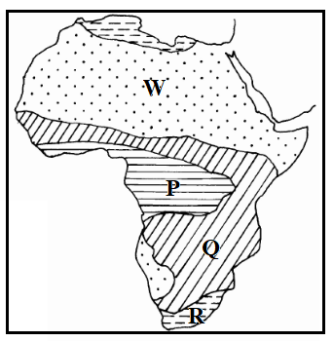
- Name the climatic types marked P, Q and R. (3mks)
- Describe the characteristics of the climatic type labeled W. (5mks)
(d) (i) Name three greenhouse gases likely to be found in the atmosphere. (3mks)
(ii) Givethree ways of combating global warming. (3mks)
(e) Members of your class plan to conduct a field study on weather in a local weather station
- Statethree factors they may identify for the citing of the weather station. (3mks)
- State two advantages of studying weather through a field study. (2mks)
- (a) (i) Define the term hydrological cycle. (2mks)
(ii) Explain the following processes of the hydrological cycle;
- Evaporation (2mks)
- Surface run off (2mks)
(b) Citing an example in each case, name three sources of rivers in Kenya. (3mks)
(c) State four factors that influence river erosion. (4mks)
(d) The diagrams below show formation of a feature of river deposition. Use them to answer the questions that follow.
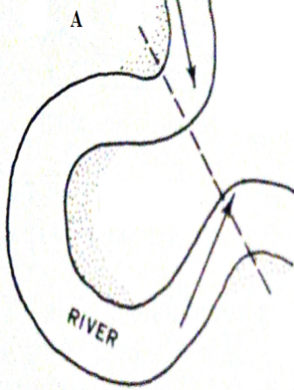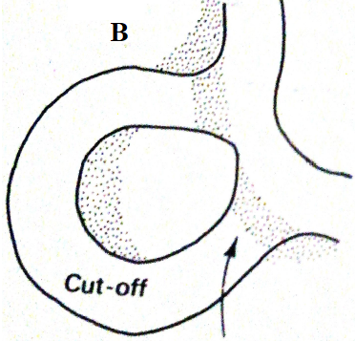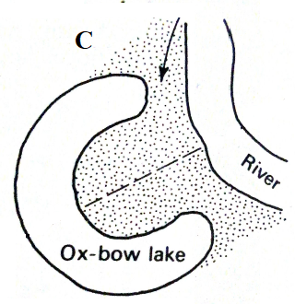

(i) Describe the processes in the diagrams labeled:
- A (1mk)
- B (2mks)
- C (2mks)
(ii) Name two examples of ox-bow lakes in Kenya. (2mks)
(e)Members of your class plan to conduct a field study on the lower course of River Nzoia.
(i) Give two equipment they are likely to carry for the study. (2mks)
(ii) State three characteristics of the river they are likely to observe during the study (3mks)
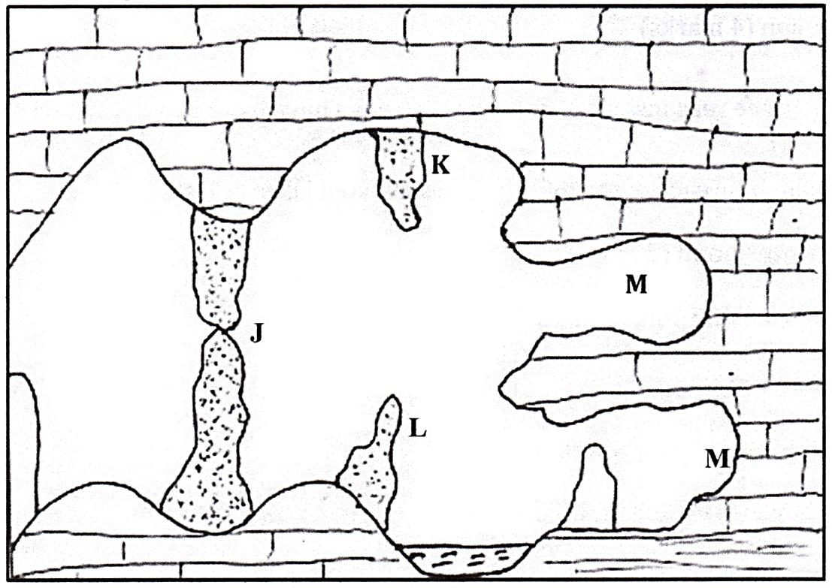
- The diagram below represents underground features in a limestone area. Use it to answer question.

- (i) Name the features marked K,L and M. (3mks)
(ii) Describe how the feature marked J is formed. (6mks)
- (i) What is a water table (2mks)
(ii) Explain three conditions necessary for the development of karst scenery. (6mks)
- You are supposed to carry a field study of an area eroded by water.
i Give three ways you would prepare before conducting the field study. (3mks)
ii Name two erosional features you are likely to identify during the field stud (2mks)
iii State three significance of the resultant features in limestone areas. (3mks)

