NAME----------------------------------------------------------------CLASS---------------

Candidate’s Signature------------ Date_----------- Index Number-----------------
312/2
GEOGRAPHY
Paper 2
Time: 2 ¾ Hours
September/October

WISDOM PRE-MOCK EXAMINATIONS 2021
Kenya Certificate of Secondary Education (K.C.S.E)
GEOGRAPHY
PAPER 2
2 ¾ HRS

INSTRUCTIONS TO CANDIDATES
- This contains two sections A and B.
- Answer ALL questions in section A. In section B answer question 6 and two other questions.
- All answers must be written in the booklet provided.

This paper consists of 5 printed pages. Candidates should check the question paper to ascertain that all pages are printed as indicated and that no questions are missing.

SECTION A
Answer ALL Questions in This Section
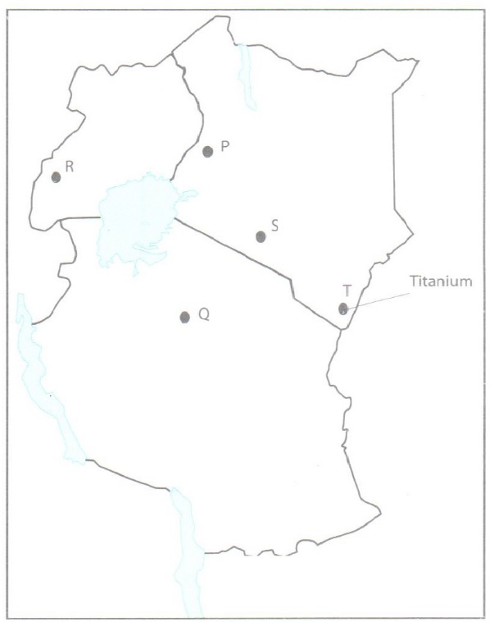
Q1. Use the map of East Africa below to answer question 1.

(a) Name the minerals found in the areas labelled P,Q,R,S and T.(5mks).
Q
R
S
T
(b) Identify the method of mining for the minerals labelled S and T (2mks)
S
T
2. (a) Define the term ‘Forest management’. (2 marks)
(b) Explain three measures taken by the Kenya government to conserve forest. (6 marks)
3. Name three areas in Kenya where sugar cane is grown. (3 marks)
4. (a) Define the term fisheries. (2 marks)
(b) State three ways in which marine fisheries in Kenya can be conserved. (3 marks)
5 . Name two methods used in deep sea fishing. (2 marks)
SECTION B
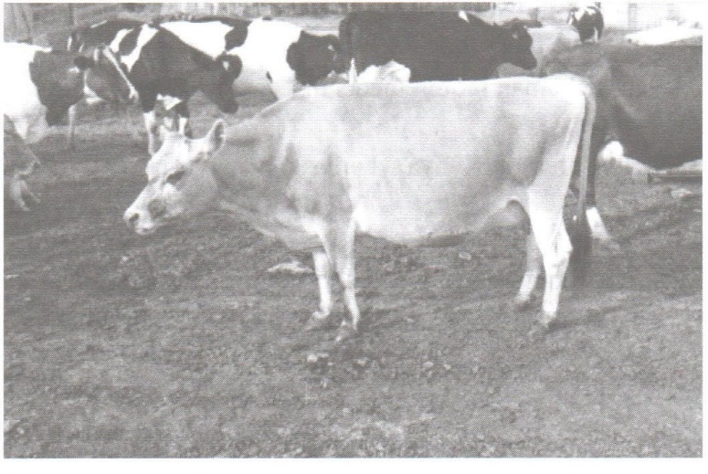
6. Study the photograph below and use it to answer question (a) and (b).

(a) Identify the type of photograph above. (1 marks)
(b) (i) Identify the type of farming shown in the photograph . (1 mark)
(ii) Name two main areas in Kenya where the type of farming identified in (i) above is practiced. (2 marks)
(c) Explain three human factors that influence the type of farming in the photograph in the Kenya
highlands. (6 marks)
(d) Explain five factors that favour horticulture in Kenya. (10 marks)
(e) (i) Name two areas where horticulture is practiced in The Netherlands. (2 marks)
(ii) Give three difference between horticulture in Kenya and the Netherlands. (3 marks)
7. (a) (i) What is agroforestry? (2 marks)
(ii) Give four reasons why agroforestry is encouraged in Kenya. (4 marks)
(b) Use the map of Kenya to answer questions (b) (i) and (ii).
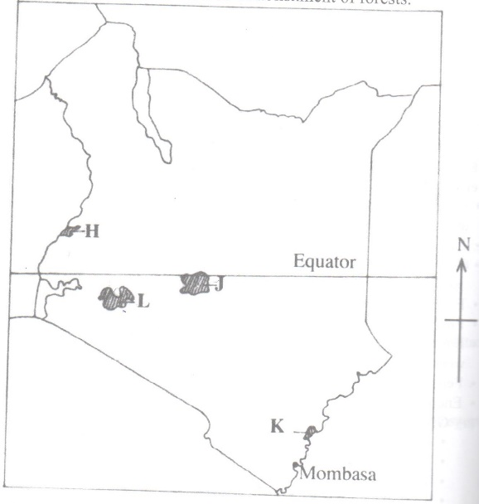

(i) Name the forest reserves marked H, J and K. (3 marks)
H
J
K
(ii) Explain four factors that favour the growth of natural forests in the area marked L.
(8 marks)
(c) Explain four problems facing forestry in Kenya. (8 marks)
8. (a) Describe the stages in the reclamation of land from the sea in the Netherlands. (6 marks)
(b) Explain four benefits of land reclamation in Netherlands. (8 marks)
(c) (i) Explain three conditions that face irrigation farming in Kenya. (6 marks)
(ii) State five problems experienced in irrigation farming in Kenya. (5 marks)
9. The map below shows some major fishing grounds in the world. Use it to answer question
(a).
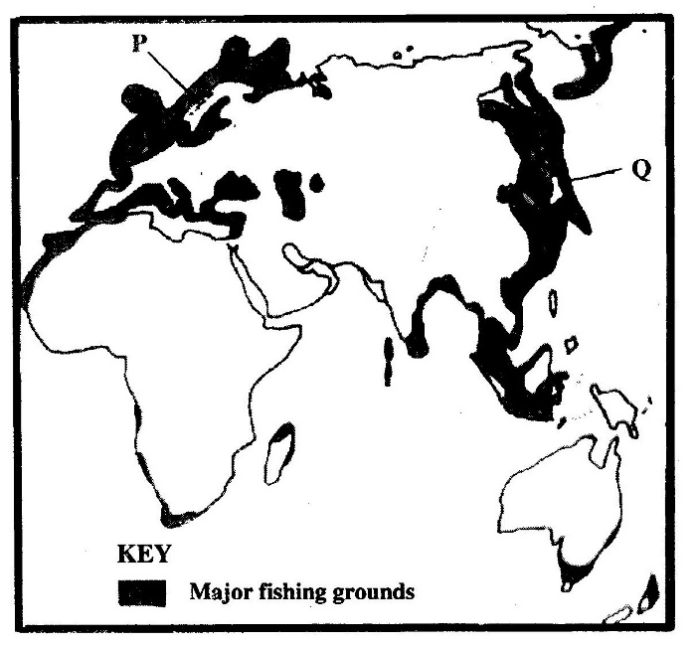

(a) (i) Name the countries marked P and Q. (2 marks)
P
Q
(ii) Explain four conditions that favour fishing in the shaded coastal waters. (8 marks)
(b) The diagram below represents some fishing methods.

(i) Name methods R and S. (2 marks)
R
S
(ii) Describe how each of the two methods are used in fishing. (7 marks)
(c) Explain three measures used to conserve fish in Kenya. (6 marks)
10. (a) (i) Distinguish between a game sanctuary and a national park. (2 marks)
(ii) Draw a map of Kenya and on it mark and name Sibiloi National park, Maasai Game Reserve and Tsavo National park. (4 marks)
(b) (i) Give three factors that favour the establishment of the national Parks in the semi-arid areas of East Africa. (3 marks)
(ii) Explain two effects of drought on wildlife in Kenya. (4 marks)
(c) Explain four measures that the government of Kenya has taken to conserve wildlife other than
establishing national parks and game reserves. (8 marks)
(d) State four ways in which wild animals are of significance to the economy of Kenya. (4 marks)

