Name …………………………………..………………Adm No …………….Class……………….
Index Number……….………………………….. Student’s signature……………………………

312/1
GEOGRAPHY
PAPER 1
TIME: 2 HRS 45MIN
SEPTEMBER/OCTOBER
WISDOM PRE-MOCK EXAMINATIONS 2021
Kenya Certificate of Secondary Education
312/1
GEOGRAPHY
PAPER 1
TIME: 2 HRS 45MIN
SEPTEMBER/OCTOBER

INSTRUCTIONS TO CANDIDATES
- This paper has two sections.
- Answer all the questions in Section A.
- Answer Question 6 and any other Two questions from section B
- All answers must be written in the answer booklet provided
- This paper consists of 5 printed pages
- Ascertain that all pages are printed as indicated.

- (a) Define the term meteorite (2 marks)

(b) Give three reasons why in 360◦ Atlas, Pluto as a planet has been disqualified by the International Astronomical Union (3 marks)

- (a) Differentiate between cleavage and lustre in minerals (2 marks)

(b) Identify three types of iron ore (3 marks)

- (a) Define the term Tsunami (2 marks)

(b) Name three types of earthquakes depending on the depth of focus (3 marks

- The diagram below shows the formation of a lake.

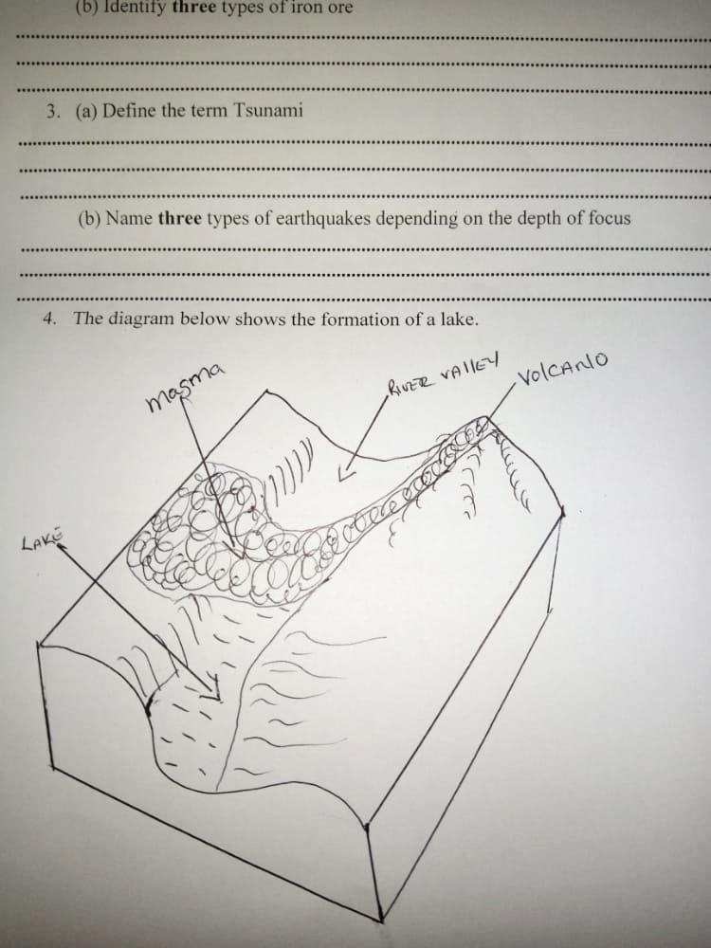

- Identify the type of lake (1mark)

- State two characteristics of such a lake and give one example. (3 marks)

- (a) Identify two soil forming processes. (2 marks)

(b) The diagram below shows soil arrangement.
- Identify the soil arrangement. (1 mark)

- Describe the nature of the soil found in parts
B- (1 mark)

C- (1 mark)

D- (1 mark)
- Study the map of Kijabe 1:50,000 sheet 134/3
- (i) Give the vertical interval of the area covered by the map (1 mark)

- Give the approximate height of the murrum pit at grid square 3297 (1 mark)

- Identify two manmade features found at grid square 3495 (2 marks)

- (i) Using the Map scale, draw a rectangle to represent the area enclosed by easting 31 and 34, and Northing 91 and 98. (1 mark)

On the rectangle, mark and name the following:
- Forest (1 mark)

- Bridge (1 mark)

- Escarpment (1 mark)

- All weather bound surface road (1 mark)
(ii) What evidence in the Kijabe map shows that the area receives high amount of rainfall (4 marks)
- (i) Identify the activirties that take place as represented by the following features (2 marks)
- Murrum pit-

- Carbacid plant-

- Citing evidence from the map explain three factors that favor dairy farming of kijabe area (6 marks)
(d) Citing evidence, explain two factors that have favored the location of a plantation in Kijabe (4 marks)
7. (a) (i) Define the term folding (2 marks)
(ii) What is an orogeny (2 marks)
(iii) Name two types of orogenies (2 marks)
(b) Describe how the plate tectonics theory contributes to the formation of Fold Mountains. (4 marks)
(c) (i) Identify two factors which influence folding of crustal rocks (2 marks)
(ii) Apart from fold mountains, name three other features formed by folding process (3 marks)
(iii) Using a well-labeled diagrams, describe the formation of fold mountains by the continental drift theory (6 marks)
(d) (i) Your class carried out a field study on a fold mountain region.
(ii) Give two alternative hypotheses that you could have formulated for the study (2 marks)
(iii) Give two reasons the student must have put into consideration before rejecting observation as a method of data collection (2 marks)
8. (a) (i) Define the term karst scenery (2 marks)
(ii) Give three conditions that influence the development of a karst landscape (3 marks)
(b) Describe the formation of a limestone cave (5 marks)
(c) (i) give four reasons why there are few settlement in karst region (4 marks)
(d) (i) Explain three factors that favor existence of underground water (6 marks)
(ii) Give the significance of ground water (5 marks)

9. (a) (i) Define weather (2 marks)
(ii) Give three reasons why weather forecasting is important (3 marks)
(b) (i) Using a well-labeled diagram, describe the formation of convectional rainfall (5 marks)
(ii) Name the instrument shown below and describe how it is used (5 marks)
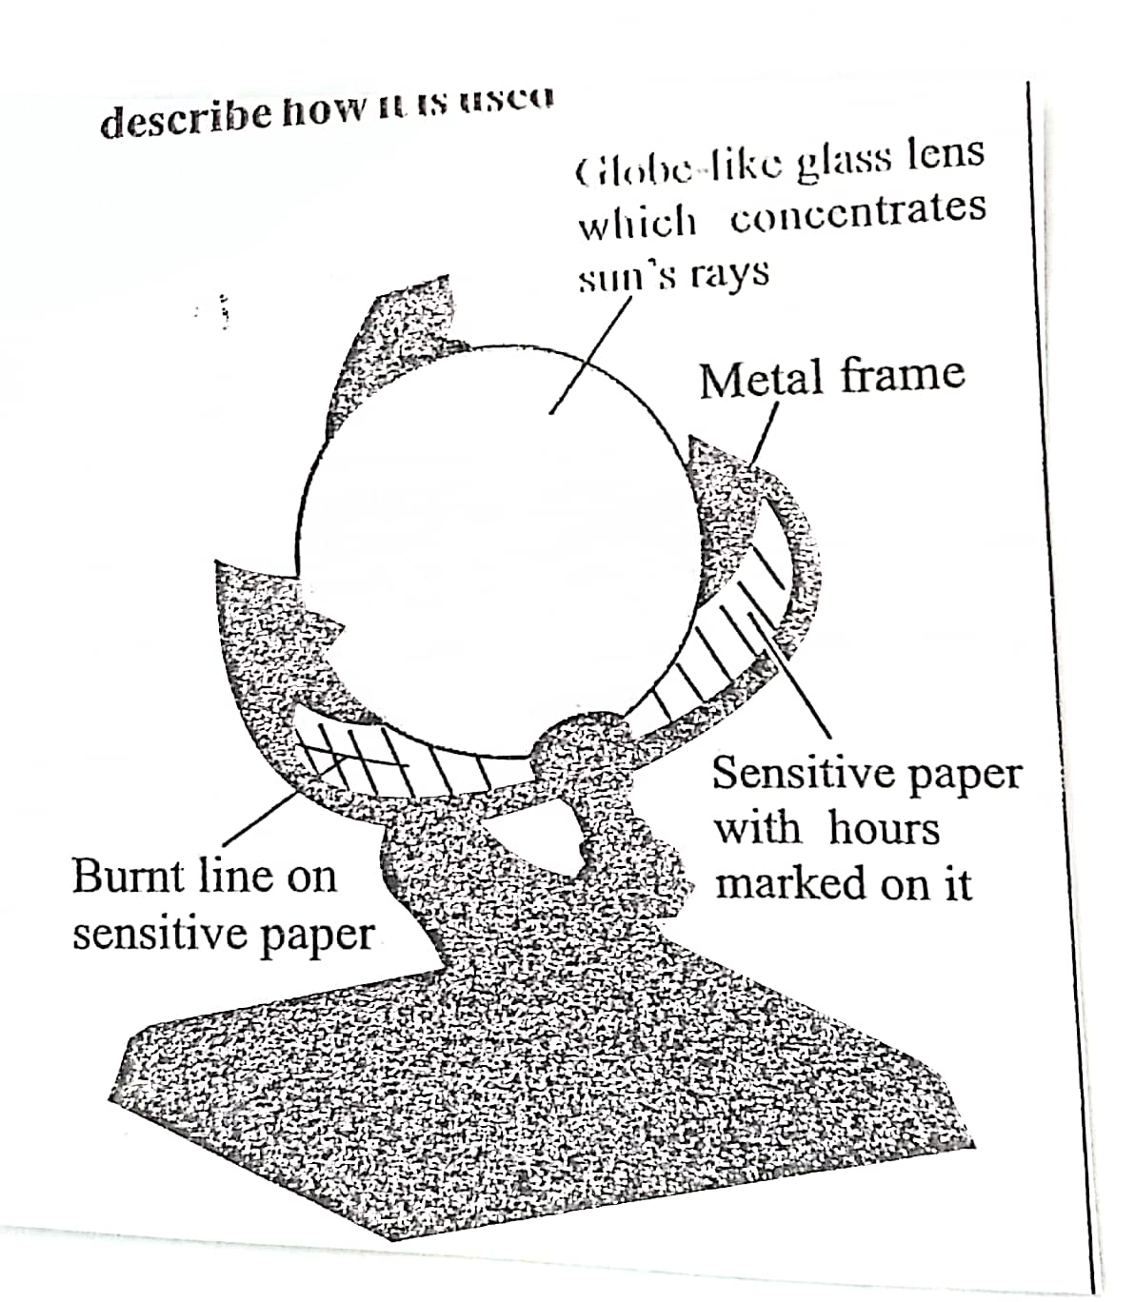
(c) (i) Differentiate between mist and fog (2 marks)
(ii) Give four causes of temperature inversion (2 marks)
(iii) Your geography class carried out a field study on weather in a school weather station. Give four reasons why it would be difficult to obtain accurate data from school weather station. (4 marks)
10. (a) (i) Define the term glaciation. (2 marks)
(ii) Give two processes of glaciation movement (2 marks)
(b) Explain three factors that influence glacial erosion (6 marks)
(c) Describe the formation of cirque lake (6 marks)
d. (i) Apart from rock pedestal name two other erosion feature formed by wind in desert. (2 marks)
(ii) With well labeled diagrams describe the formation of a rock pedestal. (7 marks)

