GEOGRAPHY 312/1
MARKING SCHEME
PAPER 1
TIME: 2HRS 45MIN

WISDOM PRE-MOCK EXAMINATIONS
Kenya Certificate of Secondary Education
Geography Paper 1
INSTRUCTIONS:
- This paper has two sections.
- Answer all the questions in Section A.
- Answer Question 6 and any other Two questions from section B
- All answers must be written in the answer booklet provided
- This paper consists of 7 printed pages
- Ascertain that all pages are printed as indicated.

- (a) Define the term meteorite 2mks
-Refers to a remnant of a meteoroid that has not completely burnt up and which has reached the earths surface.
(b) Give three reasons why in 2006 Pluto as a planet has been disqualified by the International Astronomical Union 3mks
-Seems not to be in orbit round the sun
-It’s not large enough/ dwarf
- Crosses Neptune’s orbit
-Has not cleared its neigbouring region of other objects
- (a) Differentiate between cleavage and lustre in minerals 2mks
-Cleavage is the way a mineral breaks while lustre is the way in which a mineral reflects light
(b) Identify three types of iron ore 3mks
-Haematite
-Limonite
-Magnetite
-Siderite

- (a) Define the term Tsunami 2mks
-A series of giant waves caused by earthquakes or undersea volcanic eruptions.
(b) Name three types of earthquakes depending on the depth of focus 3mks
-Shallow focus earthquakes
-Intermediate focus earthquakes
-Deep focus earthquakes
- The diagram below shows the formation of a lake.

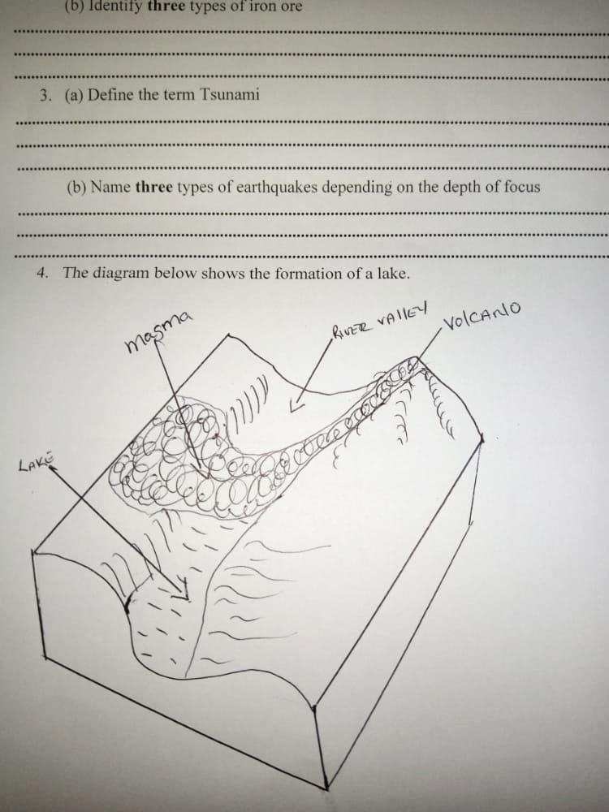

- Identify the type of lake 1mk
-Lava-dammed lake
- State two characteristics of such a lake and give one example. 3mks
-Are long and shallow as they follow the profile of the river’s course.
-Characterized by branches which represents drowned mouths of the original tributaries e.g Mutanda, Kayumba, Ruhondo, Bulera, Kivu and Mokoto.
- (a) Identify two soil forming processes. 2mks
-Weathering process
-Decomposition of organic matter
-Leaching

- The digram below shows soil arrangement.
- Identify the soil arrangement. 1mk
-Soil Catena
- Describe the nature of the soil found in parts
B- Soils are very thin because of high rates of erosion 1mk

C- Well drained mature soils, thick soils. 1mk

D- Thick alluvial soils, Poorly drained soils 1mk
- Study the map of Kijabe 1:50,000 sheet 134/3
- (i) Give the vertical interval of the area covered by the map 1mk
20M

- Give the approximate height of the murrum pit at grid square 3297 1mk
2560M

- Identify two manmade features found at grid square 3495 2mks
-School
-Foot-path
-Dry weather (Road E443)
-Settlement
-Motorable track
- (i) Using the Map scale, draw a rectangle to represent the area enclosed easting 31 and 34, and Northing 91 and 98. 1mk
On the rectangle, mark and name the following:
- Forest 1mk
- Bridge 1mk
- Escarpment 1mk
- All weather bound surface road 1mk

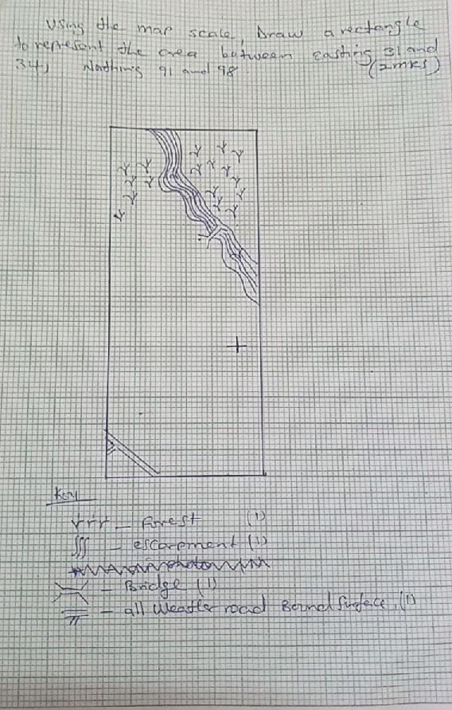

- What evidence in the Kijabe map shows that the area receives high amount of rainfall 4mks
-Forest
-Dairy cattle evidence cattle dips and dairy
-Permanent rivers e.g R.Sugumi
-High Altitude/Highland
-Dense settlement
-Plantation

- (i) Identify the activirties that take place as represented by the following features (2mks)
- Murrum pit- Road construction/Building and construction
- Carbacid plant- Extracts carbon dioxide, supplies major drinks bottlers and breweries
- Citing evidence from the map explain three factors that favor dairy farming of kijabe area (6mks)
-Dense settlement- provides enough labor and market for the milk products especially in the central part of the area covered by the map.
-The low lying, gently sloping area of Ewaso Kendong Valley is conducive for dairy acticvities unlike in steep slopes of kijabe hill that discourages dairy activities.
-The many permanent rivers provide water through farming e.g river Tongitongi.
Dairy factory in grid square 3092 for processing the dairy products.
-Provision of cattle dips at 2693, 2799 for protecting the dairy from pests and diseases.
-Water trough for water provision on 27909
-Provision of good transport network like the all Bound surface and road from Naivasha to Nairobi.
(d) Citing evidence, explain two factors which have favoured the location of a plantation in kijabe (4mk)
-Topography/ Relief – The area is gently sloping and allows mechanization evidenced by widely spaced contours.
–High rainfall evidenced by forests and permanent rivers.
-Transport- Good all weather loose and bound surface roads are passing through the plantation.
-Railway line

7. a. (i) Define the term folding (2mks)
It is the bending of crustal rocks brought about by compression forces.
(ii) What is an orogeny (2mks)
An orogeny is a fold mountain building period.
(iii) Name two types of orogenies (2mks)
Charnian orogeny
Caledonian orogeny
Herlynian orogeny
Alpine orogeny
Any 2x1 = (2mks)
b. Describe how the plate tectonics theory contributes to the formation of Fold Mountains (4mks)
- Two continental/a continental and an oceanic plate meet along compresioanal boundaries
- When an oceanic plate meets a continental plate, the oceanic plate sinks beneath/subduction occurs
- Sediments trapped between the two plates are squeezed as they converage
- When two continental plates meet along a compressional boundary, they get squeezd to form fold mountains.
c. (i) Identify two factors which influence folding of crustal rocks (2mks)
- the strength of the forces involved
- the direction of the forces/ presence of compressional forces
- the flexibility of crustal rocks
Any 2x1 = 2mks
(ii) Apart from fold mountains, name three other features formed by folding process (3mks)
- Intermontane pateau
- Intermontane basins
- Rolling plains
- Ridge and valley landscape
- Any 3x1 = (3mks)

(iii) Using a well-labelled diagrams, describe the formation of fold mountains by the continental drift theory (6mks)

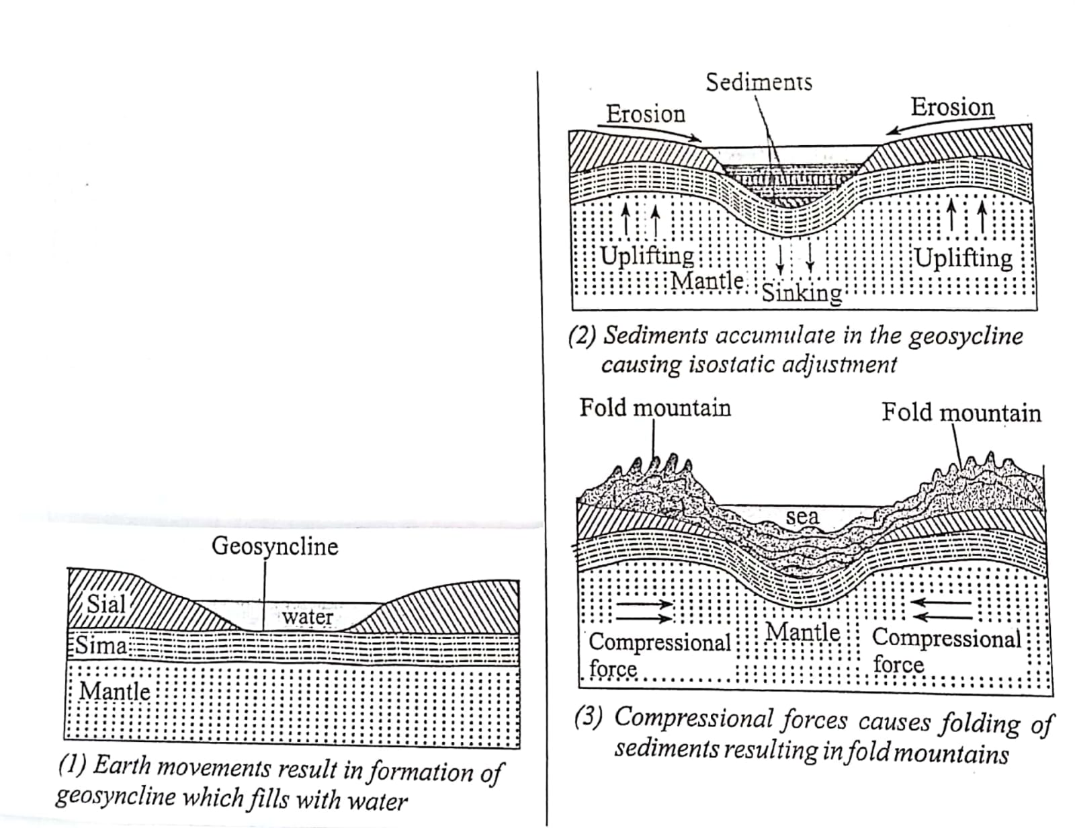
    - An extensive depression (geosynclines ) existed on the earth surface of the earth.
    - Prolonged and extensive erosion occurred on the surrounding land masses.
    - The eroded materials were deposited in the geosynclines forming thick layers
- The eroded materials were deposited in the geosynclines forming thick layers
- The accumulation and weight of materials caused the geosynclines to subside.
- More materials were deposited leading to development of very thick layers in the geosynclines.
- Further subsidence of the geosynslines triggered off compressioanla forces.
- The sediments were then subjected to compressional forces caused by the subsidence of the geosynclines
- The compressional forces drew the land masses tongehter squeezing the deposited materials.
- Folding of the materials occurred along the edges of the geisyncliness to form fold mountains.
- NB last point must be mentioned to score maximum point
- Text – 4mks
- Diagram – 2mks
- Total (6mks)

d. (i) Your class carried out a field study on a fold mountain region.
- (ii) Give two alternative hypotheses that you could have formulated for the study (2mks)
- The formation of fold mountain has promoted the economic standards of people living in the area
- The fold mountain are a major income earner for the government.(accept any other relevant point)
(iii) Give two things the student must have put into consideration before rejecting observation as a method of data collection (2mks)
- It cannot provide information about the past activities
- It cannot be used on high mountain due to foggy conditions
- It requires physical presence which might be difficult on the high mountain
- (any 2x1 = 2mks)

8. a. (i) Define the term karst scenery. (2mks)
This is a rugged region, covered by limestone/chalk dolomite rocks which decompose due to carbonation /solution to produce unique features.
(ii) Give three conditions that influence the development of a karst landscape (3mks)
- The surface rock and rocks beneath should be thick limestone /dolomite chalk
- The rocks should be well-jointed to allow water to infiltrate
- The rocks should be hard to discourage collapsing thus facilitating formation of underground features.
- The climate should be hot/wet huid to facilitate chemical weathering.
- The water- table should be deep below the surface to facilitate the formation of the features
- Any 3x1 =(3mks)
b. Describe the formation of a limestone cave (5mks)
- Rain water dissolves carbon IV oxide in the atmosphere
- It forms a weak carbonic acid
- The weak acid comes into contact with the limestone/chalk dolomite rocks
- it reacts with rocks along a point of weakness/along a joint on the river channel to form soluble calcium hydrogen carbonate, the joints are thus widened, forming a swallow hole.
- the river disappears underground through the swallow hole and continous to dissolve the rocks

.
c. (i) Give four reasons why there are few settlement in karst region (4mks)
- The area is rocky /rugged making construction and transport difficult
- The areas have thin soils, making cultivation difficult
- The areas have poor vegetation, making animal rearing difficult.
- There is little surface water, flow, with the little available water being inadequate this discouraging settlement.
d. (i) Explain three factors that favor existence of underground water (6mks)
Precipitation
light rains infiltrate more than heavy rains melting snow makes water available for infiltration duration of the rain is significant because the longer it rains, the higher the likelihood of infiltration
Slope
The higher infiltration of water on gentle slopes than steep slopes, on steep slopes the water flows away as surface – run – off with little/ no infiltration.
Nature of the rock
- Rocks must be permeable for the water to percolate
- Impermeable rocks will not allow the water to infiltrate with most of it flowing on the surface run-off
Vegetation cover
- a region with a lot of vegetation allows more water to infiltrate.
Regions with less vegetation experience more surface run-off reducing infiltration.
Level of ground saturation
- a region which is already saturated will not allow more water to inftrate
- Inftration will only occur in a region where the rocks are not saturated.
(ii) Give the significance of ground water (5mks)
- It it becomes source of rivers when it comes into the ground in the form of a spring, this water could be put into domestic/industrial use
- The water from the artesian, wells, springs and boreholes provide water for domestic/industrial use.
- The promation of a spring where the ground water is available
- Some of the water from underground is hot/comes from hot springs and could be pumped to homes for use.
- Underground water, that comes out in form of geysers is tourist attradction, earning revenue for a country.
- Some underground water dissolve minerals like sulphur which are then brought to the surface making it easily to mine.
- (accept any other relevant point)
9. a. (i) Define weather (2mks)
This is the condition of the atmosphere over a short period of time
(ii) Give three reasons why weather forecasting is important (3mks)
- It enables farmers to plan their farming activities
- It helps people to choose the clothing for the day
- It influences the design of houses
- It guides in the timing of sporting /tourist activites
- It helps in a averting disasters related to the weather for example tornadoes
- It helps in planning of military activities
b. (i) using a well-labelled diagram, describe the formation of convectional rainfall (5mks)
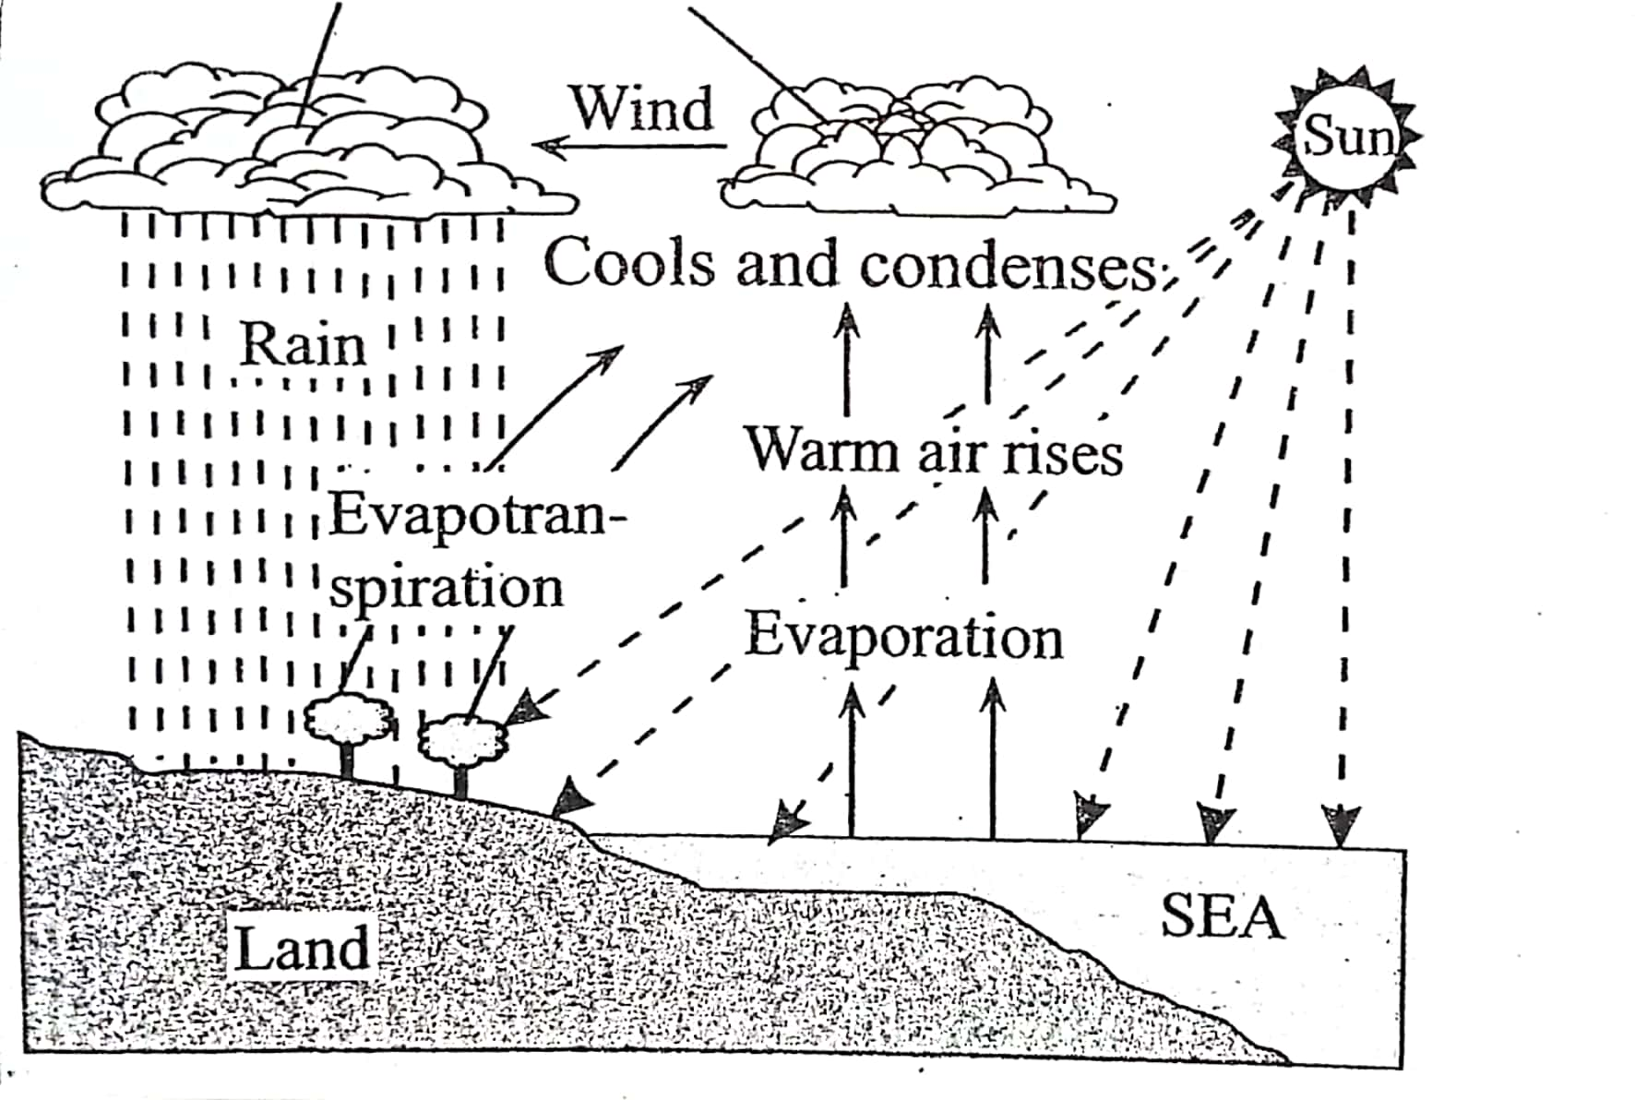
- Water in the lake/sea/wet ground surface is heated intensly by solar radiation
- Maximum heating occurs in the afternoon
- Moisture – laden air above the water rises in convectional currents
- As the warm air rises it condenses at high altitude with time, the condensed water vapour forms cumulo – nimbus clounds
- The heavy clound, give rise to heavy /torrential rain accompanied by thunder and lightinng and at times hailstones. This is convectional rainfall

(ii) Name the instrument shown below and describe how it is used (5mks)
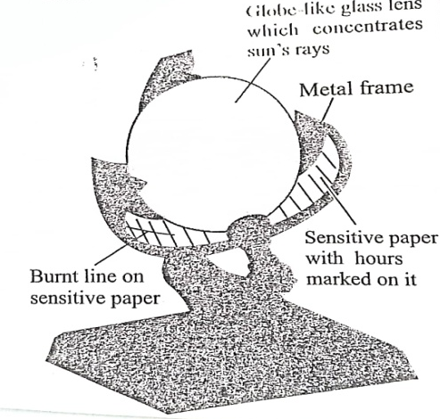

- Sunshine recorder – used to measure the duration of sunshine
- remove the sensitive paper from the metal frame read the number of sunshine hours from the burnt line on the sensitive paper.
Record the number of sunshine hours on a table
Interpret the readings and fix another sensitive paper on the metal frame.
c. (i) Differentiate between mist and fog (2mks)
Mist is whereby water vapor condenses close to the earth surface reducing visibility between 1-2 km while fog is whereby water vapor condenses close to the earth surface reducing visibility to less than 1km.
(ii) Give four causes of temperature inversion (4mks)
- Meeting of cold and warm air masses where the cold air mass sinks while the warm air rises at a front.
- Cold dense mountain air flow down to the valley bottoms by gravity at night and push up the warm lighter air in the valleys.
- Warm wind passing over a cold surface such as a cold ocean current which makes air above to be warmer than the air below.
- Terrestrial radiation on clear nights when heat moves up to higher making the lower atmosphere colder.

(iii) Your geography class carried out a field study on weather in a school weather station.
Give four reasons why it would be difficult to obtain accurate data from school weather station. (4mks)
- Lack of suitable equipment
- Lack of skills in reading/interpreting the information
- Wrong location of the wearther station
- Inaccurate readings/ irregular readings
- Possible interference from intruders
10. a. (i) Define the term glaciation. (2mks)
Glaciations is the process through which moving ice sculptures the earth surface.
(ii) Give two processes of glaciation movement (2mks)
- Plastic flowage
- Basal ship
- Extrusion flow
- Internal shearing
b. Explain three factors that influence glacial erosion (6mks)
- Nature of underlying rock: Abrasion is effective on soft rocks than hard rocks
- Well jointed and faulted rocks are more eroded than those that are not because cracks and joints enable water to enter the rocks and freeze which facilitates plucking
- Gradient of the slope; glacier on steep slopes moves faster and has greater energy to erode than slow moving ice.
- Thick ice is heavier and exerts greater pressure on rock debris ice is making them to erode the underlying rock more effectively.
- Amount of rock debris. The more the rock debris the more effective ebrasion will be since they acts as abrasive tools.
c. Describe the formation of cirque lake (6mks)
      - Snow accumulates in a shallow depression on a mountain side.
      - Show gets compacted into ice/to form a cirque glacen.
      - The accumulated ice erodes the hollus through plucking continued plucking and abrasion, eventually forms a deep armchair depression known as a circle.
      - The depression is filled with melt. Water/rain water to form a cirque lake/tarn/currie.
d. (i) Apart from rock pedestal name two other erosion feature formed by wind in desert (2mks)
- Millet seeds
- Ventyjacts
- Mushroom block
- Deflation hollows
- Zeygens
- Yardangs

(ii) With a well labelled diagrams describe the formation of a rock pedestal (7mks)
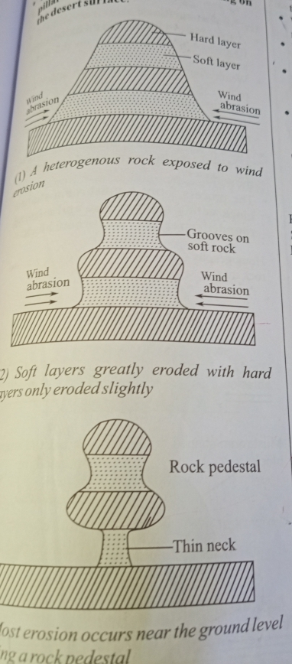
- Wind abrasion acts upon rock with alternating hard and softs t rocks layers
- Weathering and wind abrasion erodes faster on the soft layers than the hard layer.
- Soft layers are eroded inwards forming hollows while hard. Layers are left protruding outwards
- Wind abrasion undercuts more near the ground level forming a thin neck since heavier rock material are carried at the base
- The result is an irregularly shaped rock. Pillar called a rock pedestal standing on the desert surface

Text 5 marks
Diagram 2 marks
Total 7 marks

