MARKING SCHEME
312/2
GEOGRAPHY
Paper2
Time: 2 ¾ Hours
September/October
WISDOM PRE-MOCK EXAMINATIONS 2021
Kenya Certificate of Secondary Education (K.C.S.E)
GEOGRAPHY PAPER 2
2 ¾ HOURS

INSTRUCTIONS TO CANDIDATES
- This contains two sections A and B.
- Answer ALL questions in section A. In section B answer question 6 and two other questions.
- All answers must be written in the booklet provided.

This paper consists of 3 printed pages. Candidates should check the question paper to ascertain that all pages are printed as indicated and that no questions are missing.

SECTION A
ANSWER ALL QUESTIONS IN THIS SECTION
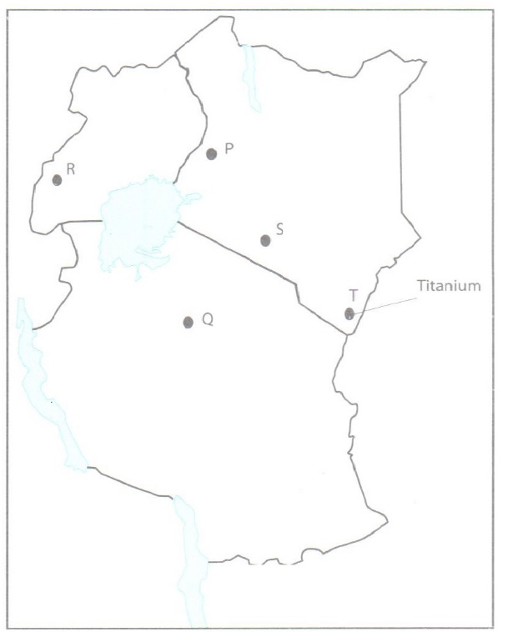
Q1. Use the map of East Africa below to answer question 1.

(a)Name the minerals found in the areas labelled P,Q,R,S and T.(5mks).
P-Flouspar
Q-Diamond
R-Copper
S-Trona
T-Limestone
(b)Identify the method of mining for the minerals labelled S and T (2mks)
S- Dredging
T- Sripping
2. (a) Define the term ‘Forest management’ (2mks)
Management of forests means careful planning and control of the use of forest resources .
(b) Explain three measures taken by the Kenya government to conserve forest (6mks)
-Registering /recognitising the efforts of NGO’s like the Green Belt Movement which have mounted campaign on planting trees.
-Gazetting forested areas to reduce encroachment by public.
-Creating public awareness through mass media/ public barazas on the importance of conserving forest resources.
-Enacting laws to prohibit the cutting of trees without a license/protecting indigenous tree species.
-Establishing NEMA / Ministry of Environment and Natural Resources to co-ordinate environmental management and conservation activities.
-Setting aside national tree planting day to encourage people to plant more trees.
-Advising people to practice agro-forestry so as to avoid cutting trees from the forests.
-Employing forest guards to protect forests from fires/other illegal human activities.
-Encouraging recycling of papers/wood based products/use of other sources of energy to reduce demand for trees.
-Carrying out research through KEFRI and ICRAF in order to come up with ways of controlling diseases/pests/develop species suitable for different ecological regions.

3. Name three areas in Kenya where sugar cane is grown.(3mks)
-Bungoma -Migori
-Busia -Mumias
-Kakamega -Rongo
-Mumias -Tana River
-Nyando
-Kwale
4. (a) Define the term fisheries.(2mks
-Fisheries are water bodies where aquatic organisms/fish are found/ reared foe exploitation.
(b) State three ways in which marine fisheries in Kenya can be conserved (3mks)
-Restocking the overfished areas.
-Standardising the mesh size of nets to be used in fishing.
-Licensing commercial fishermen to control their number.
-Restricting the disposal of untreated/ waste into the sea/ control of water pollution .
-Restricting fishing to specific seasons.
-Monitoring/ discouraging the entry of foreign fishermen off the Indian Ocean water/ 320km .
Enforcing the International conventions to protect endangered fish species.
5.Name two methods used in deep sea fishing (2mks)
-Trawling, Seining, Drifting, Line fishing/ Lining.
SECTION B
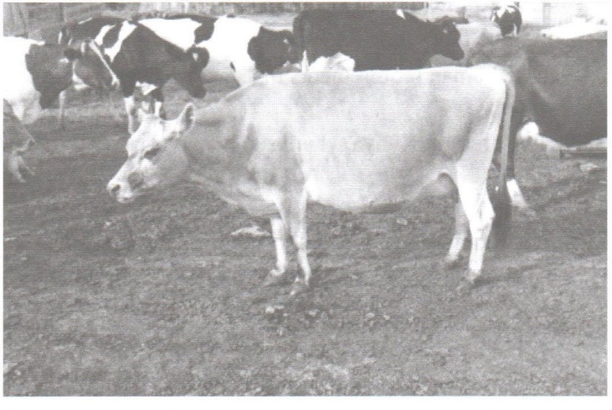
6. Study the photograph below and use it to answer question (a) and (b).

(a)Identify the type of photograph above.(1 mks)
Ground close-up photograph.
(b) (i) Identify the type of farming shown in the photograph .(1mk)
Dairy farming.
(ii) Name two main areas in Kenya where the type of farming identified in (i) above is practiced.(2mks)
-Thika
-Uasin Gishu
-Nakuru
-Trans-Nzoia

( C) Explain three human factors that influence the type of farming in the photograph in the Kenya highlands.(6mks)
-High population in the area offers ready market for milk and other dairy products/ provides labour.
-There are milk processing factories which help in milk processing/storage.
-Many parts of Kenya highlands has well served by road network which supports fast transport of milk to processing plants.
-Cooperative societies have been set up to market the dairy products.
-Provision of veterinary services that have helped to promote rearing of high quality breeds/treat the sick animals.
-Provision of extension officers to educate the farmers on cattle rearing.
(d)Explain five factors that favour horticulture in Kenya. (10mks)
-Diversified hot and wet climate that favours the growth of tropical crops while the cool and wet climate of the Kenya highlands encourages the growth of temperate crops.
-Lack of winter in Kenya favours the growth of horticultural crops all year round.
-Most parts of the country have well drained volcanic soils that are condusive for the growing horticultural crops.
-There is ready market , both locally and internationally.
-Capital is available to invest in horticultural farming in Kenya leading to its rapid development.
-The companies included the Thika, Oserian and Pan African Foods.
-There is technical and financial assistance from friendly countries like German.
-Most areas where horticultural crops are grown have good transport and communication network to both local and international markets.
(e)(i)Name two areas where horticulture is practiced in The Netherlands.(2mks)
-Limburg
-Venen district
-Rotterdam
-Guelderland province
-The Hague.
(ii)Give three difference between horticulture in Kenya and the Netherlands.(3mks)
Kenya | Netherlands
Fruits are grown in the open fields | Horticultural crops are grown in the open as well as in the greenhouses.
Market is less organised | Market procedures are more organized with auction marts.
More problems facing horticulture farming. | Less/ fewer problems facing horticulture farming.

7.(a) (i) What is agroforestry? (2mks)
-Is the deliberate growing of trees and crops/keeping of animals on the same piece of land.
(ii)Give four reasons why agroforestry is encouraged in Kenya (4mks)
-To ensure continuous supply of wood fuel/ to conserve forests.
-Provide raw materials for industries
-To conserve soil.
--To provide fruits for human consumption
To provide fodder for animals.
-Trees are a source of income to farmers when converted into timber.
-Trees act as windbreaker/ provide shade for young plants.
(b) Use the map of Kenya to answer questions (b) (i) and (ii).
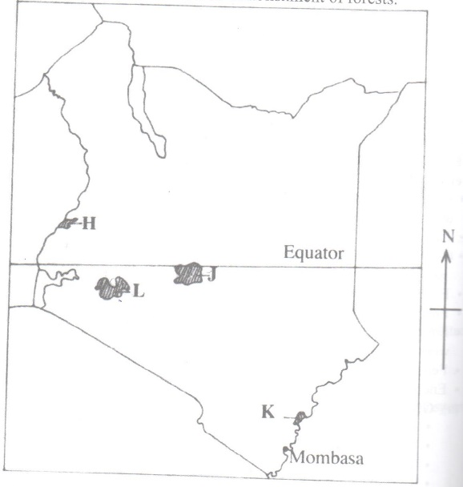

(i) Name the forest reserves marked H,J, and K. (3mks)
H- Mt. Elgon
J-Mt. Kenya
K- Arabuko Sokoke
(ii)Explain four factors that favour the growth of natural forests in the area marked L.(8mks)
-The area receives high rainfall ( over 1000mm-1500mm) per year which encourages the growth of trees.
-The area has deep, well drained volcanic soils that allow roots to penetrate deep into the ground.
-The area has moderate to high temperatures of about 14-20⁰C that allows for the growth of variety of trees.
-The area is a gazette forest hence settlement / cultivation is prohibited.
-Some areas are steep/ rugged and allow for forest growth..
-Enforcement of laws to allow re- establishment of forests.

(c)Explain four problems facing forestry in Kenya (8mks)
-Rapid increase in population has led to the destruction of large areas under forests.
-Illegal logging / indiscriminate cutting of trees has reduced/ depleted indigenous tree species.
-Attack by pests /diseases has led to destruction of valuable tree species.
-Some wild animals through debarking/ trampling and uprooting damages trees.
-At time , the government allocates land to private developers thus redcing the land under forests
-Prolonged drought leads to the dying up of some trees.
-Occurrence of forest fires has led to the destruction of large areas under trees.
8. (a) Describe the stages in the reclamation of land from the sea in the Netherlands.(6mks)
-Protective dykes/sea walls are constructed enclosing the part of the sea to be reclaimed.
-Ring canals are constructed.
-Pumping stations are installed to pump out sea water from the area enclosed by the dyke.
-Water is pumped out of the area enclosed by the dyke.
-Reeds are sown to help dry out the soil.
-Drainage ditches and more pumping stations are made on the land being reclaimed.
-Drainage pipes are laid below the soil.
-The area is divided into rectangular portions using inner dykes and ring canals.
-Soil treated with chemical to lower salinity.
-The drained land is flushed with fresh water to remove salt from the soil.
-Pumping out water from the polders is a continuous process to prevent water from accumulating.
(Students note: the sequence need to be followed).
(b) Explain four benefits of land reclamation in Netherlands.(8mks)
-Reclamation has created more land for agriculture/ settlement.
-Reclaimed land has improved agricultural output hence more food and more raw materials for industries.
-Land reclamation has resulted in improved fresh water supply for domestic, industrial and irrigation.
-Construction of dykes/walls around the polders has helped control floods/ sea invasion.
-Construction of dykes and canals has improved road transport network.
-Reclamation has created sceneries that have become tourists’ attractions and improved social amenities.
-Reclamation and associated activities have created more employment opportunities and improved the standard of living of citizens.
(C)(i) Explain three conditions that face irrigation farming in Kenya.(6mks)
-Gently sloping land which permits flow of water by gravity hence reducing the costs of pumping water to the fields.
-Presence of clay/back cotton soils which retain water for longer use by crops.
-Presence of rivers/reservoirs/ lakes which provide regular water supply/ permanent/constant making it possible to irrigate land throughout the year.
-High temperatures throughout the year which allows multiple cropping continuous farming activities throughout the year.
-Availability of large tracts of land make the project viable.
-Sparsely populated land reduces the costs of resettlement/provides land for large scale farming.
(ii) State five problems experienced in irrigation farming in Kenya,(5mks)
-Unreliable rainfall in the river catchment areas leading to fluctuating river volumes which reduces the amount of water available for irrigation.
-The constant moist conditions promote the breeding of pests. In the soil after irrigation encoura
-Flooding of the fields leads to sheet erosion.
-Leaching of nutrients from the topsoil occur when the water is seeping/percolating through ,leading to low yields.
-Stagnant water in the plots and canals encourage the breeding of snails and mosquitoes which spread bilharzia and malaria respectively.
-Increased moisture in the soil after irrigation encourages the growth of weeds.
-Soil accumulation in the canals is quite frequent. It is expensive to dredge such canals continuously.
Prices of fertilizers, tractors and insecticides are quite high .
-Fluctuations of the world prices due to competition affects the agricultural produces.

9.The map below shows some major fishing grounds in the world. Use it to answer question (a).
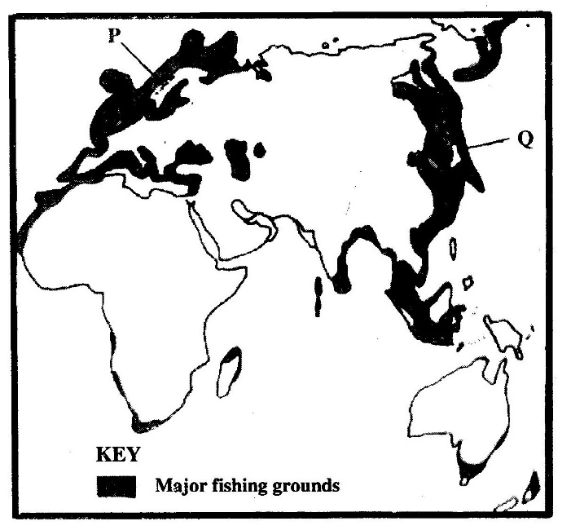

(a) (i) Name the countries marked P and Q.(2mks)
P-Norway
Q-Japan

(ii) Explain four conditions that favour fishing in the shaded coastal waters.(8mks)
-The are has cool waters which have abundant supply of planktons which is the main food for fish.
-The area has shallow continental shelves which allow light to penetrate to the sea below encouraging the growth of micro-organisms used as food by fish.
-The areas experience convergence of warm and cool currents which result in upwelling of ocean waters thus bringing minerals for fish and l from the sea bed to the surface.
-cool waters experiences in most of these coastal areas encourage thriving of numerous fish species.
-Most of the coast are indented/ have numerous sheltered bays which provide secure breeding grounds for fish.
-The sheltered bays provide suitable sites for building fishing ports/fish-landing sites.
-The large population in these area limits agricultural activities thus people turn to fishing as an alternative economic activity/cold climate also limit agriculture.
-Cold climate provides natural preservation of fish.

(b) The diagram below represent some fishing methods.

(i) Name methods R and S.(2mks)
R-Trawling
S-Basket fishing
(ii)Describe how each of the two methods are used in fishing.(7mks)

BASKET FISHING
-The basket funnel shaped to allow easy entry for fish.
-At the mouth there is a non-return valve which restricts the out ward/escape movement of fish once inside the basket it is held in position with ropes/stones/ sticks to prevent it from being swept downstream.
-The basket is left in that position for sometime/overnight then removed for landing the fish.
TRAWLING
-A bag-shaped net is attached to a ship-trawler.
-The nets mouth is kept open by otter boards/ head beam.
-The upper part of the net is kept a float by corks/floats.
-Weights are used to keep the lower parts of the net at the seabed.
-The trawler drags along the net.
-After sufficient fish is caught, the net is hauled to the trawler.
(c)Explain three measures used to conserve fish in Kenya.(6mks)
-Fishing is restricted to specific seasons to allow for breeding and maturing of fish.
-The size of the nets used in fishing are standardized to ensure that fingerlings are not caught.
-Licenses are issued to prospective fishermen to control their number and to ensure that there is no overfishing .
-The law of the sea restricts fishing I the exclusive economic zones/ this ensure the protection of marine fisheries from external exploitation.
-Fish farming is being encouraged to ensure that there is sufficient supply of fish from other than the natural fisheries
-There is restriction of the disposal of untreated waste into the sea /lakes/rivers to ensure that the water remain artificial fertilization is carried out in special hatcheries to sustain the supply of fish/ restocking of over fished waters.
10 .(a) (i)Distinguish between a game sanctuary and a national park. (2mks)
A game sanctuary is a specific area established to give protection to a specific animal community which is either threatened with extinction or only found in a particular area while a national park is a large area set aside for the propagation , protection and preservation of wildlife in their natural habitat and in which hunting is prohibited.

(ii) Draw a map of Kenya and on it mark and name Sibiloi National park, Maasai Game Reserve and Tsavo National park.(4mks).
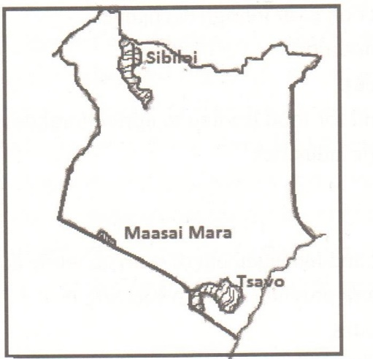

(b) (i) Give three factors that favour the establishment of the national Parks in the semi-arid areas of East Africa.(3mks)
-Availability of large tracts of sparsely populated land.
-Availability of a wide variety of vegetation which provides food for the wild animals.
-The harsh climatic conditions that discourage farming and settlement/ makes wildlife conservation the best alternative land use.
-The type of vegetation found in such areas provide suitable habitat for wild animals.
(ii) Explain two effects of drought on wildlife in Kenya. (4mks)
-It leads to shortage of pasture and water causing loss of life of animals and drying up of plant species.
-Prolonged drought leads to migration of animals to areas that have sufficient supply of food/water/some animals migrate to the neighbouring countries reducing the number of wild animals.
-Forest fires break out during drought causing environment degradation and destroying the habitat for wild animals.
-Wild animals invade farmlands destroying crops/some killed as they search for food.
( C )Explain four measures that the government of Kenya has taken to conserve wildlife other than establishing national parks and game reserves. (8mks)
-Enacting laws and regulations to curb poaching and game trade.
-Educating the general public on the need to conserve wildlife /to support conservation practices/encouraging joint ownership of parks with local authorities/ local communities who also benefit from the proceeds.
-Enhancing international cooperation to help enforce the existing laws and convections which protect wildlife especially the endangered species.
-promoting eco-tourism to reduce tourism related environment damage that may lead to extinction of wildlife species.
-Constructing electric fences around the parks to minimize human animal conflict.
-Establishing the ministry of wildlife to oversee the conservation process/ creating of the anti-poaching unit to track down and arrest poachers/ forest guards to protect forests.
-Encouraging individuals to set up game ranches for controlled/ hunting.
-Provision of veterinary services to treat animals/ translocation of game animals by law.
(d) State four ways in which wild animals are of significance to the economy of Kenya.(4mks)
-They create employment opportunities
-They are a major tourist attraction/ earn foreign exchange.
-They promote research activities
-Tourism creates a large demand for food leading to agricultural development.
-Some provide raw materials for industries
-They provide game meat .
-Government earns Revenue.

