SUNRISE EVALUATION EXAM 2021
Name: …………………………………….. Index No: ……………………Adm No………..

Candidate Signature: …………………… Date: ……………………Class…………...

312/1
GEOGRAPHY
Paper 1
September 2021
Time 2 hours 45 min.

Instructions to Candidates

- Answer all questions in section A.
- In section B, Answer question 6 and any other two questions from the remaining questions.
- Answer all questions using the answer booklet provided.
- Candidate should check that all pages are printed and no questions are missing.

For Examination use only.

 | Maximum Score | Candidate Score
Section A. | 25
Question 6 | 25
Question 7 | 25
Question 8 | 25
Question 9 | 25
Question 10 | 25
TOTAL | 100%
SECTION A
Answer all questions in this section
- (a) What is geography? (2marks)
………………………………………………………………………………………………………………………………………………………………………………………………………………………………
(b) Give three proofs that the earth is almost spherical in shape. (3marks)
………………………………………………………………………………………………………………………………………………………………………………………………………………………………
………………………………………………………………………………………………………………………………………………………………………………………………………………………………
………………………………………………………………………………………………………………………………………………………………………………………………………………………………
- (a) Differentiate between weathering and mass wasting. (2 marks)
………………………………………………………………………………………………………………………………………………………………………………………………………………………………
………………………………………………………………………………………………………………………………………………………………………………………………………………………………
(b) State three causes of landslides. (3 marks)
………………………………………………………………………………………………………………………………………………………………………………………………………………………………
………………………………………………………………………………………………………………
- Describe the formation of planet earth according to the passing star theory. (5 marks)
………………………………………………………………………………………………………………………………………………………………………………………………………………………………
………………………………………………………………………………………………………………………………………………………………………………………………………………………………
………………………………………………………………………………………………………………………………………………………………………………………………………………………………………………………………………………………………………………………………………………

- The diagram below shows a coastal landform.
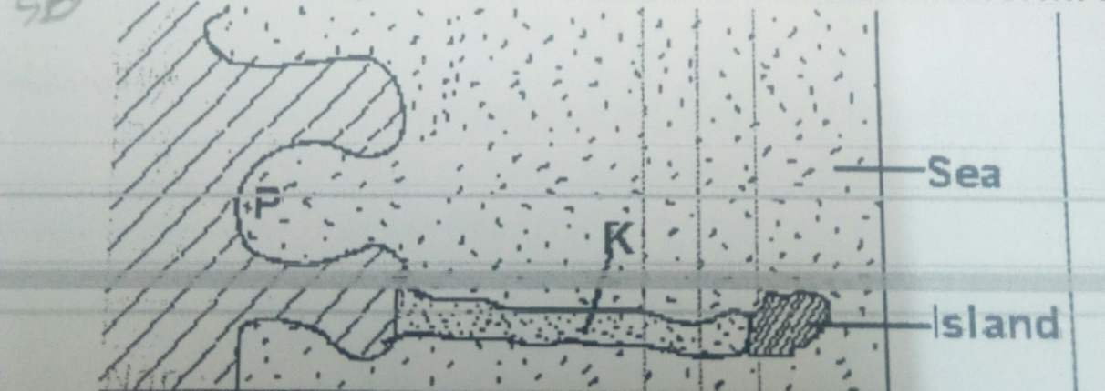
(a) Name the features marked P and K. (2marks)
P……………………………………………………………………………………………………K……………………………………………………………………………………………………
(b) List down three types of ocean tides. (3marks)
………………………………………………………………………………………………………………………………………………………………………………………………………………………………
………………………………………………………………………………………………………………
- (a) Name the types of earth movements that occur within the earth’s crust. (2marks)
………………………………………………………………………………………………………………………………………………………………………………………………………………………………
(b) Describe the origin of continents according to the theory of continental drift. (3marks)
………………………………………………………………………………………………………………………………………………………………………………………………………………………………
………………………………………………………………………………………………………………………………………………………………………………………………………………………………
………………………………………………………………………………………………………………………………………………………………………………………………………………………………
………………………………………………………………………………………………………………………………………………………………………………………………………………………………
………………………………………………………………………………………………………………………………………………………………………………………………………………………………
………………………………………………………………………………………………………………………………………………………………………………………………………………………………
SECTION B
Answer question 6 and any other two questions in this section
- Study the map of Yimbo (East Africa 1:50,000) to answer questions that follow.
(a) (i) what is the sheet title (1 mark)
……………………………………………………………….
(ii) Find the magnetic declination of the map in January 1965. (2 marks)

(b) (i) Find the distance in kilometers of loose surface road c506 from port southby through
the junction to where it ends at Kerebi. (2 marks)
……………………………………………………………….
(ii) Find the area of Busia district (in kilometer square) to the northwestern part of the
map. (2 marks)

(c) Draw a rectangle 9 cm by 10 cm to represent the area north of northing 90 and east
of easting 30. On it mark and label
- River Yala
- Road c501/2
- Maranda school (5 marks)

(d) Describe the drainage of the area covered by the map (5 marks)
………………………………………………………………………………………………………………………………………………………………………………………………………………………………
………………………………………………………………………………………………………………………………………………………………………………………………………………………………
………………………………………………………………………………………………………………………………………………………………………………………………………………………………

(e) Students of Maranda school wanted to do a field study on vegetation on the area covered
by the map.
- Identify two means of transport they are likely to use. ( 2 marks)
………………………………………………………………………………………………………………………………………………………………………………………………………………………………
- Name three types of vegetation they are likely to identify (3 marks)
………………………………………………………………………………………………………………………………………………………………………………………………………………………………
………………………………………………………………………………………………………………
- State three preparations they could make. (3 marks)
………………………………………………………………………………………………………………………………………………………………………………………………………………………………
………………………………………………………………………………………………………………
- Identify two problems they are likely to encounter. (2 marks)
………………………………………………………………………………………………………………………………………………………………………………………………………………………………
- (a) Name two instruments kept in a Stevenson screen. (2 marks)
………………………………………………………………………………………………………………………………………………………………………………………………………………………………
(b) The diagram below shows a weather measuring instrument. Use it to answer
the questions below.
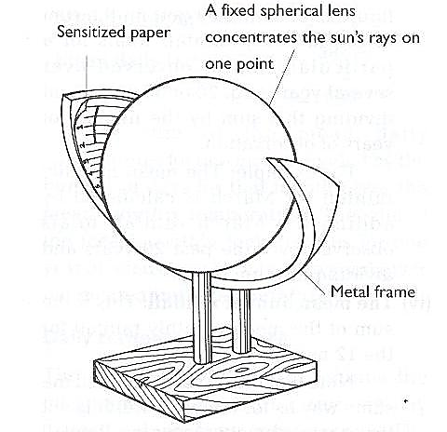

Metal frame
M
N

- Name the parts marked M and N. (2 marks)
M………………………………………………………………………………………………………N………………………………………………………………………………………………………
- Describe how the instrument works. (4 marks)
………………………………………………………………………………………………………………………………………………………………………………………………………………………………
………………………………………………………………………………………………………………
(c) The table below shows climatic figure for station Q. Use it to answer the questions
that follow.
Months | J | F | M | A | M | J | J | A | S | O | N | D
Temp in ⁰C | 30 | 31 | 31 | 29 | 27 | 27 | 28 | 29 | 28 | 28 | 27 | 30
Rainfall in mm | 257 | 246 | 231 | 234 | 207 | 201 | 218 | 227 | 234 | 240 | 235 | 230

(i) Calculate the annual range of temperature for station Q. (2 marks)

(ii) Give four characteristics of climate for station Q. (4 marks)
………………………………………………………………………………………………………………………………………………………………………………………………………………………………
………………………………………………………………………………………………………………
………………………………………………………………………………………………………………
(d) With the aid of a well-labelled diagram, describe the formation of cyclonic rainfall.(6 marks)

(e) You intend to carry out a field study of a weather station in your school.
(i) Give two methods of recording data that you are likely to use. (2 marks)
………………………………………………………………………………………………………………………………………………………………………………………………………………………………
(ii) State three reasons why the recording of data at a school weather station may be
inaccurate. (3 marks)
………………………………………………………………………………………………………………………………………………………………………………………………………………………………
………………………………………………………………………………………………………………
- (a) Name three types of faults: (3 marks)
………………………………………………………………………………………………………………………………………………………………………………………………………………………………
………………………………………………………………………………………………………………
(b) (i) With the aid of well labeled diagrams explain how compressional forces can lead to
the formation of a rift valley. (7 marks)

(ii) Give two examples of Horst Mountains in east Africa: (2 marks)
………………………………………………………………………………………………………………………………………………………………………………………………………………………………
(c) Describe two ways in which faulting may influence drainage systems. (4 marks)
………………………………………………………………………………………………………………………………………………………………………………………………………………………………
………………………………………………………………………………………………………………
………………………………………………………………………………………………………………
(d) A part from the Rift Valley name two other relief features that were formed
as result of faulting. (3 marks)
………………………………………………………………………………………………………………………………………………………………………………………………………………………………
………………………………………………………………………………………………………………
………………………………………………………………………………………………………………
(e) Explain three ways in which features resulting from faulting are of economic importance: (6 marks)
………………………………………………………………………………………………………………………………………………………………………………………………………………………………
………………………………………………………………………………………………………………
………………………………………………………………………………………………………………
………………………………………………………………………………………………………………………………………………………………………………………………………………………………
………………………………………………………………………………………………………………
- (a)(i) What is a lake? (2marks)
………………………………………………………………………………………………………………………………………………………………………………………………………………………………
(ii) Name three ways through which lakes are formed. (3marks)
………………………………………………………………………………………………………………………………………………………………………………………………………………………………
………………………………………………………………………………………………………………
………………………………………………………………………………………………………………
(iii) List three sources of Lake Water. (3marks)
………………………………………………………………………………………………………………………………………………………………………………………………………………………………
………………………………………………………………………………………………………………
(b) Describe how L. Victoria was formed. (4marks)
………………………………………………………………………………………………………………………………………………………………………………………………………………………………
………………………………………………………………………………………………………………
………………………………………………………………………………………………………………
………………………………………………………………………………………………………………
(c) Explain two reasons why some Lakes in the Rift Valley have fresh water. (4marks)
………………………………………………………………………………………………………………………………………………………………………………………………………………………………
………………………………………………………………………………………………………………
……………………………………………………………………………………………………………..
(d) State three economic significance of Lakes. (3marks)
………………………………………………………………………………………………………………………………………………………………………………………………………………………………
………………………………………………………………………………………………………………
………………………………………………………………………………………………………………

(e) Students from your school intends to carry out a field study on Lakes.
(i) State two objective for their study. (2marks)
………………………………………………………………………………………………………………………………………………………………………………………………………………
………………………………………………………………………………………………………
(ii) Identify two methods they will use to record the data collected. 2marks)
………………………………………………………………………………………………………………………………………………………………………………………………………………

(iii) Which human activity might they have found to be affecting the Lakes? (2marks)
………………………………………………………………………………………………………………………………………………………………………………………………………………
………………………………………………………………………………………………………
………………………………………………………………………………………………………

- (a) Describe plucking as a process in glacial erosion. (4 marks)
………………………………………………………………………………………………………………………………………………………………………………………………………………………………
………………………………………………………………………………………………………………
………………………………………………………………………………………………………………
………………………………………………………………………………………………………………………………………………………………………………………………………………………………
………………………………………………………………………………………………………………
………………………………………………………………………………………………………………

(b) Explain three conditions that lead to glacial deposition. (6 marks)
………………………………………………………………………………………………………………………………………………………………………………………………………………………………
………………………………………………………………………………………………………………
………………………………………………………………………………………………………………
………………………………………………………………………………………………………………………………………………………………………………………………………………………………
………………………………………………………………………………………………………………
……………………………………………………………………………………………………………

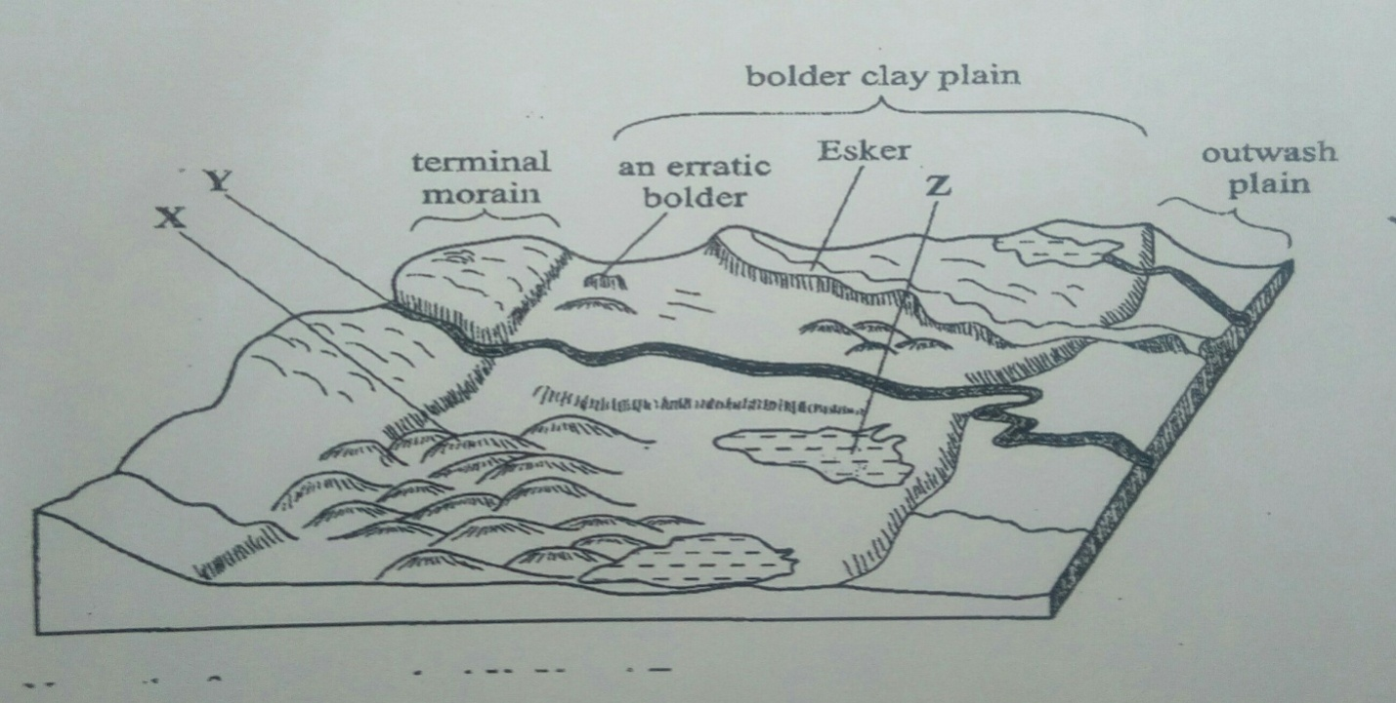
(c) The diagram below shows features resulting from glacial deposition in a lowland area.

(i) Name the features marked X, Y, and Z. (3 marks)
X……………………………………………………………………………………………………………Y…………………………………………………………………………………………………………
Z……………………………………………………………………………………………………………
(ii) Describe how terminal moraine is formed. (4 Marks)
………………………………………………………………………………………………………………………………………………………………………………………………………………………………
………………………………………………………………………………………………………………
(d) Explain four positive effects of glaciation in low land area. (8 marks)
………………………………………………………………………………………………………………………………………………………………………………………………………………………………
………………………………………………………………………………………………………………
………………………………………………………………………………………………………………
………………………………………………………………………………………………………………
………………………………………………………………………………………………………………

