WILDLIFE.
1. Use the map of East Africa below to answer question (a) (i)
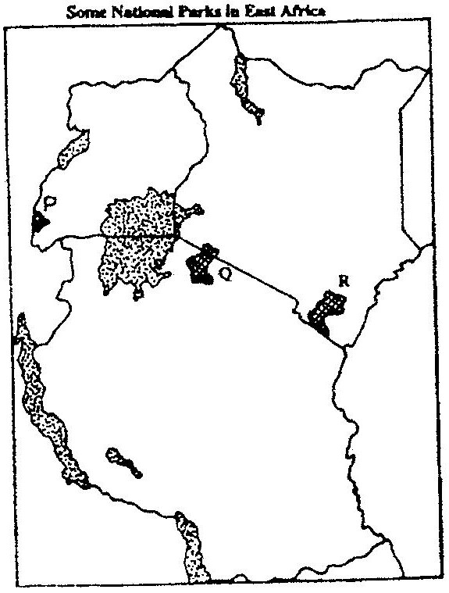

Name the national parks marked P, Q and R. 3 mks
2. Give FOUR reasons why wildlife conservation is encouraged in Kenya. 4 mks
3. State three reasons why National Parks have been established in Kenya. 3 mks
4. (a) Differentiate between game reserves and game parks. 4 mks
(b) State four steps taken by Kenyan government to promote wildlife resources. 4 mks
5. Explain three ways in which human activities are a threat to wildlife. 6 mks
6. What is wildlife? 2 mks
7. State five reasons for the need to conserve wildlife? 5 mks
8. State three types of wildlife one may find at I, Nakuru. 3 mks
9. Explain four problems the government of Kenya faces in efforts to conserve wildlife? 8 mks
10. State human factors that affect existence of wildlife. 5 mks
11. State ways in which government of Kenya can strengthen anti poaching unit.
12. (a) Define:
(i) Wildlife
(ii) Tourism 4 mks
(b) Distinguish between Same Reserves, National Parks and Sanctuaries.
(c) State five significance of wildlife in East Africa. 5 mks
13. (a) Discuss the problems facing wildlife in East Africa. 5 mks
(b) Explain the measures taken to manage and conserve wildlife in East Africa 6 mks

