WEATHER
1. (a) How does a sea breeze occur? ( 2 mks)
(b) Use the map of Africa below to answer questions (b) (i)
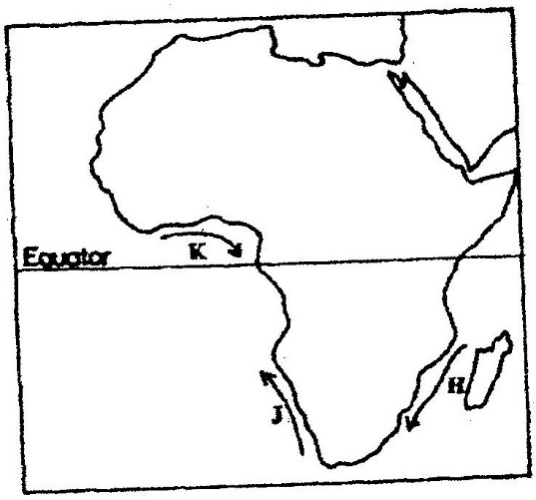

(i) Name the ocean currents marked H, J, and K (3 mks)
(ii) State two effects of a warm ocean current on the adjacent
coastlands (2 mks)
2. (a) Name two theories of the origin of the earth (2 mks)
(b) Name four layers of the earth’s atmosphere (4 mks)
3. (a) State two conditions that are necessary for the formation of fog.
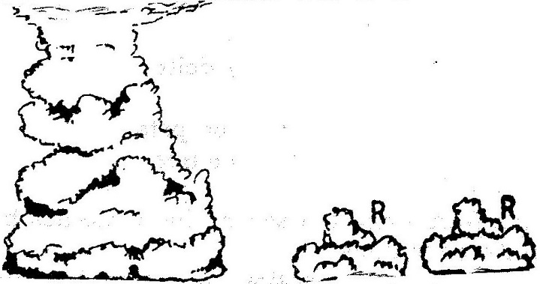
(b) The diagram below shows some types of clouds. Use it to answer the questions that follow.

(i) Name the clouds marked R

(ii) Give two weather conditions associated with cumulonimbus clouds
4. a) the tables below represent rainfall and temperature of stations X and Y.
Use them to answer questions (a) and (b)
MONTHS | J | F | M | A | M | J | J | A | S | O | N | D
TEMPERATURE IN ^{0c} | 30 | 31 | 31 | 31 | 30 | 29 | 29 | 28 | 28 | 29 | 29 | 30
RAINFALL IN MM | 250 | 250 | 325 | 300 | 213 | 25 | 25 | 25 | 100 | 275 | 380 | 200

MONTHS | J | F | M | A | M | J | J | A | S | O | N | O
TEMPERATURE IN ⁰C | 21 | 20 | 20 | 17 | 15 | 13 | 12 | 13 | 15 | 16 | 18 | 20
RAINFALL IN MM | 12 | 12 | 15 | 50 | 90 | 110 | 87 | 87 | 50 | 35 | 20 | 15

a) (i) For each of the two stations calculate the mean annual temperature.
X -
Y -
(ii) Calculate the annual rainfall for station Y
(iii) On the graph paper provided, draw a bar graph to represent rainfall for station x. Use vertical scale of 1cm to represent 50mm
b) Describe the climatic characteristics of station Y.
5. a) The table below shows climatic data of a station in Kenya.
Use it to answer question (a)

Month | Jan | Feb | Mar | April | May | June | Jul | Aug | Sep | Oct | Nov | Dec
Temp in ºC | 28.9 | 29.7 | 30.3 | 29.9 | 29.7 | 29.2 | 28.4 | 28.7 | 29.6 | 30.1 | 29.2 | 28.7
Rainfall in mm | 9.0 | 8.0 | 21.0 | 49.0 | 25.0 | 9.0 | 20.0 | 10.0 | 4.0 | 10.0 | 17.0 | 11.0

- What is the annual range of temperature at the station?
- Calculate the total rainfall for the station.
b) State three factors that influence climate.
6. (a) Name two elements of weather that can be recorded at a school weather
station
(b) Give three reasons why the recording of data at a school weather station
may be inaccurate

7. (a) Describe a suitable site where you would locate a weather station in your
School (2 mks)
(b) Give reasons why a Stevenson’s screen is:
(i) Painted White (2 mks)
(ii) Has louvers (2 mks)
8. Define relative humidity. (2 mks)
9. (a) Identify four characteristics of convectional rainfall. (4mks)
(b) State the difference between radiation fog and advection fog. (4mks)
10. (a) Briefly describe how the six thermometers operate. (5mks)
(b) Three ways in which clouds are classified. (3mks)
11. (a) Give three precautions to be taken when citing a weather station. (3mks)
(b) State three factors determining the amount of solar radiation reaching the earth's surface. (3mks)
12. Define the following terms:
(i) Climate
(ii) Relative humidity
(iii) Weather forecasting
(iv) Absolute humidity
(v) Weather lore (5mks)
13. State the advantages of studying weather through field work. (5mks)
14. (a) Describe how you would use the following apparatus during a field study.
Rainfall, maximum and minimum thermometers. (3mks)
(b) Identify and explain the formation of the type of rainfall found in the Lake Region or Kenya. (8mks)
(c) Briefly write down two problems associated with the type rainfall above.
(4mks)
15. (a) What is weather forecasting? (2mks)
(b) List four problems of weather forecasting. (4mks)
(c) State four ways in which weather forecasting is important to the human activities. (4mks)
16. (a) Explain three ways in which clouds influence weather. (3mks)
(b) Use the data below to answer questions that follow.
Month of the year | J | F | M | A | M | J | J | A | S | O | N | D
Temp in °C | 25 | 26 | 26 | 24 | 23 | 22 | 21 | 21 | 22 | 22 | 22 | 22
Rainfall in mm | 42 | 40 | 73 | 171 | 90 | 89 | 163 | 160 | 71 | 68 | 64 | 42
(i) Calculate mean annual temperature
(ii) Calculate annual rainfall
(iii) Calculate annual range of temperature.
(iv) Calculate the mean annual rainfall
(v) Which is the wettest month? (10 mks)
17. (a) Define 3 air mass. (2mks)
(b) Name types of air masses. (3mks)
(c) A mass of air at 15°C can hold 20gm/cm3 of moisture. The same air at the same temperature has 6gm/cm³ of moisture. What is its relative humidity?
(4mks)
18. Name two instruments placed in the Stevenson Screen. (2mks)
19. Why does sea breeze flow at night time? (3mks)

