THE HYDROLOGICAL CYCLE
1. (a) The diagram below shows the hydrological cycle. Name the stages marked
E, F, and G (3mks)
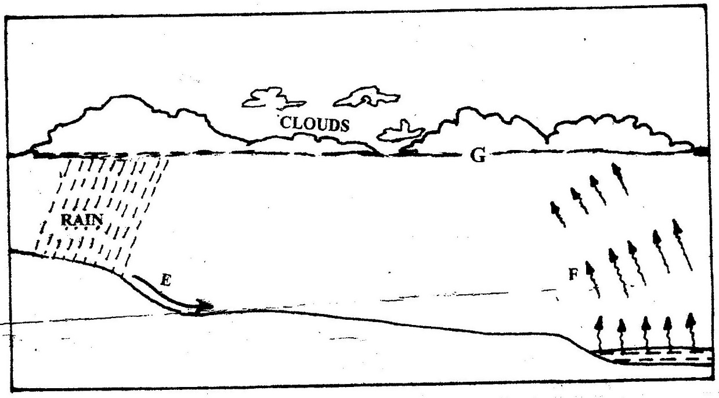

(b) Differentiate between watershed and a catchments area (2mks)
2. State four factors that determine the amount of surface run-off.
3. What is hydrological cycle? (2mks)
4. Explain factors that influence percolation of voter. (8mks)
5. (a) What is cyrosphere? (2mks)
(b) Name the significance of hydrological cycle. (4mks)
6. List other forms of precipitation other than rainfall that may also form major inputs into the system. (4mks)
7. What factors can influence surface run off or overland flow. (5mks)
8. In what ways can we sustain the process of the hydrological cycle? (8mks)

