INTERNAL LAND FORMING PROCESSES – FAULTING
1. a) A part from the Rift Valley name two other relief features that were
formed as result of faulting. (2mks)
b) With the aid of a well labeled diagram, describe how a Rift Valley is
formed by tensional forces. (8mks)
2. The diagram below represents features produced by faulting.
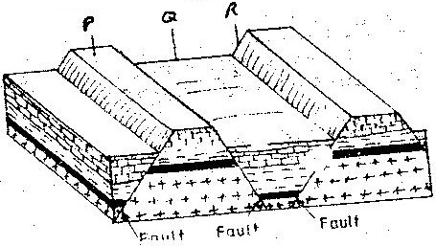
Use it to answer questions that follow.

- Name the features marked P, Q, and R
- Differentiate between a normal faulty and a reverse fault.
3. State ways in which faulting influences drainage. (3mks)
4. Name two examples of Horst Mountains in East Africa. (2mks)
5. Explain two ways in which features resulting from faulting are of economic importance (4mks)
6. (a) (i) With aid of diagrams outline formation of rift valley by tension
theory. (5mks)
(b) Students are planning to carry out field study of an area affected by
faulting.
(i) State four importance of having a pre-visit of the area.
(ii) Give three disadvantages of using observation to study such an
area.
7. Name three types of fault. (3mks)
8. Explain how compressional forces lead to formation of rift valley. (5mks)
9. Give two of escarpments in East Africa. (2mks)
10. Explain ways in which features resulting from faulting are of importance. (8mks)
11. Describe formation of fault steps with aid of diagrams. (6mks)

