INTERNAL LAND FORMING PROCESSES - FAULTING
1. a) Fault scarp
Tilt block
Block/horst mountain
b)
- Faulting disrupts lines of transport and communication
- Some features like Rift Valley form barriers which make establishment of transport and communication expensive.
- Faulting cause sinking of land which leads to destruction of property such as buildings and crops.
- Leads to formation of depressions which are filled with water to form lakes
- Unique features are formed which attracts tourists.
- Faulting exposes minerals making exploitation easier.
- Makes rivers to have waterfalls.
2 a) P- Horst
Q- Rift valley
R- Escarpment
b) Normal fault is fault resulting from tension in inclined place with
inclination of fault plane and direction of downthrow on same side while reversed fault is fault that results from compression forces where the one block is pushed upwards in relation to another forming up throw.
3. - Vertical faulting, across a river may cause waterfall/river rejuvenation.
- Rift faulting in an enclosed area may lead to formation of a depression which can be filled with water for form a lake.
- Some rivers flow along fault lines/fault guided drainage
- Uplifting of landscape which may cause reversal of direction of river flow
- Rivers may disappear to the ground through a fault line.
4. Pare, Usambara, Ruwenzori, Nyandarua and Mau Ranges.
5. - Block/ horst mountains are a source of rivers which provide water for
industrial/ agriculture/domestic use.
- Rift Valley formation has led to exposure of minerals such as diatomite, soda ash which are mined on rift valley.
- Mountains formed are barrier to moisture carrying wind leading to orographic rainfall which favours agriculture and settlement.
- Some Rift valley lakes are important fishing grounds/mining sites/provide water for irrigation
- Faulted features provide beautiful scenery which promotes tourism.
6. a) Layers of rocks are subjected to tensional forces.
Two normal fault develop
Middle block subsides between two side block
Middle part form depression called rift valley enclosed by escarpment

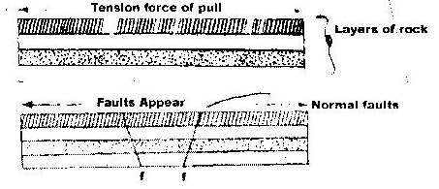

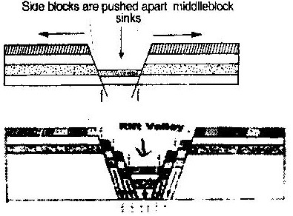

b) i) The importance of pre-visit
- To enable them to draw up study objectives hypothesis.
- To familiarize themselves with themselves with area of study/identify problems.
- To enable them prepare a work schedule plan of activities.
- To enable them identify/sort out relevant tools/ equipments for the study.
- To identify suitable methods of data collection.
- To seek permission from the occupants of the site of study.
- To enable them prepare financial requirements.
ii) Disadvantages of direct observation of the area.
- It is expensive
- It is time consuming
- It is tiresome
- It is limited to only direct sources/primary sources of data.
- It only suitable to sighted people
- Some features may be hidden out of view.

7.
- Normal fault
- Reverse fault
- Tear fault
- Anticlinal fault
- Thrust fault

8.
- Compression force tends to push rocks together.
- Lines of weakness develop and lead to formation of parallel reversed faults on the crustal rocks.
- Further compression thrust side blocks over middle block leaving it to form rift valley floor.
9.
- Nyandarua Range
- Lake Manyara escarpment.
- Nyando escarpment
10.
- Rift valley provides a spectacular scenery that attracts tourists earning foreign
- Mining of soda ash in rift valley generate export earnings
- Rift valley floor has fertile soils suitable for farming
- Rift valley lakes are suitable for fishing grounds.

