**CHOGORIA MURUGI ZONE**

**232/2**

**PHYSICS**

**PAPER 2**

**MARKING SCHEME**

1.

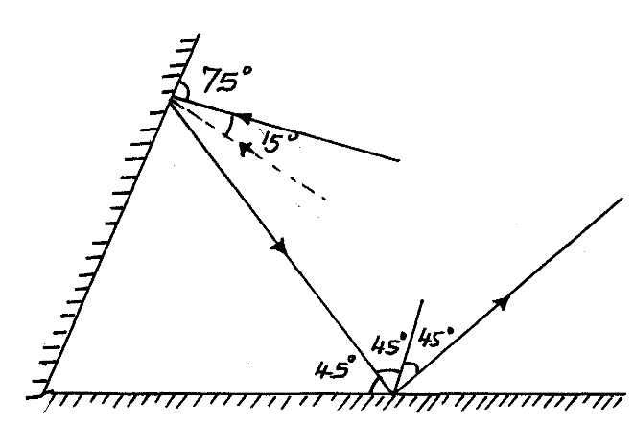

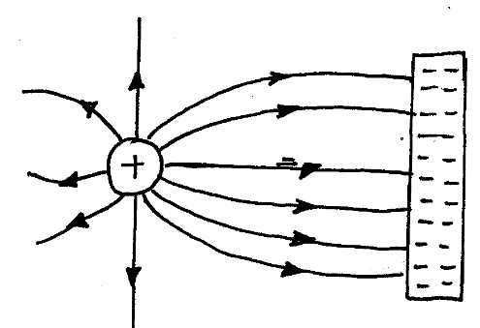

2.

3. They acquire North poles at the ends thus they repel.

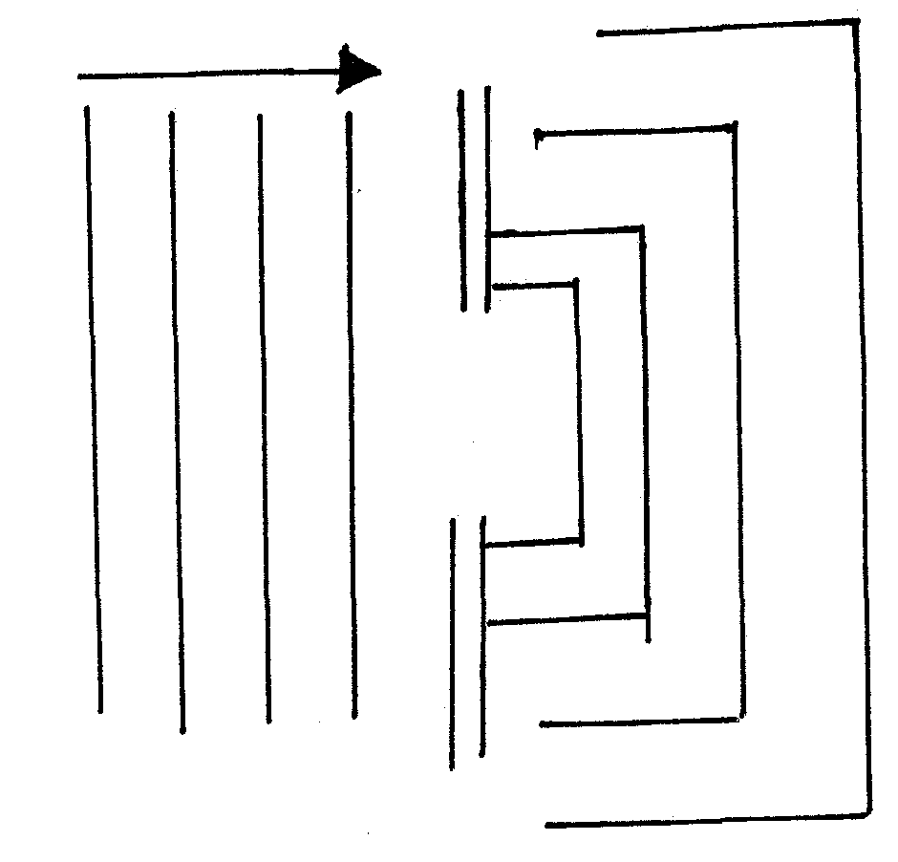4. i) 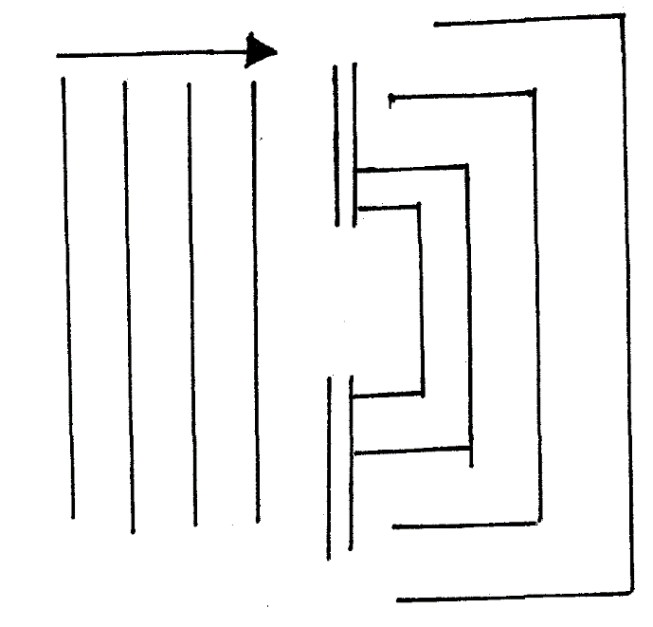

ii)

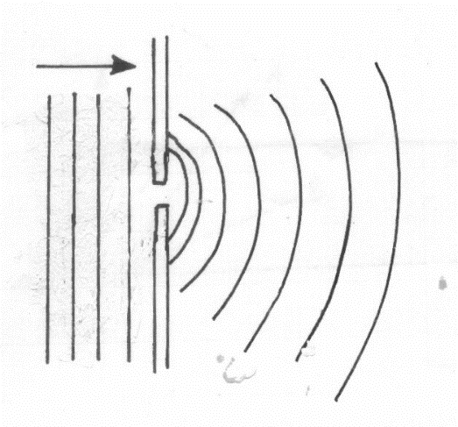

5. Light energy to electrical energy

6. i) Microwaves, infrared, visible light, x – rays

ii) - Observing objects

- Taking pictures

7. Alkaline - Produces higher current

- Lasts longer

- It is portable

- Less maintenance & care



9. Separation of colours of light from white light.

10 I = V/R

= 2/6 = 1/3

= 0.33A



12. - Distance between the plates

- Area of plates

- Dielectric material used

**SECTION B**

13. a) For an atomic conductor p.d across the ends is directly proportional to current

if temperature and other constants kept constant ;

b) i)

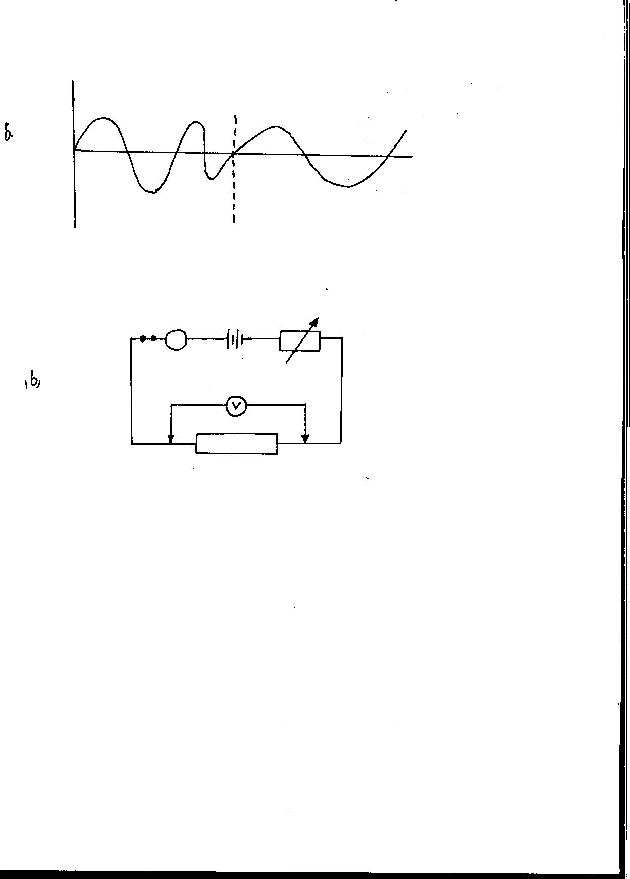

Ammeter in series ;

Voltmeter in parallel

Variable resistor in series

(apparatus must be workable)

ii) - Connect the apparatus as shown

- Vary variable resistor such that I is certain value ;

- Record I in ammeter and V in Voltmeter ;

- Draw graph of V against I ;

c) Parallel I = 1 + 1 + 1

R 6 4 8

1= 2+3+4

R 12

I = 9

R 12

R = 4=l 1/3Ω

R1 = 4+11/3

= 51/3Ω

(ii)V=IR

I = V/R=4.5/5.33

= 0.844A

=3.377V

14. (i) Time taken for n number of claps. The claps should concide with the echos;

The distance between the civil and walls;

(ii) Sound has to travel to the walls and reflected back to the coil

Distance travelled is 2d;

For n claps there will be n echo’s;

Total distance travelled = n x 2d

2nd;

Speed of sound 

(iii) 200m;

10m is short distance and timing will be inaccurate;

500m is too long for sound to travel through and be reflected back. Energy will have been lost along the way;

(iv)



b) (i) Destructive and constructive interference

(ii) Maximum amplitude or horizontal line

(iii) Loud sound all through

15. (a) (i) Light must travel from denser medium to less dense medium.

Angle of incidence in the denser medium must be greater than critical angle in the less dense medium.

(b) (i) sini =n

sin r

sin30°= 1.618

sin 18°

n = 1.618

(ii) sin C=1

n

sin C = 1

1.6 18

C=sin-1 0.61804

C = 38.17°

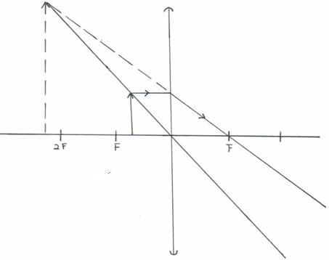16. (i)

(ii) As a magnifying glass.

(c)

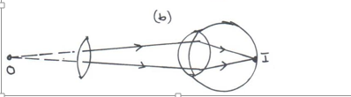

(d) (i)  

 🗸¹





V = 6.67cm 🗸¹

(ii) 

🗸¹



= 7.00cm 🗸¹

(iii) 

= 0.667cm 🗸¹

1. (a) State the Lenz’s law of electromagnetic induction. (1 mark)

The direction of induced e.m.f is such that the induced current that it causes to flow produces a magnetic effect which opposes the charge producing it√

(b) A bar magnet is moved into a coil of an insulated copper wire connected to a zero

centre galvanometer as shown below

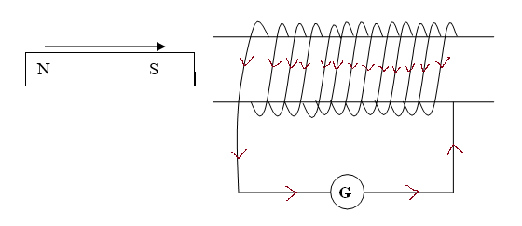

1. Show on the figure above the direction of the induced current in the coil (1 mark)
2. State and explain what is observed on the galvanometer when the south pole of the magnet is moved into and then withdrawn from the coil. (2 marks)

The pointer deflects in one direction and comes back to zero. √When magnetic fields cut through the conductor, emf is induced which makes the current to flow and the pointer deflect but comes back to zero when there is no relative motion between the coil and the magnet√

(c) A transformer has 800 turns in the primary and 40 turns in the secondary winding.

The alternating voltage connected to the primary is 240V and current of 0.5.A. If 10% of the power is dissipated as heat within the transformer, determine the current in the secondary coil.

(3 marks)

$$\frac{N_{G}}{N_{P}}=\frac{V_{S}}{V_{P}}$$

$\frac{40}{800}$**= $\frac{V_{S}}{240}$ √**

$V_{S}$**= $\frac{40+240}{800}$ = 12V**

$\frac{V_{S}I_{S}}{V_{P}I_{P}}$**× 100 = 90√**

$I_{S}$**= $\frac{0.9 ×240 ×0.5}{12}$ = 9 A√**