CHOGORIA -MURUGI JOINT EXAMINATION

32/2
PHYSICS
Paper 2
(Theory)
2023
2 Hours
Kenya Certificate of Secondary Education (K.C.S.E)
232/2
PHYSICS
Paper 2
(Theory)
2023
2 Hours

Name………………………………………………………. Adm No……………….
Stream……………………………………………………. Date ………………………….
Sign ..............................................................................

Instructions to Candidates

- Write your name and index number in the spaces provided above.
- Sign and write the date of the examination in the spaces provided above
- This paper consists of two sections A and B.
- Answer all the questions in section A and B in the spaces provided
- All working MUST be clearly shown in the spaces provided in this booklet.
- Non programmable silent electronic calculators and KNEC mathematical tables may be used except where stated otherwise.
Take: Speed of light in vacuum C = 3.0 x 10⁸m/s
Acceleration due to gravity g = 10N/S²

FOR EXAMINER’S USE ONLY

Section | Question (s) | Max. Score | Candidates Score
A | 1 – 12 | 25
B | 13 | 12
 | 14 | 8
 | 15 | 11
 | 16 | 12
 | 17 | 12
 | Total | 80
This paper consists of 12 printed pages. Candidates should check the question
paper to ensure that all the pages are printed as indicated and no questions are missing

SECTION A (25 MARKS)
Answer all the questions in the spaces provided.
1. Figure 1 below shows a ray of light incident to the first of the two mirrors placed at an angle of 60⁰
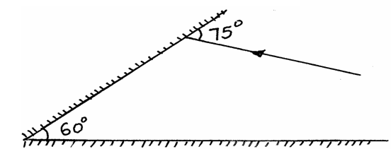fig 1

Complete the path of the ray after reflection from the mirrors. (1mk)
2. Figure 2 below shows a positive charge near a plate carrying negative charge.
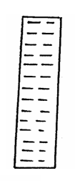fig 2
+

Draw the electric field between them. (2mks)
3. Two pins are hanging from a magnet as shown in the diagram below (figure 3)
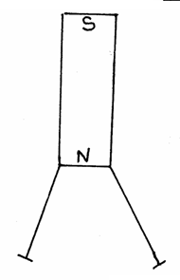fig 3
Explain why they do not hang vertically downwards. (2mks)
……………………………………………………………………………………………………
…………………………………………………………………………………………………….

4. Draw the diagrams to illustrate what happens when plane waves are incident on a slit.
i) When the width of the slit is large compared with the wavelengths of the waves. (2mks)

ii) When the width of the slit is small compared with wavelength of the waves. (2mks)

5. What energy conversion occurs in a photocell? (1mk)
……………………………………………………………………………………………………
6. i) Arrange the following waves in order of decreasing wavelength; infrared, X-rays, micro-waves
and visible light (1mk)
……………………………………………………………………………………………………
ii) State one application of visible light. (1mk)
……………………………………………………………………………………………………
7. State two advantages of an alkaline battery over lead acid battery. (2mks)
……………………………………………………………………………………………………
……………………………………………………………………………………………………
8. A girl shouts and ears an echo after 0.6 seconds later from a cliff. If velocity of sound is 330m/s, calculate the distance between her and the cliff. (3mks)

9. What is dispersion of light? (1mk)
……………………………………………………………………………………………………
…………………………………………………………………………………………………….

10. Determine the reading of an ammeter in figure 4 below (2mks)
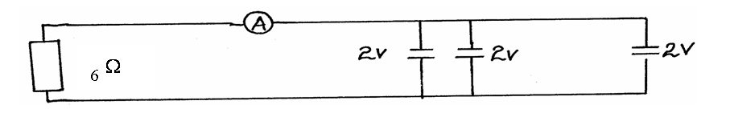fig 4

11. A ray of light is incident on a glass oil interface as shown in figure 5 below. Determine the value of r (Take refractive index of glass and oil as 3/2 and 6/3 respectively) (3mks)
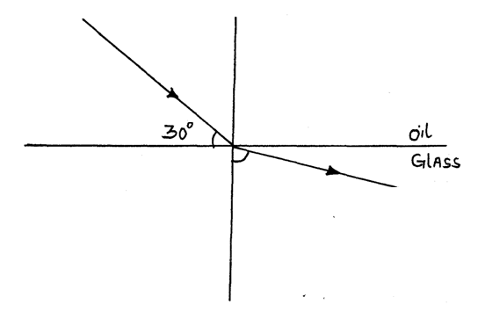fig 5
r
12. State two factors that affect the capacitance of a parallel plate capacitors. (2mks)
……………………………………………………………………………………………………
……………………………………………………………………………………………………
…………………………………………………………………………………………………….
…………………………………………………………………………………………………….

SECTION B (55 MARKS)

13. (a) State Ohm’s law. (1 mark)
……………………………………………………………………………………………………
……………………………………………………………………………………………………
…………………………………………………………………………………………………….
…………………………………………………………………………………………………….
(b) You are provided with the following apparatus:
- Connecting wires
- An ammeter
- Fixed resistor
- A voltmeter
- A variable resistor
- Switch
- 2 dry cells in a cell holder

(i) In the spaces below, draw the circuit that can be used using the apparatus above to verify Ohm’s Law. (3 marks)

(ii) Briefly explain how you can obtain the results to verify Ohm’s law. (4 marks)

……………………………………………………………………………………………………
……………………………………………………………………………………………………
…………………………………………………………………………………………………….
…………………………………………………………………………………………………….
……………………………………………………………………………………………………
……………………………………………………………………………………………………
…………………………………………………………………………………………………….
…………………………………………………………………………………………………….
(c)Study the circuit diagram below and answer the questions that follow.
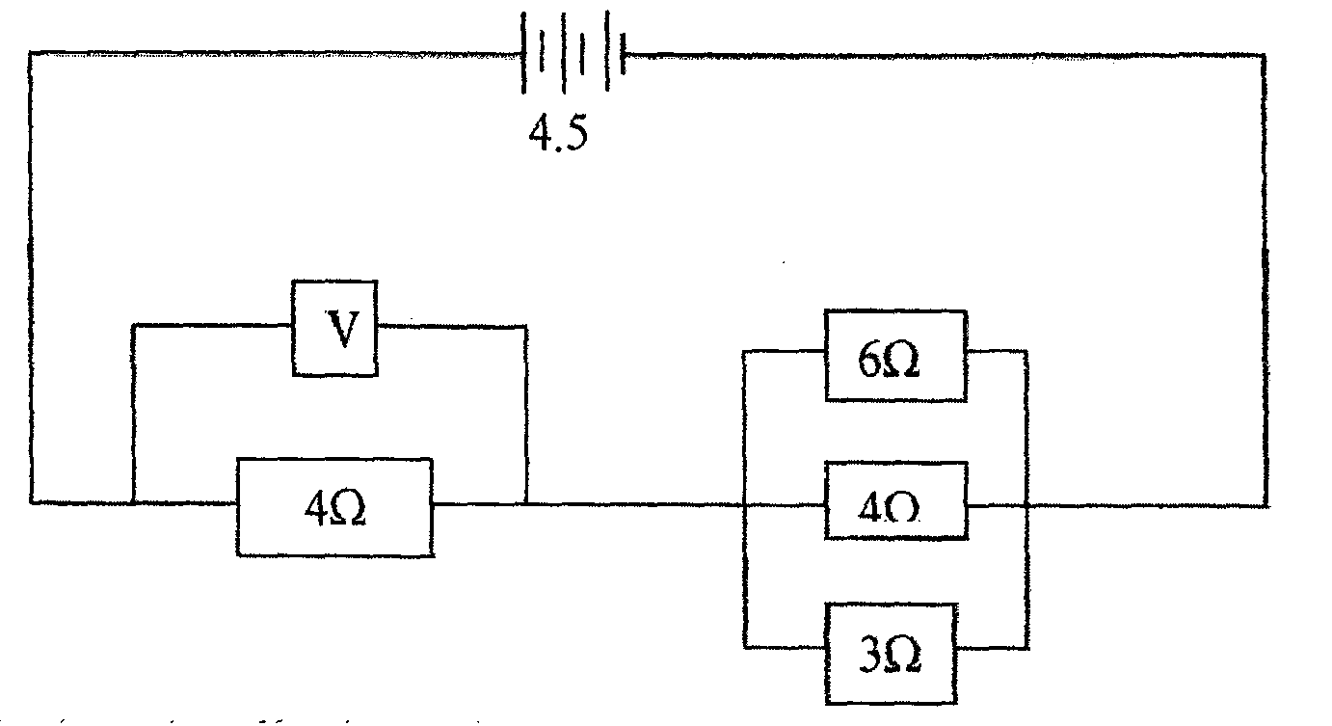

(i) Calculate the effective resistance of the circuit. (3marks)

(ii) Find the voltmeter reading. (2marks)

- (a) A Girl stands some distance from a high wall and claps her hands

- What two measurements would need to be made in order to determine the speed of sound? (2mks)
……………………………………………………………………………………………………………………………………………………………………………………………………………………………………………………………………………………………………………………….

- Describe how you would make use of these measurements (3mks)
………………………………………………………………………………………………………………………………………………………………………………………………………………………………………………………………………………………………………………………………………………………………………………………………………………………………

- The speed of sound in air is 330m\s.How far from the wall would you stand? Choose an answer from the following distances .10m, 200m, 500m.
Give reasons why you did not choose each of the other two distances (2mks)

……………………………………………………………………………………………………………………………………………………………………………………………………………………………………………………………………………………………………………………….

- The frequency of the sound emitted by the loud speaker is 1020Hz. Calculate the wavelength of the sound wave in air where its velocity is 340m\s (2mks)

b) Figure 15 shows the set up used to demonstrate interference of sound

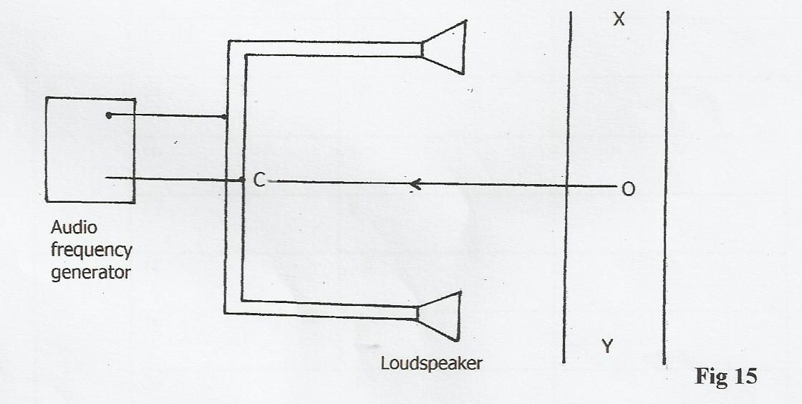

- An observer O, moves along XY.

State the observation(s) made. (1 mark)

……………………………………………………………………………………………………
……………………………………………………………………………………………………
…………………………………………………………………………………………………….
…………………………………………………………………………………………………….

(ii) State what would be observed if a cathode ray oscilloscope is moved along line XY. (1 mark)

……………………………………………………………………………………………………
……………………………………………………………………………………………………
…………………………………………………………………………………………………….
…………………………………………………………………………………………………….

(iii) What will a student hear if he moves along the line OC? (1 mark)
……………………………………………………………………………………………………
……………………………………………………………………………………………………

- (a) State the conditions to be satisfied for total internal reflection to occur.
(2marks)
…………………………………………………………………………………….…………………..……………………………………………………………………………………………….…………………..

(b) A ray of light traveling in the direction EO in air enters a rectangular block as shown in the diagram. The resulting angle of refraction is 18°.
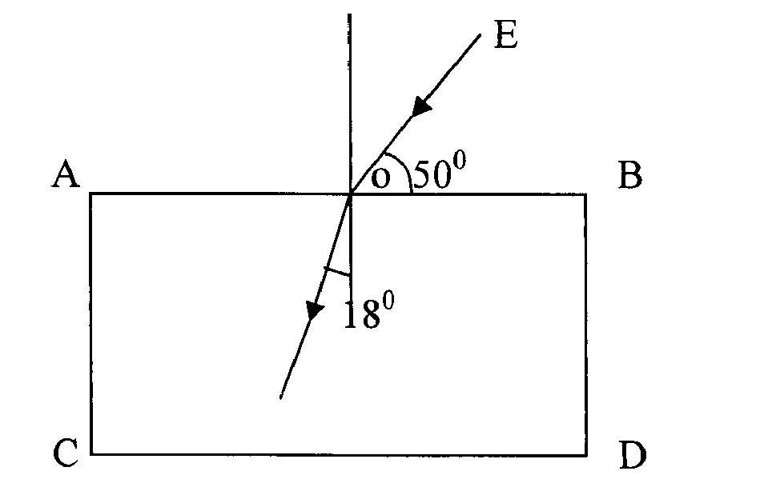
C

18º

Find:

(i) The refractive index of the block. (2marks)
…………………………………………………………………………………….…………………..……………………………………………………………………………………………….…………………..……………………………………………………………………………………………….…………………..……………………………………………………………………………………………….…………
(ii) The critical angle C of the block. (3marks)
……………………………………………………………………………………….…………………..…………………………………………………………………………………………….…………………..……………………………………………………………………………………………….………………
16. (a) The figure below shows an object in front of lens.
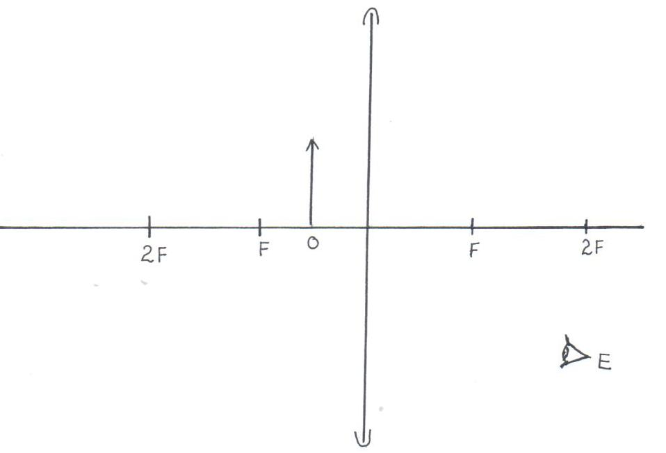

(i) Using rays locate the image as seen by observer, E. (2 marks)

(ii) Give one application of such a lens as used above. (1 mark)

……………………………………………………………………………………………………
……………………………………………………………………………………………………

(b) Figure below shows a diagram of the human eye. Sketch a ray diagram showing how lens is used to correct long sightedness. (2 marks)

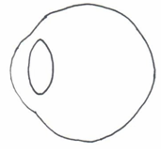

(c) An object of height 10.5cm stands before a diverging lens of focal length 20cm and a distance of 10cm from the lens. Determine;
(i) image distance. (3 marks)

……………………………………………………………………………………………………
……………………………………………………………………………………………………
…………………………………………………………………………………………………….
…………………………………………………………………………………………………….

(ii) height of the image. (3mark)
……………………………………………………………………………………………………
……………………………………………………………………………………………………
…………………………………………………………………………………………………….
…………………………………………………………………………………………………….
(iii) magnification. (2 mark)

……………………………………………………………………………………………………
…………………………………………………………………………………………………….
…………………………………………………………………………………………………….

17. (a) State the Lenz’s law of electromagnetic induction. (1 mark)
………………………………………………………………………………………………………………………………………………………………………………………………………………………………………………………………………………………………………
(b) A bar magnet is moved into a coil of an insulated copper wire connected to a zero
centre galvanometer as shown below

N S

G

- Show on the figure above the direction of the induced current in the coil (1 mark)

- State and explain what is observed on the galvanometer when the south pole of the magnet is moved into and then withdrawn from the coil. (2 marks)

………………………………………………………………………………………………………………………………………………………………………………………………………………………………………………………………………………………………………
(c) A transformer has 800 turns in the primary and 40 turns in the secondary winding.
The alternating voltage connected to the primary is 240V and current of 0.5.A. If 10% of the power is dissipated as heat within the transformer, determine the current in the secondary coil.
(3 marks)
……………………………………………………………………………………………………………………………………………………………………………………………………………………………………………………………………………………………………………………………………………………………………………………………………………………………………………………………………………………………………………

