FARM POWER AND MACHINERY

This topic entails the following:
- Sources of farm power
- Systems of a tractor
- Tractor implements, uses and maintenance
- Animal drawn implements uses and maintenance
- Tractor servicing and maintenance practices

The following relevant questions and their answers in this topic will greatly motivate and
help the user to comprehend and understand the required concepts and practices:

1. Give four farm operations powered by engines

2. a) Describe the maintenance practices required on a tractor before it is put to daily use
b) Outline the factors that influence the power output by a draught animal

3. State two uses of gear box in a tractor
4. State two uses for which wind power is harnessed
5. Name three implements that are connected to the power take-off shaft
6. Below is a farm implement, study it keenly and answer the questions that follow:-
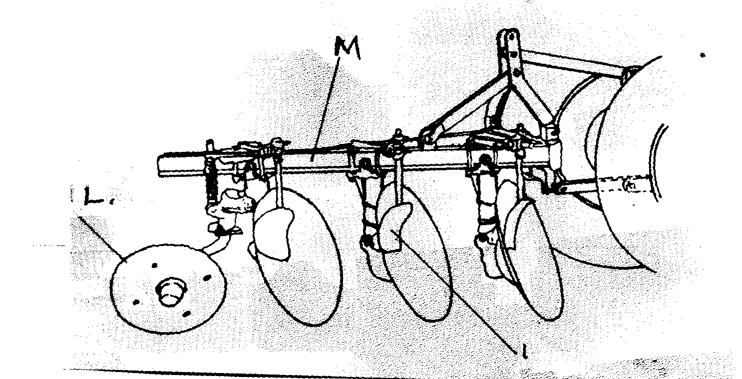

N

(a) Name the farm implement drawn above
(b) Identify the parts labelled L and M above
(c) Give the function of the part labeled M
(d) State the field condition under which the implement can work better than the others (½mk)

7. (a) Explain the factors that a farmer should consider in ensuring fast and efficient cultivation
by oxen
(b) Outline the importance of lubrication system in a tractor
(c) State the daily maintenance and servicing of a tractor

8. State the functions of the following parts of power transmission in a tractor:
(i) Hydraulic system
(ii) Draw bar
(iii) Propeller shaft
(ii) State three sources of tractor hire service

9. (i) What is a tractor hires services (1mk)
(ii) State three sources of tractor hire service (1½mks)

10. The diagram below represents an assembled differential of a tractor. Use it to answer the
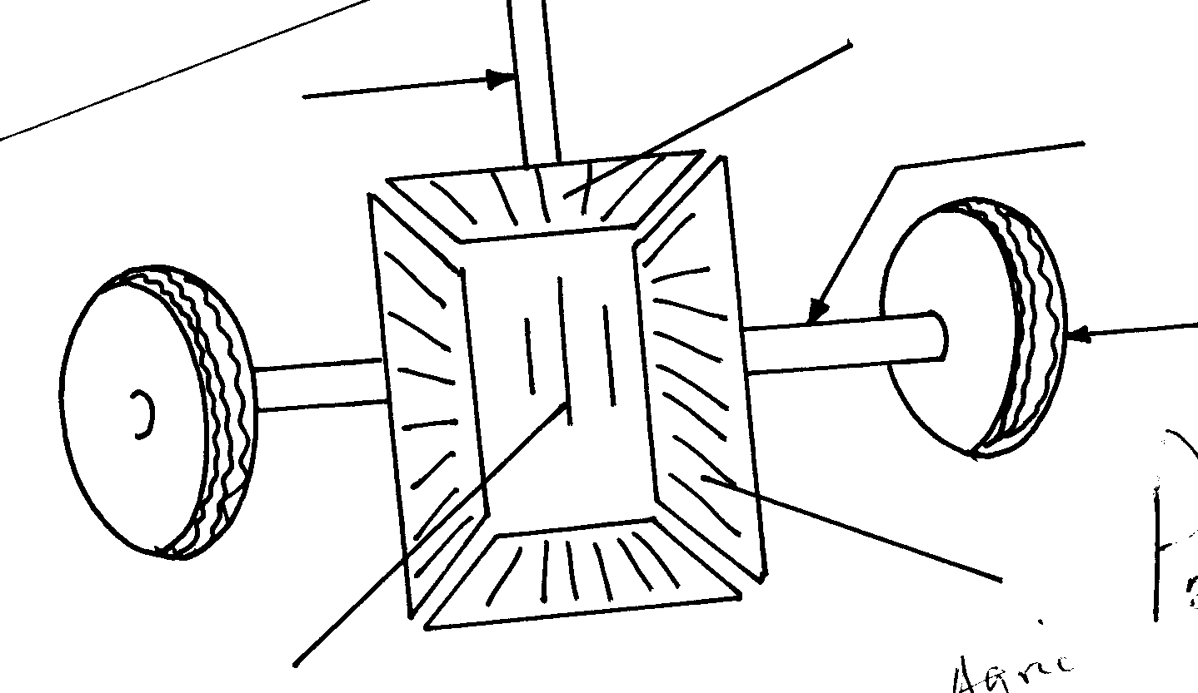
questions that follow:-
D
Wheel
B
A
Propeller shaft

C

(a) Name the parts labeled A, B, C and D
(b) State two functions of differential system of a tractor
(c) Give two reasons why wheel skidding of a tractor is not allowed

11. State four sources of power in the farm

12. Give the four strokes of a four stroke cycle tractor engine

13. State four factors which ensure efficient working by oxen in the farm

14. Mention two sources from which farmers can hire tractors
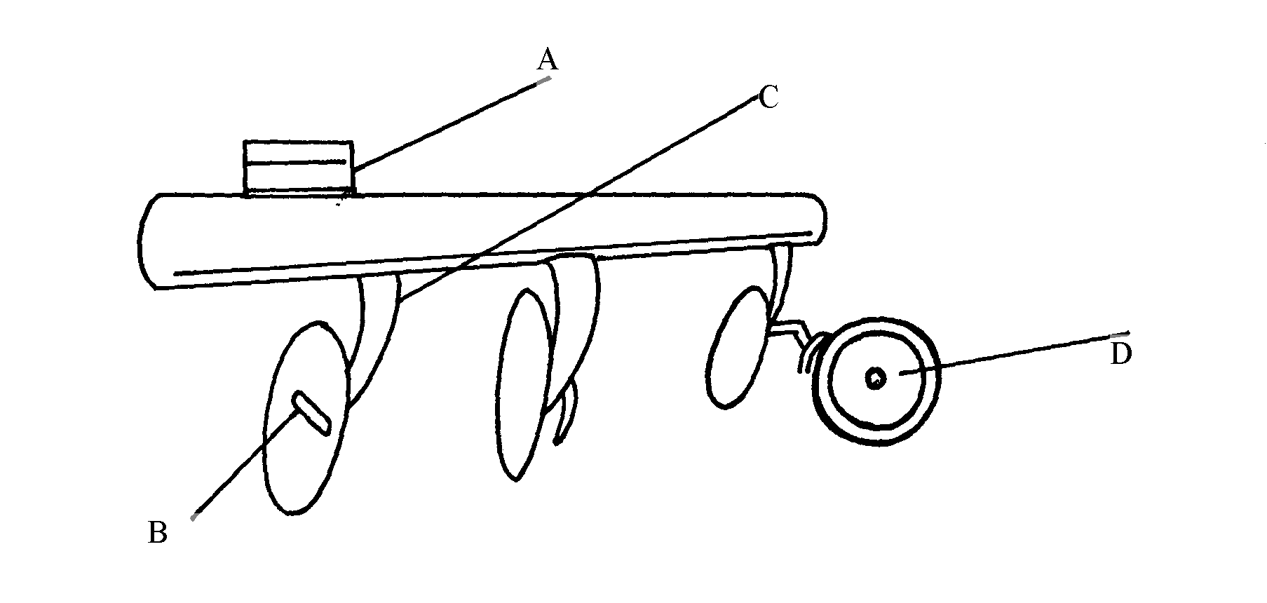
15. (a) Below is a diagram of a farm implement

(i) State the use of the implement shown above
(ii) Name the parts labeled A, B, C, and D
(iii) State two methods of increasing the depth of penetration of the implement

16. State four ways through which a farmer would ensure maximum power output from
ploughing animals

17. State three advantages of a disc plough over mould board plough

18. a) Explain the differences between petrol and chisel engine
b) Describe components of transmission system of a tractor

19. Name four systems of a tractor engine

20. Give one function of the clutch

21. State two adjustments that should be carried out on a tractor – mounted mould board plough
in preparation for ploughing
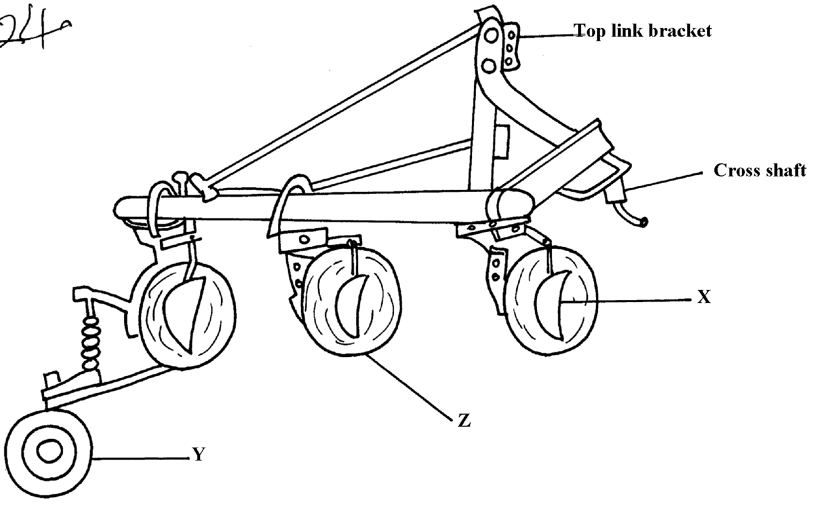
22. The diagram below illustrates a farm implement. Study it and answer the questions that follow

a) Identify the implement
b) Name the parts labeled X, Y and Z
c) State three maintenance practices that are carried out on a disc plough

23. a) Describe the operational differences of a disc plough and mould board plough
b) Explain six marketing problems affecting dairy farming in Kenya
c) State four reasons for culling a boar

24. Name the role of the following parts of a mould board plough
a) Share .
b) Mould board
c) Land side....

25. a) State five maintenance practices of a mould board plough
b) Explain five structural and functional differences between the petrol and diesel engines c) List five uses of farm fences

26. Give two uses of ox-drawn fine harrow

27. List four care and maintenance of a tractor battery

28. Study the diagram of a farm implement shown below and answer the questions that follow:
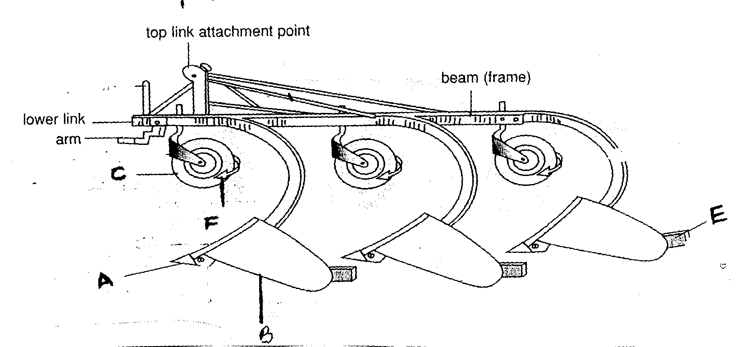

(a) Identify the farm implement illustrated above
(b) Label parts A, B and C
(c) Outline the functions of the parts labeled E and F
(d) Give two care and maintenance of the above implement

29. Outline six uses of live fences on the farm

30. List two possible causes of over heating in a tractor engine

31. List two events occur during induction stroke in a four stroke engine

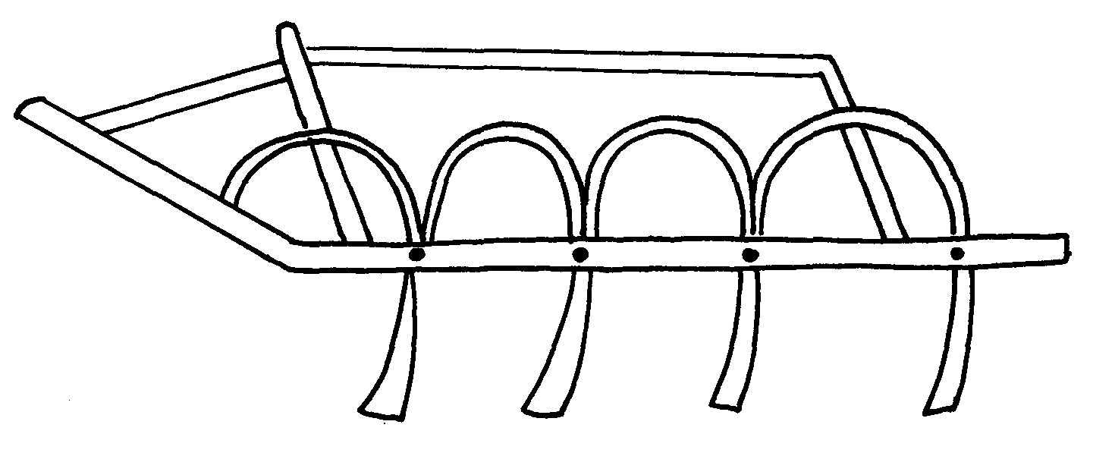
32. i) the diagram below shows a tractor drawn implement.

a) Name the implement
b) Give two uses of the implement above
c) State three maintenance practices carried out on the above implement. ii) Below is an illustration of a farm equipment. Study it and answer questions that follow
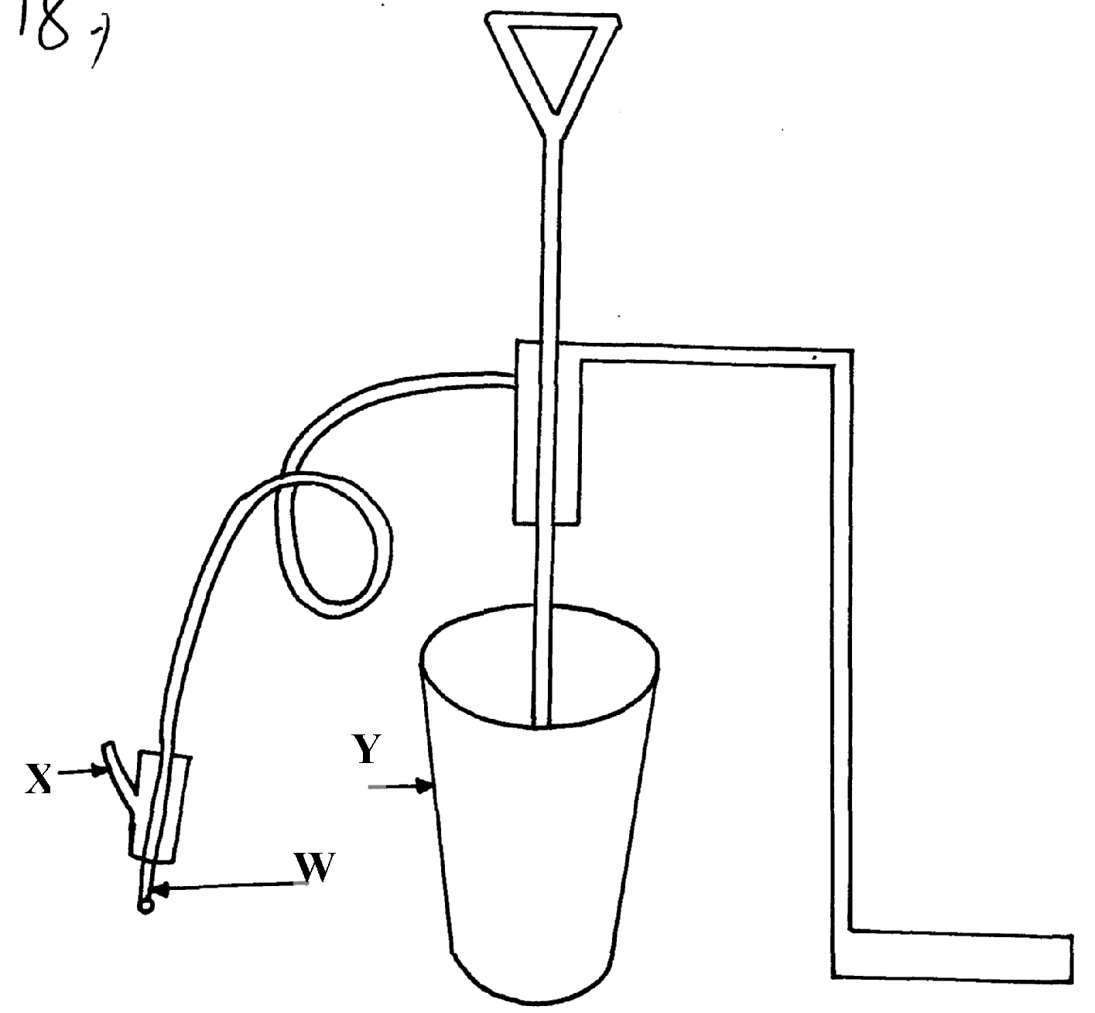

a) Identify the farm equipment illustrated above b) What is the use of the equipment c) Name the parts labelled W, X and Y d) What is the functions of Y on the equipment

33. a) Explain the factors that influence the power output of farm animals
b) State the importance of farm fences

34. Study the illustration of a biogas digester plant and answer the questions that follow.
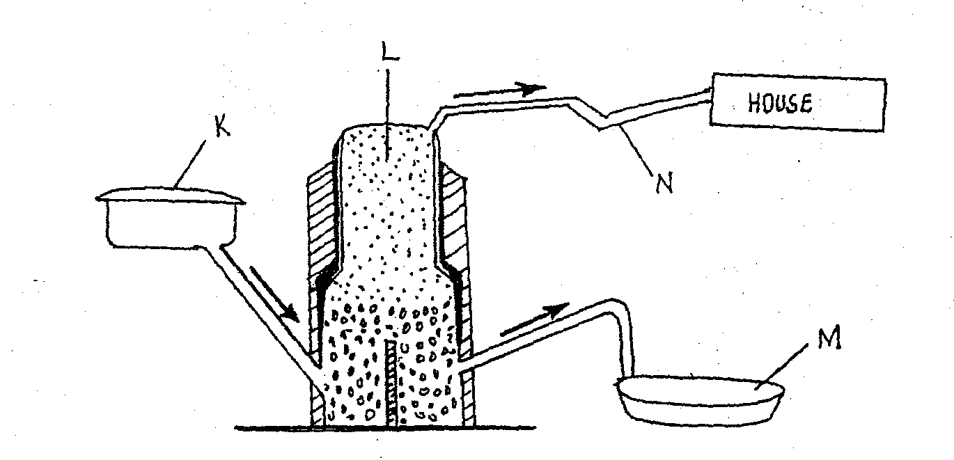
HOUSE
N
L
KL
M

a) Name the major component of biogas that is trapped in part L above
b) Give the name of the material deposited in part labeled M and its use
c) What is the component of K in the biogas production
d) Give three disadvantages of biogas as a source of farm power

35. Other than hydro-electricity mention two sources of electrical energy which can be available
for use in the farm

36. a) Describe the maintenance practices required on a tractor before it is put to daily use
b) Discuss the factors that influence the power output by a draught animal

