NAME……………………………………………………INDEX NO. ………………CLASS………
ADM NO…………………….DATE: ……………………………..SIGN: …………………….………
SCHOOL ……………………………………………………………………………………………….

233/2
CHEMISTRY PAPER TWO
APRIL 2023
TIME: 2 HOURS

MURANG’A EXTRA COUNTY SCHOOLS (MECS) EXAMINATION
TERM I, 2023
KENYA CERTIFICATE OF SECONDARY EDUCATION (K.C.S.E)

INSTRUCTIONS
- Write your name and index number in the space provided
- Sign and write the date of examination in the space provided above
- Answer all questions in the space provided after each question
- Mathematical tables and electronic calculators may be used
- All working must be clearly shown where necessary

QUESTION | MAXIMUM SCORE | CANDIDATE’S SCORE
1 | 14
2 | 14
3 | 10
4 | 10
5 | 11
6 | 12
7 | 10
TOTAL SCORE | 80

- The grid below represents part of the periodic table. Study it and use it to answer the questions that follow. The letters do not represent actual symbols of the elements.

Z |  |  |  |  |  |  | Y
 | Q |  | X |  | L | D |  | M
 |  |  |  | N
T |  |  |  | K |  |  | P

- To which chemical family does element M belong? (1 mark)

……………………………………………………………………………………………………

b. Giving a reason, compare the following;
- Atomic radius of T and K (2 marks)
………………………………………………………………………………………………………………………………………………………………………………………………………………………………………………………………………………………………………………………
- Boiling point of Y and P (2 marks)
………………………………………………………………………………………………………………………………………………………………………………………………………………………………………………………………………………………………………………………………………………………………………………………………………………………………

- Physical state at room temperature (25 ⁰C) of an oxide of Q and an oxide of L (2 marks)
……………………………………………………………………………………………………………………………………………………………………………………………………………………………………………………………………………………………………………………
……………………………………………………………………………………………………
c. An element W forms a stable ion with the formula W²⁺. The ion of W has an electron configuration similar to the electron configuration of an atom of M
- Write the electron configuration of an atom of W. (1 mark)

………………………………………………………………………………………………
- Place element W in its position on the grid (1 mark)

d. Identify the element from the grid that; (1 mark)
- Has the lowest first ionization energy (½ mark)
……………………………………………………………………………………………
- Forms an amphoteric oxide (½ mark)
…………………………………………………………………………………………………

e. G is a metallic element in the same group Z and less reactive than T. Draw a dot (O) and cross(X) diagram showing how element G and D combine (1 mark)
…………………………………………………………………………………………………………………………….……………………………………………………………………………………………………………………………………………………………………………………

f. The table below gives the atomic and ionic radii of three elements P, Q and R. Study it and use it to answer the questions that follow.
Element | Atomic radius | Ionic radius
P | 0.099 | 0.181
Q | 0.157 | 0.095
R | 0.133 | 0.216

- Identify the element that is a good conductor of electricity. (1 mark)
………………………………………………………………………………………………………

- Give a reason for your answer in e(i) above (1 mark)
…………………………………………………………………………………………………………………………….………………………………………………………………………………………………………………………………………………………………………………………
- In an experiment to investigate the molar enthalpy of displacement of copper (II) ions, 25 cm³ of 0.1M copper (II) sulphate solution was reacted with zinc powder. The temperature of the solution was recorded after every minute for 2 minutes. On the 3rd minute, 6g of zinc was added to the solution. The mixture was stirred with a thermometer and temperature was recorded after every minute for an additional 6 minutes. The results were recorded in the table below.
Time in minutes | 0 | 1 | 2 | 3 | 4 | 5 | 6 | 7 | 8 | 9
Temperature (⁰C) | 25.0 | 25.0 | 25.0 | X | 28.6 | 28.3 | 28.0 | 27.7 | 27.5 | 27.1

- On the grid provided, plot a graph of temperature (y– axis) against time (x – axis) (3 marks)

- Use your graph to determine the temperature change (1 mark)
………………………………………………………………………………………………………

- Calculate the;
- Enthalpy change for the reaction (density of solution = 1g/cm³, specific heat capacity = 4.2 kJ/Kg/K) (2 marks)
………………………………………………………………………………………………………
………………………………………………………………………………………………………
………………………………………………………………………………………………………
ii Moles of copper (II) ions displaced, given that the zinc powder was in excess (1 mark)
………………………………………………………………………………………………………
………………………………………………………………………………………………………
………………………………………………………………………………………………………iii Molar enthalpy of displacement of copper (II) ions (2 marks)
………………………………………………………………………………………………………
………………………………………………………………………………………………………
………………………………………………………………………………………………………
d) A similar reaction was carried out using the copper (II) sulphate solution and metal Q in place of zinc powder. The molar enthalpy change was found to be – 201kJ/mol.
- Compare the reactivity of element Q and zinc. (1 mark)
………………………………………………………………………………………………………
………………………………………………………………………………………………………
………………………………………………………………………………………………………
- Explain your answer in d(i) above (1 mark)
………………………………………………………………………………………………………
………………………………………………………………………………………………………
………………………………………………………………………………………………………

- a) Name the following compounds; (2 marks)
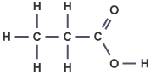

…………………………………………………………………………………………..

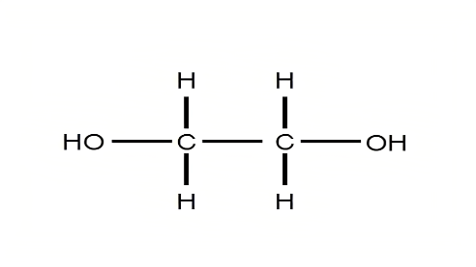………………………………………………………………………………………………..

b) An organic compound has the molecular formula C₅H₁₂.
- To which homologous series does the compound belong? (1 mark)
………………………………………………………………………………………………………

- Define isomers (1 mark)
………………………………………………………………………………………………………
………………………………………………………………………………………………………
………………………………………………………………………………………………………

- Draw and name two isomers of the compound. (2 marks)
………………………………………………………………………………………………………
………………………………………………………………………………………………………
………………………………………………………………………………………………………
………………………………………………………………………………………………………
………………………………………………………………………………………………………

c) In an experiment, ethanol was reacted with acidified potassium manganate (VI) to form product T
- Identify the product T (1 mark)
………………………………………………………………………………………………………

- Name the process of converting ethanol to product T (1 mark)
………………………………………………………………………………………………………

- State the observation made when;

Acidified potassium manganate (VII) is added to ethanol (1 mark)
………………………………………………………………………………………………………
………………………………………………………………………………………………………

Sodium carbonate is added to solution T (1 mark)
………………………………………………………………………………………………………
………………………………………………………………………………………………………

d) An organic compound L has the formula CH₃CH₂CH₂COOCH₃.

- To which group of organic compounds does it belong to. (1 mark)
………………………………………………………………………………………………………

- Identify the two substances that react to give the compound above (2 marks)
………………………………………………………………………………………………………
………………………………………………………………………………………………………

- The set – up below was used to prepare sulphur (IV) oxide in the laboratory. Study it and use it to answer the questions that follow.

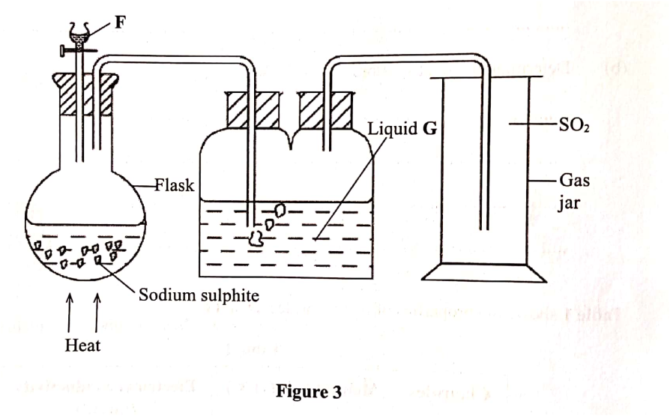
  - Identify (1 mark)
(i) Liquid F……………………………………………………………………
(ii) Liquid G……………………………………………………………………

  - State the role of liquid G (1 mark)
………………………………………………………………………………………………………
………………………………………………………………………………………………………

  - State and explain two observations made when moist blue litmus paper is put in the gas jar.
(2 marks)
………………………………………………………………………………………………………
………………………………………………………………………………………………………
………………………………………………………………………………………………………

  - Sulphur (IV) oxide is used industrially in the manufacture of sulphuric (VI) acid.
- Name the process (1 mark)
…………………………………………………………………………………………………

ii. Identify two raw materials used in the process named above (1 mark)
………………………………………………………………………………………………

iii. Name the most suitable catalyst used (1 mark)
…………………………………………………………………………………………………

iv. Write an equation for the reaction in the catalytic chamber (1 mark)
………………………………………………………………………………………………………
e. State and explain the observations made when concentrated sulphuric (VI) acid is added to the following
- Glucose (1 mark)
………………………………………………………………………………………………………
………………………………………………………………………………………………………
………………………………………………………………………………………………………

- Hydrated cobalt (II) chloride (1 mark)
………………………………………………………………………………………………………
………………………………………………………………………………………………………
………………………………………………………………………………………………………

5. a) Define the following terms; (3 marks)
- Deliquescence
………………………………………………………………………………………………………
………………………………………………………………………………………………………

- Strong acid
………………………………………………………………………………………………………
………………………………………………………………………………………………………

- Saturated solution
………………………………………………………………………………………………………
………………………………………………………………………………………………………

b) Starting with lead (II) oxide, describe how you can obtain a dry sample of lead (II) sulphate in the laboratory. (3 marks)
………………………………………………………………………………………………………
………………………………………………………………………………………………………
………………………………………………………………………………………………………
………………………………………………………………………………………………………
c) Study the flow diagram below and use it to answer the questions that follow.

Solid D
Gas R which forms a white ppt with lime water
Water
White Solid P
Sodium chloride solution
HCl (aq)

Heat

- Identify the following (1 ½ marks)
Solid D ………………………………………………………………………………
White solid P ……………………………………………………………………………
Gas R ………………………………………………………………………………

- State and explain the observation made when lead (II) nitrate is added to sodium chloride solution (1 ½ mark)
……………..……………………………………………………………………………………………
…………………………………………………………………………………………………………
………………………………….………………………………………………………………………

d) Study the equation below and answer the question that follows
H₂ O₂ (l) + H₂O (l) H₃O⁺ (aq) + HO₂⁻ (aq)
Giving a reason, identify the;
- Acid (1 mark)
……………..……………………………………………………………………………………………
…………………………………………………………………………………………………………
………………………………….………………………………………………………………………

- Base (1 mark)
……………..……………………………………………………………………………………………
…………………………………………………………………………………………………………
………………………………….………………………………………………………………………

- The set up below was used to isolate nitrogen from a sample of air. Use it to answer the questions that follow.

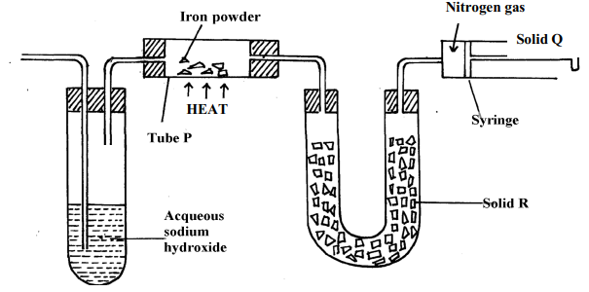
  - Name solid R and state its role (2 marks)
Name ……………………………………………………………………………………
Role…………………………………………………………………………………………

b. Identify the substance removed in the; (2 marks)
- Boiling tube
…………………………………………………………………………………………………

ii. combustion tube
……………………………………………………………………………………………

c. Write an equation for the reaction in the boiling tube (1 mark)
…………………………………………………………………………………………………

d. Explain what would happen if iron powder is replaced with magnesium powder (1 mark)

…………………………………………………………………………………………………
e. Name the impurity collected in the syringe (1 mark)
…………………………………………………………………………………………………
f. State two uses of nitrogen gas (1 mark)
…………………………………………………………………………………………………
……………………………………………………………………………………………

g. Ammonia gas is prepared in the lab by reaction of ammonium chloride with solid F
- Name solid F (1 mark)
………………………………………………………………………………………………………

- Name the most suitable substance used to dry ammonia gas (1 mark)
………………………………………………………………………………………………………

- State two physical properties of ammonia gas (2 marks)
………………………………………………………………………………………………………
………………………………………………………………………………………………………
…………………………………………………………………………………………………

7. a) The diagrams below represent allotropes of carbon
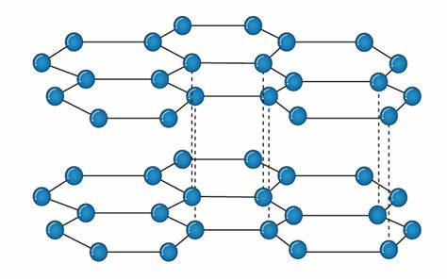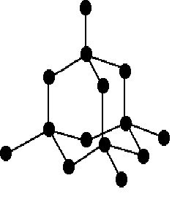
Allotrope X Allotrope Y

- Define allotropes (1 mark)
………………………………………………………………………………………………………
………………………………………………………………………………………………………
………………………………………………………………………………………………………

- Identify allotrope (2 marks)
X ………………………………………………………………………………………………

Y ………………………………………………………………………………………………

- Using structure and bonding, explain one physical difference between the two allotropes
(2 marks)
………………………………………………………………………………………………………………………………………………………………………………………………………………………………………………………………………………………………………………………

b) Carbon reacts with excess oxygen to form a gaseous oxide of carbon
- State the nature of the oxide formed (1 mark)

………………………………………………………………………………………………………

- Write an equation for the reaction (1 mark)
………………………………………………………………………………………………………

- 400g of carbon was burnt in limited oxygen gas. Calculate the volume of the gaseous product formed at R.T.P (C=12.0, O=16.0, Molar gas volume at RTP=24,000 cm³)
(3 marks)
………………………………………………………………………………………………………………………………………………………………………………………………………………………………………………………………………………………………………………………
………………………………………………………………………………………………………………………………………………………………………………………………………………………………………………………………………………………………………………………

THIS IS THE LAST PRINTED PAGE

