NAME……………………………………………………INDEX NO. ………………CLASS………
ADM NO…………………….DATE: ……………………………..SIGN: …………………….………
SCHOOL ………………………………………………………………………………………….

233/1
CHEMISTRY PAPER ONE
APRIL 2023
TIME: 2 HOURS

MURANG’A EXTRA COUNTY SCHOOLS (MECS) EXAMINATION
TERM I, 2023
KENYA CERTIFICATE OF SECONDARY EDUCATION (K.C.S.E)

INSTRUCTIONS
- Write your name and index number in the space provided
- Sign and write the date of examination in the space provided above
- Answer all questions in the space provided after each question
- Mathematical tables and electronic calculators may be used
- All working must be clearly shown where necessary

QUESTION | MAXIMUM SCORE | CANDIDATE’S SCORE
1-28 | 80

1. List three differences between a conductor and an electrolyte (3mks)
CONDUCTOR | ELECTROLYTE

2. Describe how you can prepare ethane starting with calcium carbide and water (3mks)
………………………………………………………………………………………………………………………………………………………………………………………………………………………………………………………………………………………………………………………………………………………………………………………………………………………………………………………………………………………………………………………………………………………………………………
3. Define the following terms
i. covalent bond (1mk)
………………………………………………………………………………………………………………………………………………………………………………………………………….………………
ii. Coordinate bond (1mk) ………………………………………………………………………………………………………………………………………………………………………………………………………….………………
iii. Draw a dot(o) and cross(x) diagram of ammonium chloride (N=14, H=1, Cl=17) (2mks)
………………………………………………………………………………………………………………………………………………………………………………………………………………………………………………………………………………………………………………………………………………………………………………………………………………………………………………………………………………………………………………………………………………………………………………

4. State two functions of a school laboratory (2mks)
………………………………………………………………………………………………………………………………………………………………………………………………………………………………
………………………………………………………………………………………………………………………………………………………………………………………………………………………………
5. Identify substances with the following properties (1mk)
- it is an ionic compound, an electrolyte and can be used as a food additive (1mk)
…………………………………………………………………………………………………
- Relights a glowing splint, has a slight smell, slightly less dense than air, and fairly soluble in cold water (1mk)
………………………………………………………………………………………………………
iii. Has a density of 1.84 g/cm³, an oily liquid, changes blue hydrated copper (ii) sulphate to white (1mk)
……………………………………………………………………………………………………..
6. a) Define the term fermentation (1mk)
……………………………………………………………………………………………………………………………………………………………………………………………………………………………
b) Name the compounds formed when potassium metal reacts with (2mks)
i. ethanol ……………………………………………………………………………
ii. ethanoic acid ……………………………………………………….……………………
7. A hydrated salt of copper has the formula CuSO₄.nH₂O. About 25g of the salt was heated until all the water evaporated. If the mass of the anhydrous salt is 16.0g, find the value of n. (Cu = 64.0, S = 32.0, O = 16.0, H = 1) (3 mks)
………………………………………………………………………………………………………………………………………………………………………………………………………………………………………………………………………………………………………………………………….…………
………………………………………………………………………………………………………………………………………………………………………………………………………………………………

8. When 100 cm³ of 0.5 M sulphuric acid solution, H₂SO₄, react with 100 cm³ of 1 M sodium hydroxide solution, NaOH, the temperature rises by 6.85 Kelvins. (Density = 1.0g/cm³, specific heat capacity = 4.2kJkg⁻¹K⁻¹). Calculate the molar heat of neutralization described by the equation:
H₂SO_{4(aq)} + 2NaOH_{(aq)} → Na₂SO_{4(aq)} + 2H₂O_{(l)} (3 mks)
………………………………………………………………………………………………………………………………………………………………………………………………………………………………………………………………………………………………………………………………………………
9. Name the catalysts used in the following (3mks)
i. Esterification…………………………………………………………………………………….
ii. Ostwald process…………………………………………………………………………………
iii. Preparation of hydrogen in the laboratory……………………………………………………..
10. a) State Gay Lussac’s law (1mk)
………………………………………………………………………………………………………………………………………………………………………………………………………………………………
b) 15.0cm³ of ethene were mixed with 50.0cm³ of oxygen and the mixture was sparked to complete the reaction. If all volumes were measured at a pressure of one atmosphere and 25°C, calculate the volume of the resulting gaseous mixture. (2mks)
………………………………………………………………………………………………………………………………………………………………………………………………………………………………………………………………………………………………………………………………………………
11. The set-up below was used to prepare Nitric(V)acid.
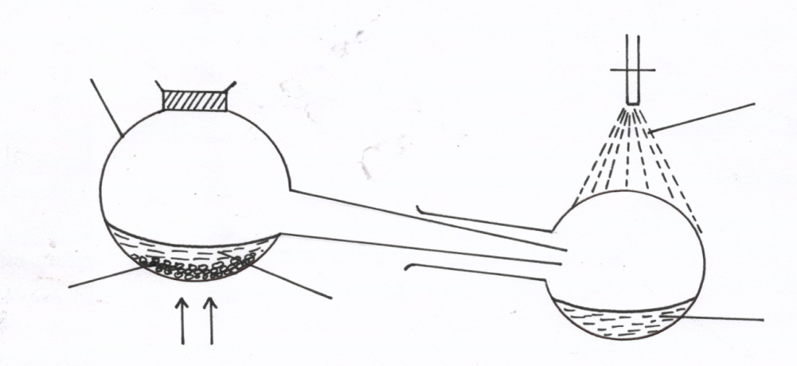
Glass retort
Tap water

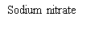
Heat
Nitric acid
Liquid R
(i) Give the name of liquid R. ( 1mk)
……………………………………………………………………………………………………..
(ii) Write an equation for the reaction which takes place in the retort flask (1mk)
……………………………………………………………………………………………………
(iii) State the role of tap water. (1mk)
…………………………………………………………………………………………………….
12. Study the information given in the table below and answer the questions that follow.
Bond | Bond energy (KJ mol)
C-H | 413
Br-Br | 193
C-Br | 280
H-Br | 365

(a) Calculate the Enthalpy changes for the reaction below (2mks)
CH₄ (g) + Br₂ (g) CH₃Br (g) + HBr (g)
………………………………………………………………………………………………………………………………………………………………………………………………………………………………………………………………………………………………………………………………………………………………………………………………………………………………………………………………………………………………………………………………………………………………………………
(b) State whether the reaction is exothermic or endothermic. Explain (1mk)
………………………………………………………………………………………………………
13. Differentiate between hydrolysis and saponification (2mks)
………………………………………………………………………………………………………………………………………………………………………………………………………………………………………………………………………………………………………………………………………………………………………………………………………………………………………

14. a) Zeolites (Na₂X) is a complex compound used to soften hard water in the ion-exchange methods according to the equation below.
Ca ²⁺ (aq) +Na₂X (aq) CaX_{(s)} + 2Na⁺ _{(aq)}
After sometimes the Zeolites get exhausted and cease to soften water. Write an equation to show how Zeolite is regenarated. (1mk)
.....................................................................................................................................................
b) Name two other method used in softening hard water (2mks)
………………………………………………………………………………………………………………………………………………………………………………………………………………………………
15. The table below gives information about some reactions of metals A,B, C and D and their rates.
METAL | Reaction with acid | Reaction with water | Action of heat on its nitrate
A | Hydrogen evolved | No reaction | Oxide formed
B | NO reaction | No reaction | Metal formed
C | Hydrogen evolved | Hydrogen evolved | Oxide formed
D | NO reaction | NO reaction | Oxide formed
Arrange the metals in order of decreasing activity (3mks)
………………………………………………………………………………………………………………………………………………………………………………………………………………………………
16. Elements X, Y and Z have atomic numbers 9, 11 and 18 respectively.
- Which element can be used in electric light bulbs? (1mark)

…………………………………………………………………………………………………

- Which two elements react to form an ionic compound? (1 Mark)

…………………………………………………………………………………………………

- Write an equation for the reaction between element B and water? (1mark)

…………………………………………………………………………………………………

17. (a) What is a universal indicator? (1mark)
………………………………………………………………………………………………………………………………………………………………………………………………………………………………
………………………………………………………………………………………………………………

(b) State one advantage of universal indicator over other commercial indicators. (1mark)
………………………………………………………………………………………………………………………………………………………………………………………………………………
18. Explain how solid calcium sulphate can be prepared from solid samples of calcium carbonate and sodium sulphate. All other reagents and apparatus are provided. (3 marks)
………………………………………………………………………………………………………………………………………………………………………………………………………………………………………………………………………………………………………………………………………………………………………………………………………………………………………………………………………………………………………………………………………………………………………………
19. A heavy metal (P) was dissolved in dilute nitric acid to form a solution of compound P(NO₃)₂. Portions of the resulting solution were treated as follows:
  - To the first portion a solution of dilute hydrochloric acid is added, where a white precipitate (S) is formed, which dissolves on warming.
  - The second portion is treated with two drops of 2M Sodium hydroxide solution where a white precipitate (T) is formed. The white precipitate dissolved in excess sodium hydroxide to form a colourless solution.
  - A solution of potassium iodide is added to the third portion where a yellow precipitate (U) is formed.
  - When the resulting solution is evaporated to dryness and heated strongly a yellow solid (V) is formed and a brown gas (W) and a colourless gas (X) are formed.
    - Identify the substances P, S, T, U, V, W. (3 marks)
P …………………………………………… U ……………………………………..
S ………………………………………….. V ………………………………………
T …………………………………………… W ………………………………………….

- Sodium thiosulphate was reacted with dilute hydrochloric acid in a round bottomed flask as shown below. The gas evolved was collected by downward delivery in a gas jar.

  - Write an equation to show the reaction going on in the reaction in vessel.(1 mark)
…………………………………………………………………………………………………………………………………………..………………………………………………....
  - State the observation noted on the filter paper. Give a reason for your answer (1 mark)
………………………………………………………………………………………………………………………………………………………………………………………………………………………………………………………………………
  - Give a reason why the filter paper soaked in the acidified potassium chromium (VI) is used at the top of the flask (1 mark)
………………………………………………………………………………………………………………………………………………………………………………………………………………………………………………………………………
- State one use of each of the following apparatus in the laboratory

- Conical flask (1mk)
…………………………………………………………………………………………………….
- Desiccator (1mk)
…………………………………………………………………………………………………….
- Crucible (1mk)
…………………………………………………………………………………………………….
22 i. Define Vulcanisation (1mk)
………………………………………………………………………………………………………………………………………………………………………………………………………….
ii. What is the importance of the above defined process (2mks)
………………………………………………………………………………………………………………………………………………………………………………………………………………
23. Two gas jar containing hydrogen chloride gas and ammonia gas were close to each other as shown below
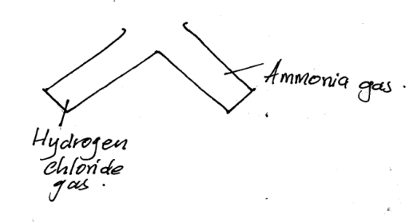
- State and explain the observation made (2mks)
…………………………………………………………………………………………………….………
…………………………………………………………………………………………………….………
…………………………………………………………………………………………………….………
ii) State the significance of the above experiment (1mk)
………………………………………………………………………………………………………………………………………………………………………………………………………………………………
24. Unknown substances had PH values as shown in the table below.
Substance | PH values
A | 6.0
B | 2.0
C | 8.0

State which substance is likely to be;
- Lemon juice (1mk)
…………………………………………..…………………………………………

- Identify a substance that would be a better electrolyte? explain (2mk)
………………………………………………………………………………………………………………………………………………………………………………………………………………

25. The scheme below shows some reaction sequence starting with solid M.
H₂SO₄
+ Gas burns with a ‘pop’sound
Solution N
Solid M

Few drops NH₃
Excess NH₃(aq)
White ppt
Colourless Soln Q

    - Name solid M (1mk)
......................................................................................................................................

    - Write the formula of a complex ion present in solution Q (1mk)
…………………………………………………………………………………………………………………………………………………………………………………………
    - Write an ionic equation of the reaction between lead (ii) nitrate and solution N. (1mk)
………………………………………………………………………………………………………………………………………………………………………………………………………………………………………………………………………………………………

26. Describe how you can separate a mixture of water and hexane (3mks)
………………………………………………………………………………………………………………………………………………………………………………………………………………………………………………………………………………………………………………………………………………
27. A solid p was suspected to be a sulphate of sodium, describe the tests that would be carried out to determine whether the sold was actually sodium sulphate (3mks)
………………………………………………………………………………………………………………………………………………………………………………………………………………………………………………………………………………………………………………………………………………
28. Define the term chemistry (1mk)
………………………………………………………………………………………………………………………………………………………………………………………………………………………………
THIS IS THE LAST PRINTED PAGE

