NAME ……………………………..……………ADMN NO ……………CLS ……………
233/1
CHEMISTRY
PAPER 1(THEORY)
TERM 1 2023
TIME: 2 Hours

MURANG’A EXTRA COUNTY SCHOOLS EXAMINATION (MECS)
Instructions to Candidates
- Write your name, admission number in the spaces provided above
- Answer all the questions in the spaces provided
- KNEC Mathematical tables and silent electronic calculator may be used.
- All the working must be shown clearly where necessary
- Candidates should answer questions in English.
- this exam consists of 10 printed pages
For Examiner’s Use Only
Question | Maximum Score | Candidate’s Score
1-29 | 80
1. List three differences between a conductor and an electrolyte (3mks)
Conductor | Electrolyte
solid | Molten/ aqueous
Has delocalized electrons | Had mobile ions
Remains unchanged | Decomposed by current
2. Describe how you can prepare ethane starting with calcium carbide and water (3mks)
-Add water to calcium carbide in a dry flask to produce ethyne gas
-In presence of a nickel catalyst and 200ºC , react excess hydrogen gas with ethyne gas to form ethane gas
-fractionate to obtain ethane gas
3. Define the following terms
i. covalent bond(1/2mk)
-a bond formed where the shared pair of electrons are contributed by each of the atoms forming the bond
ii. Coordinate bond (1/2mk)
a special covalent bond where the shared pair is contributed to one of the atoms forming the bond
iii. Draw a dot and cross diagram of ammonium chloride (2mks)
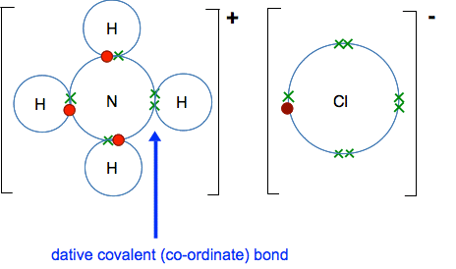
4. State two functions of a school laboratory (2mks)
- Storage of chemicals
- performing/carrying out practical’s
5. Identify substances with the following properties (1mk)
i. it is an ionic compound, an electrolyte and can be used as a food additive(1mk)
-Sodium chloride
ii. Relights a glowing splint, has a slight smell, slightly less dense than air, and fairly soluble in cold water (1mk)
-Nitrogen (ii) oxide
iii. Has a density of 1.18g/cm3, an oily liquid, changes blue hydrated copper (ii) sulphate to white (1mk)
-Concentrated sulphuric (VI) acid
6. a)Define the term fermentation(1mk)
A process in which organic material are decomposed by microorganisms with the production of ethanol, carbon (iv) oxide and heat
b) Name the compounds formed when potassium metal reacts with (2mks)
i. ethanol………………………………potassium ethoxide
ii. ethanoic acid……………………………potassium ethanoate
7. A hydrated salt of copper has the formula CuSO₄.nH2O. About 25g of the salt was heated until all the water evaporated. If the mass of the anhydrous salt is 16.0g, find the value of n. (Cu = 64.0, S = 32.0, O = 16.0, H = 1) (3 marks)
Mass of water = 25-16 = 9 g
molecules | CuSO₄ | H₂O
mass | 16 | 9
Molar mass | 160 | 18
moles | 16/160=0.1 | 9/18= 0.5
Mole ratio | 0.1/0.1 | 0.5/0.1
 | 1 | 5
N=5
8. When 100 cm³ of 0.5 M sulphuric acid solution, H₂SO₄, react with 100 cm³ of 1 M sodium hydroxide solution, NaOH, the temperature rises by 6.85 Kelvins. (Density = 1.0g/cm³, specific heat capacity = 4.2kJkg⁻¹K⁻¹)
Calculate the molar heat of neutralization of sulphuric (vi) acid: (3 marks)
H₂SO_{4(aq)} + 2NaOH_{(aq)} → Na₂SO_{4(aq)} + 2H₂O_{(l)}

ΔH=MCΔT
=200/1000 x 4.2 x 6.85= -5.754kJ
1mole----------1000cm3
? -------------100cm3= 0.1moles
0.1mol---------------- 5.754
1mol-------------------? = -57.54kJ/Mol

9. Name the catalysts used in the following (3mks)
i. Esterification…….conc sulphiuric (vi) acid.
ii.Ostwald process…………………Platinum/Rhodium
iii. Preparation of hydrogen in the laboratory……………copper(ii) sulphate crystals
10. (a) State Gay Lussac’s law
When gases react they do so in volumes that bears simple whole number ratios to each other and to the products if gaseous (1mk)
b) 15.0cm³ of ethene were mixed with 50.0cm³ of oxygen and the mixture was sparked to complete the reaction. If all volumes were measured at a pressure of one atmosphere and 25°C, calculate the volume of the resulting gaseous mixture. (2mks)
C₂H₄ + 3O₂ 2CO₂ + 2H₂O
15cm3 45cm3 30cm3 30cm3
Resulting mixture 5cm3 excess oxygen + 30cm3 CO₂ + 30 cm3 steam= 65 cm3
11. The set-up below was used to prepare Nitric(V)acid.
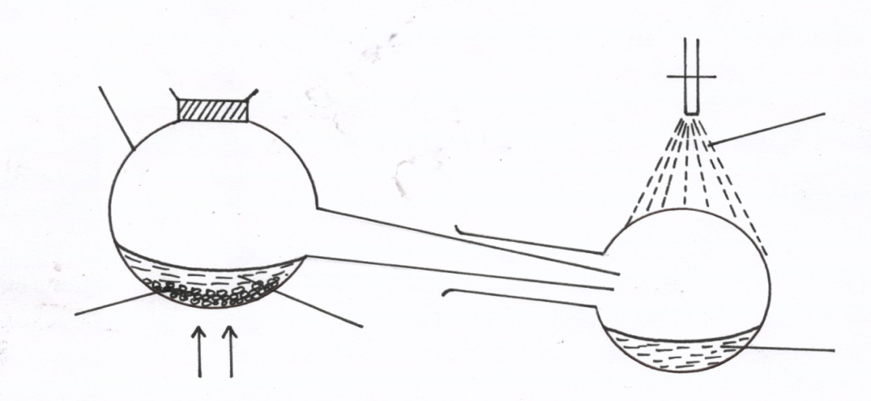
Glass retort
Tap water

Nitric acid
Sodium nitrate
Heat
Liquid R

(i) Give the name of liquid R. ( 1mk)
Conc sulphuric (vi) acid
(ii) Write an equation for the reaction which takes place in the retort flask (1mk)
NaNO₃(s) + H₂SO₄(l) NaHSO₄(s) + HNO₃ (g)
(iii) State the role of tap water. (1mk)
Condense nitric (v) acid fumes
12. Study the information given in the table below and answer the questions that follow.
Bond | Bond energy (KJ mol)
C-H | 413
Br-Br | 193
C-Br | 280
H-Br | 365

(a) Calculate the Enthalpy changes for the reaction below (2mks)
CH₄ (g) + Br₂ (g) CH₃Br (g) + HBr (g)
C-H + Br-Br C-Br + HBr
413 + 193=606 280 + 365=645
ΔH=-39kJ
(b) State whether the reaction is exothermic or endothermic. Explain (1mk)
Exothermic, evolves energy
13. Differentiate between hydrolysis and saponification (2mks)
Saponification: it’s the hydrolysis of fats/oils by an alkali by boiling
Hydrolysis: chemical break down of a compound by reacting with water
14. a) Zeolites (Na₂X) is a complex compound used to soften hard water in the ion-exchange methods according to the equation below.
Ca ²⁺ (aq) +Na₂X (aq) CaX_{(s)} + 2Na⁺ _{(aq)}
After sometimes the Zeolites get exhausted and cease to soften water. Write an equation to show how Zeolite is regenarated. (1mk)
2NaCl( aq) + CaX (s) Na₂X (s) + CaCl₂ (aq)
b) Name two other method used in softening hard water (2mks)
- Addition of ammonia
- Boiling
- Addition of sodium carbonate
15. The table below gives information about some reactions of metals A,B, C and D and their rates.
METAL | Reaction with acid | Reaction with water | Action of heat on its nitrate
A | Hydrogen evolved | No reaction | Oxide formed
B | NO reaction | No reaction | Metal formed
C | Hydrogen evolved | Hydrogen evolved | Oxide formed
D | NO reaction | NO reaction | Oxide formed
Arrange the metals in order of decreasing activity (2mks)
C A D B
16. Elements X, Y and Z have atomic numbers 9, 11 and 18 respectively.
- Which element can be used in electric light bulbs? (1mark)
Z
- Which two elements react to form an ionic compound? (1 Mark)
X and Y
- Write an equation for the reaction between element B and water? (1mark)
2Y (s) + 2H₂O(l) 2YOH(aq) + H₂ (g)
17. (a) What is a universal indicator? (1mark)
It’s a mixture of several dyes that shows different colours depending on the strength of acids and bases
(b) State one advantage of universal indicator over other commercial indicators. (1mark)
Shows the strengths of acids and bases wtte
18. Explain how solid calcium sulphate can be prepared from solid samples of calcium carbonate and sodium sulphate. All other reagents and apparatus are provided. (3 marks)
-Add calcium carbonate to dilute nitric(v) acid til in excess, filter to obtain calcium nitrate solution
-Dissolve sodium sulphate in distilled water, to form sodium sulphate solution,
-Add sodium sulphate solution to calcium nitrate solution, a white precipitate is formed.
-Filter to obtain calcium sulphate as the residue and sodium nitate as the filtrate
-Wash the residue with distilled water and dry between filter papers/ sun dry
19. A heavy metal P was dissolved in dilute nitric acid to form a solution of compound P(NO₃)₂. Portions of the resulting solution were treated as follows:
  - To the first portion a solution of dilute hydrochloric acid is added, where a white precipitate (S) is formed, which dissolves on warming.
  - The second portion is treated with two drops of 2M Sodium hydroxide solution where a white precipitate T is formed. The white precipitate dissolved in excess sodium hydroxide to form a colourless solution.
  - A solution of potassium iodide is added to the third portion where a yellow precipitate (U) is formed.
  - When the resulting solution is evaporated to dryness and heated strongly a yellow solid (V) is formed and a brown gas (W) and a colourless gas (X) are formed.
    - Identify the substances P, S, T, U, V, and W. (3 marks)
P- lead metal, S- Lead (ii) chloride, T- Lead (ii) hydroxide, U- Lead (ii) iodide, V- Lead (ii) oxide, W- Nitrogen (iv) oxide
- Sodium thiosulphate was reacted with dilute hydrochloric acid in a round bottomed flask as shown below. The gas evolved was collected by downward delivery in a gas jar.

  - Write an equation to show the reaction going on in the reaction in vessel.(1 mark)
Na₂S₂O₃(s) + 2HCl (aq) 2NaCl (aq) + S(s) + SO₂ (g) + H₂O(l)
  - State the observation noted on the filter paper. Give a reason for your answer (1 mark)
The filter paper changes from orange to green
  - Give a reason why the filter paper soaked in the acidified potassium chromium (VI) is used at the top of the flask (1 mark)
Test whether the gas jar is full of sulphur (iv) oxide
- State one use of each of the following apparatus in the laboratory
- Conical flask (1mk)
Measuring approximate volume/general laboratory experiments
- Desiccator (1mk)
Keep substances free from moisture
- Crucible (1mk)
Heating solids that require very strong heating
- i. Define Vulcanisation (1mks)
it is the process of hardening rubber by heating with sulphur
    - what is the importance of the above defined process(2mks)
- makes rubber tougher, less flexible and less soft
- improves the quality of rubber
23. Two gas jar containing hydrogen chloride gas and ammonia gas were close to each other as shown below
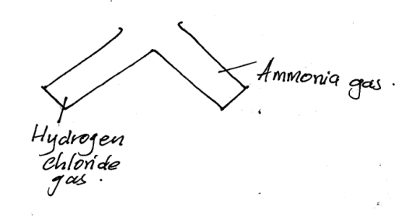
- State and explain the observation made (2mks)
White dense fumes are formed; ammonia reacts with hydrogen chloride to form ammonium chloride
    - State the significance of the above experiment(1mk)
Used to test for the presence of hydrogen chloride gas
.24. Unknown substances had PH values as shown in the table below.
Substance | PH values
A | 6.0
B | 2.0
C | 8.0

State which substance is likely to be;
- Lemon juice (1mk)
A
- Identify a substance that would be a better electrolyte? explain (2mk)
B, it’s a strong acid, or it dissociates completely to form hydrogen ions in water
25. The scheme below shows some reaction sequence starting with solid M.
H₂SO₄
+ Gas burns with a ‘pop’sound
Solution N
Solid M

Few drops NH₃
Excess NH₃(aq)
White ppt
ColourlessSoln Q

    - Name solid M (1mk)
Zinc metal
    - Write the formula of a complexion present in solution Q (1mk)
[Zn(NH₃)₄]²⁺
    - Write an ionic equation of the reaction between lead (ii) nitrate and solution N.(1mk)
Pb²⁺ (aq) + SO₄²⁻ (aq) PbSO4(s)
26. Describe how you can separate a mixture of water and hexane (3mks)
Put the mixture in a separating funnel and wait for it to settle
Open the tap to lease the bottom layer of water into a beaker, throw away the interphase
Release the top layer of hexane into a different beaker
27. A solid p was suspected to be a sulphate of sodium, describe the tests that would be carried out to determine whether the sold was actually sodium sulphate(3mks)
Heat the solid,in a non-luminous flame , the solid burns in a yellow flame
Add the solid to 2cm3 of distilled water, it dissolves
To the resulting solution add acidified lead (ii) nitrate followed by warming, a white ppt doesn’t dissolve.
28. Define the term chemistry (1mk)
It is the study of properties ,composition, structure and changes that matter undergoes

