**SUNRISE ONE TERM 1 EXAMINATION -2023**

***Kenya certificate of Secondary Education***

***FORM 4***

**233/1**

**CHEMISTRY**

**PAPER 1**

**NAME:………………………………………………………………………….ADM NO:………………………..**

**CLASS: ……………………………………………………………CANDIDATE’S SIGNATURE:…….............**

**DATE: …………………**

**233/1**

**CHEMISTRY**

**PAPER 1(Theory)**

**APRIL-2023**

**TIME: 2 HOURS**

**INSTRUCTIONS TO CANDIDATES**

1. Answer all the questions in the spaces provided.
2. Mathematical table and electronic calculators may be used
3. All workings must be clearly shown where necessary
4. Answer all questions in English.

|  |  |  |
| --- | --- | --- |
| **QUESTION** | **MAXIMUM SCORE** | **CANDIDATE’S SCORE** |
| 1-30 | 80 |  |

***This paper consists of 11 printed pages Check the Question paper to ensure that all pages are printed as indicated and no question are missing.***

1. The products formed by the action of heat on carbonates A,B, and C are shown below.

|  |  |
| --- | --- |
| **Carbonates** | **Products Formed** |
| A | Metal Oxide + Carbon (iv) Oxide |
| B | Metal, Oxygen and Carbon (IV) Oxide |
| C | No Product |

1. Arrange the metals in order of reactivity starting with the most reactive. ( 2 mks)

……………………………………………………………………………………………………….……………………………………………………………………………………………………….

1. Which of the carbonate is soluble in water? (1 mk)

……………………………………………………………………………………………………………………………………………………………………………………………………………….

1. Samples of urine from three participants E, F and G at a national police recruitment exercise were spotted onto a chromatography paper alongside two illegal drugs D1 and D2. A chromatogram was run using ethanol. The diagram below shows the chromatogram.

**Solvent Front**

**Baseline**

**F**

**G**

**E**

**D2**

**D1**

a) Identify the participant who had used an illegal drug. (1 mk)

……………………………………………………………………………………………………………………………………………………………………………………………….

b) Which drug is less soluble in ethanol? (1 mk)

………………………………………………………………………………………………

1. Describe a simple laboratory experiment that can be used to distinguish between Sodium sulphite and Sodium Sulphate. (3 mks)

………………………………………………………………………………………………………………………………………………………………………………………..…………………….……………………………………………………………………………………………………………………………………………………………………………..……………………………………………………………………………………………………………………………………..

1. Explain why burning Magnesium ribbon continues to burn in a gas jar full of sulphur

(iv) Oxide while a burning wooden splint would be extinguished. (3 mks)

……………………………………………………………………………………………………………………………………………………………..……………………………………………………………………………………………………………………………………………………………………………………………………………………………..………………………………...

1. Study the arrangement below and answer the questions that follow

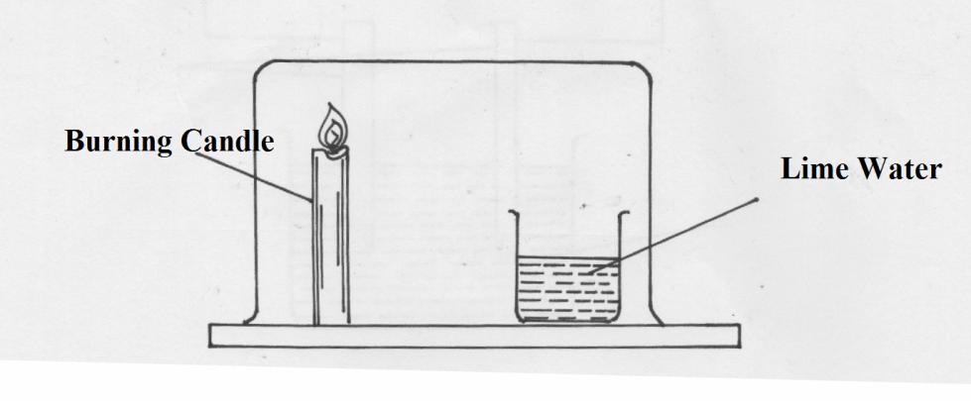

State and explain what will be observed after sometime. (2 mks)

………………………………………………………………………………………………………………………………………………………………………………………………………………………………………………………………..………………………………………………………………………………………………………………………………………………………….

1. Study the diagram below and answer the questions that follow.

Ca (OH)2

CaC2 + X

Step 1

1 mole HCl

Gas Y

Z

Step 2

H H

| |

C — C |

H H 2

1 mole H2

Step 3

CH3CH3

C2H4

2000C, High pressure H2 1500C

Step 5 Step 4

1. Identify reagent X. (1 mk)

…………………………………………………………………………………………………..

1. Draw the structural formula of gas Y. (1 mk)

……………………………………………………………………………………………………………………………………………………………………………………………………

1. What name is given to the process that takes place in step 5? (1 mk)

…………………………………………………………………………………………………..

7. Describe a laboratory experiment that can be used to obtain aluminum chloride from a mixture of sodium chloride and aluminum chloride. (2 mks)

……………………………………………………………………………………………………………………………………………………………..……………………………………………………………………………………………………………………………………………………………………………………………………………………………………………………………

8. The graph below shows the solubility curves for salts J and K.

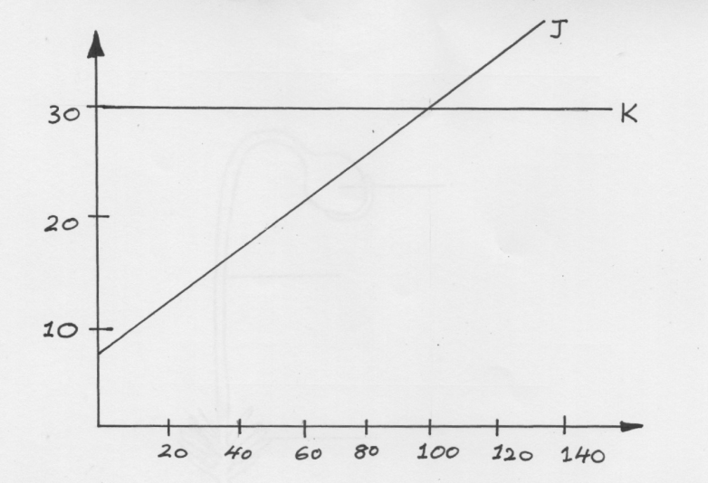

Which of the two salts is more soluble in water? Explain (2 mks)

…………………………………………………………………………………………………...…………………………………………………………..……………………………………….

9. The electronic configuration of the ions of L2+ and M- are 2.8 and 2.9 respectively.

a) Write the electronic configuration of atoms of element L and M. (1 mk)

L………………………………………………………

M…………………………………………………….

1. Write the formula of the Oxide of L ( 1 mk)

……………………………………………………………………………………………………………………………………………………………..……………………………………..

1. Compare the atomic radius of the element M and the ionic radius of ion M- (1 mk)

……………………………………………………………………………………………………………………………………………………………..……………………………………

10. Iron roofing sheets are coated with zinc as “Sacrificial” metal.

a) Give the name of the process by which iron sheets are coated with zinc. (1 mk)

……………………………………………………………………………………………

1. Give a reason why copper is not used as “ sacrificial” metal in the process you

have named in (a) above. (2 mks)

……………………………………………………………………………………………………………………………………………………………..……………………………..…………………………………………………………………………………………………

11. The empirical formula of a hydrocarbon is C2 H3. It has a molecular mass of 54.

a) Determine the molecular formula of the hydrocarbon. (1 mk)

( C= 12, H= 1)

………………………………………………………………………………………………………………………………………………………………………………………………………………………………………………………………………………………………

b) Draw the structural formula and name the hydrocarbon. (2 mks)

………………………………………………………………………………………………………………………………………………………………………………………………………………………………………………………………………………………………

12. Write chemical equations to show the difference between the bleaching action by chlorine and bleaching action by sulphur (IV) Oxide gases. (2 mks)

……………………………………………………………………………………………………………………………………………………………..………………………………………………………………………………………………………………………………………………………………………………………………………………………………………………………………

13. Elements Q and R have atomic numbers 12 and 17 respectively.

a) i) Which element is a metal. (1 mk)

………………………………………………………………………………………

ii) Which dot(.) and (x)cross to represent electrons, show the bonding between Q and R in the compound of the elements. (2 mks)

……………………………………………………………………………………………………………………………………………………………..………………………………………………………………………………………………………………………………………………………………………………………………

14. Study the set- up below and answer the questions that follow:-

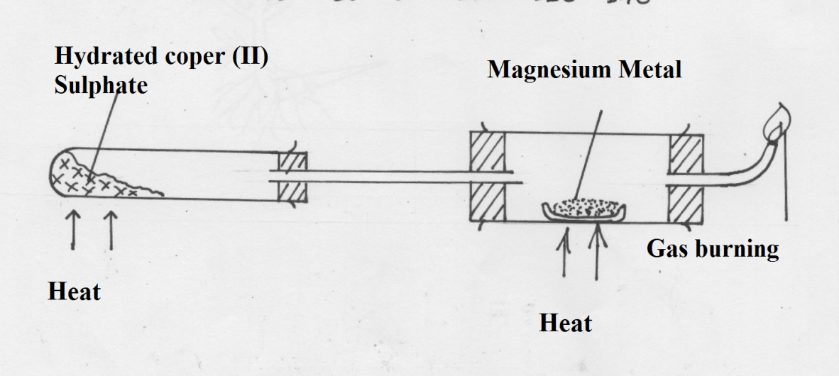

1. What is the role of hydrated copper (II) Sulphate in the set- up. (1 mk)

……………………………………………………………………………………………………………………………………………………………..…………………………………….

1. Identify Gas S? (1 mk)

…………………………………………………………………………………………………

1. Write a chemical equation for the reaction taking place in the combustion tube. (1 mk)

……………………………………………………………………………………………………………………………………………………………..……………………………………

15. Calculate the number of aluminum ions in 250 cm3 of 0.1 M aluminum sulphate.

( Avogadro’s Constant = 6.0 x1023) (3 mks)

……………………………………………………………………………………………………………………………………………………………..………………………………………………………………………………………………………………………………………………………………………………………………………………………………………………………………

16. The table below shows solutions and their PH values.

|  |  |
| --- | --- |
| Solution | PH Value |
| T | 1.5 |
| U | 7.0 |
| V | 14.0 |

1. Select any pair that would react to form a solution of PH 7. (1 mk)

………………………………………………………………………………………………

1. Identify two solutions that would react with Alluminium hydroxide. Explain your answer. (2 mks)

………………………………………………………………………………………………

17. Name two allotropes of carbon. (2 mks)

……………………………………………………………………………………………………………………………………………………………..………………………………………………

18. 20 cm3  of gas W takes 12.6 seconds to pass through a orifice. 10cm3 of Oxygen gas takes 11.2 seconds to diffuse through the same orifice under same conditions of temperature and pressure calculate the molecular mass of gas W. (2 mks)

……………………………………………………………………………………………………………………………………………………………..……………………………………………….………………………………………………………………………………………………………………………………………………………………………………………………………………

19. The diagram below shows an incomplete set- up of the laboratory preparation of dry carbon (IV) Oxide. Complete the diagram. (3 mks)

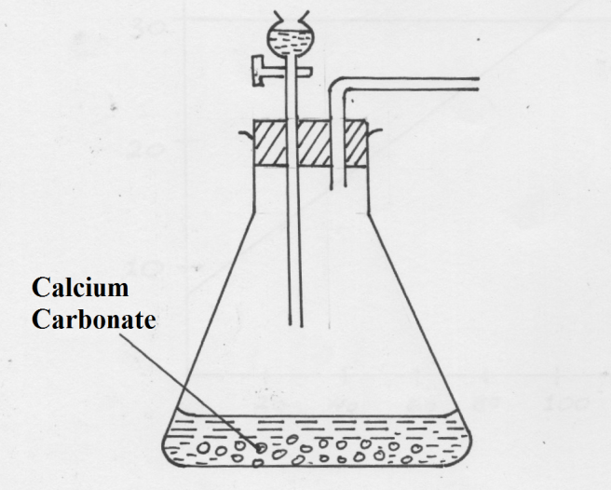

20. State three uses of Argon (3 mks)

a)……………………………………………………………………………………………………..

b)…………………………………………………………………………………………………….

c)……………………………………………………………………………………………………

21. The table below shows the results obtained when halogens are bubbled into a test tube containing solutions of halides labeled A, B and C. A tick ( 🗸) means reaction takes place and (x) no reaction occurs.

Halide ion in solution

|  |  |  |  |
| --- | --- | --- | --- |
| Halogen | A | B | C |
| 12 | X | X | X |
| Br 2 | X | 🗸 | X |
| Cl2 | X | 🗸 | 🗸 |

1. Identify the halide ions represented by letters

A,B,and C (1 ½ mks)

A………………………………………….……………………………………

B……………………………………………………………………………….

C……………………………………………………………………………….

b) State the colour change for the reaction between chlorine and iodide ions and write an

ionic equation for the reaction. (1 ½mks)

……………………………………………………………………………………………………………………………………………………………..………………………………………………………………………………………………………………………………………………………

1. In one of the dry practicals assignment to analyze cation a salt, the following observations were

made:

|  |  |  |  |
| --- | --- | --- | --- |
|  | Test | Observation | Inference |
| (i) | NaOH dropwise till in excess | White ppt formed soluble in excess |  |
| (ii) | NH3 solution dropwise till in excess. |  | Presence of Zn2+ions confirmed. |

1. Fill in the blanks in the table above. (2 mks)
2. Give an ionic equation for the reaction that occurs in test (ii) when excess NH3 solution is added. (1 mk)

……………………………………………………………………………………………………….

23. Describe how you would prepare a pure sample of lead (II) carbonate starting with lead (II ) oxide. (3 mks)

……………………………………………………………………………………………………………………………………………………………..…………………………………………………………………………………………………………………………………………………………………………………………………..…………………………………………………………………………………………………………………………………………………………………

24. Explain how sodium hydrogen carbonate and ammonium chloride are separated in solvey process. (2 mks)

……………………………………………………………………………………………………………………………………………………………..…………………………………………………………………………………………………………………………………………………………………………………………………..………………………………………………………….

25. a) What is fuel? (1 mk)

……………………………………………………………………………………………………………………………………………………………..……………………………………

……………………………………………………………………………………………………………………………………………………………..……………………………………

1. Firewood is the main source of fuel in most Kenyan homes. State two effects of

wood products of burning fuel on environment. (1 mk)

……………………………………………………………………………………………………………………………………………………………..……………………………………

26. Calculate the mass of Calcium Oxide that can be obtained from 30g of calcium carbonate if completely decomposed by strong heating. (3 mks)

( Ca =40 , C=12, O=16)

………………………………………………………………………………………………………………………………………………………………………………………………………………………………………………………………………………………………………………………………………………………………………………………………………………………………………………………………………………………………………………………………………………………………………………………………………………………………………………

27. State the two ions that causes hardness in water. (1 mk)

i)…………………………………………………………………………………………………

ii)…………………………………………………………………………………………………

1. Below is a table giving solubility a substance A and B at 200 C and 500C

|  |  |  |
| --- | --- | --- |
| Substance | Solubility | 100g of water |
|  | 200C | 40C |
| A | 40 | 65 |
| B | 15 | 17 |

When aqueous mixture containing 55g of A and 12g of B at 800C was cooled to 200C crystals were formed

1. Identify the crystal formed (1 mk)

…………………………………………………………………………………………………...

1. Determine the mass of the crystals formed (1 mk)

…………………………………………………………………………………………………...

1. Name the method use dot obtain the crystals (1 mk)

…………………………………………………………………………………………………...

1. The diagram below shows sodium metal being dropped in water. Study it and answer

the questions that follow;



i) State and explain two observations made during the reaction. (2 mks)

………………………………………………………………………………………………………………………………………………………………………………………………………………………………………………………………………………………………………………………………………………………………………………………………

ii) Write an equation for the reaction that takes place during the experiment. (1 mk)

……………………………………………………………………………………………….  
30. i) In an experiment to determine solubility of solid P in water at 250C, the following results were obtained.

Mass of empty evaporating dish – 24.2g

Mass of evaporating dish + saturated solution = 40.4g

Mass of evaporating dish + dry solid P = 28.4g

Using the information above calculate the solubility of solid Pat 250C in g/100g of water. (2 mks)

……………………………………………………………………………………………………………………………………………………………………………………………………………………………………………………………………………………………………………………………………………………………………………………………………………………………….

ii) State one precaution observed when carrying out the experiment in (i) above (1 mk)

…………………………………………………………………………………………………..

**THIS IS THE LAST PRINTED PAGE**