SUNRISE ONE TERM 1 EXAMINATION -2023
Kenya certificate of Secondary Education
FORM 4

233/1
CHEMISTRY
PAPER 1
MARKING SCHEME
1. a) C Most reactive (2mks)
A
B
b) Carbonate C is soluble in water (1mk)
2. a) F (1mk)
b) D₁ (1mk)
3. To Sodium sulphate add barium chloride if precipitate forms add dilute Hcl . If the substance is Na₂ SO₃ the precipitate dissolves. If the same treatment is given to Na₂SO₄ a white precipitate forms but insoluble in dilute HCl ( 3mk)
4. A burning magnesium flame decomposes SO₂ to form Sulphur and Oxygen. Oxygen reacts with Mg to form MgO. Wooden splint flame burns at a low temperature not hot enough to decompose SO_{2.} (3mks)
5. - Candle goes off since all oxygen is used up.1
- Lime water forms white precipitate due to1 the evolved from combustion of candle wax. (2mk)
6. i. Water .1
ii. H – C $≡$ C – H.1
iii. Polymerisation .1

7. - Heat to mixture 1/2 a beaker covered with a watch glass with water ½ in it. AlCl₃
Sublimes ½ and deposits at the base of the watch glass. Sodium chloride remains ½ in the beaker as residue. ( 2mks)
8. Salt J1 . Its solubility increases with increase temperature1. (2mks)
9. a) L = 2.8.2 ½
M= :2.7 ½ (1mk)
b) LO 1
c) Atomic radius of element M is less than ionic radius of M⁻, 1 (1mk)

10. a) Galvanization
b) Copper is less reactive than ion. Copper will not corrode. Iron rust instead of copper.
11. 1/2
24 x 3x =54
27x = 54
X= 2. ( C₂H₃)2
Molecular formula = C₄ H₆ ½
b)
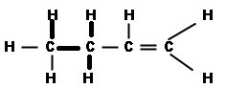
But- I- ene
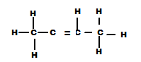
But-2- ene
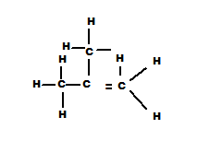2 mentylpropane
But- 2- ene
( Any one of the above structures and name)
12. HOCl (aq) + Dye HCL (_{aq}) + dye [O] 1
H₂SO₃ + dye (O) H₂SO₄ + dye 1
13. a) (i) Q ½
(ii) R ½
b)

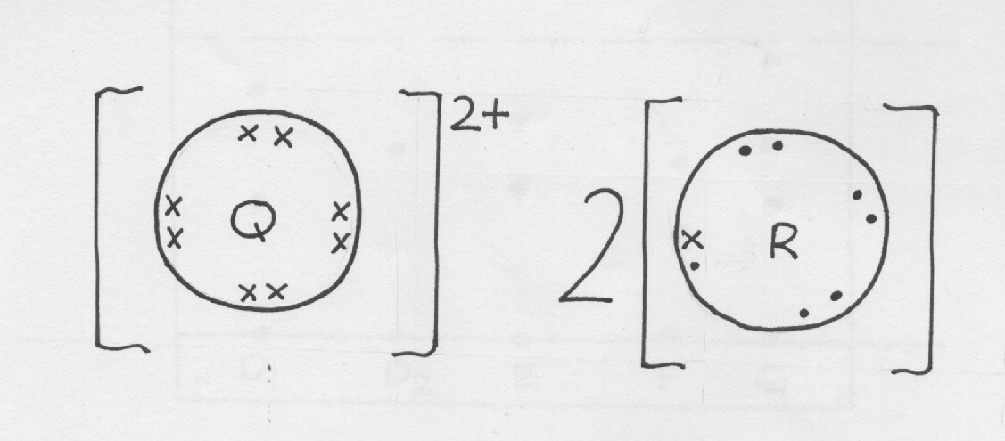
14. a) Produce stream 1
b) Hydrogen 1
c) Mg_{(s)} + H₂ O_{(g)} MgO _{(s)} + H _{2 (g)1}
15. - Moles of AlCl₃ in 250 cm³
$\frac{250x 0.1 }{1000}=0.0251$
- AlCl₃ (aq) Al³⁺_{(aq)} + 3c ( 1am) 1
Moles of Al³⁺ in 250 cm³
0.0250 x 1 = 0.025 moles ½
Number of Al³⁺ = 0.025 x 6.0 x 10²³
= 1.5 x 10²² ions ½
16. a) T and V1
b) T and V 1 Al ( OH) ₃ is amphteric hydroxide1
17. - Graphite1
- Diamond1
18. 20 cm³ of W takes 12.6 sec
10cm³ of W $\frac{10 X 12.6}{20 }=6.3 seconds$
$\frac{TW}{To2}= \sqrt{\frac{Mw}{Mo2}} 1/2$ Mo₂ = 16 x 2 = 32 ½
$\frac{6.3}{11.2}$ = $\sqrt{\frac{Mw}{32 }} 1$
$\left(\frac{6.3}{11.2}\right)$² = $\left(\sqrt{\frac{Mw}{32}}\right)$ ²

0.5625² ⁼ $\frac{MW}{32}$
Mw = 0.5625² x 32= 10.125g1
Accept any other method which is correct.

19.
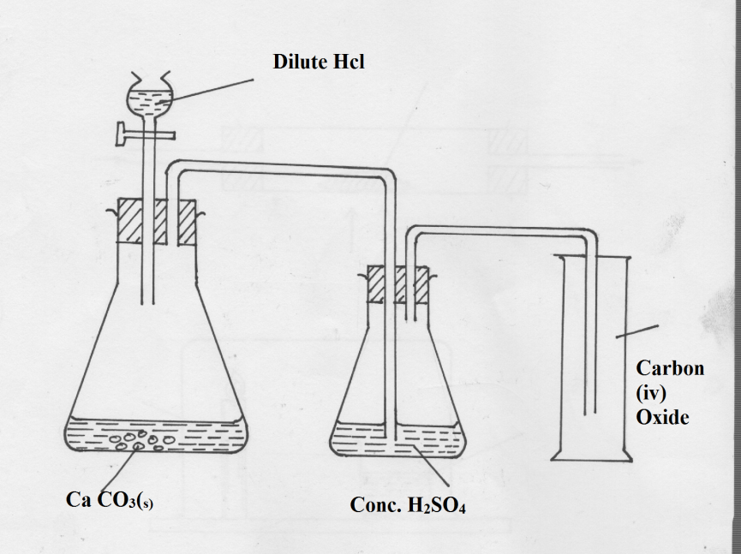
20. a) Argon is used in ore welding.
- Used in electrical light bulb
- Used in the production of titanium
- Used in growing of crystals of silicon and germanium.
( any threes uses 1mk each)
21. a) A-Cl⁻ ( Chloride Ion) ½
B – I⁻ ( Iodide Ion) ½
C – Br⁻ ( Bromide Ion) 1/2 ( 1 ½ mks)
b) The solution turns from colourless to black ½ 2 I _{(aq)}+ Cl _{2 (g)} 2C⁻_{Aq)} + I _{2 (aq)}
22. a. Al³⁺; Zn²⁺, Pb²⁺ present1
White ppt formed soluble in excess1

b. Zu (OH)_{2 (s)} + 4NH_{3 (g)} [Zu (NH₃)₄] ²⁺_{(aq)} + 2OH⁻_{(aq)} 1

23. - Measure 20 cm³ of HNO₃ and place it in a beaker.
- Add lead (II) Oxide until excess ½
- Filter off the lead (II ) nitrate formed 1/2 and transfer the filtrate in a clean beaker.
- Add a solution of sodium carbonate to lead T ½ (II) nutrate a white precipitate forms which is lead (II) carbonate 2
- Filter off the precipitate and was it with distilled water than to dry the residue between dry filter paper.
24. Separation is done by filtration 1 NaHCO₃ is less soluble at low temperature .NH₄cl is more soluble at low temperatures. NaHCO₃ crystal form and filtered off.

25. a) Fuel is a substance which releases energy when burned. ( 1mk)
b) Carbon in ½ firewood when burnt in insufficient air ½ forms CO. The gas is poisonous when ½ breathed in and leads to death carbon ( iv) Oxide is also formed. This gas can form acid rain and causes global warming. (2mks)
26. Ca CO_{3(s)} CaO_{(c)} + CO_{2 (g)} 1
40 + 12 + 48 ½ 40+16 ½ 40+1 ½
100g 56g
If 100g of CaCO₃ produce 56 g of Ca ½ O
30g of caCo₃ $\left(\frac{30 x 56}{100}\right)=16.8 g 1/2$
27. - Calcium Ions 1
- Magnesium 1
- a) Substance A1
b) 55 – 40 = 15g1
c) Fractional crystallization1

29. i. - Hissing sound produced due to the production of hydrogen gas. 1
- Darts on the surface of water because hydrogen produced propels it. 1
- Melts into a silvery ball because of the heat produced during the reaction.
- Floats on the water because its less denser than water (mark any two correct)

ii. 2Na_{(s)} + 2H₂O_{(l)} →2NaOH_{(aq)} + H_{2(g)} 1

- i) Mass of solute = 28.4 – 24.2
= 4.2
Mass of water = 40.4 – 28.41
= 12
Solubility = 4.2 x 100
12
=35g/100gm1
ii) Ensure that no solid is lost during evaporation1

