**Name**: **…………………………………………………… Adm No……………..Class………**

**School………………………………………………………………………………**

**232/1**

**FORM 4**

**PHYSICS THEORY-P1**

**SUNRISE ONE TERM 1 EXAMINATION -2023**

**PRE-MOCK EXAM**

**MARCH/APRIL 2023**

**Time: 2HRS**

**INSTRUCTIONS TO CANDIDATES**

* *This paper consists of* ***12*** *questions.*
* *Answer* ***ALL*** *the questions in the spaces provided.*
* ***ALL*** *working* ***MUST*** *be clearly shown.*
* ***ALL*** *numerical answers* ***MUST*** *be expressed in decimal forms.*

**For Examiner’s Use Only**

|  |  |  |  |
| --- | --- | --- | --- |
| **SECTION** | **QUESTION** | **MAXIMUM SCORE** | **CANDIDATE’S SCORE** |
| **A** | **1-12** | **25** |  |
| **B** | **13** | **12** |  |
| **14** | **11** |  |
| **15** | **12** |  |
| **16** | **12** |  |
| **17** | **08** |  |
| **TOTAL SCORE** | | **80** |  |

**The paper consists of 12 printed pages.**

***Students should check the question paper to ensure that all the pages are printed as indicated and no questions are missing.***

**SECTION A (25 MARKS)**

***Answer all the questions in this section in the spaces provided.***

1. The Figure below shows part of a scale of vernier calipers. What is the reading indicted by the scale? (2 marks)

2 3

1. The Figure shows two match sticks placed on water in a basin a few centimeters apart.

**X**

Match sticks

State and explain the observation made when a drop of soap solution is placed at a point marked x. (2 marks)

………………………………………………………………………………………………………………………………………………………………………………………………………………………………………………………………………………………………………………………………………………………………………………………………

1. When a body of mass 0.35kg is acted upon by a force, its velocity changes from 3.5m/s to 6.0m/s.Determine the power developed by the force. (2marks)

……………………………………………………………………………………………………………………………………………………………………………………………

1. Figure below shows a uniform rod 4m long and of mass 2kg. It is pivoted 1m from one end and balanced horizontally by a string attached near the other end.



Determine the position where a mass of 5kg should be placed on the rod so that the rod remains horizontal and the tension in the string is zero. (3 marks)

…………………………………………………………………………………………………………………………………………………………………………………………………………………………………………………………………………………………………………………………………………………………………………………………………………

1. Water flows steadily along a horizontal pipe at a volume rate of m3/s. if the area of cross-section of the pipe is 20 cm2. Calculate the velocity of the fluid. (2marks)

………………………………………………………………………………………………………………………………………………………………………………………………………………………………………………………………………………………………………………………………………………………………………………………………………

1. State any two states of equilibrium. (2 marks)

………………………………………………………………………………………………………………………………………………………………………………………………

1. A ball is thrown from the top of a cliff 20m high with a horizontal velocity of 10ms-1. Calculate the distance from the foot of the cliff to where the ball strikes the ground. (3 marks)

…………………………………………………………………………………………………………………………………………………………………………………………………………………………………………………………………………………………………………………………………………………………………………………………………………..

1. Explain o**n**e advantage of mercury over alcohol as a thermometric liquid.

(1mark)

……………………………………………………………………………………………………………………………………………………………………………………………………

1. A body of mass **M** is allowed to slide down an inclined plane. State **two** factors that affect its final velocity at the bottom of the inclined plane. (2marks)

………………………………………………………………………………………………………………………………………………………………………………………………………………………………………………………………………………………………………

1. For an enclosed system with a liquid, a force is applied at one point.
2. Briefly explain how force is transmitted to other parts of the system. (1 marks)

………………………………………………………………………………………………………………………………………………………………………………………………………………………………………………………………………………………………………

1. State one application of such a system. (1 marks)

…………………………………………………………………………………………………

1. A 150g mass tied on a string is whirled in a vertical circle of radius 30cm with a uniform speed. At the lowest position the tension in the string is 9.5N, Calculate the velocity of the mass. (2 marks)

…………………………………………………………………………………………………………………………………………………………………………………………………………………………………………………………………………………………………………………………………………………………………………………………………………

1. A spring of elastic constant K has its length increased from 4.00m when unloaded to 4.25m when loaded with a 75N weight. Assuming that the elastic limit is not exceeded, determine the value of K. (2 marks)

……………………………………………………………………………………………………………………………………………………………………………………………………

…………………………………………………………………………………………………..

**SECTION B: 55 MARKS**

1. (a) Sketch a block and tackle pulley system with three movable pulleys in the lower block and two fixed pulleys in the upper block. (2marks)

(b) Find:

(i) Velocity ratio (V.R.) (1mark)

................................................................................................................................................

(ii) An effort of 450 N is used to raise a load of 2700N.Determine:

1. Mechanical advantage (M.A) (2marks)

………………………………………………………………………………………………………………………………………………………………………………………………………………………………………………………………………………………………………………….

1. Efficiency of the pulley system. (2marks)

............................................................................................................................................................................................................................................................................................................

(iii) All the wasted energy is used to raise the lower block and to overcome frictional force between the pulleys and moving parts; determine the weight of the lower block if the frictional force is 3.6N. (2marks)

..................................................................................................................................................................................................................................................................................................................................................................................................................................................................

(c) If the load moved through a distance of 50cm, determine the useful work done by the effort. (2marks)

..................................................................................................................................................................................................................................................................................................................................................................................................................................................................

(d) John applied a force of 400N in pushing a stationery wall. If he took one hour to push the wall, calculate the power developed. (1mk)

............................................................................................................................................................................................................................................................................................................

1. State two factors that affect the boiling point of a liquid (2 marks)

……………………………………………………………………………………………………………………………………………………………………………………………………

1. 100g of a liquid at a temperature of 100 C is poured into a well lagged calorimeter. An electric heater rated 50W is used to heat the liquid. The graph in figure shows the variation of the temperature of the liquid with time.

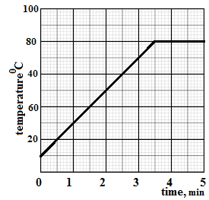

1. From the graph, determine the boiling point of the liquid (1 mark)

……………………………………………………………………………………………………………………………………………………………………………………………………

1. Determine the heat given out the by the heater between the times t = 0.5 minutes and t = 5.0 minutes (2 marks)

…………………………………………………………………………………………………………………………………………………………………………………………………………………………………………………………………………………………………………………………………………………………………………………………………………

1. From the graph determine the temperature change between the times t = 0.5 minutes and t = 5.0 minutes, hence determine the specific heat capacity of the liquid. (3 marks)

…………………………………………………………………………………………………………………………………………………………………………………………………………………………………………………………………………………………………………………………………………………………………………………………………………………………………………………………………………………………………………….

1. 1.8 g of vapor was collected from above the liquid between the times t= 3.5 minutes and t= 4.5 minutes. Determine the specific latent heat of vaporization of the liquid. (3 marks)

……………………………………………………………………………………………………………………………………………………………………………………………………………………………………………………………………………………………………………………………………………………………………………………………………………………………………………………………………………………………………………

1. a) Define “absolute zero temperature” for an ideal gas (1 mark)

……………………………………………………………………………………………………………………………………………………………………………………………………

b) Using kinetic theory, explain Boyle’s law for an ideal gas. (2marks)

……………………………………………………………………………………………………………………………………………………………………………………………………...…………………………………………………………………………………………………..…………………………………………………………………………………………………..

1. The diagram shows an experiment to investigate the relationship between volume and temperature of a fixed mass of gas at constant pressure.

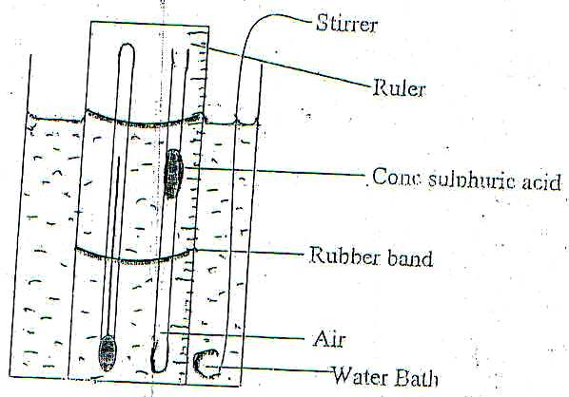

1. Explain the function of;

(I) Concentrated sulphuric acid (1 mark)

…………………………………………………………………………………………………

(II) Stirrer (1 mark)

…………………………………………………………………………………………………

ii). Explain how the set up above can be used to verify Charles law for an ideal gas (3marks)

……………………………………………………………………………………………………………………………………………………………………………………………………

…………………………………………………………………………………………………………………………………………………………………………………………………………………………………………………………………………………………………………………………………………………………………………………………………………

iii. On the grid below sketch a graph of volume (cm3) against temperature (0c). Mark with letter T the absolute zero temperature. (2 marks)

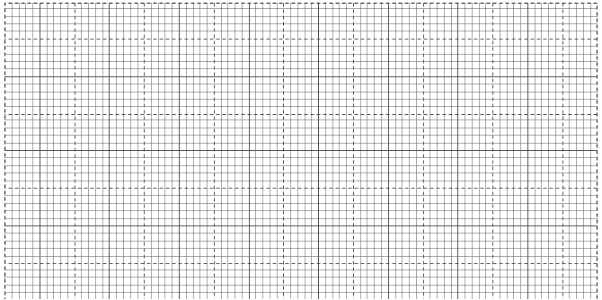

(d)A column of air 20cm long is trapped by mercury thread 6cm long as shown in figure below.

20cm

6cm

6cm

x

Air

If the tube is now inverted, determine column X in figure b).Take atmospheric pressure as 76cm of mercury. (2marks)

………………………………………………………………………………………………………………………………………………………………………………………………………………………………………………………………………………………………………………………………………………………………………………………………………....

1. State the law of floatation (1 mark)

………………………………………………………………………………………………………………………………………………………………………………………………………………………………………………………………………………………………………

1. Figure below shows a simple hydrometer

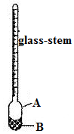

A ……………………………………………….....

B ……………………………………………………

1. Identify the parts labelled A and B (2 marks)

………………………………………………………………………………………………

1. State the purpose of the part labelled B (1 mark)

………………………………………………………………………………………………………………………………………………………………………………………………........

1. How would the hydrometer be made more sensitive? (1 mark)

……………………………………………………………………………………………………………………………………………………………………………………………………

1. Describe how the hydrometer is calibrated to measure relative density. (3 marks)

……………………………………………………………………………………………………………………………………………………………………………………………………………………………………………………………………………………………………………………………………………………………………………………………………………………………………………………………………………………………………………

1. Figure shows a cork floating on water and held to the bottom of the beaker by a thin thread.
2. 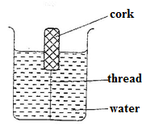Name the forces acting on the cork (2 marks)
3. Describe how each of the forces mentioned in(i) above changes when water is added until the container is completely filled (2 marks)

………………………………………………………………………………………………………………………………………………………………………………………………………………………………………………………………………………………………

1. (a) (i) What is meant by perfectly inelastic collision. (1 mark)

………………………………………………………………………………………………………………………………………………………………………………………………

1. A minibus of mass 1600kg travelling at a constant velocity of 20mls collides with a stationary car of mass 800kg. The impact takes 2 seconds before the two moves together and come to rest after 15 seconds. Determine.

(a) The common velocity. (3marks)

………………………………………………………………………………………………………………………………………………………………………………………………………………………………………………………………………………………………………………………………………………………………………………………………………………………………………………………………………………………………………………………………………

(b) The distance moved after the impact. (2 marks)

……………………………………………………………………………………………………………………………………………………………………………………………………………………………………………………………………………………………………………………………………………………………………………………………………………………………...

(iii) The impulse force. (2 marks)

………………………………………………………………………………………………………………………………………………………………………………………………………………………………………………………………………………………………………………………………………………………………………………………………………………………………

**This is the last printed page.**