**Name …………………………………..…………………………..……. Adm No ……………..**

**Class…………..…… Date……….……………….Student’s signature………………………..**

**232/3**

**PHYSICS**

**Paper 3**

**Time 21/2 HOURS**

**WISDOM PRE-MOCK EXAMINATION 2021**

***Kenya Certificate of Secondary Education (K.C.S.E)***

**Paper 3(232/3)**

**(Practical)**

**232/3**

**PHYSICS**

**Paper 3**

**Time 21/2 HOURS**

**INSTRUCTIONS TO CANDIDATES**

1. Write your **name, index number, class, date** and **signature** in the spaces provided above.

2. This paper consists of two questions **1** and **2.**

3. Answer all questions in the spaces provided.

4. Non-programmable calculators and mathematical tables may be used.

5. Show all your workings.

|  |  |  |  |  |  |  |  |
| --- | --- | --- | --- | --- | --- | --- | --- |
| **QUESTION 1** | **a(ii)** | **a(iii)** | **a(iv)** | **a(v)** | **a(vi)** | **b(vii)** | **TOTAL** |
| **Maximum score** | **6** | **5** | **3** | **1** | **2** | **3** |  |
| **Candidates score** |  |  |  |  |  |  |

|  |  |  |  |  |  |  |  |  |  |  |  |
| --- | --- | --- | --- | --- | --- | --- | --- | --- | --- | --- | --- |
| **QUESTION 2** | **a(i)** | **a(ii)** | **a(iii)** | **b(vii)** | **b(viii)** | **b(ix)** | **b(xi)** | **b(xii)** | **b(xii)I** | **b(xii)II** | **b(xiii)** |
| **Maximum score** | **1** | **1** | **1** | **6** | **2** | **1** | **1** | **1** | **1** | **2** | **3** |
| **Candidates score** |  |  |  |  |  |  |  |  |  |  |  |

***This paper consists of 8 printed pages.***

***Candidates should check the question paper to ensure that all pages are printed as indicated and no questions are missing***

**Question 1**

You are provided with the following

-Two dry cell

- Cell holder

-A piece of resistance wire labeled **W**

-Voltmeter (**0 - 3V** or **0 - 5V**)

-Ammeter (**0 - 1A**)

-A nichrome wire mounted on a millimeter scale labelled **PQ**

-Seven connecting wires in which four are with crocodile clips on both ends and three are with crocodile clips on one end

- Jockey attached to a connecting wire

- Micrometer screw gauge (can be shared)

Proceed as follows:

a) i). Set up the circuit as shown in the figure below.

**W**

Jockey

Nichrome wire

**P**

**Q**

ii) With the Jockey at **Q** i.e. **L= 0.0 cm**, take the voltmeter reading and ammeter reading. Record **V** and **I.** Repeat to get the readings for **L=20.0cm**, **40.0cm**, **60.0cm**, **60.0cm, 80.0cm** and **100.0cm** respectively and complete the table below.

|  |  |  |  |  |  |  |  |
| --- | --- | --- | --- | --- | --- | --- | --- |
| **Length L (cm)** | **0.0** | **20.0** | **40.0** | **60.0** | **80.0** | **100.0** |  |
| **Current I (A)** | *0.46* | *0.26* | *0.18* | *0.14* | *0.12* | *0.10* | *@1/2 mk 2d.p must* |
| **Voltage V (v)** | *1.8* | *1.0* | *0.7* | *0.55* | *0.45* | *0.4* | *@1/2 mk atleast 1d.p* |

(6marks)

iii).Plot a graph of voltmeter readings (y-axis) against ammeter readings. (5marks)

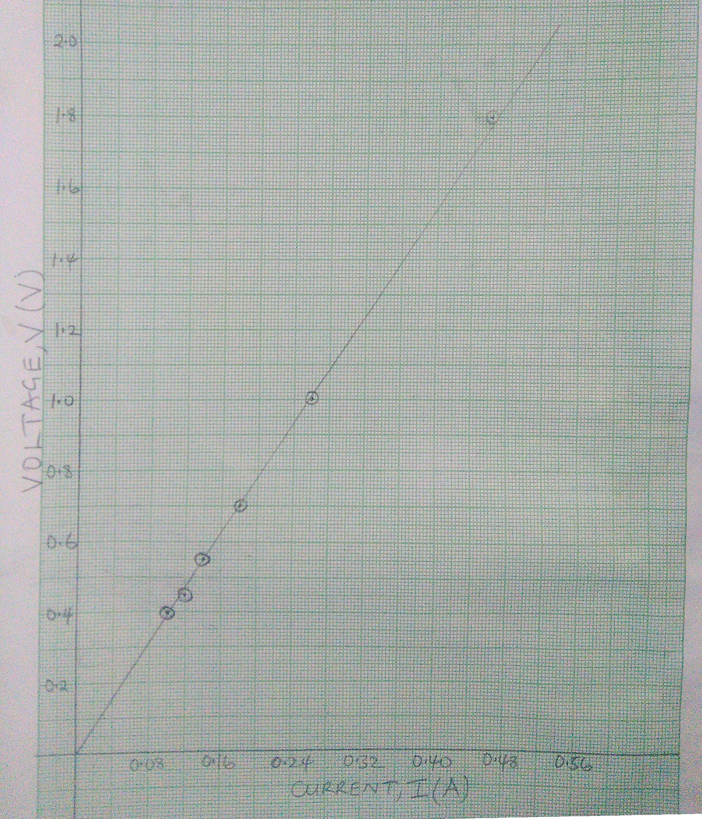

**Axis - 1 mark**

**Scale – 1 mark**

**Plotting – 2 marks**

**Line – 1 mark**

iv). Determine the slope of the graph (3marks)

 



*Correct substitution 1mark*

*Correct evaluation 1mark*

*Correct unit 1mark*

v). what physical quantity is represented by the slope of the graph at any given point (1mark)

***Resistance of wire W***

vi). Using a micrometer screw gauge, measure the diameter, **d** of the wire **W**.

**d** = **0.29 ± 0.02 mm** (1mark)

= **0.00029 ± 0.00002 m** (1mark)

vii). Calculate the quantity and give its units. (3marks)

*Correct substitution 1mark*

*Correct evaluation 1mark*

*Correct unit 1mark*



**Question 2**

**PART A**

**You** are **provided with the following apparatus**

- A meter rule

- A concave lens with holder

- A candle stick

- A white screen

- A stop watch

- Marble

- Watch glass

- Plasticine

- Micrometer screw gauge

**Proceed as follows:**

1. Find the approximate focal length by focusing a sharp image of a distant object onto a screen. The object (preferably window frame) must be **at least 4m** away. Repeat this procedure twice.

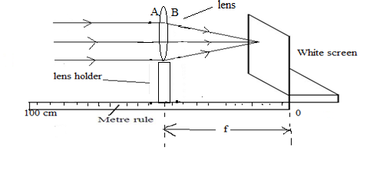

i)f1= ***10.0cm*** (1mark)

(ii)f2=***10.0cm*** (1mark)

iii) Find the Average of f1 and f2 = (1mark)

* ***principal of averaging $\frac{1}{2}$ mk***
* ***correct evaluation to 4s.f or exact with units cm $\frac{1}{2}$ mk mk***

b)(i)Now Set up the apparatus as shown in figure below such that S=55cm.Adjust the position of the lens to obtain a sharp enlarged image of the candle flame. (**Ensure that the candle flame, the lens and white screen same horizontal level)**

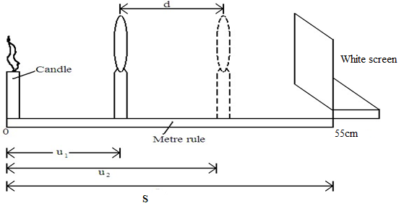

**ii)** Measure the distance **u1** between the candle and the lens

**iii)**Without changing the positionof the candle and the screen, move the lens to obtain a sharp diminished image of the candle

**iv)** Measurethe distance u2 between the candle and the lens

v) Record the values of **u1** and **u2** in the table below.

vi) Repeat the procedure in (i) above for S=45cm.

(vii)complete the table (6mks)

|  |  |  |  |  |
| --- | --- | --- | --- | --- |
| **S(cm)** | **U1(cm)** | **U2(cm )** | **d=U1-U2** |  |
| 55 | ***14.0 1mk*** | ***41.0 1mk*** | ***27.0*** | ***10.44*** |
| 45 | ***15.0 1mk*** | ***30.0 1mk*** | ***15.0*** | ***10.00*** |

viii) Determine the average value of K (2mks)

* ***principal of averaging 1mk***
* ***correct evaluation to 4s.f or exact with units cm 1mk***

ix) What does physical quantity k represent(1mk)

***focal length***

**PART B**

**Procedure:**

i. Arrange the apparatus as shown in the figure 5:

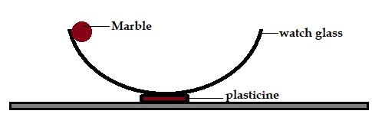

## Figure 5

1. Release the marble from the edge of the watch glass to freely oscillate. Measure the time taken, t, for 5 oscillations.

t = ***4.02cm 1mk 2d.p*** (1 mark)

1. Calculate the periodic time, T for the 5 oscillations.

T = ***Correct evaluation to 4sf or exact with correct unit 1mk***

i. Measure the diameter, D of the marble using the micrometer screw-gauge.

D = ***0.01746 m*** (1 mark)

ii. Determine the volume, V of the marble.

***correct substitution 1mk***

***Correct evaluation to 4sf or exact with correct unit m31mk***

m. The period, T, of oscillation of the marble is related by the equation:

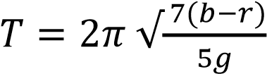 where r is the radius of the marble; g = 10 m/s2 and b is a constant

of the watch glass. Determine the value of b ( 3 marks)

***correct substitution 1mk***

***Correct evaluation to 4sf or exact with correct unit 2mk***s