Name ………………………..………………………… Index No...………………..…….…..

Candidate’s Signature: …………....……. Date: ……………………………….

232/2
PHYSICS
Paper 2
September 2021
Time: 2 Hours

WISDOM PRE-MOCK EXAMINATIONS 2021
Kenya Certificate of Secondary Education (KCSE)
232/2
PHYSICS
Paper 2
September 2021
Time: 2 Hours

INSTRUCTION TO CANDIDATES
- Write your name, index number in the spaces provided.
- This paper consists of TWO sections: A and B.
- Answer ALL questions in section A and B in the spaces provided.
- ALL workings MUST be clearly shown.
- Mathematical tables and electronic calculators may be used.

For Examiner’s Use Only
Section | Question | Maximum score | Candidate’s score
A | 1 – 12 | 25
B | 13  14  15  16 | 16  14  14  11
 | Total | 80

This paper consists of 12 printed pages. Candidates should check the question paper to ensure that all the pages are printed as indicated and no questions are missing.
1. The figure below shows an object O in front of a curved mirror M.
- On the figure, locate the image formed. (3 marks)
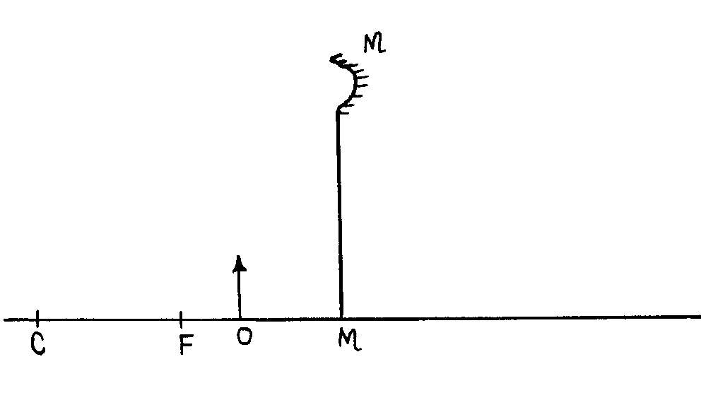
2. State two ways of decreasing the strength of an electromagnet. (2 marks)
…………………………………………………………………………………………………………………………………………………………………………………………………………………………………………………………………………………………………………………………………………………………………………………………………………………………………………
3. State one disadvantage of using a convex mirror as a driving mirror. (1 mark) …………………………………………………………………………………………………………………………………………………………………………………………………………………..
5. State two factors that affect the resistivity of an electrical conductor. (2 marks) ………………………………………………………………………………………………………………………………………………………………………………………………………………………………………………………………………………………………………………………………………………………………………………………………………………………………
6. A coin is placed at the bottom of a beaker containing a transparent liquid. When viewed from the top, the coin appears nearer the surface than it actually is. Explain the observation. (2 marks)
…………………………………………………………………………………………………………………………………………………………………………………………………………………….………………………………………………………………………………………………………………………………………………………………………………………………………………….

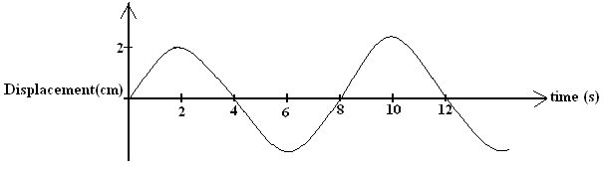
7. The figure below shows a wave in progress.
Determine the
a) Amplitude (1 mark) ………………………………………………………………………………………………… …………………………………………………………………………………………………
b) Frequency (2 marks) ………………………………………………………………………………………………… ………………………………………………………………………………………………….
c) On the figure above, draw how the wave would appear if the period and amplitude is
halved. (1 mark)
8. A ferromagnetic material is being magnetized by single stroking method. On the axes provided,
sketch a graph to show how the strength of the magnet being created varies with the number of
strokes (1 mark)

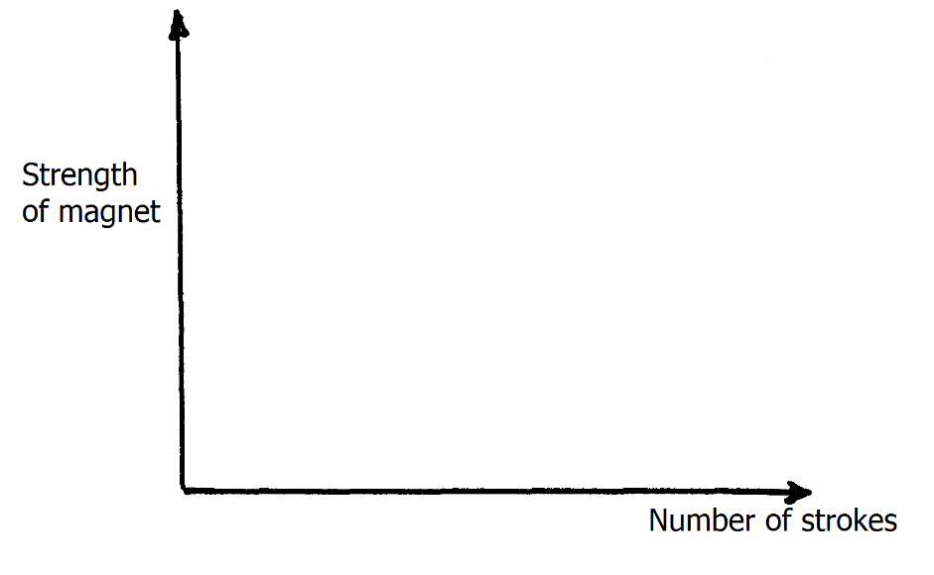

9. Figure 4 shows a conductor carrying current placed in the magnetic field and moves in the
direction shown
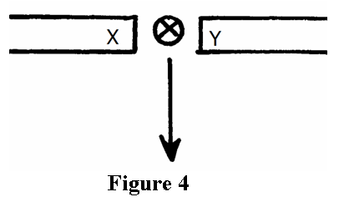
Identify the polarities of X and Y. (2 marks)
X…………………………………………………………………………………………………
Y…………………………………………………………………………………………………
10. A boy standing in front of a cliff blows a while and hears echo after 0.5s. He then makes
17metres further away from the cliff and blows the whistle again. He now hears the echo after
6.0 s. determined the speed of the sound. (3 marks)
………………………………………………………………………………………………… ………………………………………………………………………………………………… ………………………………………………………………………………………………… ………………………………………………………………………………………………..
11. (a) What is meant by the term electric current? (1 mark)
………………………………………………………………………………………………… ………………………………………………………………………………………………
(b) 0.25A of current passes through a point in a conductor in 3.5 minutes. Calculate the
amount of charge passing through the point in this time. (2 marks)
………………………………………………………………………………………………… …………………………………………………………………………………………………... …………………………………………………………………………………………………..

12. An unmagnetized steel rod is clamped facing North-South direction and then hammered
repeatedly for some time. When tested, it is found to be magnetized. Explain this observation (2 marks) ………………………………………………………………………………………………… ………………………………………………………………………………………………… ………………………………………………………………………………………………… ………………………………………………………………………………………………..
SECTION II (55 MARKS)
13. (a) State Ohm’s law. (1 mark)
………………………………………………………………………………………………… ………………………………………………………………………………………………… …………………………………………………………………………………………………
b). The graph below shows results obtained in an experiment to determine the e.m.f.(E) and the
internal resistance, r, of a cell.
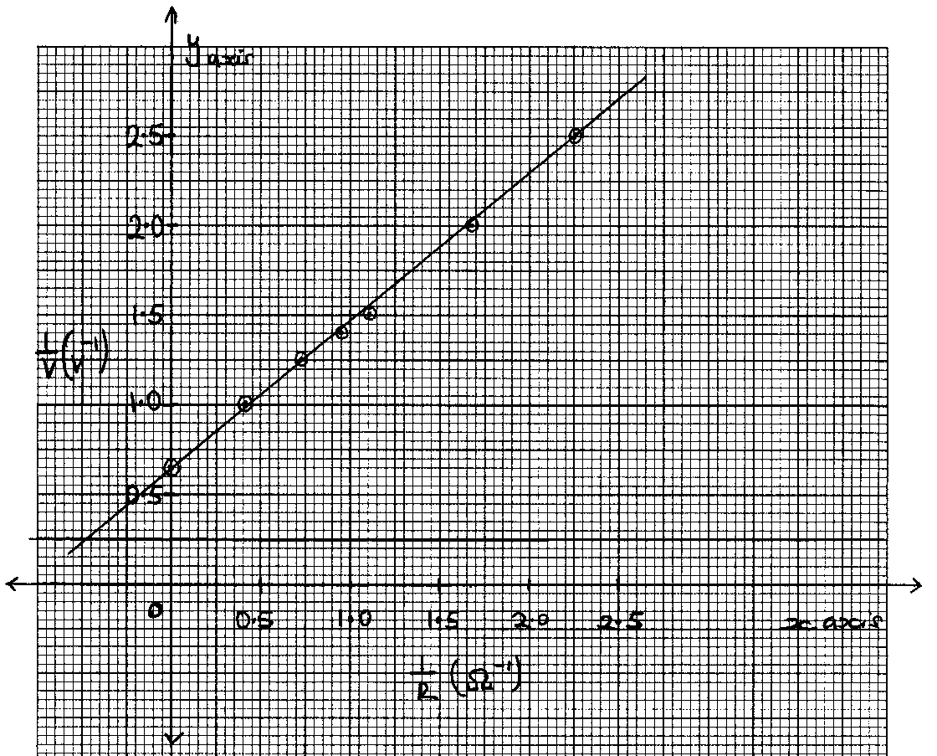
Given that the equation of the graph is = + 1
Use the graph to determine the values of:-
(i) E (2 marks)
………………………………………………………………………………………………… ………………………………………………………………………………………………… ………………………………………………………………………………………………… ………………………………………………………………………………………………..
(ii) r (3 marks) ………………………………………………………………………………………………… ………………………………………………………………………………………………… ………………………………………………………………………………………………… …………………………………………………………………………………………………
c) The figure below shows five resistors and a source of voltage of 6V.
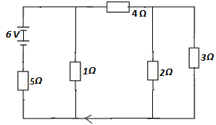
i) Find the effective resistance of the circuit. (2 marks)
………………………………………………………………………………………………… ………………………………………………………………………………………………… ………………………………………………………………………………………………… …………………………………………………………………………………………………
ii) Calculate the current through 5Ω. (3 marks)
………………………………………………………………………………………………… ………………………………………………………………………………………………… ………………………………………………………………………………………………… …………………………………………………………………………………………………

(iii) What is the p.d across 2Ω. (3 marks)
………………………………………………………………………………………………… ………………………………………………………………………………………………… ………………………………………………………………………………………………… ………………………………………………………………………………………………..
iv) Calculate the current through 1Ω. (2 marks)
………………………………………………………………………………………………… ………………………………………………………………………………………………… ………………………………………………………………………………………………… ………………………………………………………………………………………………..
14. (a) An object is placed 30cm in front of a thin converging lens of focal length 20cm. The set up
is represented in the figure.
lens

40 30 20 10 10 20 30 40

- On the same figure construct a ray diagram to locate the position of the image. (3 marks)

- Determine the magnification produced. (2 marks)
………………………………………………………………………………………………… ………………………………………………………………………………………………… ………………………………………………………………………………………………… ………………………………………………………………………………………………..

(b) An object 6cm tall is placed 40cm from a convex lens of focal length 50cm. Find the position of the image. (3 marks)
………………………………………………………………………………………………… ………………………………………………………………………………………………… ………………………………………………………………………………………………… ………………………………………………………………………………………………… ………………………………………………………………………………………………..
(c) State two differences between the human eye and the camera. (2 marks)
………………………………………………………………………………………………… ………………………………………………………………………………………………… ………………………………………………………………………………………………… ………………………………………………………………………………………………..
(d) The figure below shows an eye defect.
- Identify the defect. (1 mark)
………………………………………………………………………………………
- State the cause of the defect. (1 mark)
………………………………………………………………………………………..
(iii) Using a well labeled diagram, illustrate how the defect is corrected. (2 marks)

15. (a) The figure below shows a pair of parallel plates of a capacitor connected to a Battery the upper plates is displaced slightly to the left.
+
-

State with reason the effect of this movement of the capacitance (2 marks)
………………………………………………………………………………………………… ………………………………………………………………………………………………… ………………………………………………………………………………………………… ………………………………………………………………………………………………..
(b) The figure below shows an electrical circuit with three capacitors A, B and C of Capacitance
4.0 μF, 5.0 μF and 3.0 μF respectively connected to a 12V battery
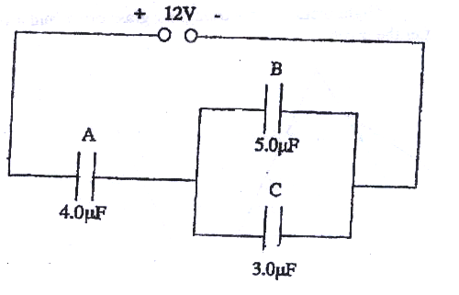
Determine:
(i) The combined capacitance of the three capacitors (3 marks)
………………………………………………………………………………………… ………………………………………………………………………………………… ………………………………………………………………………………………… ………………………………………………………………………………………….
(ii) The charge of the capacitor A (2 marks)
…………………………………………………………………………………… ……………………………………………………………………………………… ………………………………………………………………………………………… ………………………………………………………………………………………..

(iii) The potential difference across the capacitor B (2 marks)
…………………………………………………………………………………… ………………………………………………………………………………………… ………………………………………………………………………………………… ……………………………………………………………………………………….
c) A positively charged sphere is suspended by an insulating thread. A negatively charged conductor is suspended near it. The conductor is first attracted, after touching the sphere it is repelled. Explain this observation. (2 marks)
……………………………………………………………………………………………….. ………………………………………………………………………………………………… ………………………………………………………………………………………………… ………………………………………………………………………………………………..
d) A 2μF capacitor is charged to a potential of 200V, the supply is disconnected. The capacitor is then connected to another uncharged capacitor. The p.d across the parallel arrangement is 80V. Find the capacitance of the second capacitor. (3 marks)
………………………………………………………………………………………………… ………………………………………………………………………………………………… ………………………………………………………………………………………………… ………………………………………………………………………………………………..
…………………………………………………………………………………………………
16. (a) A single ray of light in incident on an equilateral glass position as shown in the figure below. Complete the diagram to show the path of light through and out of the position.(critical angle of glass = 42⁰) (3 marks)
(b) State two (2) conditions necessary for total internal reflection (2 marks)
………………………………………………………………………………………………… ………………………………………………………………………………………………… …………………………………………………………………………………………………

(c) (i) Figure below shows an object O at the bottom of a beaker full of a liquid. An observer above the beaker sees its image at point X inside a liquid.
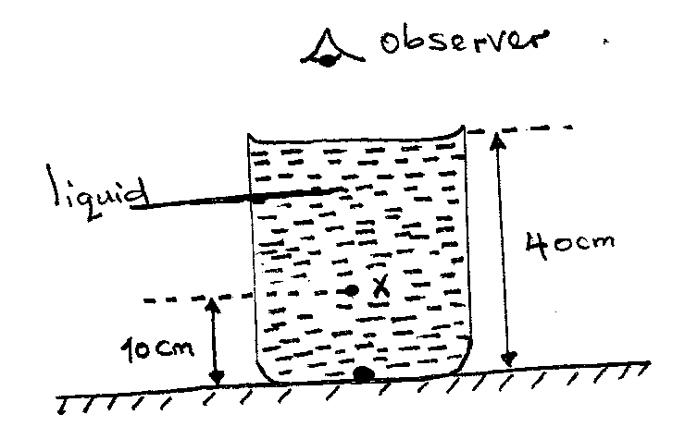

Determine the refractive index of the liquid. (3 marks)
……………………………………………………………………………..
………………………………………………………………………………
…………………………………………………………………………………
(ii) Define the term critical angle(c) of a medium. (1 mark)
…………………………………………………………………………………………
…………………………………………………………………………………………
(d) State two uses of optical fibre. (2 marks)
………………………………………………………………………………………………. ………………………………………………………………………………………………… ………………………………………………………………………………………………… ………………………………………………………………………………………………..

