NAME:................................................................................. ADM:.............. CLASS:.....................

INDEX NUMBER:…………………………………… SIGNATURE:………………………………

232/1
PHYSICS
PAPER 1
(THEORY)
SEP/OCT 2021
TIME: 2 HOURS

WISDOM PRE-MOCK EXAMINATIONS 2021

Kenya Certificate of Secondary Education (K.C.S.E)

INSTRUCTIONS TO CANDIDATES
- Write your Name, Admission number, Class and Index Number in the spaces provided above.
- This paper consists of two sections: A and B
- Answer all the questions in the spaces provided
- All working must be clearly shown.
- Mathematical tables and electronic calculators may be used
- Take g=10ms⁻²
- Density of mercury = 13600 kg/m³

For Examiner’s Use
SECTION | QUESTION | MAXIMUM SCORE | CANDIDATE’S SCORE
A | 1-13 | 25
B | 14 | 11
 | 15 | 11
 | 16 | 09
 | 17 | 12
 | 18 | 12
TOTAL |  | 80

This paper consists of 12 printed pages. Candidates should check the question paper to ascertain that all pages are printed as indicated and that no questions are missing.
Section A (25 marks)
Water Paraffin
Answer all the questions in the spaces provide

- A partially inflated balloon at sea level becomes fully inflated at higher altitudes. Explain this observation (2 marks)
……………………………………………………………………………………………………
…………………………………………………………………………………………………….
……………………………………………………………………………………………………
…………………………………………………………………………………………………….
- The figure below shows a pith ball being lifted into the funnel by blowing air into the funnel Explain this observation (2 marks)
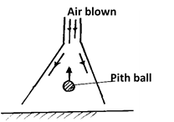
……………………………………………………………………………………………………
…………………………………………………………………………………………………….
……………………………………………………………………………………………………
…………………………………………………………………………………………………….
- State two reasons why gases diffuses at a higher rate than liquids. (2 marks)
……………………………………………………………………………………………………
…………………………………………………………………………………………………….
……………………………………………………………………………………………………
- A student set up an experiment as shown below using two gas jars, one with hot coloured water, the other with cold clear water separated by a smooth card. The upper jar is upside down. Explain the observation made when the card is removed. (2 marks)
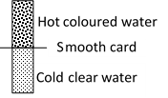

……………………………………………………………………………………………………
…………………………………………………………………………………………………….
……………………………………………………………………………………………………
…………………………………………………………………………………………………….
- The figure below shows the scale of a Vernier calipers which is closed fully. State the Zero error of the instrument (1 mark)

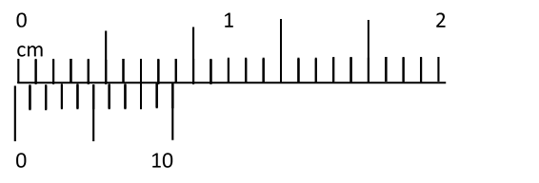
……………………………………………………………………………………………………
…………………………………………………………………………………………………….
……………………………………………………………………………………………………
- The figure below shows a uniform body suspended freely through a hole on an optical pin. State with reason the case where the body is more stable (2 marks)
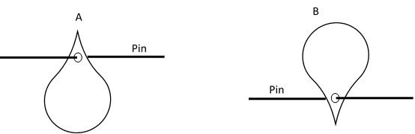

……………………………………………………………………………………………………
…………………………………………………………………………………………………….
……………………………………………………………………………………………………
…………………………………………………………………………………………………….

- The figure below shows a metal being heater at the middle. Giving the reason state the wax that will fall off first (2 marks)

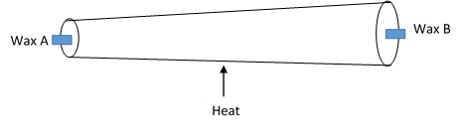
……………………………………………………………………………………………………
…………………………………………………………………………………………………….
……………………………………………………………………………………………………
…………………………………………………………………………………………………….
- The figure below shows a system with a liquid enclosed by two pistons. Equal force F is applied on the system as shown. Giving reason show with an arrow the direction of movement of the liquid (2 marks)
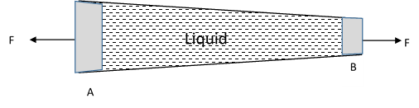

……………………………………………………………………………………………………
…………………………………………………………………………………………………….
……………………………………………………………………………………………………
…………………………………………………………………………………………………….
- The figure below shows a bimetallic wheel whose diameter is not affected by changes in
temperature. Briefly explain how the diameter of the wheel remain unchanged as the temperature increases. (2 marks)

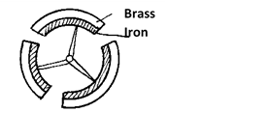
……………………………………………………………………………………………………
…………………………………………………………………………………………………….
……………………………………………………………………………………………………
…………………………………………………………………………………………………….

- Two identical springs have a combined spring constant of 3.5N/cm when in series Determine combined spring constant when the springs are in parallel. (2 marks)

- Two coins A and B of the same mass and material are placed on a turntable as show below. The turntable is then rotated at a high speed. With reason name the coin that skids first (2 marks)
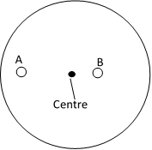

……………………………………………………………………………………………………
…………………………………………………………………………………………………….
- A substance of volume Xcm³ and density 800kgm⁻³ is mixed with 100cm³ of water of density 1000kgm⁻³. The density of the mixture is 960kgm⁻³. Determine the value of X. (2 marks)
……………………………………………………………………………………………………
…………………………………………………………………………………………………….
……………………………………………………………………………………………………
…………………………………………………………………………………………………….
- A bullet of mass 10g travelling at a speed of 400ms⁻¹ hits a tree trunk. It penetrates the tree trunk and stops inside the trunk after 4 cm. Calculate the average resistance force offered by the trunk to the bullet. (2 marks)
……………………………………………………………………………………………………
…………………………………………………………………………………………………….
……………………………………………………………………………………………………
…………………………………………………………………………………………………….
……………………………………………………………………………………………………
…………………………………………………………………………………………………….
……………………………………………………………………………………………………
…………………………………………………………………………………………………….
Section B (55 marks)
Water Paraffin
Answer all the questions in the spaces provide

- (a) A body accelerates from rest. Its velocity after 5 seconds is 26m/s and after 9 seconds its velocity is 42m/s. calculate
i) Distance moved during the motion (3 marks)

ii) Average speed of the journey (2 marks)

(b) A car can be brought to rest from a speed of 20m/s in a time of 2s when brakes are
applies.
i. Find the average deceleration (1 mark)

ii. The car is stopped by a policeman when moving at a speed of 20m/s. If the driver’s reaction time is 0.2s determine the shortest stopping distance. (2 marks)

(c) The figure below shows the graph of a tennis ball bouncing severally on a table
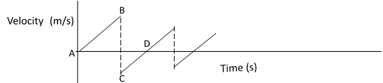

Describe the motion between
- AB (1 mark)
……………………………………………………………………………………………………
…………………………………………………………………………………………………….
……………………………………………………………………………………………………
…………………………………………………………………………………………………….
- BC (1 mark)
……………………………………………………………………………………………………
…………………………………………………………………………………………………….
……………………………………………………………………………………………………
…………………………………………………………………………………………………….
- CD (1 mark)
……………………………………………………………………………………………………
…………………………………………………………………………………………………….
……………………………………………………………………………………………………
…………………………………………………………………………………………………….

- (a) State the Pascal principle (1 mark)
……………………………………………………………………………………………………
…………………………………………………………………………………………………….
……………………………………………………………………………………………………
(b) State the principal of moments (1 mark)
……………………………………………………………………………………………………
…………………………………………………………………………………………………….
…………………………………………………………………………………………………….
(c) The figure below shows a 100cm uniform bar of weight 50N balanced horizontally on
two pistons.
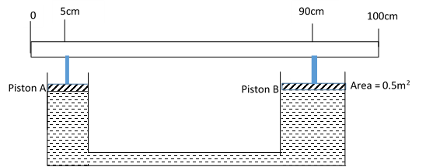

Correct to 2 decimal places determine
- Force exerted on piston A (3 marks)

- Force exerted on Piston B (3 marks)

- Cross section area of piston A (3 marks)
- a. The figure below shows 30cm³ of gas trapped in a tube containing mercury to a height of 14.5cm. The prevailing atmospheric pressure is 760mmHg. Determine the pressure acting on the gas in Pascals (3 marks)
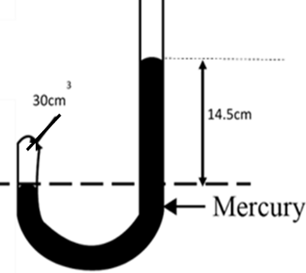

b. Determine the volume of the gas when the tube is held as shown below
i. (3 marks)
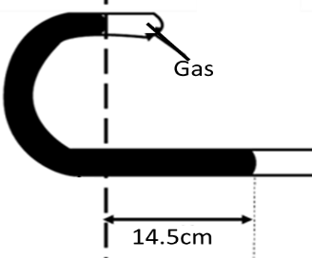

ii. (3 marks)
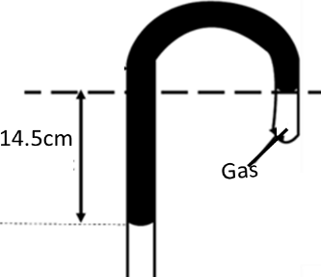
- a) State the law of floatation. (1 mark)
……………………………………………………………………………………………………
…………………………………………………………………………………………………….
……………………………………………………………………………………………………

b) The figure below shows a block cuboid of dimensions 4cm by 4cm by 16cm floating in a liquid in an overflow can with $\frac{3}{4}$ of its height submerged.
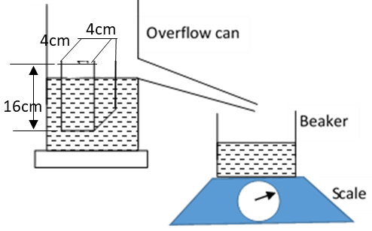
Given that the mass of the beaker when empty is 85g and the reading on the scale in the set up above is 245g, calculate:
(i) The density of the block. (3 marks)

(ii) The density of the liquid. (2 marks)

(c) A metal block is suspended from a spring balance and held inside a beaker without
touching the beaker. Water is added gradually into the beaker. The graph below shows the
variation of up thrust on the block with depth of water.
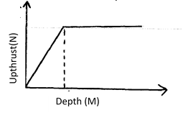
Explain the shape of the graph. (2 marks)
……………………………………………………………………………………………………
…………………………………………………………………………………………………….
……………………………………………………………………………………………………
…………………………………………………………………………………………………….
(d) The figure below shows a pulley system being used to raise a load.

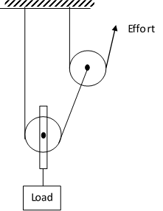
(i) Indicate the direction of the strings (1 mark)
(ii) If an effort of 35N raises a load of 105N, determine the efficiency of the system.
(3 marks)

18. (a) The figure below shows a car of mass (m) moving along a curved part of the road with a
constant speed.
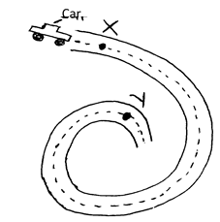
(i) Explain why the car is more likely to skid at Y than at X. (2 marks)
……………………………………………………………………………………………………
…………………………………………………………………………………………………….
……………………………………………………………………………………………………
…………………………………………………………………………………………………….
(ii) If the radius of the road at V is 250m and the car has a mass of 600kg, determine the
maximum speed at which the car can be driven while at V without skidding. Force of
friction between the road and the tyres is 18000N. (3 marks)
……………………………………………………………………………………………………
…………………………………………………………………………………………………….
……………………………………………………………………………………………………
…………………………………………………………………………………………………….
……………………………………………………………………………………………………
…………………………………………………………………………………………………….
(b) A string of length 70cm is used to whirl a stone in a circle in a vertical plane at 5 rev/s.
Determine:
(i) The period (1 mark)

(ii) The angular velocity. (2 marks)

(iii) The speed of the stone (2 marks)

(c) A body moving in a circle with constant speed is said to have an acceleration. Explain. (1 mark)

……………………………………………………………………………………………………
…………………………………………………………………………………………………….
……………………………………………………………………………………………………
…………………………………………………………………………………………………….
……………………………………………………………………………………………………
…………………………………………………………………………………………………….
……………………………………………………………………………………………………

