SUNRISE EXAMS FORM 4-2021

Name: …………………………………………………………… Index No. …………………………
School: …………………………………………………………. Candidate’s Sign. …………............
Date: ………………………………............................................

232/1
PHYSICS
PAPER 1
TIME: 2 HOURS

Kenya Certificate of Secondary Education (K.C.S.E.)

232/1
PHYSICS
PAPER 1
TIME: 2 HOURS

INSTRUCTIONS TO THE CANDIDATES:
- Write your name and index number in the spaces provided above.
- Answer all the questions both in section A and B in the spaces provided below each question
- All workings must be clearly shown; marks may be awarded for correct steps even if the answers are wrong.
- Mathematical tables and silent electronic calculators may be used.
(Take acceleration due to gravity g= 10ms⁻² Density of water 1g/m⁻³)
For Examiners’ Use Only

SECTION | QUESTION | MAXIMUM SCORE | CANDIDATE’S SCORE
Section A | 1-12 | 25
Section B | 13 | 09
 | 14 | 14
 | 15 | 14
 | 16  17 | 09  09
 | 18 | 10
 | TOTAL | 80

This paper consists of 8 printed pages. Candidates should check to ascertain that all pages are printed as indicated and that no questions are missing

SECTTION A (25 MARKS)
Answer all questions in this section in the spaces provided
1. State Pascal’s principle of transmission of pressure in fluids (1mk)
…..………………………………………………………………………………………………………
…..………………………………………………………………………………………………………
2. Water is known to boil at 100ºC . a student heated some water and noticed that it boiled at 101ºC. State two possible reasons for this observation (2mks)
…..………………………………………………………………………………………………………
…..………………………………………………………………………………………………………
3. Fig 1. Shows a flask filled with water. The flask is fitted with a cork through which a tube is inserted. When the flask is cooled, the water level rises slightly, then falls steadily.
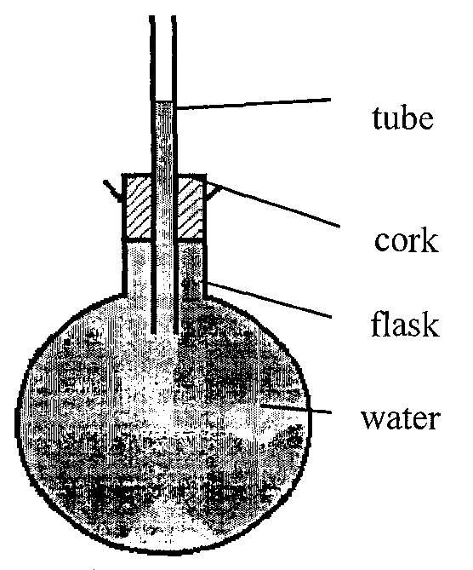

Explain the observation (3mks)
…..………………………………………………………………………………………………………
…..………………………………………………………………………………………………………
4. A pipe of radius 4mm is connected to another pipe of radius 6mm. if water flows in the wider pipe at the speed of 5ms⁻¹, what is the speed in the narrower pipe? (3mks)
…..………………………………………………………………………………………………………
…..………………………………………………………………………………………………………

5. The system in figure2 is in equilibrium
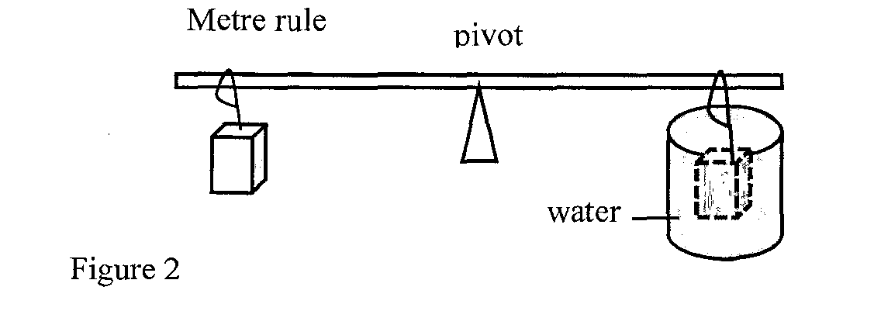

When the temperature of the water is raised the system is observed to tilt to the right, state the reason for this observation (2mks)
…..………………………………………………………………………………………………………
…..…………………………………………………………………………………………………………..………………………………………………………………………………………………………
…..………………………………………………………………………………………………………
…..………………………………………………………………………………………………………
…..………………………………………………………………………………………………………
6. Explain why a glass container with glass walls is more likely to crack than one with a thin wall when a very hot liquid is poured into them. (2mks)
…..………………………………………………………………………………………………………
…..…………………………………………………………………………………………………………..………………………………………………………………………………………………………
…..………………………………………………………………………………………………………
…..………………………………………………………………………………………………………
…..………………………………………………………………………………………………………
7. State two ways in which the stability of a body can be increased (2mks)
…..………………………………………………………………………………………………………
…..…………………………………………………………………………………………………………..………………………………………………………………………………………………………
…..………………………………………………………………………………………………………
…..………………………………………………………………………………………………………
…..………………………………………………………………………………………………………

8. The object in figure 3 is placed on a horizontal table with a chain hanging from its centre of gravity. State the type of equilibrium for the object (1mk)
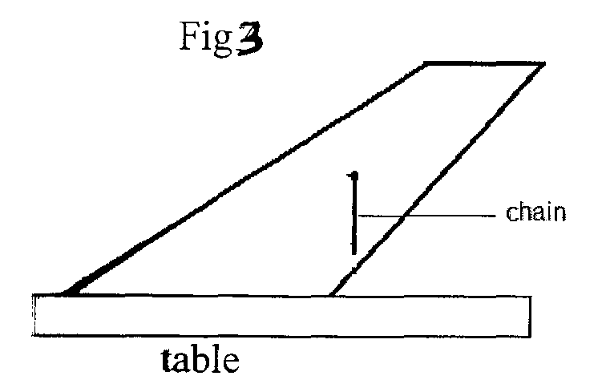

…..………………………………………………………………………………………………………
…..………………………………………………………………………………………………………
9. A ball is thrown upwards and returns to its starting point after 6 seconds. Calculate the maximum height reached(g=10m/s²) (3mks)

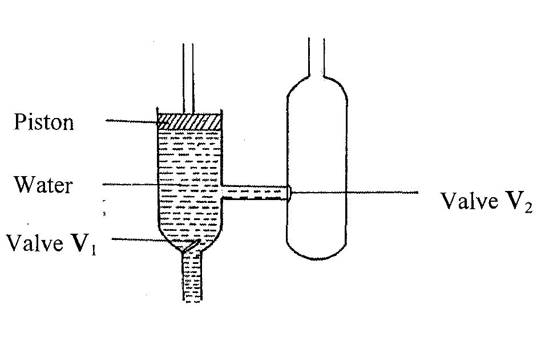
10. The figure below shows a force pump

Explain how the water gets past valve V2 (2mks)
…..………………………………………………………………………………………………………
…..………………………………………………………………………………………………………

11. When calibrating a liquid in glass thermometer, it is normally not advisable to dip the bulb in boiling water when getting the upper fixed point. Explain why it is so (2mks)
…..………………………………………………………………………………………………………
…..………………………………………………………………………………………………………
12. Convectional and diffusion both involve motion of fluid molecules. Distinguish between the two (2mks)
…..………………………………………………………………………………………………………
…..…………………………………………………………………………………………………………..………………………………………………………………………………………………………
…..………………………………………………………………………………………………………
…..………………………………………………………………………………………………………
…..………………………………………………………………………………………………………
SECTION B (55 MKS)
13. (a) Define the term heat capacity (1mk)
…..………………………………………………………………………………………………………
…..…………………………………………………………………………………………………………..………………………………………………………………………………………………………
…..………………………………………………………………………………………………………
…..………………………………………………………………………………………………………
…..………………………………………………………………………………………………………
(b) You are provided with the apparatus shown in Fig 5 and stop watch
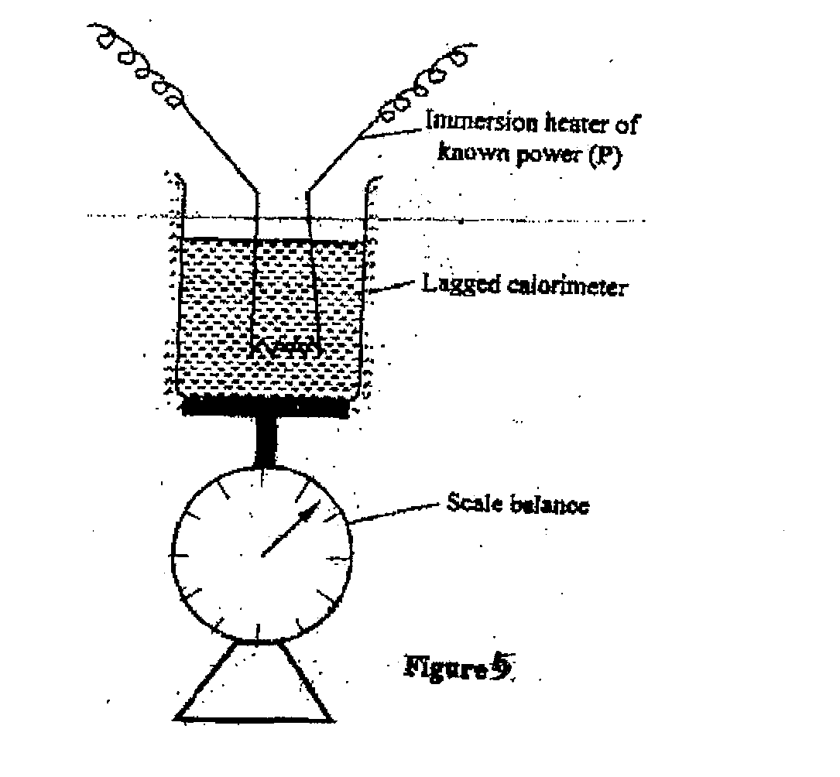

Describe an experiment to determine the specific latent heat of steam, using the set up. In your answers clearly explain the measurements to be made and how these measurements could be used to determine 1 (6mks)
…..………………………………………………………………………………………………………
…..………………………………………………………………………………………………………
…..………………………………………………………………………………………………………
…..………………………………………………………………………………………………………
…..………………………………………………………………………………………………………
…..………………………………………………………………………………………………………

(c) A block of metal of mass 150g at 100ºC is dropped into a lagged calorimeter of heat capacity 40JK⁻¹ containing 100g of water at 25ºC. The temperature of the resulting mixture is 34ºC. (Specific heat capacity of water=4200JK⁻¹)
Determine:
(i) Heat gained by calorimeter; (2mks)
…..………………………………………………………………………………………………………
…..………………………………………………………………………………………………………

(ii) Heat gained by water; (1mk)
…..………………………………………………………………………………………………………
…..…………………………………………………………………………………………………………..………………………………………………………………………………………………………
…..………………………………………………………………………………………………………
…..………………………………………………………………………………………………………
…..………………………………………………………………………………………………………
(iii) Heat lost by the metal block; (1mk)
…..………………………………………………………………………………………………………
…..…………………………………………………………………………………………………………..………………………………………………………………………………………………………
…..………………………………………………………………………………………………………
…..………………………………………………………………………………………………………
…..………………………………………………………………………………………………………
(iv) Specific heat capacity of the metal block (3mks)
…..………………………………………………………………………………………………………
…..…………………………………………………………………………………………………………..………………………………………………………………………………………………………
…..………………………………………………………………………………………………………
…..………………………………………………………………………………………………………
…..………………………………………………………………………………………………………
14. (a) Distinguish between solid and liquid states of matter in terms of intermolecular forces (1mk)
…..………………………………………………………………………………………………………
…..………………………………………………………………………………………………………
(b) In an experiment to estimate the diameter of an oil molecule, an oil drop of diameter 0.05 spreads over a circular patch whose diameter is 20cm
Determine
(i) The volume of the oil drop (2mks)
…..………………………………………………………………………………………………………
…..…………………………………………………………………………………………………………..………………………………………………………………………………………………………
…..………………………………………………………………………………………………………
…..………………………………………………………………………………………………………
…..………………………………………………………………………………………………………
(ii) The area of the patch covered by the oil (2mks)
…..………………………………………………………………………………………………………
…..…………………………………………………………………………………………………………..………………………………………………………………………………………………………
…..………………………………………………………………………………………………………
…..………………………………………………………………………………………………………
…..………………………………………………………………………………………………………

(iii) The diameter of the oil molecule (2mks)
…..………………………………………………………………………………………………………
…..…………………………………………………………………………………………………………..………………………………………………………………………………………………………
…..………………………………………………………………………………………………………
…..………………………………………………………………………………………………………
…..………………………………………………………………………………………………………
(c)State
(i) Any assumption made in (b) (iii) above (1mk)
…..………………………………………………………………………………………………………
…..………………………………………………………………………………………………………
…..………………………………………………………………………………………………………
…..………………………………………………………………………………………………………

(ii) Two possible sources of errors in this experiment (2mks)
…..………………………………………………………………………………………………………
…..………………………………………………………………………………………………………
15. (a) State what is meant by centripetal acceleration (1mk)
…..………………………………………………………………………………………………………
…..………………………………………………………………………………………………………
(b) A block of mass 200g is placed on a frictionless rotating table while fixed to the centre of the table by a thin thread. The distance from the centre of the table to the block is 15cm. if the maximum tension the thread can withstand is 5.6N. determine the maximum angular velocity the table can attain before the thread cuts. (4mks)
…..………………………………………………………………………………………………………
…..………………………………………………………………………………………………………
…..………………………………………………………………………………………………………
…..…………………………………………………………………………………………………………..………………………………………………………………………………………………………
…..………………………………………………………………………………………………………
…..………………………………………………………………………………………………………
…..………………………………………………………………………………………………………
16. (a) Define the term velocity ratio as used in machines (1mk)
…..………………………………………………………………………………………………………
…..………………………………………………………………………………………………………

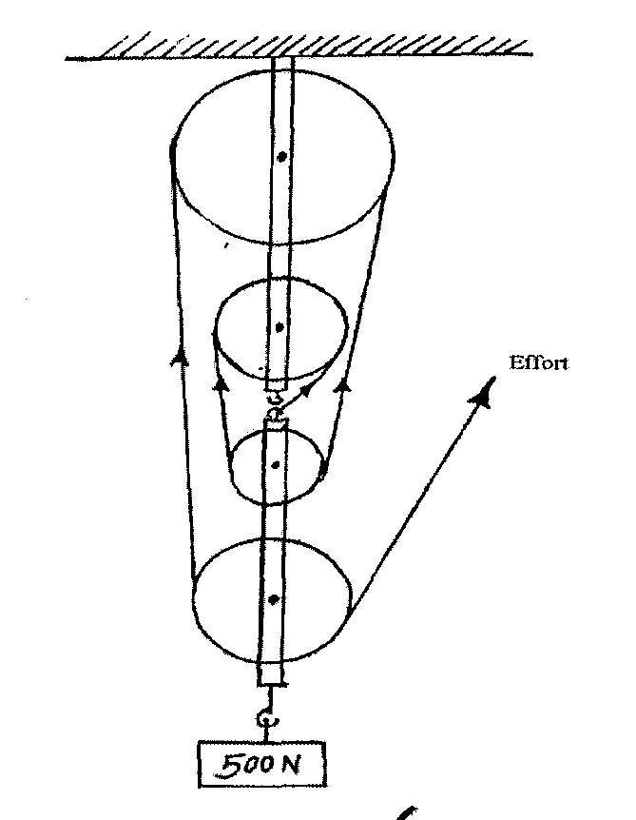
(b) Figure 6 shows a block and tackle pulley system lifting a load of 500N

(i) Determine the velocity ration of the machine (1mk)
…..………………………………………………………………………………………………………
…..………………………………………………………………………………………………………

(ii)If an effort of 120N is required to lift the load using the machines determine the efficiency of the pulley system (3mks)
…..………………………………………………………………………………………………………
…..………………………………………………………………………………………………………

(iii) In the space provided below, sketch a graph of efficiency against load for the system.
(2mks)

17. A car of mass 2000kg travelling at 5m/s collides with a minibus of mass 5000kg travelling in the opposite direction at 7m/s, the vehicles stick and move together after collision. If the collision lasts 0.1 seconds
(a) Determine the velocity of the system after collision to 3 decimal places (3mks)

(b) Calculate the impulsive force on the minibus (3mks)

(c) (i) Calculate the change in kinetic energy of the system to 5 significant figures (3mks)

18. (a)(i) State the law of floatation (1mk)
…..………………………………………………………………………………………………………
…..………………………………………………………………………………………………………
(ii) Explain why a hollow metal sphere floats on water while a solid metal sphere of the same material sinks in water. (2mks)
…..………………………………………………………………………………………………………
…..………………………………………………………………………………………………………
…..………………………………………………………………………………………………………
…..………………………………………………………………………………………………………
(b) The figure 7 below shows a uniform block of uniform cross-sectional area of 6.0cm² floating on two liquids A and B. The lengths of the block in each liquid are shown. Given that the density of liquid A is 800kg/m³ and that of liquid B is 1000kgm⁻³ determine the:
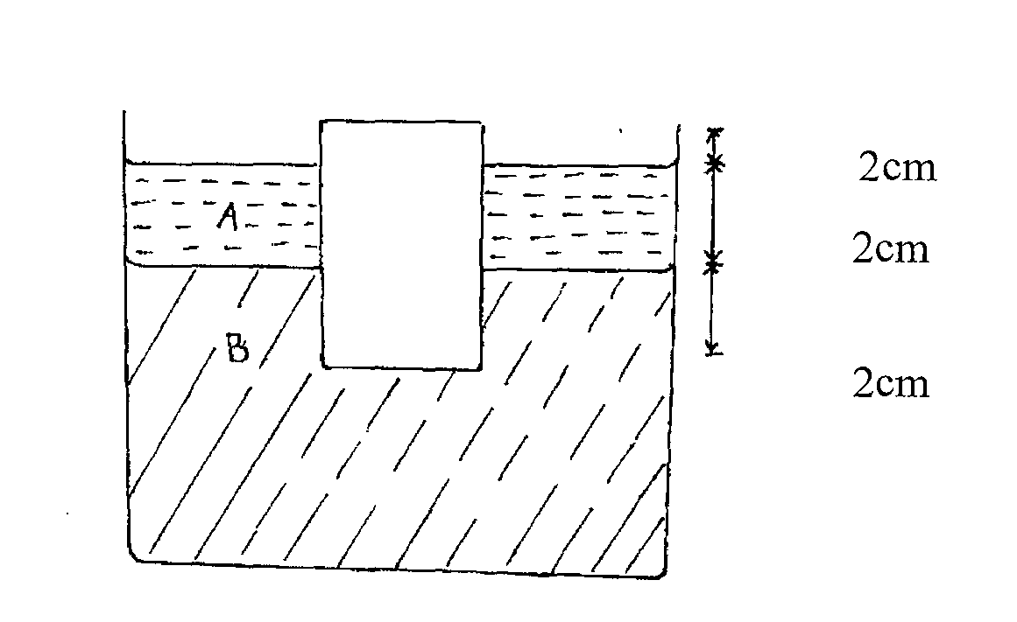

(i) Weight of liquid A displaced (2mks)

(ii) Weight of liquid B displaced (2mks)

(iii) Density of block (3mks)

